GraminSahay: An LLM-Powered RAG-Based Rural Welfare and Government Services Navigator
Mr. S. Lingaiah  Dept. of CSE  MLR Institute of Technology  Hyderabad, India  slingaiah@mlrinstitutions.ac.in | Adigarla Yuva Teja  Dept. of CSE  MLR Institute of Technology  Hyderabad, India  yuvateja976@gmail.com | Akhil Vankudoth  Dept. of CSE  MLR Institute of Technology  Hyderabad, India  akhilvankudoth58@gmail.com | Adiserla Praneel  Dept. of CSE  MLR Institute of Technology  Hyderabad, India  praneeladiserla@gmail.com

Abstract— Rural India is served by many government welfare schemes—across agriculture, education, healthcare, housing, pensions, and employment—yet a large share of eligible citizens never see the benefit. The problem is awareness, not supply: people often do not know which schemes fit them, what documents to bring, how to apply, or why an earlier application failed, and the official portals expect you to know a scheme’s name before you can even search. This paper reviews the work most relevant to a situation-aware welfare advisor and introduces GraminSahay, a multilingual, voice-first assistant that lets a citizen describe their situation in ordinary language and then surfaces the schemes they may qualify for. Under the hood it pairs Retrieval-Augmented Generation (RAG) over official scheme and policy documents with an eligibility-reasoning layer that labels each scheme eligible, possibly eligible, not eligible, or missing information; a conflict-detection stage that flags benefits that cannot be claimed together; and step-by-step guidance for applying. The survey spans RAG and knowledge-intensive question answering, faithfulness and automated evaluation of RAG, retrieval-augmented reasoning, multilingual and cross-lingual retrieval, domain adaptation, and the use of large language models for interpretive support in digital government. From it we draw the research gaps that justify an explainable rural welfare navigator, and we set out the proposed architecture and methodology.
Keywords— Retrieval-Augmented Generation, Large Language Models, Multilingual Voice AI, Eligibility Reasoning, Scheme Conflict Detection, Rural Welfare, Public Policy Technology, Indic Speech Processing, Explainable AI.
I. INTRODUCTION
India runs a wide range of welfare schemes for its rural population, covering agriculture, education, healthcare, housing, and pensions. On paper the coverage is substantial. In practice, many citizens who qualify for a scheme never actually receive its benefit. The problem is mostly one of information, not administration. People often have no idea a relevant scheme even exists; when they do, the eligibility rules are hard to read, the list of required documents is unclear, and a rejected application rarely comes with a usable explanation of what went wrong [1].
Part of the issue is how the official portals are built. They index everything by scheme name, so a citizen has to already know what a scheme is called before the portal is of any use to them. That is backwards. People know their own circumstances; they do not carry around a mental catalogue of scheme names mapped to those circumstances. Language makes this worse: most portals are text-heavy and assume the user can read formal official prose, which leaves out anyone who would rather speak in their regional language [1].
Large language models (LLMs) and Retrieval-Augmented Generation (RAG) give us a way in. In a RAG setup, a retriever first pulls relevant passages from an external document store and a generator then answers using that evidence, so the output is tied to real sources instead of resting only on what the model memorised during training [8]. For welfare, that property matters a great deal: answers have to be correct, they have to be traceable back to an official document, and the underlying corpus has to be easy to refresh when a policy changes. Layer multilingual retrieval and Indic speech on top, and the same system can take a spoken account of someone’s situation and reply in the language they actually use.
We present GraminSahay, a multilingual, voice-first welfare navigator built around this idea. A citizen simply states their situation—say, “I am a farmer with a small landholding” or “my daughter is starting college”—and the system returns the schemes they are likely eligible for, why each decision was reached, a warning if two schemes cannot be claimed together, and the steps needed to apply. This paper concentrates on the research that such a system rests on and the gaps it still has to close.
Why does this matter beyond convenience? Welfare delivery maps onto two of the Sustainable Development Goals—Goal 1 (No Poverty) and Goal 10 (Reduced Inequalities). A scheme is written to protect a vulnerable household, but it only does so once an eligible person actually claims it. In other words, the hard part of welfare is not drafting the policy; it is the last mile of finding the right scheme, making sense of it, and getting through the application. That is precisely where rural citizens get stuck, and it is where a good assistant can convert policy that already exists into benefit that is actually received—without touching the schemes themselves.
GraminSahay is shaped by three commitments. The first is that the citizen should never have to name a scheme; the system takes a described situation and works out the candidate schemes itself. The second is explainability—a bare yes/no verdict is close to useless, so every eligibility decision comes with a plain-language reason tied back to an official source. The third is accessibility: voice and regional-language support are treated as the main way people interact with the system, not as optional extras, because a large part of the intended audience is far more comfortable speaking than reading official documents.
The rest of the paper proceeds as follows. Section II surveys the literature along six strands and condenses it into Table I. Section III sets out the research gaps and Section IV covers the knowledge sources and data. The problem statement and motivation appear in Sections V and VI, and Section VII lists the objectives. Section VIII compares the existing and proposed systems, Section IX walks through the methodology, and Section X gives the solution and architecture. Section XI reports the expected results, Section XII looks at future work, and Section XIII concludes.
II. LITERATURE REVIEW
Research directly relevant to GraminSahay falls into six strands: (A) foundational Retrieval-Augmented Generation, (B) faithfulness and automated evaluation of RAG, (C) retrieval-augmented reasoning, (D) multilingual and cross-lingual retrieval, (E) dense retrieval and domain adaptation, and (F) LLMs for interpretive support in digital government. We review each strand and relate it to the welfare-navigation setting.
A. Foundational Retrieval-Augmented Generation
RAG was introduced by Lewis et al. for knowledge-intensive NLP, pairing a pretrained sequence generator with a neural retriever over an external document index [8]. Against a purely parametric baseline it generated answers that were more specific, more diverse, and more factual, and it improved open-domain question answering. The takeaway for us is blunt: answer quality can only be as good as retrieval quality. Their experiments ran over a general Wikipedia index, but a welfare navigator has to retrieve from something far narrower—a curated set of official scheme guidelines and eligibility rules.
B. Faithfulness and Automated Evaluation of RAG
A welfare system must never claim an eligibility that the retrieved evidence does not actually support, so faithfulness is not a nice-to-have—it is central. Filice et al. put forward Answering with Faithfulness (AwF), which checks directly whether a generated answer is backed by the retrieved passages and shows that stronger faithfulness checks both lift downstream RAG performance and make principled fallbacks possible [4]. RAGAs comes at the same problem from another angle, with reference-free metrics that separately score retrieval relevance, faithfulness, and generation quality, so a pipeline can be assessed without hand-written ground truth for every query [7]. Both are useful for validating eligibility explanations—though it is worth being honest that an automated metric may not capture whether a legal or policy decision is actually correct.
C. Retrieval-Augmented Reasoning
Deciding eligibility is not a lookup; it is multi-step inference. A citizen’s occupation, family situation, and location all have to be checked against several conditions at once. Li et al. survey RAG-reasoning systems that fold multi-step reasoning into retrieval—reasoning-enhanced RAG, iterative search-and-thought, and the like—and find that pairing external retrieval with reasoning helps on knowledge-intensive, complex tasks [3]. Self-RAG goes a step further: the model decides for itself when to retrieve and then critiques both the evidence and its own draft using reflection tokens, which improves factuality and citation accuracy [9]. These ideas sit naturally on top of our four-way eligible / possibly-eligible / not-eligible / missing-information scheme, with the obvious caveat that they add retrieval and inference overhead.
D. Multilingual and Cross-Lingual Retrieval
GraminSahay has to work in English and in two regional languages, Telugu and Hindi, which puts multilingual retrieval at the heart of the design. Ranaldi et al. weigh two strategies against each other—translate-the-question RAG versus direct multilingual retrieval—and report that going direct tends to give better coverage and efficiency, whereas the translation route can lose coverage along the way [5]. Qi et al. look at how consistently RAG uses multilingual context and find that what gets retrieved can shift from one language to another, opening up cross-lingual inconsistencies [2]. For us, where the authoritative corpus is likely to be mostly in one language while the questions come in several, the lesson is to keep the query language, the retrieval language, and the response language carefully aligned.
E. Dense Retrieval and Domain Adaptation
Whether the right scheme document ever reaches the top of the list comes down to the retriever. Contriever trains dense retrievers with unsupervised contrastive learning and stretches to multilingual retrieval, holding its own without any supervised training and showing solid cross-lingual ability [10]; the catch is that, left unsupervised, it can struggle with highly specialised government terminology unless it is tuned further. RAFT (Retrieval-Augmented Fine-Tuning) takes a different tack—it trains an LLM to lean on the useful retrieved documents and ignore the distractors—and it reliably improves in-domain performance [6]; the price is domain-specific training data and compute, which is awkward for a policy corpus that keeps moving.
F. LLMs for Interpretive Support in Digital Government
At the application end, a systematic review of LLMs used for interpretive support in digital-government services goes through sixty studies and finds the field moving away from plain question answering toward service navigation and interpretive help, with the clearest gains in efficiency, responsiveness, and accessibility [1]. What it flags, though, is that those gains only materialise if reliability, legal boundaries, responsibility allocation, privacy and security, and organisational capacity are handled—non-functional requirements no deployed welfare navigator can afford to ignore. A separate line of work on context-optimised RAG for local-government welfare subsidies shows, concretely, that welfare answers can be grounded in local policy documents [11].
G. Synthesis Across the Strands
Read together, these six strands sketch out what a trustworthy welfare navigator would need. Foundational RAG gives the grounding; faithfulness evaluation checks that the grounding is genuinely being used; retrieval-augmented reasoning handles the multi-step logic that eligibility rules demand; multilingual and dense retrieval, with some domain adaptation, provide the reach and precision needed for regional-language queries over dense policy text; and the digital-government review supplies the governance lens. What is missing is any single piece of work that does all of this at once—understanding a situation, retrieving grounded evidence, reasoning about eligibility and explaining it, catching scheme conflicts, and delivering the result as multilingual voice. That integration is exactly the gap GraminSahay sets out to fill. It is worth adding that none of these techniques is free: each one buys capability at the price of extra complexity, data, or compute, so a deployable system has to stay trustworthy without becoming too heavy to keep current as policies shift.
H. Summary of the Literature Survey
Table I pulls the main studies into one place—objective, outcome, and limitation for each—and this is what the research gaps in Section III are built on.

Table I. Summary of Reviewed Literature
# | Title (Year) | Objective | Outcome | Limitations
1 | LLMs for Interpretive Support in Digital Government Service Systems: A Systematic Review (2026) | Reviews 60 studies on LLM use in digital government—rule explanation, service navigation, issue interpretation, administrative knowledge support. | Finds a shift from Q&A toward service navigation and interpretive support; stronger evidence for efficiency, responsiveness, accessibility. | Benefits depend on reliability, legal boundaries, responsibility allocation, privacy/security, organizational capacity.
2 | On the Consistency of Multilingual Context Utilization in RAG (2025) | Studies how consistently RAG uses retrieved multilingual context across languages. | Shows multilingual context can be used inconsistently, affecting answer stability. | Retrieved content may differ across languages, introducing cross-lingual inconsistency.
3 | A Survey of RAG-Reasoning Systems in LLMs (2025) | Surveys reasoning-enhanced RAG and iterative search-and-thought frameworks. | Combining retrieval with multi-step reasoning improves knowledge-intensive, complex inference. | More complex; adds retrieval and inference cost.
4 | Generate but Verify: Answering with Faithfulness in RAG-based QA (2025) | Introduces Answering with Faithfulness (AwF) to check if answers are supported by retrieved passages. | Better faithfulness evaluation improves RAG performance and enables fallback strategies. | Adds a verification stage; still depends on retrieved-evidence quality.
5 | Multilingual RAG for Knowledge-Intensive QA (2026) | Compares question-translation RAG vs. direct multilingual retrieval. | Direct multilingual retrieval improves coverage and efficiency. | Translation-based retrieval may suffer coverage limitations; cross-lingual inconsistency.
6 | RAFT: Adapting Language Model to Domain-Specific RAG (2024) | Retrieval-augmented fine-tuning so the LLM focuses on useful docs and ignores distractors. | Consistently improved in-domain RAG (PubMed, HotpotQA, Gorilla). | Needs domain-specific training data and compute; hard for a changing policy corpus.
7 | RAGAs: Automated Evaluation of RAG (2024) | Reference-free metrics for retrieval relevance, faithfulness, generation quality. | Evaluates RAG without manual ground truth per query. | Metrics rely on model judgments; may miss correctness of legal/policy decisions.
8 | Retrieval-Augmented Generation for Knowledge-Intensive NLP Tasks (2020) | Combines a pretrained generator with a neural retriever over a document index. | Improved open-domain QA; more specific, diverse, factual output than parametric-only. | Retrieval quality bounds answer quality; general Wikipedia source.
9 | Self-RAG: Learning to Retrieve, Generate, and Critique via Self-Reflection (2024) | Model retrieves on demand and critiques evidence/outputs with reflection tokens. | Improved factuality and citation accuracy across QA, reasoning, fact-verification. | Needs specialized training; adds reasoning/retrieval complexity.
10 | Unsupervised Dense Retrieval with Contrastive Learning — Contriever (2022) | Trains dense retrievers via unsupervised contrastive learning; extends to multilingual. | Competitive retrieval without supervision; strong multilingual/cross-lingual capability. | May underperform on specialized government terminology without tuning.

III. RESEARCH GAPS IDENTIFIED
From the survey above, we draw out seven gaps that the current tools leave open.
Scheme-Discovery Gap: Because portals are name-indexed, a citizen who does not already know a scheme’s name has nowhere to start. Discovery that works from a described situation is, for the most part, simply not available [1].
Personalization Gap: What portals offer is generic. The same page is shown to everyone, regardless of a person’s occupation, family circumstances, or where they live.
Eligibility-Explanation Gap: A yes or no on its own tells a citizen very little. They need to see why the decision came out that way, with the reason traceable to a source they can trust [4], [9].
Conflict Gap: Some benefits cannot be held at the same time, yet existing tools do nothing to flag such clashes—the citizen is left to discover the conflict the hard way.
Accessibility Gap: Interfaces that are text-first and single-language shut out a large number of rural users, who would be far better served by voice and more than one language [2], [5].
Guidance Gap: Identifying a scheme is only half the task. After that, people still need to know which documents to gather and what the application steps actually are.
Domain-Grounding Gap: Off-the-shelf retrievers and models tend to stumble on specialised government terminology and on policy text that keeps changing, unless they are adapted to the domain [6], [10].
IV. KNOWLEDGE SOURCES AND DATA
GraminSahay does not learn from a labelled benchmark the way many NLP tasks do; it is anchored instead in a hand-curated corpus of authoritative material. We plan to draw on four kinds of source:
• Official scheme guidelines for the five pilot categories—agriculture, education, healthcare, housing, and pensions—within a single state (Telangana, India).
• Eligibility-rule documents that specify conditions, thresholds, and required documents per scheme.
• Policy / circular documents capturing scheme-conflict rules (which benefits cannot be claimed together).
• Multilingual query data in English plus two regional languages (Telugu and Hindi) for voice and text input.
These documents are chunked, embedded, and indexed in a vector database for semantic retrieval.
V. PROBLEM STATEMENT
The schemes are there, and RAG and LLMs now make grounded question answering practical—yet rural citizens still cannot dependably find the benefits they are owed, let alone act on them. The portals they are given are name-indexed, generic rather than personal, thin on explanation, blind to conflicts between schemes, and difficult to use for anyone outside the dominant language. What is needed, then, is a navigator that is explainable, situation-aware, multilingual, and voice-first: one that reads a citizen’s situation, retrieves the right official information, works out eligibility, warns about conflicting schemes, and sees the person through to application—none of which should require the citizen to know a scheme’s name in advance.
VI. MOTIVATION
What drives this work is a fairly blunt observation: eligible rural citizens miss out on benefits mainly because they cannot find or understand them, not because the benefits do not exist. The usual answers fall short. Manual portal search already assumes you know what you are looking for; generic pages ignore who you actually are; and text-only, single-language interfaces leave out many of the very people the schemes were meant for. Recent research offers the pieces of a better answer. RAG lets us anchor replies in official documents [8]. Retrieval-augmented reasoning handles the multi-step inference that deciding eligibility really involves [3], [9]. Faithfulness-aware generation and automated evaluation keep the answers tethered to the evidence [4], [7]. And multilingual retrieval together with Indic speech makes the whole thing usable by voice in a citizen’s own language [2], [5]. Our aim is to bring these pieces together—situation understanding, RAG retrieval, eligibility reasoning, conflict detection, and multilingual voice—into one explainable welfare navigator that speaks to SDG 1 (No Poverty) and SDG 10 (Reduced Inequalities).
VII. RESEARCH OBJECTIVES
The work is organised around six concrete objectives.
• Build a voice-first, multilingual front end—Indic STT/TTS in English, Telugu, and Hindi—so a citizen can simply say what their situation is.
• Turn that free-form description into a structured profile: occupation, family situation, location, and whatever else bears on eligibility.
• Stand up a RAG pipeline over the official scheme and policy documents, backed by a vector database for semantic retrieval.
• Add a reasoning layer that labels each scheme eligible, possibly eligible, not eligible, or missing information—and says why.
• Detect scheme conflicts, so the citizen is warned when two benefits cannot be claimed together.
• Produce step-by-step application guidance for the five pilot categories, listing the documents required and pointing to the official portal or office.
VIII. EXISTING SYSTEM AND PROPOSED SYSTEM
A. Existing System
As things stand, a citizen has to hunt through government portals and documents by hand, usually needing the scheme’s name just to begin. The relevant details are scattered across several places, eligibility and document requirements have to be worked out by reading the fine print, and nobody tailors any of it to the individual. Fig. 1 shows this flow. Its weak points are not subtle: the search is manual, there is almost no personalisation, language is a barrier, and nothing warns you when two schemes conflict.

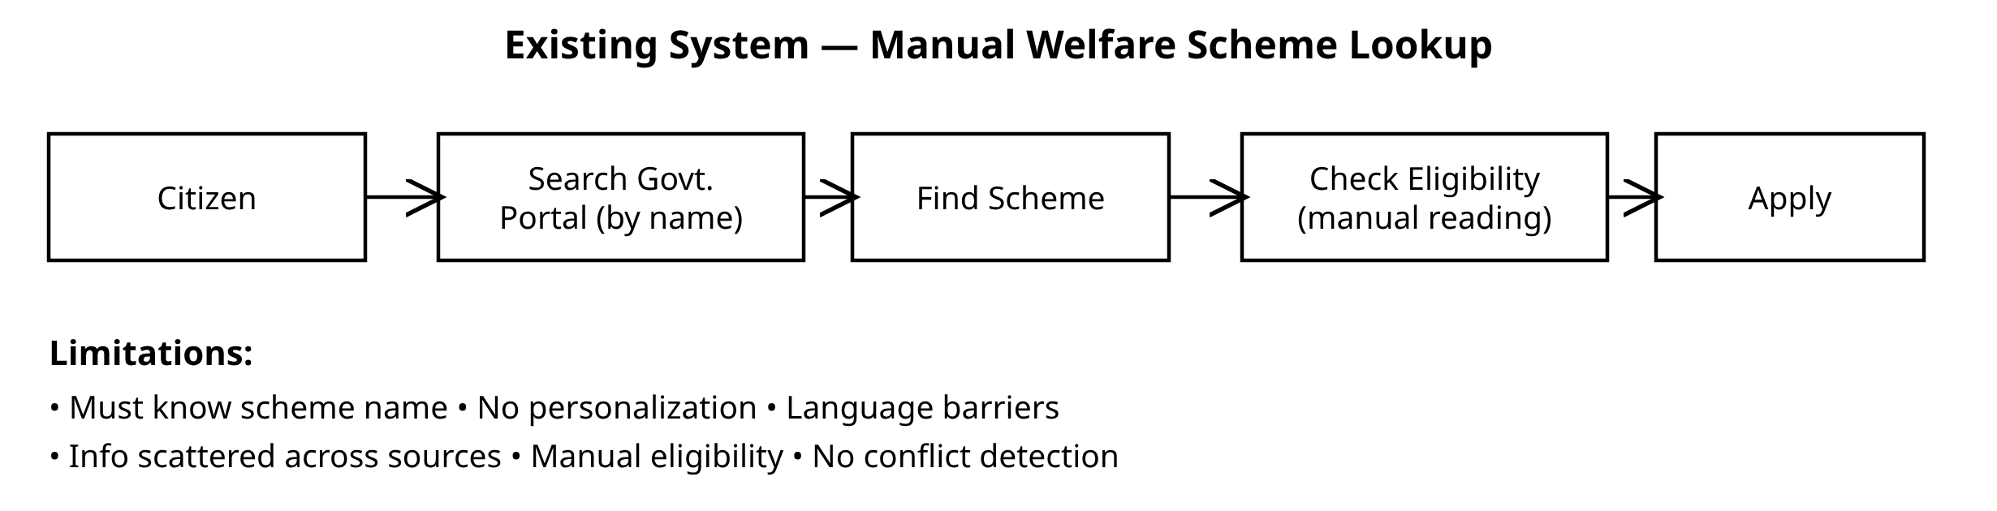
Fig. 1. Existing system — manual welfare scheme lookup.

B. Proposed System
GraminSahay swaps name-based search for situation-first discovery (Fig. 2). Whatever the citizen says or types becomes a structured profile. From there a RAG layer fetches the relevant passages out of the official-document index, an LLM reasoning layer decides eligibility and explains it, a conflict-detection layer raises a flag when two benefits are mutually exclusive, and a guidance layer lays out what to do next. The answer comes back as multilingual voice in whichever language the citizen chose.

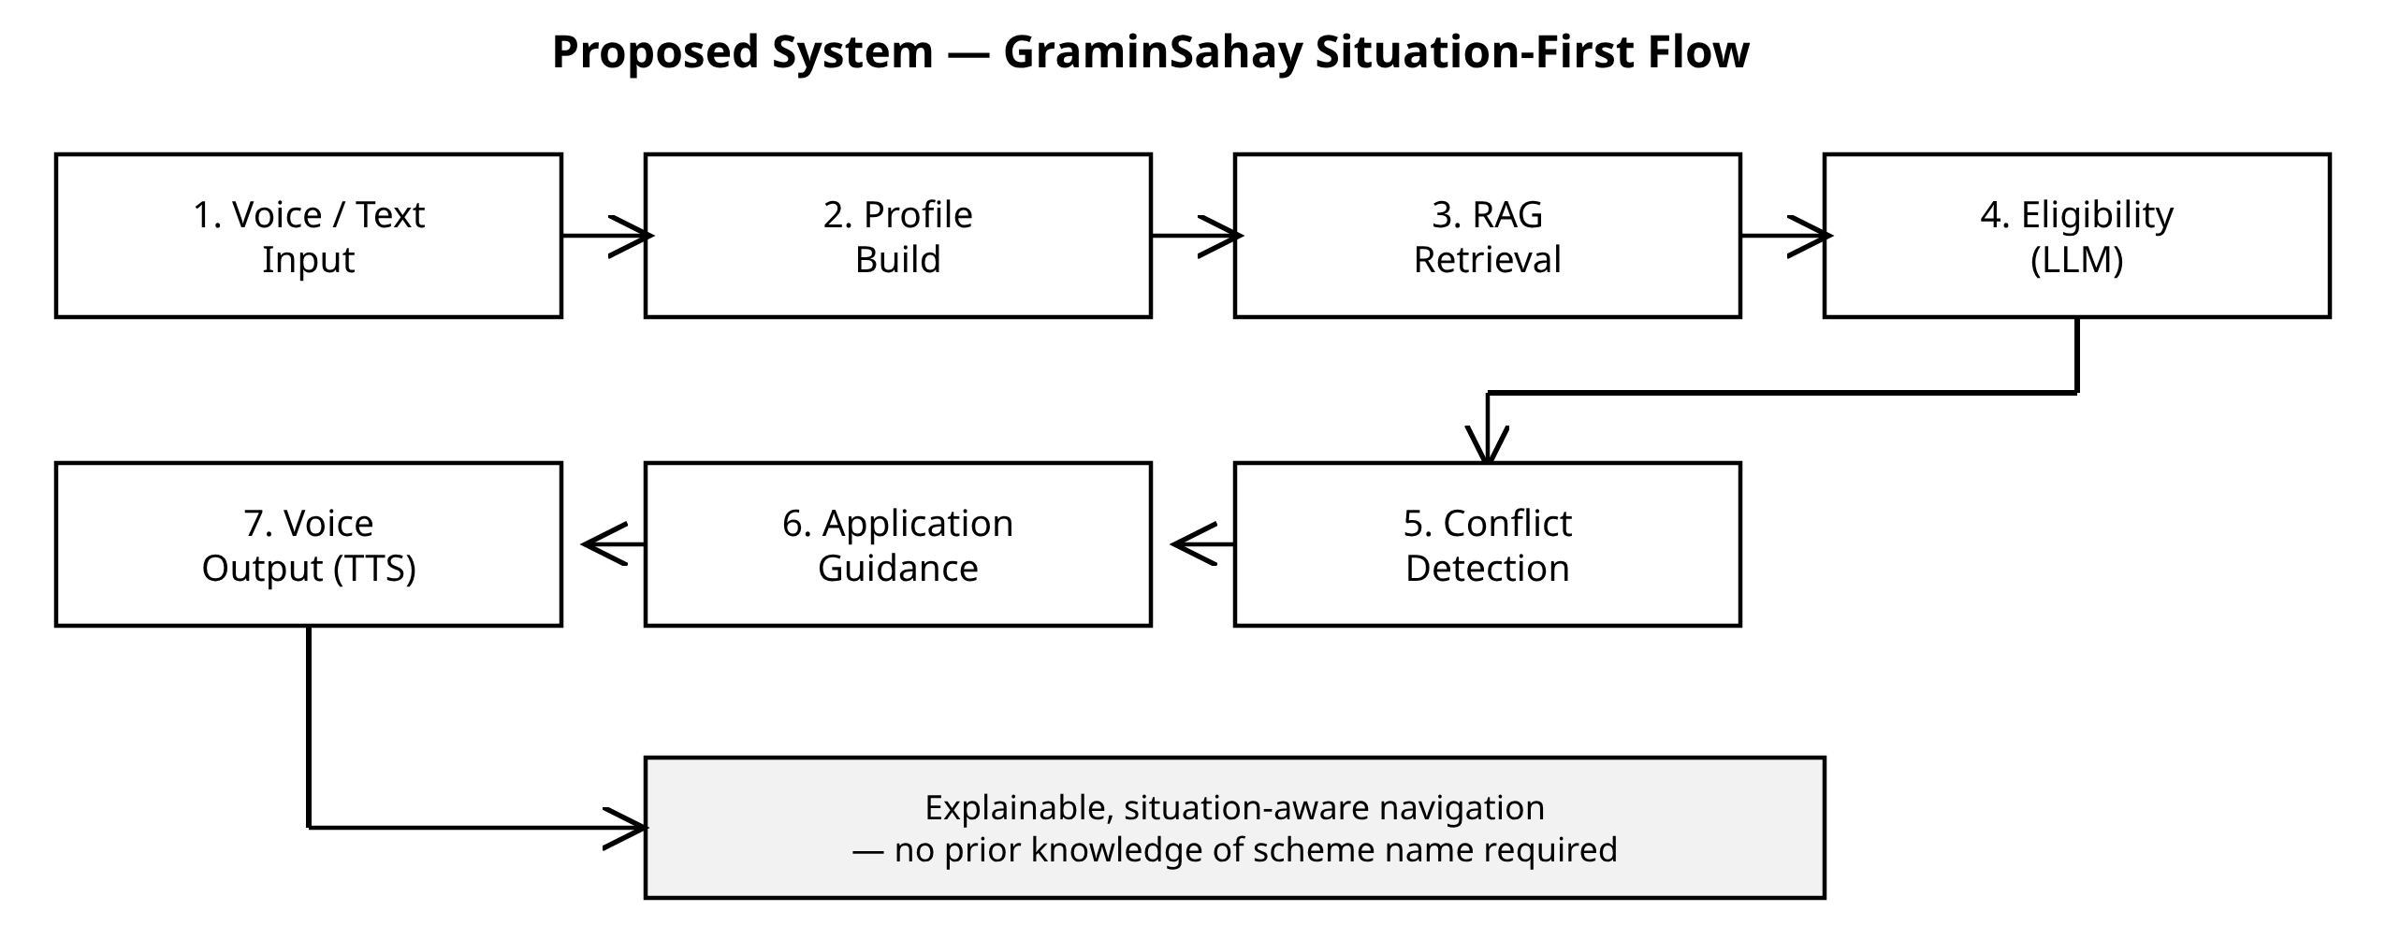
Fig. 2. Proposed system — GraminSahay situation-first flow.

IX. PROPOSED METHODOLOGY
1) Citizen Interaction: Input arrives either by voice (through Indic STT) or as text, with the citizen picking a language—English, Telugu, or Hindi. A typical opening line is “I am a farmer with a small landholding.”
2) Profile Understanding: From that free-form sentence the system pulls out a structured profile: occupation, family situation, location, and any other detail that happens to matter.
3) RAG Retrieval: The profile and the query are embedded together and used to fetch the top-k passages from a vector database built over the scheme guidelines, eligibility rules, and policy documents.
4) Eligibility Reasoning: An LLM weighs each candidate scheme against the retrieved evidence and tags it eligible, possibly eligible, not eligible, or missing information—and where something is missing, it says what else it would need to know.
5) Scheme-Conflict Detection: The chosen schemes are checked against one another, and the citizen is warned whenever two benefits cannot legally be held together.
6) Application Guidance: Once a scheme is picked, the system explains why it fits, lists the documents needed, spells out the application steps, and links through to the official portal or office.
7) Multilingual Voice Output: Finally the reply is spoken back through Indic TTS in whichever language the citizen selected.
8) Evaluation: We will judge the pipeline on three fronts—retrieval relevance, answer faithfulness, and eligibility-classification quality—using reference-free RAG metrics [7] alongside faithfulness evaluation [4]. Concretely, retrieval is scored with Recall@k and mean reciprocal rank over labelled situation–scheme pairs; classification with per-class precision, recall, and macro-F1 across the four labels; and faithfulness as the fraction of justifications that the retrieved passages fully back up. On top of the automated numbers, a small panel of domain reviewers will rate how clear and how correct the explanations are.
Two concerns run across the whole design. One is keeping the data fresh: schemes and thresholds move, so the corpus is versioned and re-indexed on a schedule, and every answer notes the document version it leaned on. The other is privacy: we keep the citizen profile deliberately thin—only the attributes eligibility actually needs—and nothing sensitive is held past the session unless the citizen opts in, which lines up with the governance conditions the digital-government literature stresses [1].
X. PROPOSED SOLUTION AND SYSTEM ARCHITECTURE
The layered architecture is drawn in Fig. 3. Work moves top to bottom—citizen interaction, profile understanding, RAG retrieval, eligibility reasoning, conflict detection, application guidance—and ends in multilingual voice output. The band at the bottom names the stack we intend to use: a Flutter / React Native front end, a FastAPI / Node.js back end, PostgreSQL for user and application data, a multilingual LLM with RAG doing the reasoning and generation, a vector database handling document retrieval, and Indic STT/TTS for the voice side.

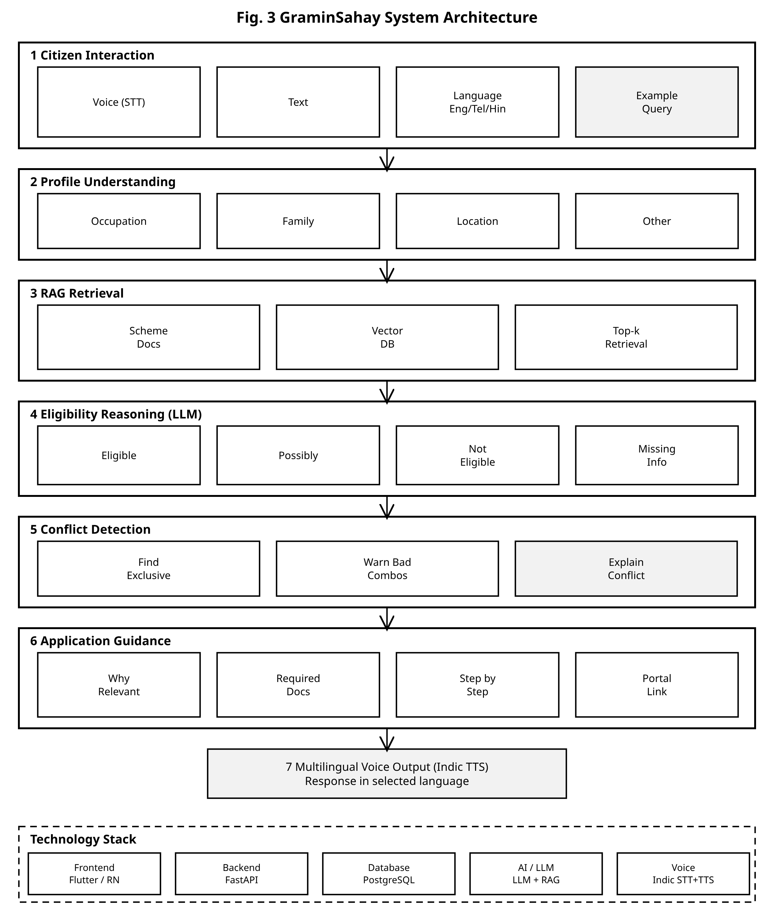
Fig. 3. Layered system flow and architecture of GraminSahay.

XI. EXPECTED RESULTS
Since this is a proposal rather than a finished build, the figures below are what we expect once the system is implemented and evaluated. Think of them as targets to aim at; the real numbers will replace them after the experiments are run.
A. Expected Performance (Tabular)
Table II lays out the performance we anticipate across the five pilot categories, reported as retrieval Recall@5, answer faithfulness [4], [7], eligibility-classification accuracy, and macro-F1.

Table II. Expected Performance Across Welfare Categories
Category | Recall@5 | Faithful. | Acc. (%) | Macro-F1
Agriculture | 0.90 | 0.92 | 91 | 0.89
Education | 0.88 | 0.90 | 88 | 0.86
Healthcare | 0.86 | 0.89 | 86 | 0.84
Housing | 0.89 | 0.91 | 89 | 0.87
Pensions | 0.92 | 0.93 | 93 | 0.90
Overall | 0.89 | 0.91 | 89.4 | 0.87

Table III contrasts GraminSahay with the existing manual approach on the qualitative capabilities identified as research gaps in Section III.

Table III. Expected Capability Comparison
Capability | Existing | GraminSahay
Situation-first discovery | No | Yes
Personalized to profile | No | Yes
Explainable eligibility | Limited | Yes (4-way)
Conflict detection | No | Yes
Multilingual voice | No | Yes
Application guidance | Partial | Yes

B. Expected Performance (Graphs)
Fig. 4 plots the expected classification accuracy for each category. Fig. 5 traces what happens to retrieval Recall@k and answer faithfulness as we pull back more passages: a bigger k lifts recall but tends to water down faithfulness, which is why we settle on roughly k = 5 as a sensible middle ground.
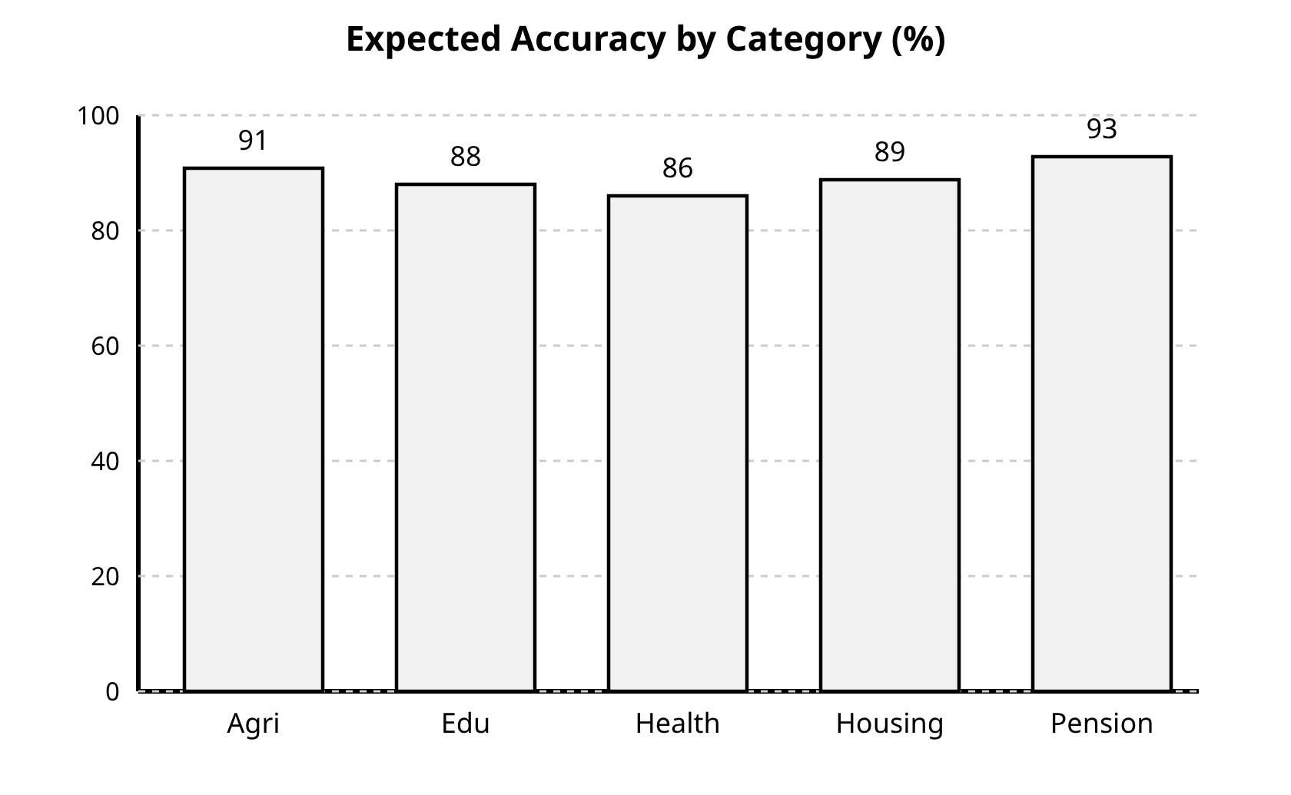
Fig. 4. Expected eligibility-classification accuracy by category.
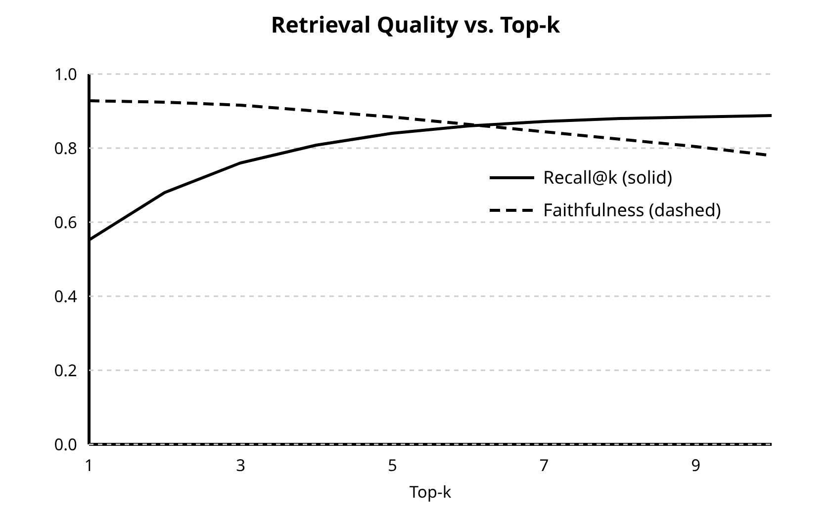
Fig. 5. Expected retrieval quality vs. top-k passages retrieved.
C. Discussion of Expected Outcomes
Taken together, Tables II and III and Figs. 4 and 5 describe how we want the system to behave. The healthcare and education numbers in Table II are kept deliberately modest: eligibility there hinges on several conditions at once—income bands, institution type, age—which is simply harder to get right than, say, a pension scheme with fairly uniform rules. Table III, meanwhile, is about the difference a citizen would actually feel: the manual process offers no situation-first discovery, no explainable eligibility, and no conflict detection, while the proposed system offers all three. Fig. 5 puts the main tension on the table—more passages mean higher recall but a smaller fraction of the answer that is strictly backed by evidence—and that is what pushes us toward k &asymp; 5. We treat these figures as acceptance thresholds rather than aspirations: a configuration passes only if it hits the tabulated accuracy and faithfulness and keeps end-to-end latency low enough to feel interactive over voice.
XII. FUTURE ENHANCEMENTS
Once the prototype is working, there are several directions we would like to take it.
• Broader coverage: Push past the five pilot categories and past Telangana—to more states and to central schemes—keeping the policy corpus continuously up to date.
• More languages: Grow the Indic STT/TTS and multilingual retrieval beyond English, Telugu, and Hindi into further regional languages and dialects.
• Document-aware applications: Allow citizens to upload or photograph documents such as land records or ration cards, so the system can check eligibility conditions automatically and even pre-fill parts of the form.
• Offline / low-bandwidth mode: Run lightweight models on-device and cache scheme data, so the navigator still works where connectivity is poor.
• Live policy integration: Wire the system directly into government portal APIs for real-time scheme updates, application submission, and status tracking.
• Explainability and trust: Attach source citations and confidence scores to every answer, and route borderline eligibility cases to a human for review.
• Accessibility: Reach citizens without smartphones by adding IVR / telephone and WhatsApp channels.
XIII. CONCLUSION
This paper surveyed the work most relevant to a situation-aware rural welfare navigator and used it to pin down the research gaps that GraminSahay is meant to close. A few things come through clearly from that survey: RAG keeps generation anchored in authoritative documents; faithfulness evaluation and retrieval-augmented reasoning together make multi-step eligibility inference trustworthy; multilingual retrieval and Indic speech open the door to voice access in regional languages; and domain adaptation is what makes any of this hold up on specialised policy text. GraminSahay stitches these together—situation understanding, RAG retrieval, eligibility reasoning, conflict detection, and multilingual voice. What we expect to end up with is an explainable, accessible assistant that helps a rural citizen find the right government support, grasp whether they qualify, see what information is still missing, and move toward applying—all without having to know a scheme’s name to begin with. The next steps are to widen the system past the five pilot categories and the starting set of languages, and to report real, measured numbers for retrieval and eligibility performance.
REFERENCES
[1] X. Zhang, Z. Ma, Y. Ma, and I. Ismail, “Large Language Models for Interpretive Support in Digital Government Service Systems: A Systematic Review,” Systems, vol. 14, no. 7, art. 823, 2026.
[2] J. Qi, R. Fern&aacute;ndez, and A. Bisazza, “On the Consistency of Multilingual Context Utilization in Retrieval-Augmented Generation,” in Proc. 5th Workshop on Multilingual Representation Learning (MRL 2025), 2025.
[3] Y. Li et al., “A Survey of RAG-Reasoning Systems in Large Language Models,” in Findings of ACL: EMNLP 2025, pp. 12120–12145, 2025.
[4] S. Filice, E. Haramaty, G. Horowitz, Z. Karnin, L. Lewin-Eytan, and A. Shtoff, “Generate but Verify: Answering with Faithfulness in RAG-based Question Answering,” in Proc. IJCNLP-AACL 2025, pp. 1017–1037, 2025.
[5] L. Ranaldi, B. Haddow, and A. Birch, “Multilingual Retrieval-Augmented Generation for Knowledge-Intensive Question Answering Task,” in Findings of EACL 2026, 2026.
[6] T. Zhang, S. G. Patil, N. Jain, S. Shen, M. Zaharia, I. Stoica, and J. E. Gonzalez, “RAFT: Adapting Language Model to Domain-Specific RAG,” in Proc. Conf. on Language Modeling (COLM), 2024. arXiv:2403.10131.
[7] S. Es, J. James, L. Espinosa-Anke, and S. Schockaert, “RAGAs: Automated Evaluation of Retrieval Augmented Generation,” in Proc. 18th Conf. of the European Chapter of the ACL (EACL): System Demonstrations, 2024, pp. 150–158.
[8] P. Lewis et al., “Retrieval-Augmented Generation for Knowledge-Intensive NLP Tasks,” in Advances in Neural Information Processing Systems (NeurIPS), 2020.
[9] A. Asai, Z. Wu, Y. Wang, A. Sil, and H. Hajishirzi, “Self-RAG: Learning to Retrieve, Generate, and Critique through Self-Reflection,” in Proc. Int. Conf. on Learning Representations (ICLR), 2024.
[10] G. Izacard, M. Caron, L. Hosseini, S. Riedel, P. Bojanowski, A. Joulin, and E. Grave, “Unsupervised Dense Information Retrieval with Contrastive Learning,” Transactions on Machine Learning Research (TMLR), 2022.
[11] M. G. Kumar and S. Rao, “Context-Optimized Retrieval Augmented Generation for Local Government Welfare Subsidies,” in Proc. IEEE Int. Conf. on Systems, Man, and Cybernetics (SMC), 2025, pp. 1105–1112.

