Project Design Phase – III

|  |  |
| --- | --- |
| Date | 18october 2023 |
| Team ID | NM2023TMI5559 |
| Name | A.yuvashree |
| Project Name | Chatbot deployment with IBM cloud Watson assistant |

Initially we have to create IBM cloud Watson assistant service account (For free trial of 365 days if users had not created the account )

PROCEDURES GIVEN(step by step):

Step 1.Create an account or log-in in skillup portal.

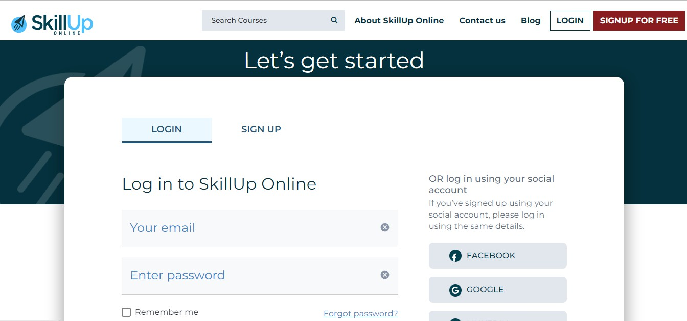

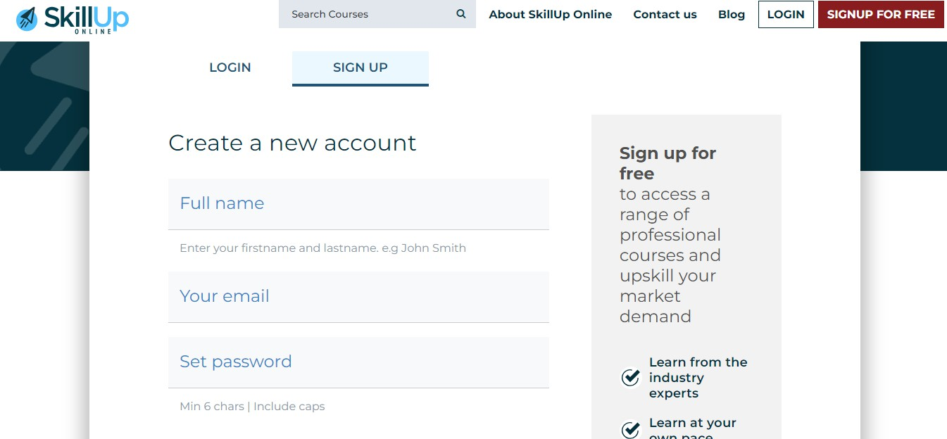

Step 2. Once you sign in skillup portal, Now open [Welcome (skillup.online)](https://myclass.skillup.online/) (myclass.skillup.online) these link and sign in

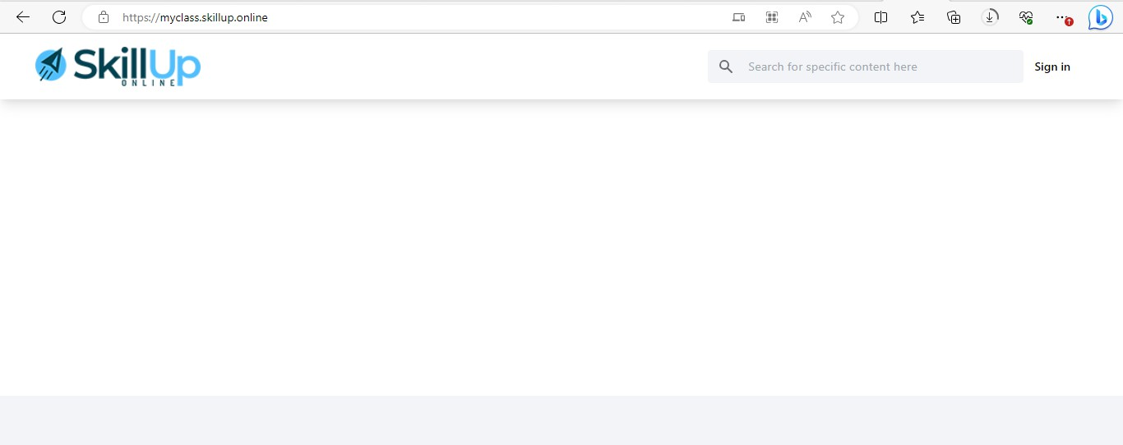

Step- 3.After clicking on sign in, It will be redirected to these page , Put the credentials that you had used while creating the account

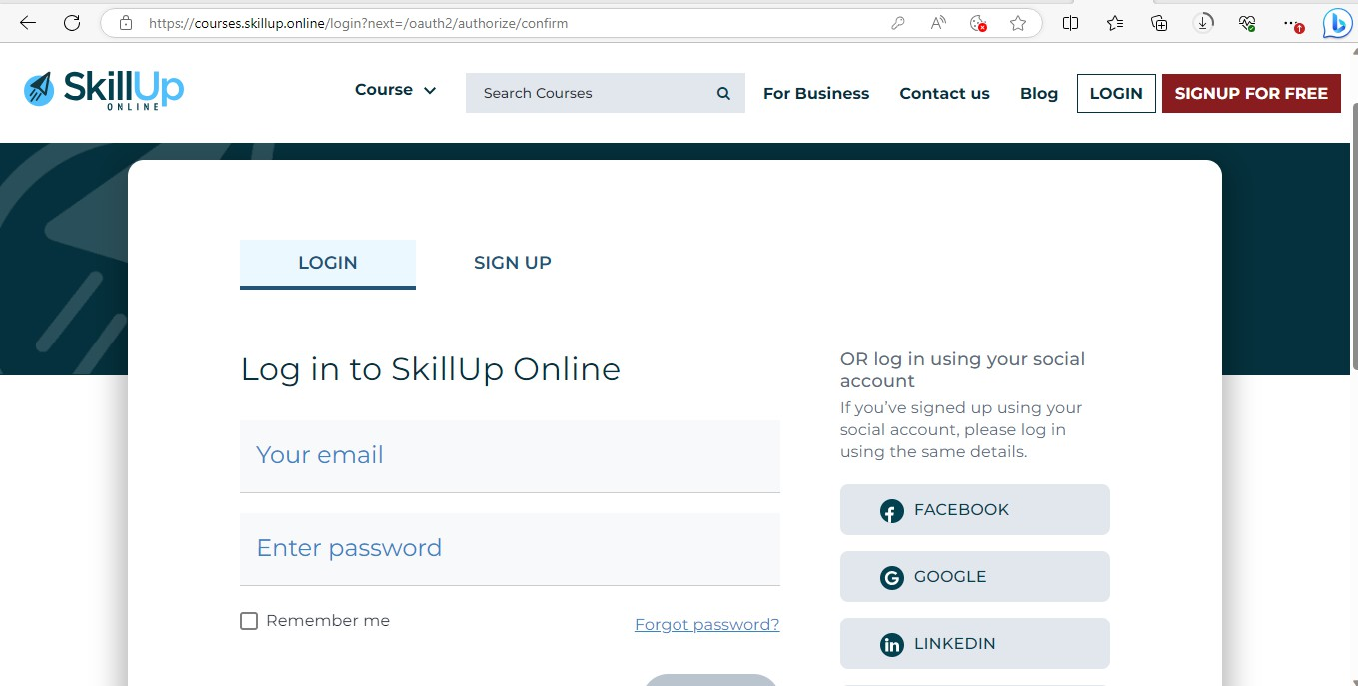

**Step 4. Once you sign in , you can check in myclass.skillup.online , You would have been logged in your profile**

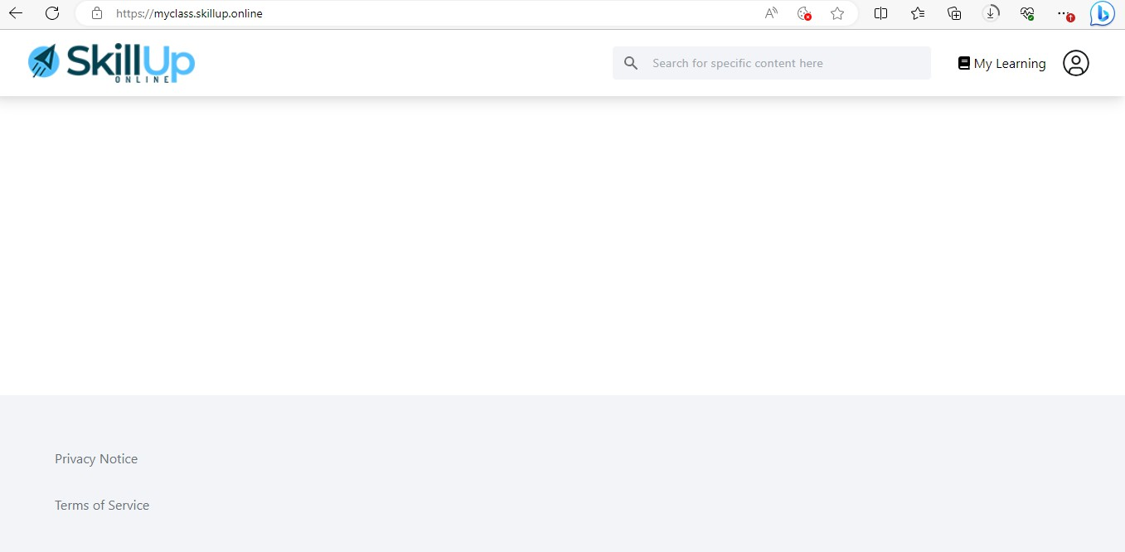

Step-5. In Search Bar, Search for Introduction to cloud .

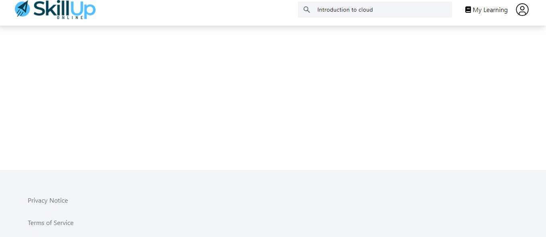

Step-6. Click on the course , that has been came after searching

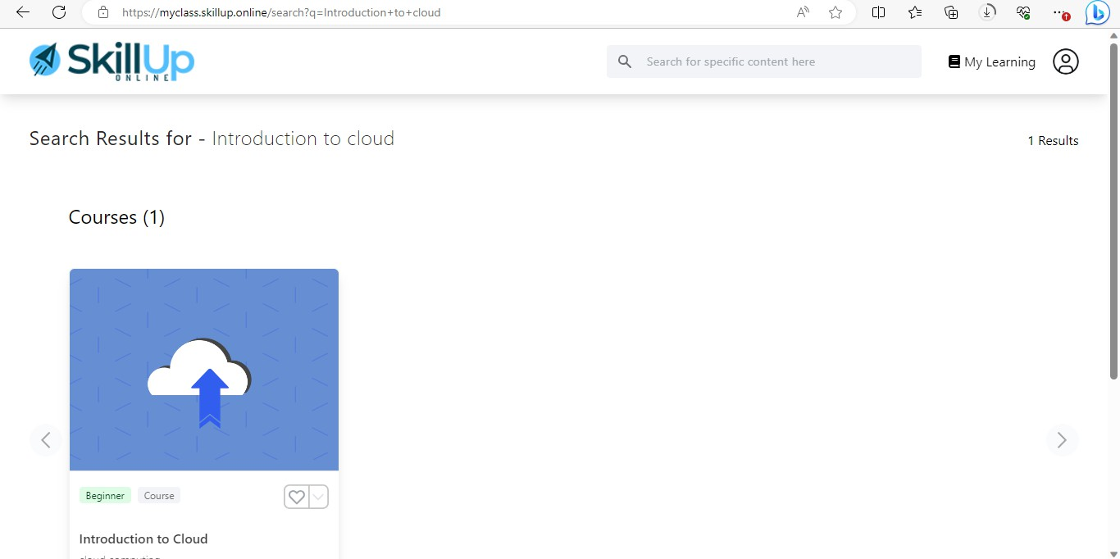

Step-7. After entering inside the course, click on the enroll now option.

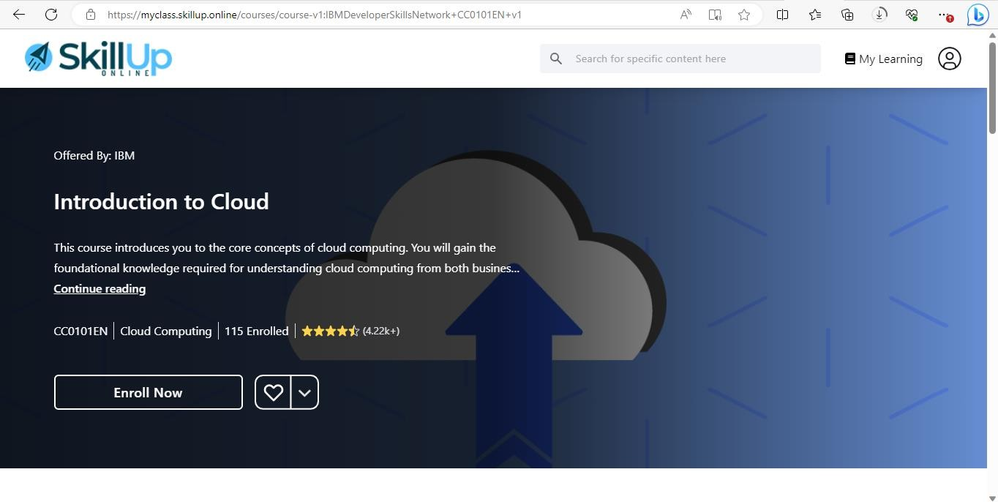

Step-8. In the Course section , Scroll Down there you will get the module 1 option, Expand the module 1 option

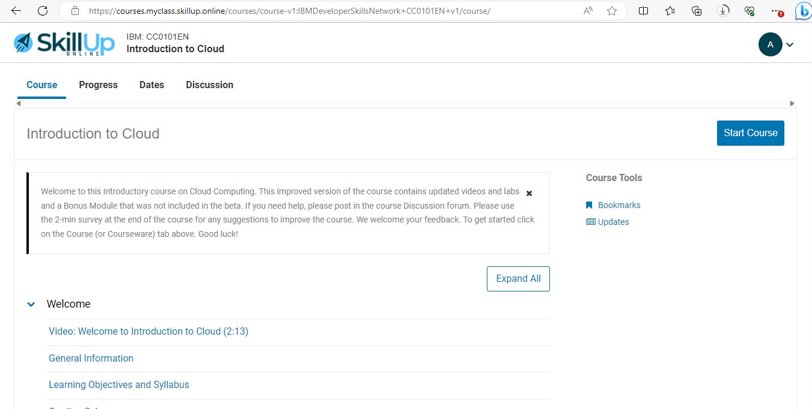

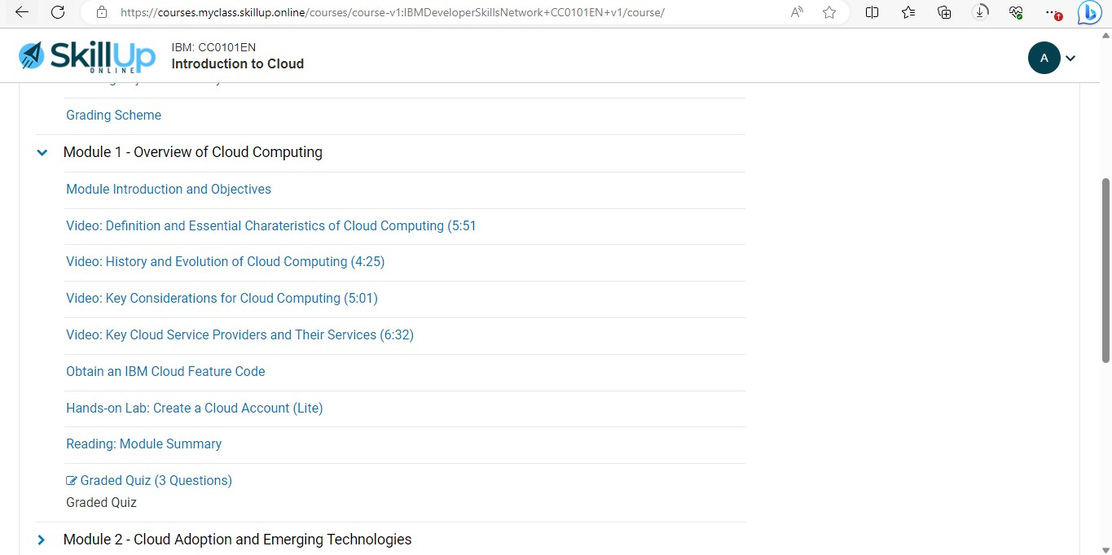

Step-9 Expand Module-1 and click on Obtain an IBM Cloud Feature Code.

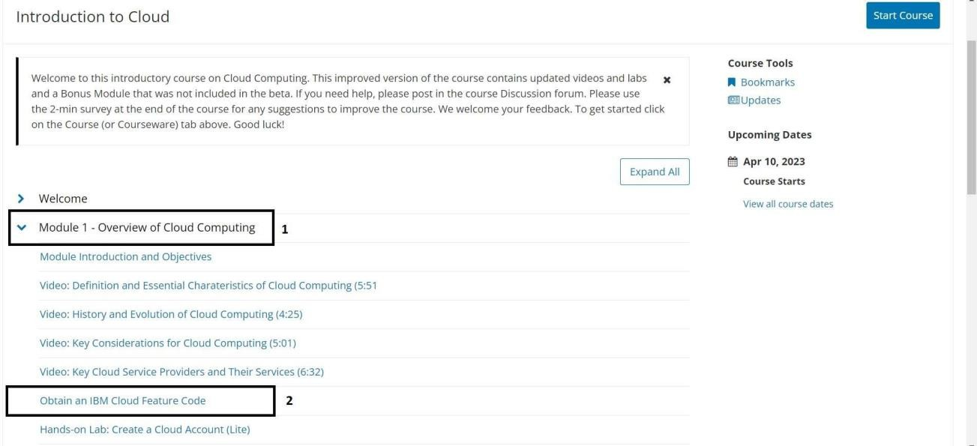

Step-10 Scroll down and click on the open tool to get the feature code for creatingan IBM cloud account.

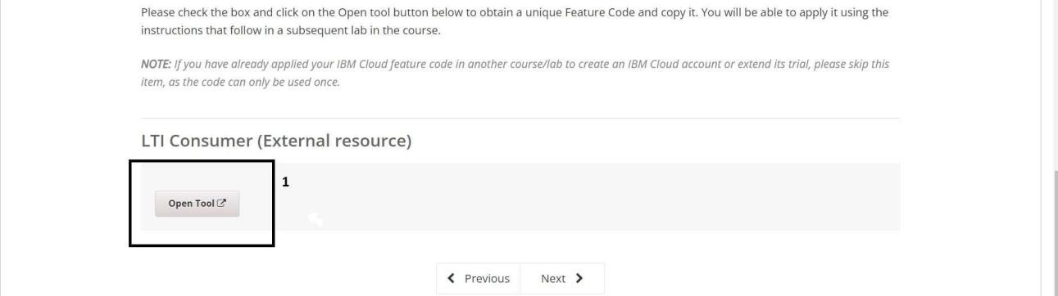

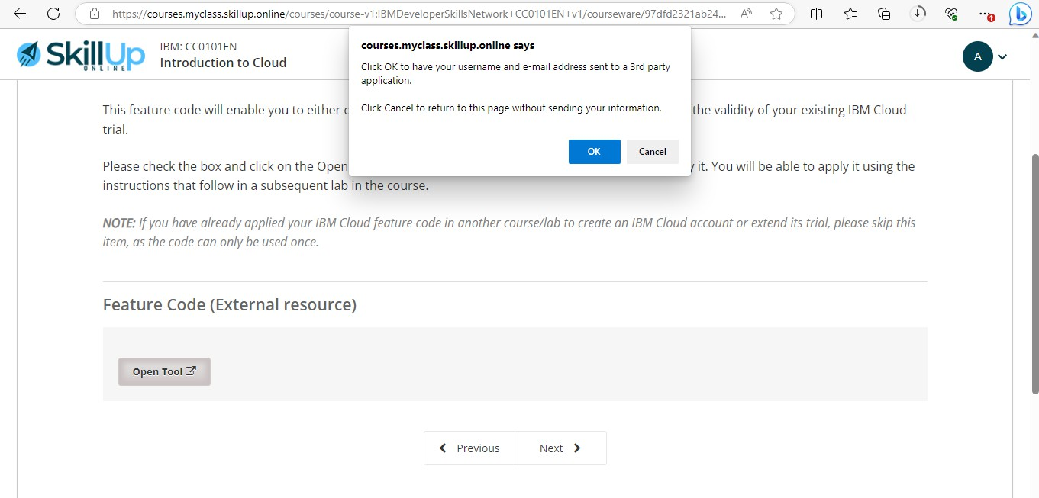Step-11 Click ok on the popup message to proceed to the next page.

Step-12 Click on activate your trial account for 365 Days with the feature code

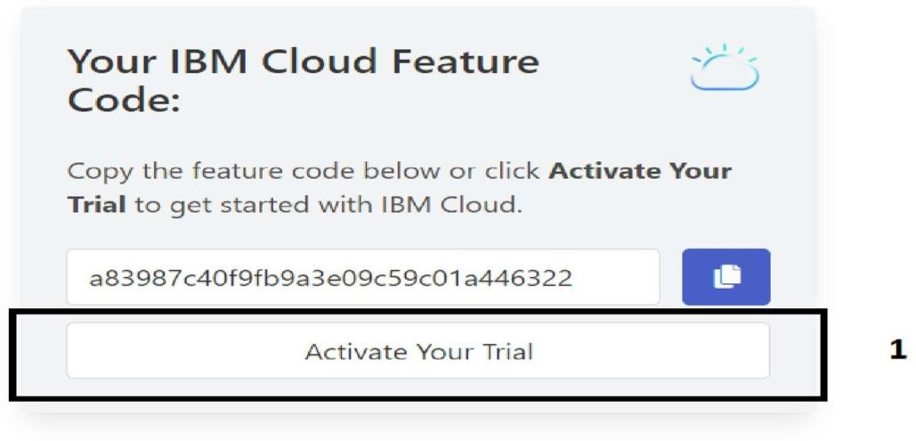

Step-13 Provide the same credentials i.e email id/username & password used for creating the skillup account and click on next to get the verification code on the registered email id or if the ibm account is already created then click in log in

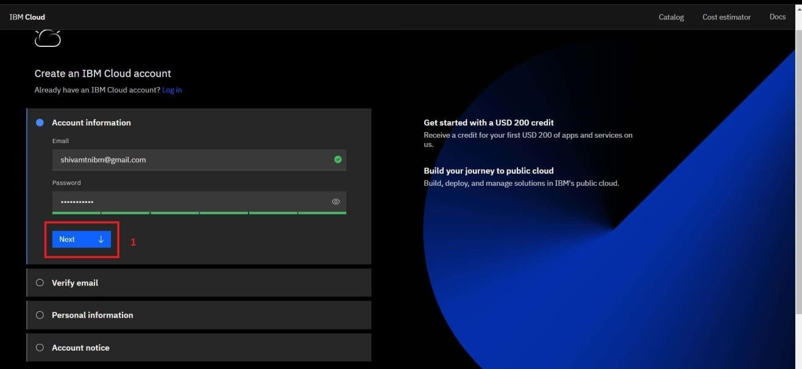

Step-14 Fill the received verification code on the registered email id and click onnext

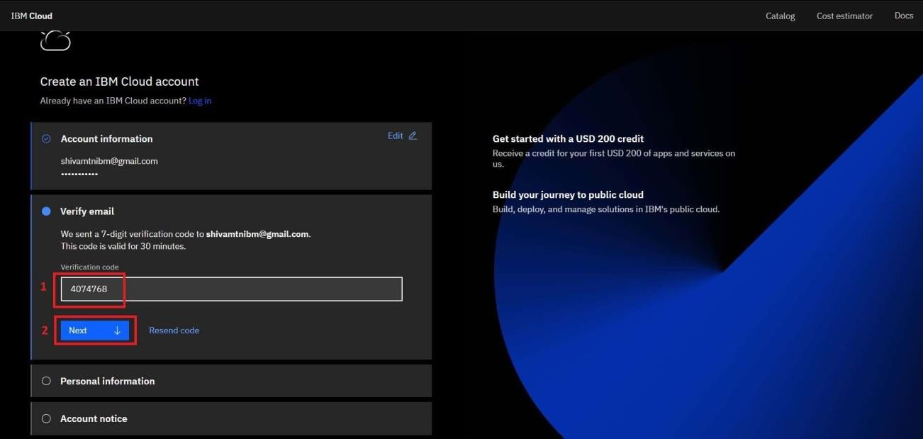

Step-15 Provide personal information and click on next

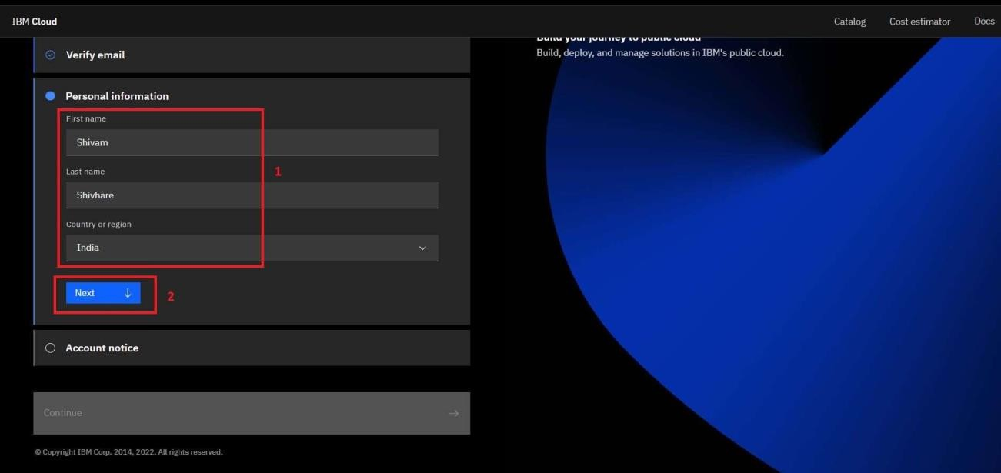

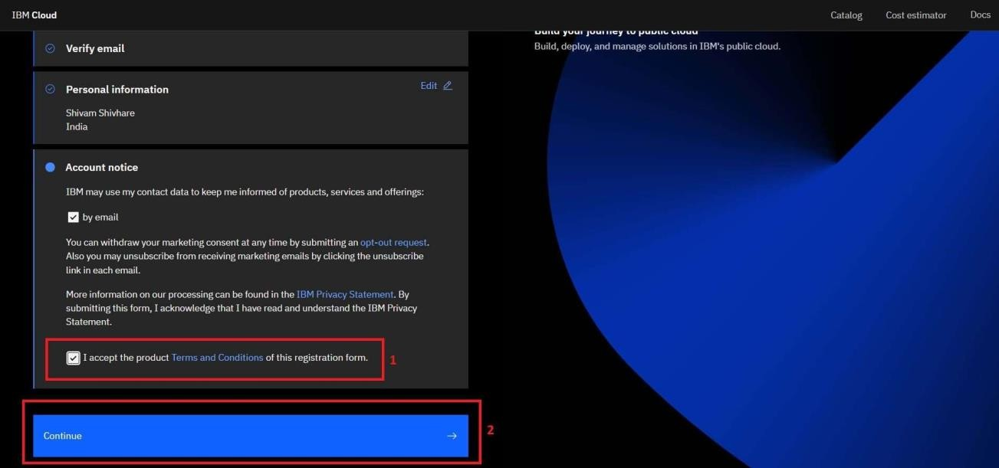Step-16 Accept the terms and conditions then click on continue

Step-17 Review account privacy notice mark the checkbox then click on continue

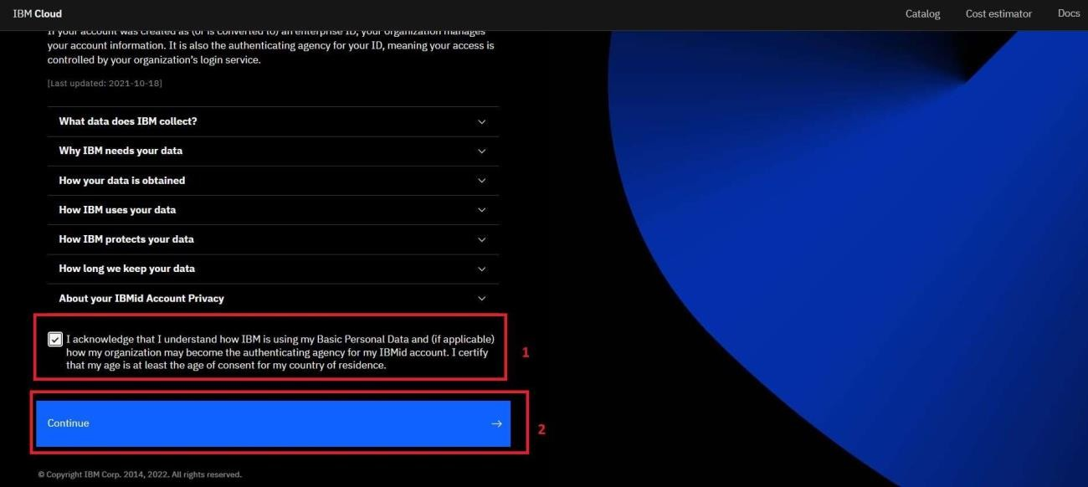

Step-18 Refer to Step-12 to copy the feature code or continue with theautomatically filled feature code then click on create account

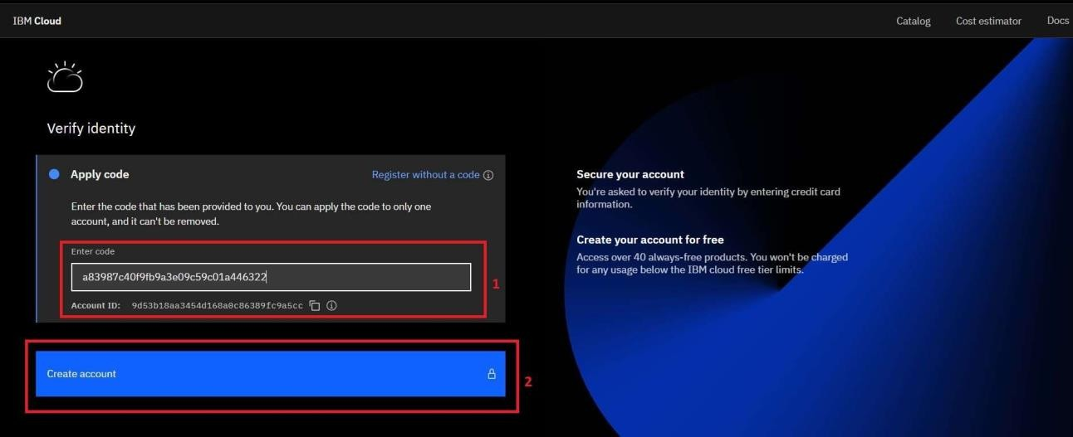

Step-19 After Successfully creating the account you are redirected to the dashboard page of the IBM Cloud account.

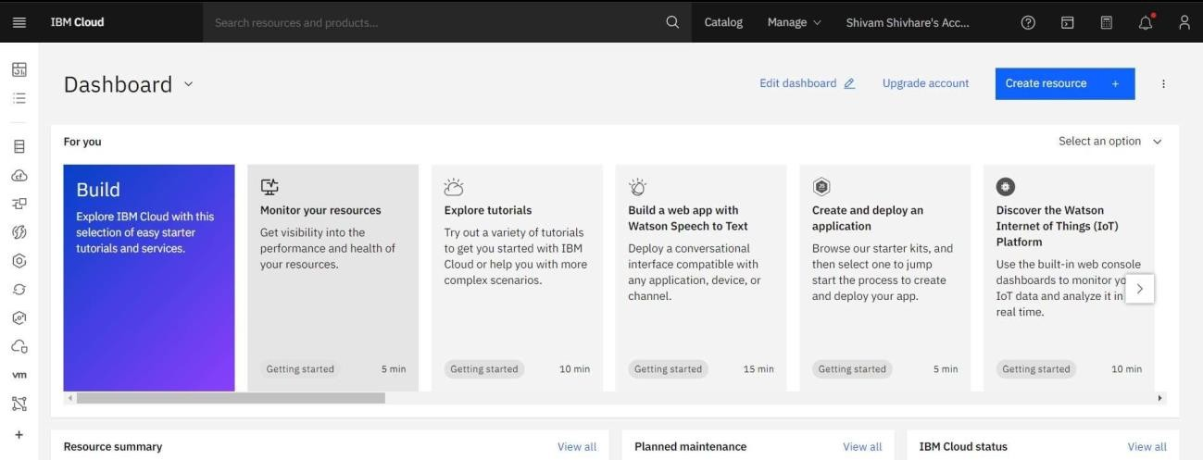

Step-20 To check the free trial details click on the manage dropdown from the top navigation bar and click on account.

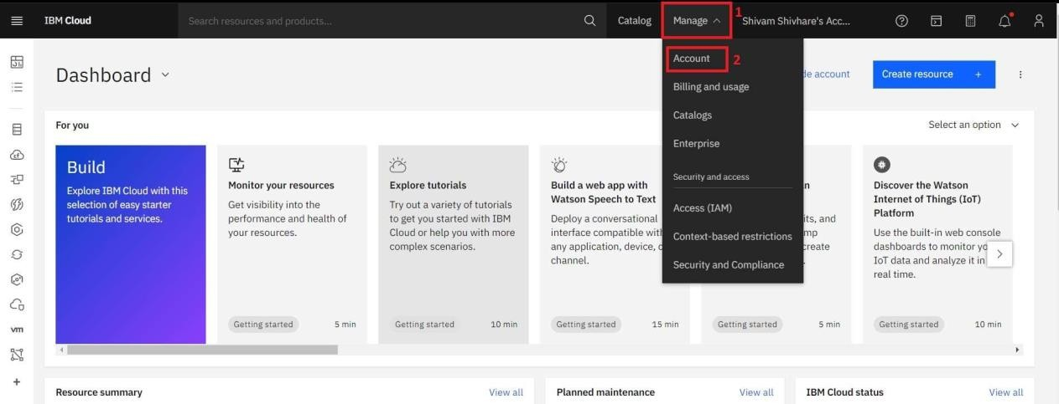

Step-21 Go to Account settings to check Free trial details

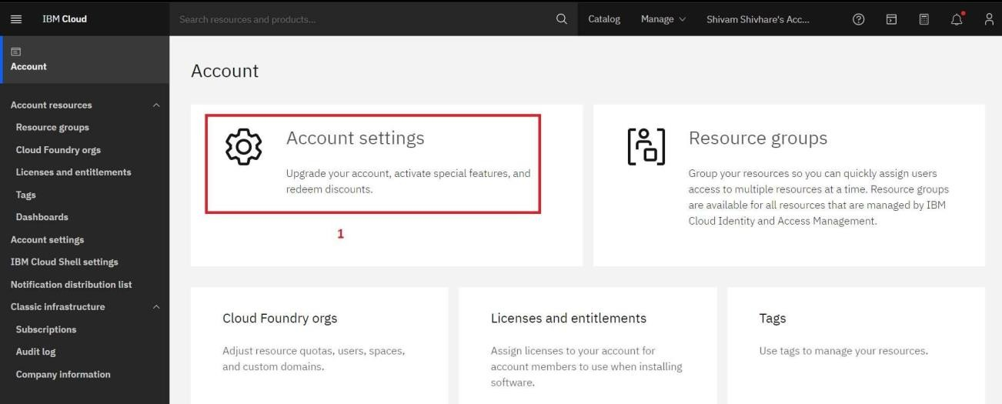

Step-22 Good Job! You created 365 Days Free trial account

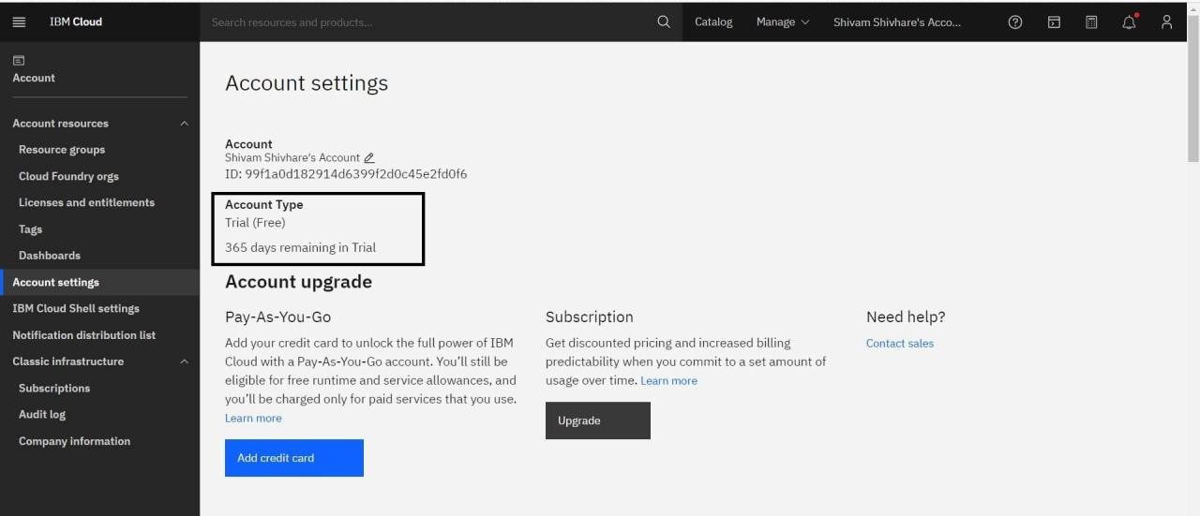

[ ]:

*# Defition of chatbot's persona:*

*#A chatbot's persona refers to the character, identity, or personality that a*␣

𝗌*chatbot is designed to embody when interacting with users.*

*#It involves giving the chatbot human-like qualities and characteristics to*␣

𝗌*make it more relatable and engaging.*

*#*

*# THE COVERSATION FLOW CONFIGURE*

*# 1.INTENTS # 2.ENTITIES*

*# 3.DIALOG NODLES*

[ ]:

*# Code implementation(procedures for creating watson assistant ):*

**from ibm_watson import** AssistantV1

**from ibm_cloud_sdk_core.authenticators import** IAMAuthenticator

*# Set up the Assistant service*

authenticator = IAMAuthenticator('YOUR_API_KEY') *# Replace with your API key*

assistant = AssistantV1(

version='2019-02-28', *# Adjust to your version*

authenticator=authenticator

)

assistant.set_service_url('YOUR_ASSISTANT_URL') *# Replace with your Assistant*␣

𝗌*URL*

[ ]:

*# Define the workspace ID (replace with your own)*

[ ]:

workspace_id = 'YOUR_WORKSPACE_ID'

[ ]:

*# Send a message to the assistant*

[ ]:

**def** send_message(message): response = assistant.message(

1

workspace_id=workspace_id, input={

'text': message

}

).get_result()

**return** response

[ ]:

*# Get intents, entities, and dialogue nodes*

**def** get_intents_entities_nodes():

intents = assistant.list_intents(workspace_id=workspace_id).get_result() entities = assistant.list_entities(workspace_id=workspace_id).get_result() nodes = assistant.list_dialog_nodes(workspace_id=workspace_id).get_result() **return** intents, entities, nodes

*# Example usage*

**if**  name == ' main ': message = 'Hello'

response = send_message(message) print(response)

intents, entities, nodes = get_intents_entities_nodes() print("Intents:", intents)

print("Entities:", entities) print("Dialog Nodes:", nodes)

[ ]:

Here's what you need to do:

1. Install the necessary packages using `pip install ibm-watson`.
2. Replace `'YOUR_API_KEY'` **with** your actual IBM Watson API key.
3. Replace `'YOUR_ASSISTANT_URL'` **with** the URL of your IBM Watson Assistant␣

𝗌service.

1. Set the `workspace_id` variable **with** the ID of your Watson Assistant␣

𝗌workspace.

1. You can call `send_message(message)` **with** a user's message to interact with␣

𝗌the chatbot. The response will be stored in the `response` variable.

1. `get_intents_entities_nodes()` retrieves the intents, entities, **and** dialogue␣

𝗌nodes.

Please remember to replace the placeholders **with** your actual values. If you're␣

𝗌unsure about where to find certain values, refer to your IBM Cloud account␣

𝗌or the IBM Watson Assistant documentation.

2

