Name of the Student | S. Yuva Guru Mani Varma
Reg. No | 192425005
GitHub Link | https://github.com/YuvaGuruManiVarmaS-018/MLA0405-192425005

SIMATS ENGINEERING

CO4 - ASSESSMENT TOOL 3

Article Review

COURSE NAME: Deep Learning COURSE CODE: MLA04
SLOT : D

COURSE OUTCOME COVERED

CO 4: Students will be able to understand and apply probabilistic graphical models including Bayesian Networks, Markov Random Fields, Hidden Markov Models, and Conditional Random Fields. They will learn how to represent complex probabilistic relationships among variables and perform inference and learning in graphical models. Students will be able to use these models for reasoning under uncertainty and solving real-world decision-making problems. BL-6

Course Outcome Weightage: 10% Duration: 90 minutes
Assessment Tool Weightage: 30% Mark : 25

Code of Conduct:
I S. Yuva Guru Mani Varma / 192425005 (Name / Reg No) certify that this submission is my original work and that I have adhered to the guidelines specified for this assessment.
I understand that any violation of academic integrity rules will result in disciplinary action.


Signature of the student: Name of the student: S. Yuva Guru Mani Varma

Criteria | Article Selection & Problem Understanding (2) | Deep Learning Model & Methodology Analysis  (2.5) | Results & Performance Evaluation (2.5) | Critical Analysis & Technical Evaluation (2) | Future Scope, Presentation & Documentation (1) | Total (10)
Weightage | 20 % | 25% | 25% | 20 % | 10 % | 100%
Q1
Total

QUESTIONS: 01 Total Marks:25
Select and review a recent research article related to the below topic, such as Transfer Learning, DenseNet, PixelNet, RNN, Bidirectional RNN, Encoder–Decoder/Seq2Seq, BPTT, or LSTM. Summarize the problem addressed, dataset used, proposed deep learning model, methodology, performance metrics, major results, and key findings, and critically comment on the advantages, limitations, and possible future improvements of the approach presented in the article.

Prepare a structured Article Review addressing the following sections:

1. Article Details
Provide the following information:
Title of the research article
Answer: Long short-term memory (LSTM)-based news classification model.
Names of the authors
Answer: Chen Liu.
Journal/Conference name
Answer: PLOS ONE, Volume 19, Issue 5, Article e0301835.
Year of publication
Answer: 2024; published on 30 May 2024.
DOI or publication link
Answer: https://doi.org/10.1371/journal.pone.0301835
Topic/Deep Learning technique addressed

2. Research Problem
What problem does the article attempt to solve?
Answer: The article addresses automatic classification of Chinese online news into sports, entertainment, and technology categories. The central challenge is to represent word meaning and context well enough to distinguish categories when traditional bag-of-words and shallow machine-learning methods lose word order and long-range dependencies.
Why is the problem important?
Answer: Accurate news classification supports information organization, search, recommendation, website navigation, and rapid access to relevant content. It is important because online news grows rapidly and manual classification is slow, expensive, and difficult to scale.
What are the limitations of existing approaches identified by the authors?
Answer: The authors note that conventional methods such as naïve Bayes, KNN, and SVM often depend on handcrafted features or bag-of-words representations. These approaches can ignore context, create high-dimensional sparse inputs, require substantial manual labeling, and struggle with long-term dependencies in text.
3. Objectives of the Study
What are the main objectives of the research?
Answer: The study aims to build LSTM-based classifiers for Chinese news, compare unidirectional LSTM with BiLSTM, and examine whether using contextual information from both directions improves feature extraction and classification quality.
What specific goals does the proposed model attempt to achieve?
Answer: The proposed dual-stage model attempts to preserve contextual information, integrate the sequence features extracted by BiLSTM, reduce information loss, improve generalization, and obtain higher F1-score than the unidirectional LSTM and selected benchmark methods.

4. Dataset Description
What dataset(s) are used?
Answer: The authors collected Chinese news articles with a web crawler from sports, entertainment, and technology sources. The article also identifies the public Bert-THUCNews source link: https://github.com/pengwei-iie/Bert-THUCNews.
What is the size of the dataset?
Answer: The final dataset contains 7,147 texts: 2,491 entertainment articles, 2,360 sports articles, and 2,296 technology articles. The reported split contains 5,717 training texts, 715 validation texts, and 715 testing texts.
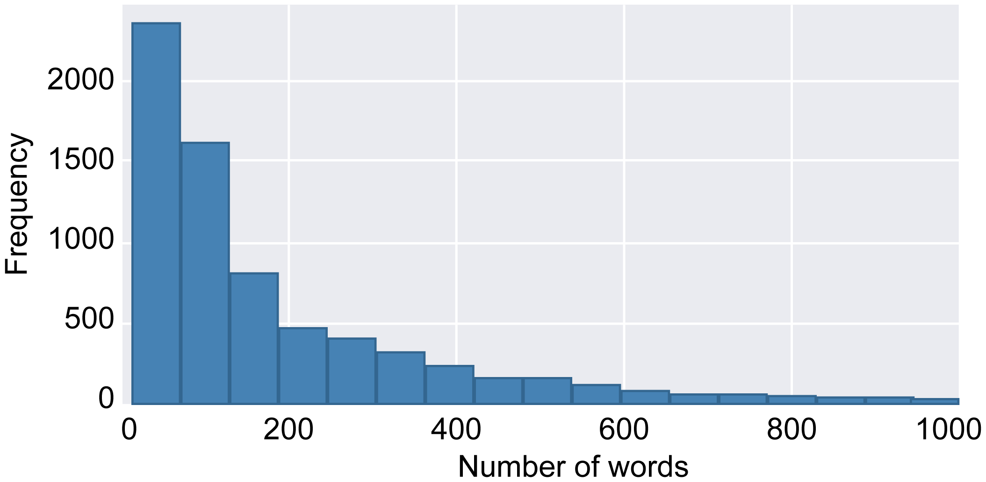
Figure 1. Word-count distribution reported in the selected article. Source: Liu (2024), PLOS ONE, Fig. 11.
What type of data is used—images, text, time-series, video, etc.?
Answer: The data are Chinese natural-language news texts. Non-text elements such as images and links are removed during cleaning; the first 200 words of each processed text are used as the sequence input.
How is the dataset divided into training, validation, and testing sets?
Answer: The dataset is divided into 80% training, 10% validation, and 10% testing. The validation set is used for hyperparameter adjustment, while the held-out test set is used for the final performance estimate.

5. Proposed Methodology
Explain the overall methodology adopted in the article.
Answer: The methodology follows a complete NLP pipeline: collect news with a crawler, remove duplicates and irrelevant content, segment Chinese text with jieba, remove stop words, analyze word frequency, convert words into 200-dimensional word2vec vectors, extract features with BiLSTM, integrate the sequence features with LSTM, and classify the resulting representation with a fully connected layer.
Identify the deep learning architecture used.
Answer: The main architecture is a stacked recurrent classifier consisting of a BiLSTM feature-extraction stage, an LSTM feature-integration stage, and a fully connected classification layer. A unidirectional LSTM is trained as a comparison model.
Explain the important layers/components of the model.
Answer: Word2vec maps tokens into dense vectors. The BiLSTM reads the sequence from both left-to-right and right-to-left, so each hidden representation contains past and future context. The subsequent LSTM integrates the BiLSTM outputs into a compact feature vector. The fully connected layer converts that vector into class probabilities, and dropout reduces co-adaptation and overfitting.
Describe the data preprocessing techniques used.
Answer: The crawler output is cleaned by removing duplicate records, blank content, images, hyperlinks, non-Chinese characters, symbols, and other non-news material. Jieba performs word segmentation, stop words are removed, and the cleaned tokens are mapped to word2vec embeddings. Sequence length is controlled by retaining up to 200 words per article.
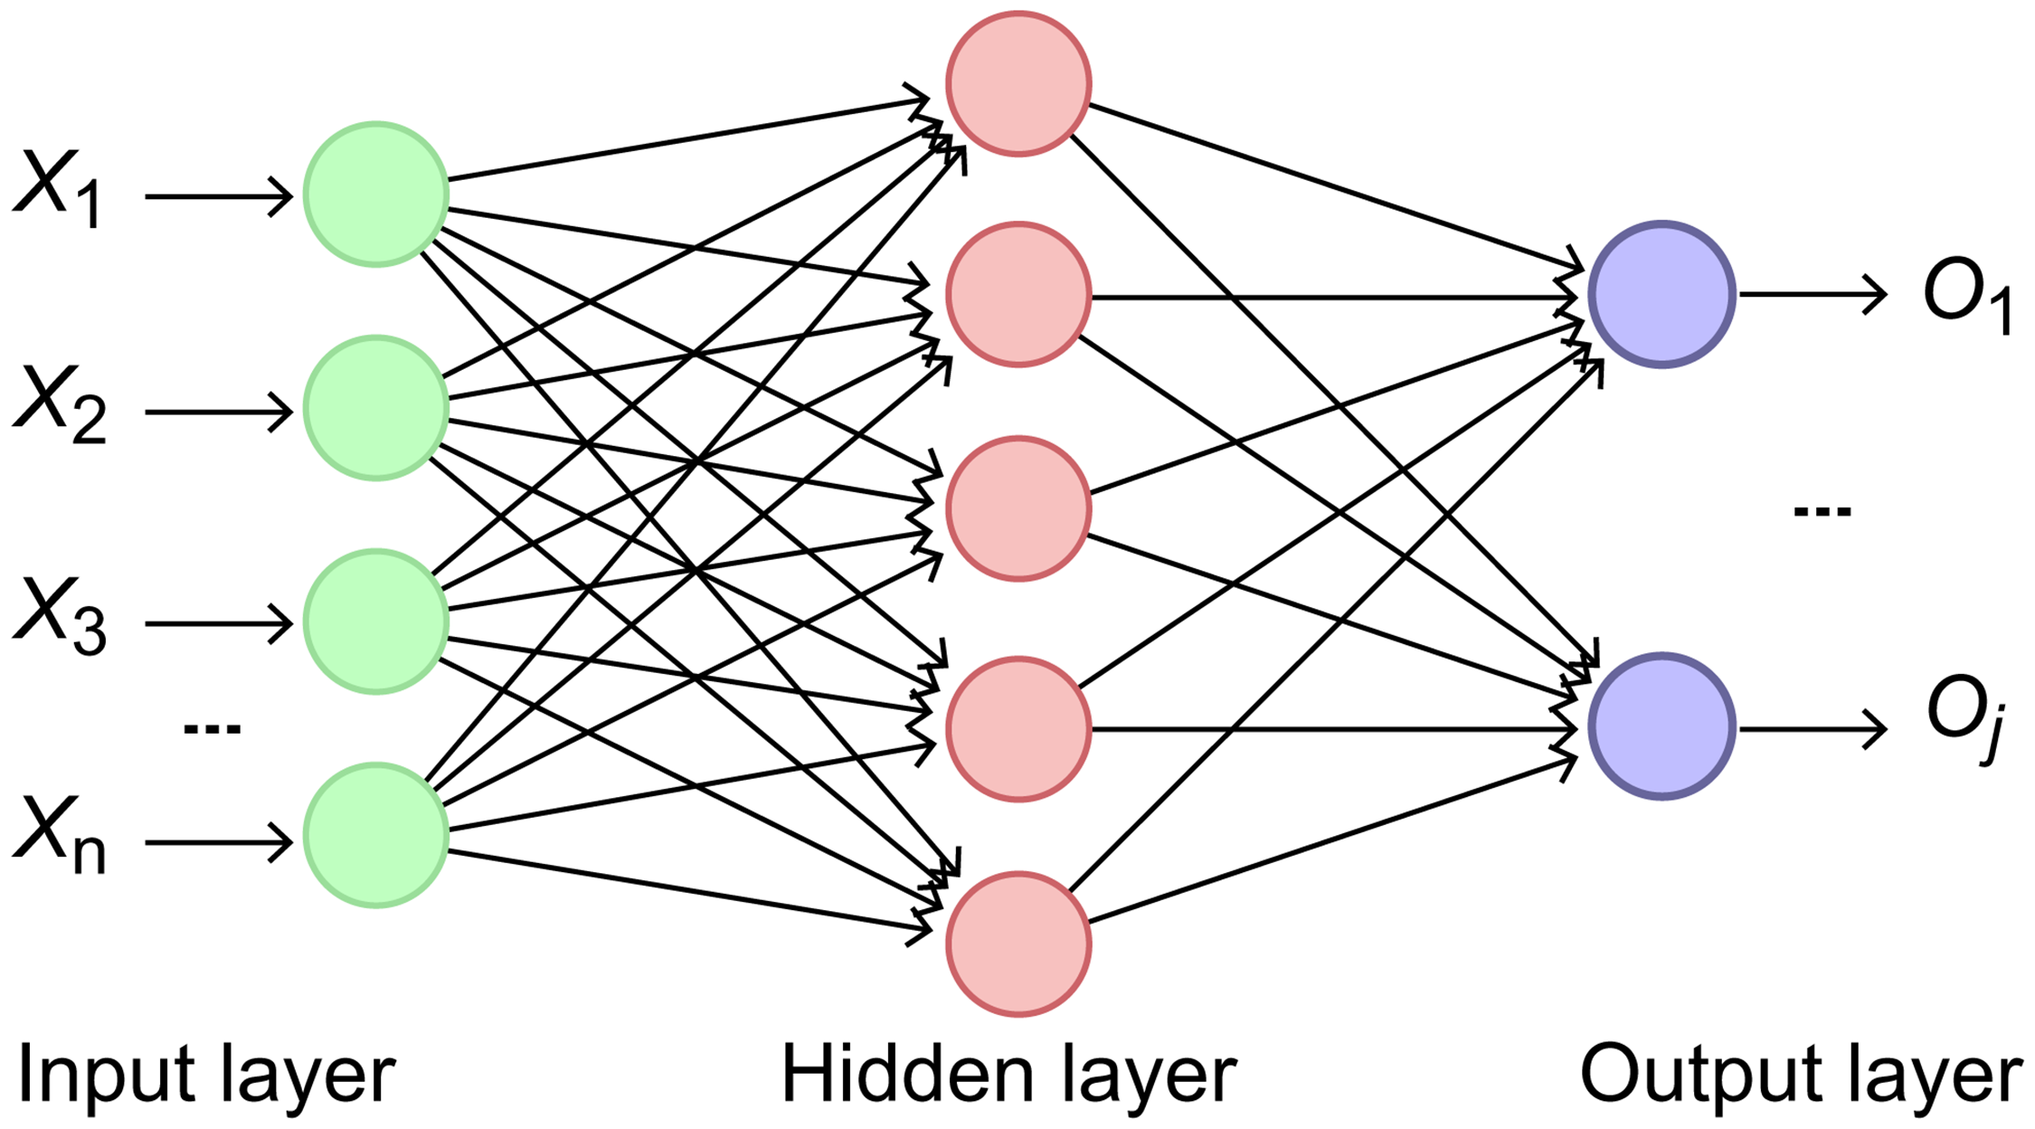
Figure 2. Data-processing flow used for the news-classification experiment. Source: Liu (2024), PLOS ONE, Fig. 10.
Explain the training procedure and important parameters, wherever available.
Answer: The models are trained with categorical cross-entropy loss and the Adam optimizer. The training data are processed in batches; dropout layers are used for regularization, and the validation set supports hyperparameter adjustment. The article reports 200-dimensional word vectors and a maximum sequence length of 200 words; exact settings such as learning rate and epoch count should be read from its experimental-configuration table rather than inferred.

6. Deep Learning Technique Used
Explain how the selected technique is applied in the research.
Answer: LSTM is used to learn dependencies across a sequence of Chinese words. In the proposed system, BiLSTM first captures contextual features in both directions, and a second LSTM integrates those features before classification. This directly connects the recurrent architecture to the article’s goal of context-aware news categorization.
How is Transfer Learning used?
Answer: Transfer learning is not the main method in this article. The study trains the recurrent classifiers for the news-classification task, while word2vec supplies pretrained-style distributed word representations. Therefore, the work is better characterized as task-specific recurrent learning with pretrained word embeddings rather than transfer learning from a large end-to-end language model.
How does DenseNet perform feature reuse?
Answer: DenseNet is not used in the selected article because the problem is text classification rather than image classification. In general, DenseNet reuses features by connecting each layer to all later layers in a dense block, which improves gradient flow and reduces redundant feature learning; this concept is not part of the reported LSTM experiment.
How is RNN/LSTM used to process sequential data?
Answer: An RNN processes tokens one time step at a time and carries a hidden state forward. LSTM improves this design with a memory cell and input, forget, and output gates that regulate information flow. This allows the network to preserve useful context over longer sequences and is appropriate for ordered news text.
How does a Bidirectional RNN utilize information from both directions?
Answer: A BiLSTM contains a forward recurrent layer and a backward recurrent layer. Their hidden states are combined so that each token representation uses both preceding and following context. This is especially useful for news classification because the meaning of a word can depend on words that appear later in the sentence.
How does an Encoder–Decoder/Seq2Seq architecture process input and output sequences?
Answer: Encoder–Decoder/Seq2Seq is not the architecture evaluated in this article. In a general Seq2Seq model, an encoder converts an input sequence into hidden representations and a decoder generates an output sequence step by step, often with attention. The selected study instead produces a fixed feature vector for classification.
How is BPTT used for training recurrent networks?
Answer: Backpropagation through time (BPTT) unfolds the recurrent network across the sequence positions, computes the loss at the output, and propagates gradients backward through the unrolled time steps. LSTM gates help reduce vanishing-gradient effects, although long sequences can still increase memory and computation requirements.
7. Model Architecture
Draw or reproduce a simplified architecture diagram of the proposed model and explain:
Input → Preprocessing → Feature Extraction/Encoder → Hidden Layers → Classification/Decoder → Output
Identify the role of the major components in the architecture.
Answer: The input is a cleaned and tokenized news article. Word2vec provides dense token features, BiLSTM extracts bidirectional context, the second LSTM integrates the extracted sequence information, the fully connected layer performs classification, and the output is a probability distribution over sports, entertainment, and technology.
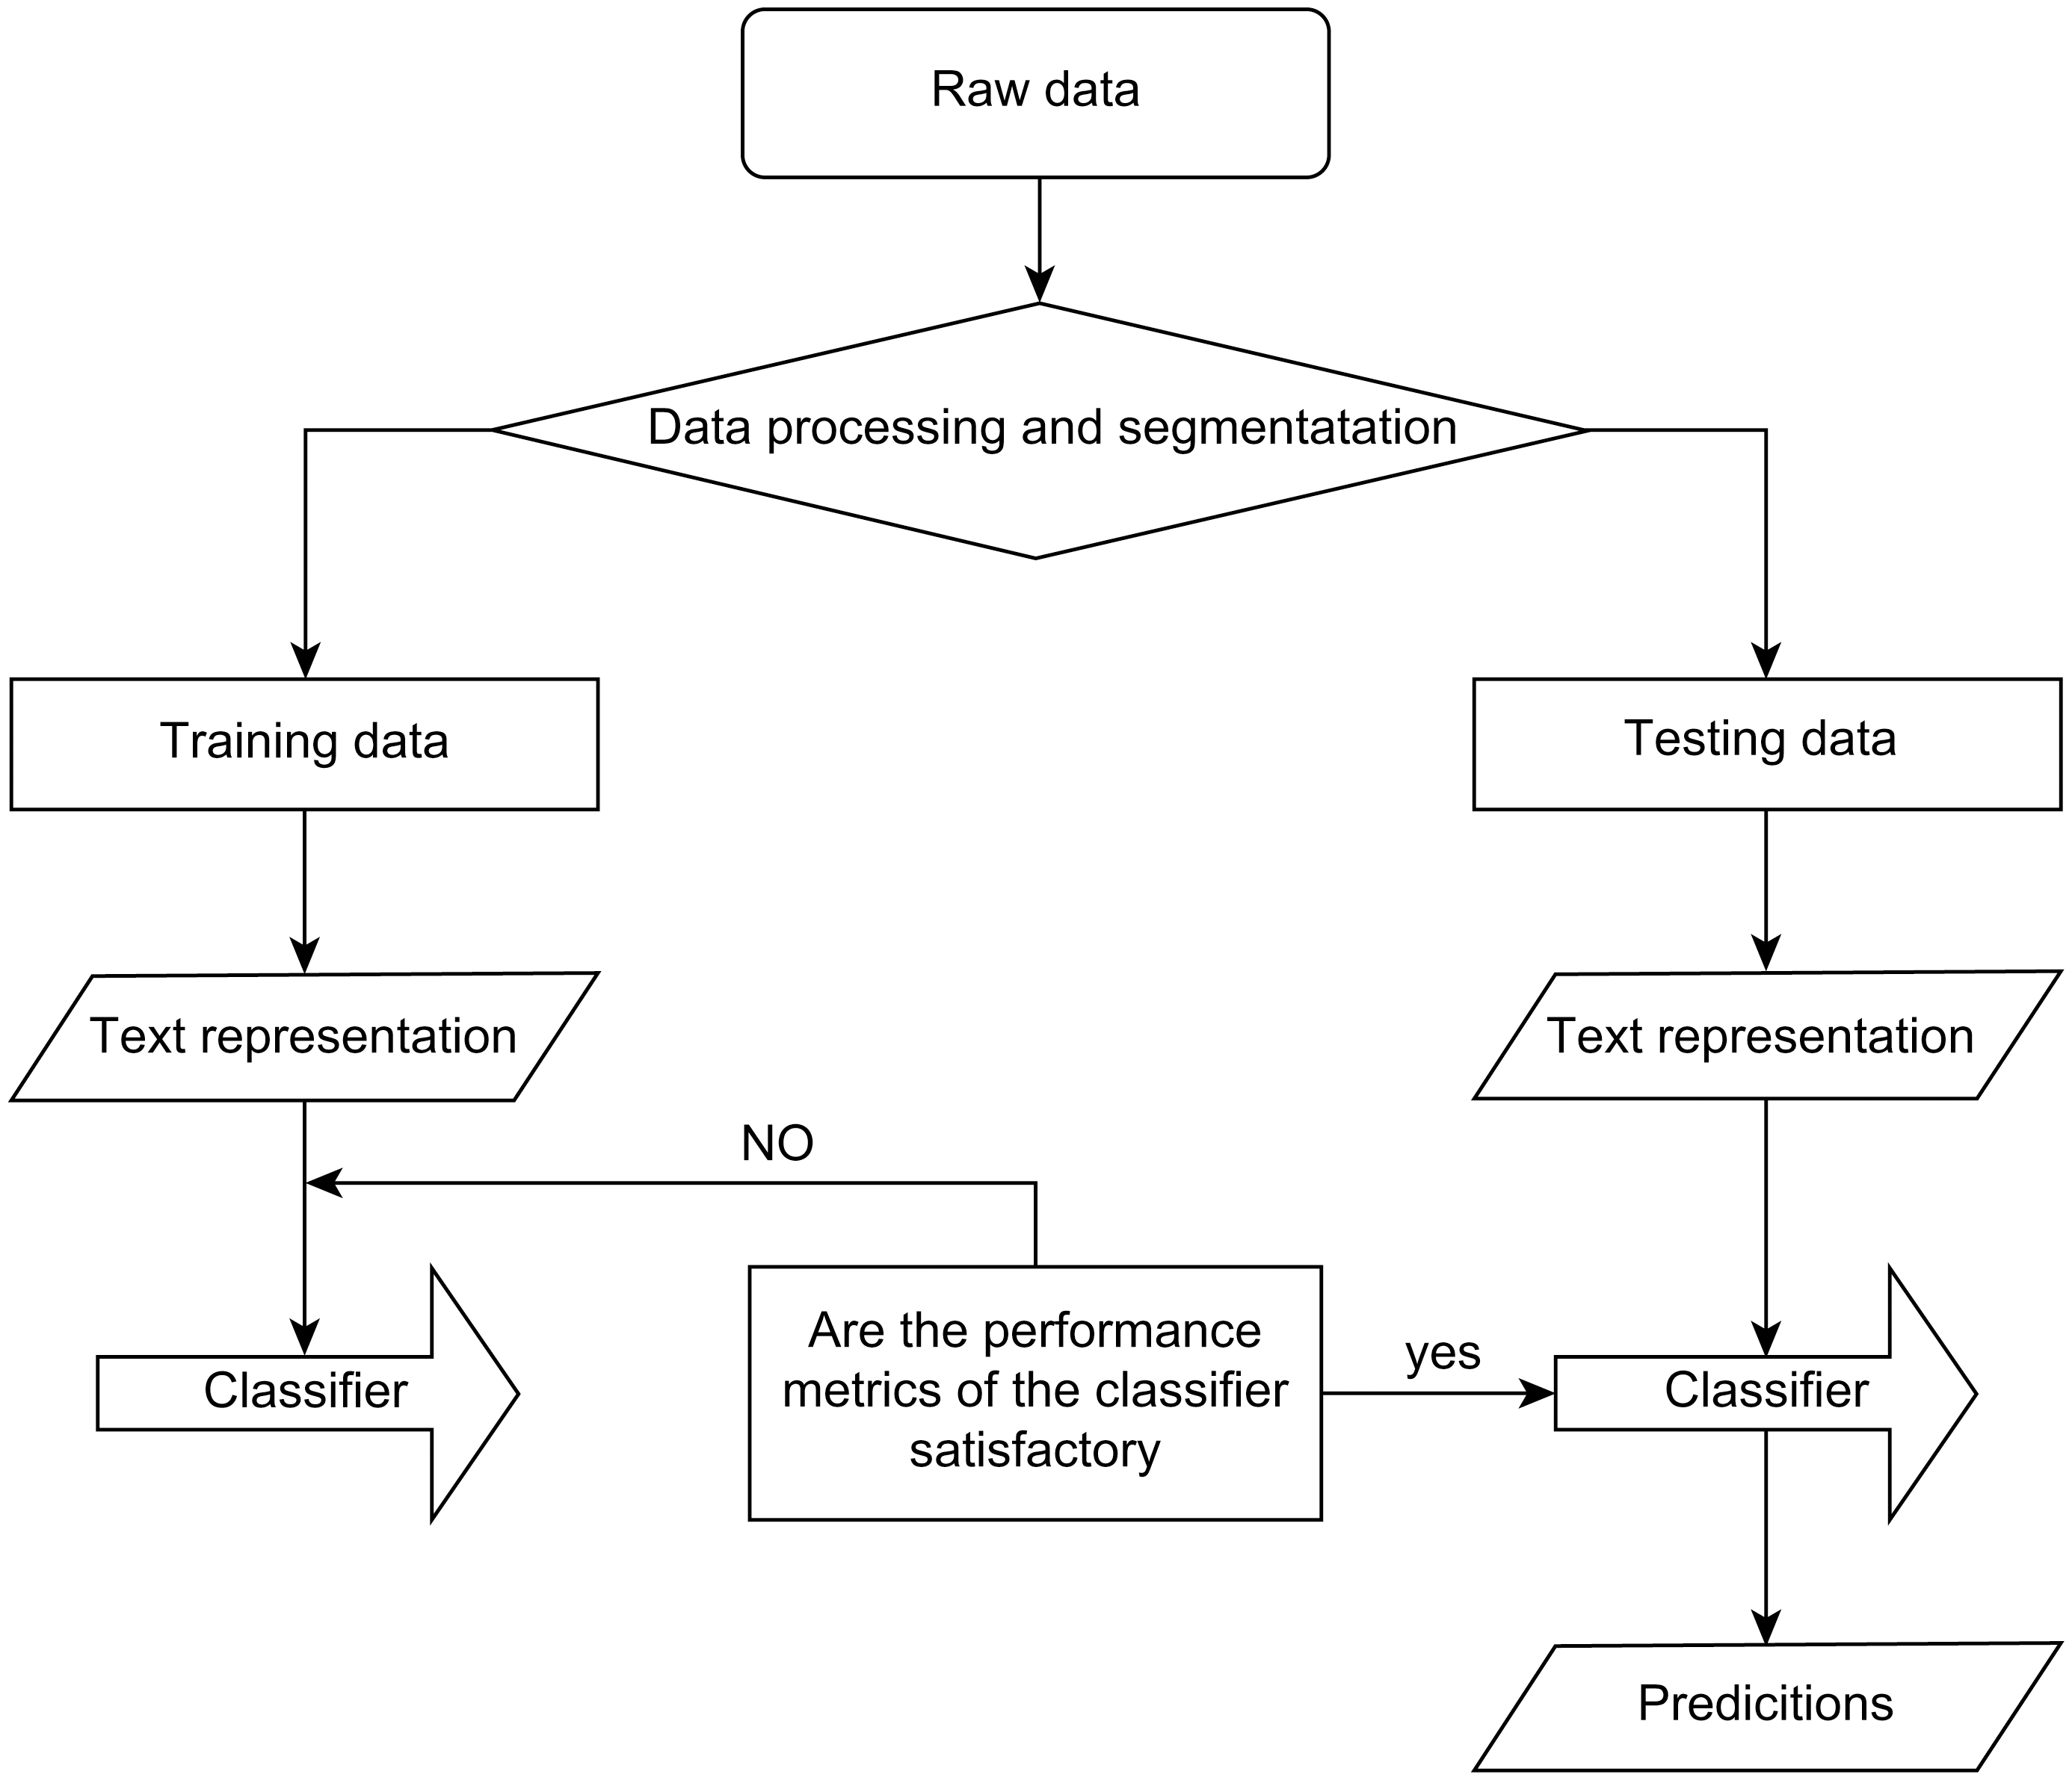
Figure 3. Simplified recurrent architecture used in the selected study. Source: Liu (2024), PLOS ONE, Fig. 1.

8. Performance Evaluation
Identify the evaluation metrics used in the article, such as:
Answer: The article evaluates classification with accuracy, precision, recall, and F1-score. It also analyzes loss and accuracy curves during training and validation. F1-score is particularly useful because it combines precision and recall and is more informative than accuracy alone when class-wise errors differ.
Accuracy, Precision, Recall, F1-Score , Loss , Mean Squared Error (MSE)
BLEU Score, where applicable
Answer: BLEU score is not applicable because the study classifies news articles rather than generating translated or summarized sequences. It would be suitable for machine translation or other text-generation tasks, not for this three-class classification problem.
Report the major performance results obtained by the proposed model.
Answer: The BiLSTM model achieves an overall F1-score of 94.15%, while the unidirectional LSTM achieves 93.16%. Class-wise BiLSTM F1-scores are reported as 0.9448 for sports, 0.9607 for entertainment, and 0.9190 for technology. These results indicate a consistent advantage for bidirectional contextual feature extraction.
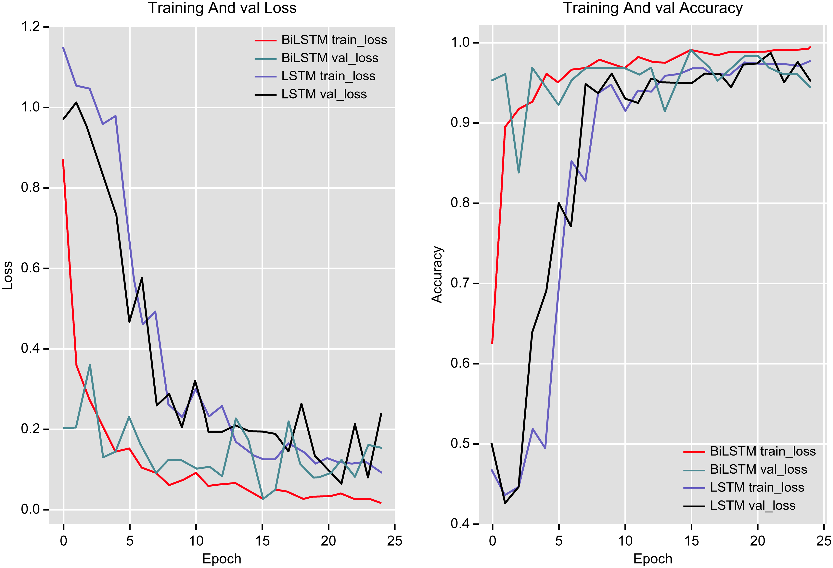
Figure 4. Training and validation loss/accuracy curves. Source: Liu (2024), PLOS ONE, Fig. 13.

9. Results and Discussion
What are the major findings of the research?
Answer: The major finding is that BiLSTM provides better feature extraction and classification performance than unidirectional LSTM for the selected Chinese news data. The model benefits from word2vec representations, two-stage recurrent processing, dropout, and Adam optimization.
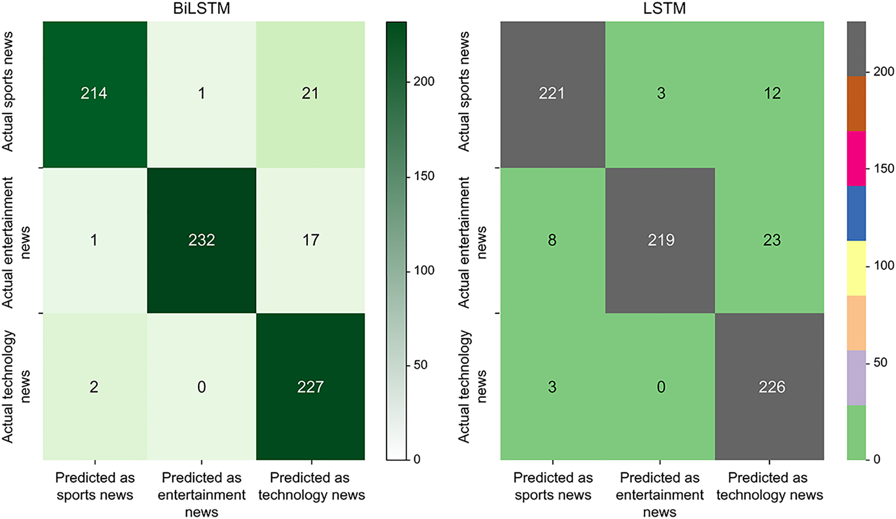
Figure 6. Confusion-matrix visualization for the classification results. Source: Liu (2024), PLOS ONE, Fig. 14.
How does the proposed model perform compared with existing methods?
Answer: The article compares the proposed BiLSTM with unidirectional LSTM and benchmark models including FastText, BERT, and TextCNN. The authors report that BiLSTM obtains the strongest test performance among the compared models, although the size and collection method of the dataset should be considered when interpreting the comparison.
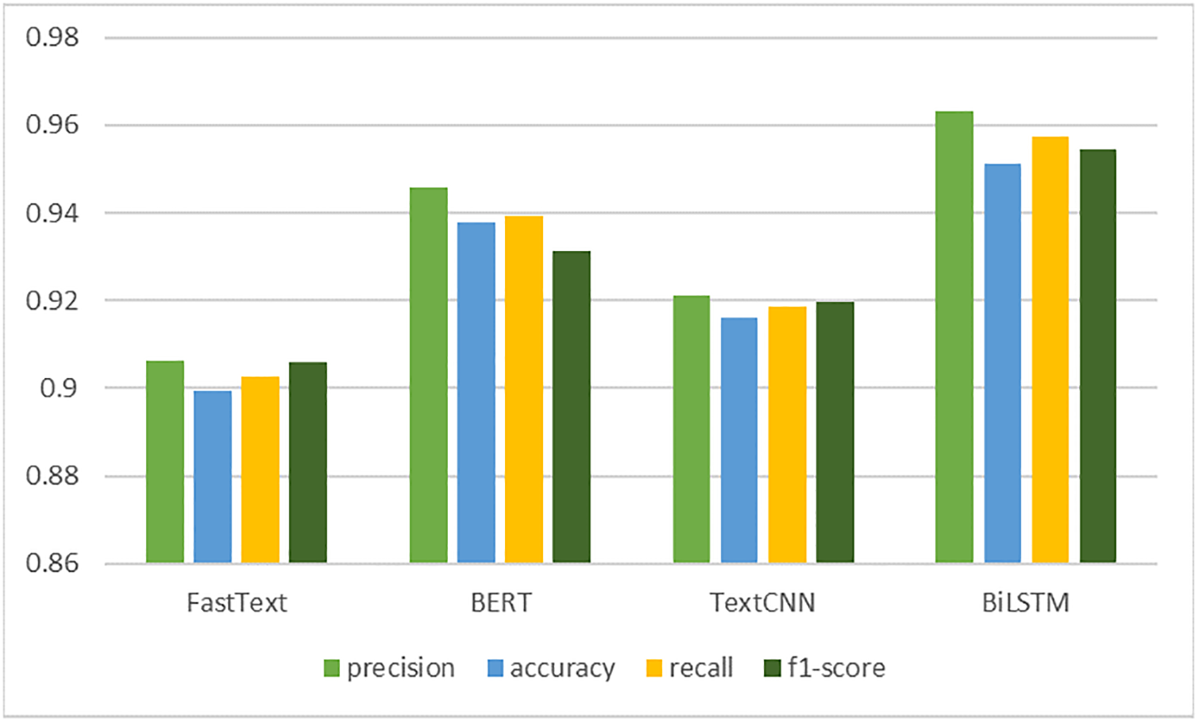
Figure 5. Comparison of the proposed model with benchmark methods. Source: Liu (2024), PLOS ONE, Fig. 15.
Which model/technique produced the best results?
Answer: The proposed BiLSTM-based model produces the best reported results in the study, with an overall F1-score of 94.15%, exceeding the 93.16% F1-score of the unidirectional LSTM.
What factors contributed to the observed performance?
Answer: Performance is supported by dense word2vec representations, bidirectional context, the additional LSTM integration layer, appropriate sequence-length control, Adam optimization, dropout regularization, and the relatively distinct semantic content of the three news categories.

10. Advantages of the Proposed Model
Identify at least three advantages of the proposed approach.
Answer: The approach has at least three important advantages: it captures both preceding and following context; it reduces information loss by integrating BiLSTM outputs with another LSTM; and it uses a practical end-to-end pipeline with word embeddings, dropout, and Adam optimization. It also provides a clear comparison with a unidirectional LSTM and other baseline models.

11. Limitations of the Study
Identify the major limitations mentioned by the authors and any additional limitations you observe, such as: Small dataset,High computational requirements,Training time,Overfitting
Limited generalization,Model complexity.
Answer: The model’s complexity is higher than a single LSTM because it combines BiLSTM, LSTM, and fully connected stages. This may increase inference cost and make deployment on low-resource devices difficult. Generalization could also be limited by the three-category dataset and by possible class or source imbalance, even though the reported class counts are relatively similar.

12. Critical Analysis
Provide your own analysis of the research article:
Answer: Overall, the selected architecture is technically appropriate for context-sensitive text classification, but the evidence should be interpreted as task- and dataset-specific. The article is strongest in explaining the preprocessing and recurrent pipeline and in comparing LSTM directions. Its claims would be more convincing with repeated cross-validation, confidence intervals, stronger ablation studies, and evaluation on an external news corpus.
Is the selected deep learning architecture appropriate for the problem?
Answer: Yes. LSTM and BiLSTM are suitable because news articles are sequences in which word order and contextual dependencies matter. BiLSTM is especially appropriate for offline classification, where the complete article is available. For real-time streaming classification, a unidirectional model may be preferable because future tokens are not yet available.
Is the dataset adequate?
Answer: The dataset is adequate for a controlled proof-of-concept with three relatively distinct categories, but it is not fully adequate for claiming broad real-world generalization. A larger, more diverse, independently collected, and carefully annotated corpus would strengthen the conclusions.
Are the evaluation metrics appropriate?
Answer: Yes. Accuracy, precision, recall, and F1-score are appropriate for multi-class classification, and class-wise F1-scores provide useful detail. Reporting a confusion matrix is also valuable. Additional macro- and weighted-average scores, calibration, and confidence intervals would improve the evaluation.
Are the experimental results convincing?
Answer: The results are reasonably convincing for the reported dataset because the BiLSTM consistently outperforms the unidirectional LSTM and is compared with several baselines. However, the conclusions would be stronger if the authors reported multiple random seeds, statistical significance, external validation, and a detailed ablation of the dual-stage architecture.
Could another Unit IV technique provide better performance?
Answer: A Transformer-based encoder could potentially outperform LSTM/BiLSTM on a larger dataset because self-attention models long-range relationships in parallel. A pretrained Chinese language model with fine-tuning might also improve performance, while a lightweight CNN–LSTM hybrid could offer a useful accuracy–efficiency trade-off. The best alternative would need to be tested under the same data split and tuning budget.

13. Future Scope
Suggest possible improvements or future research directions based on the limitations identified in the article.
Answer: Future work should evaluate the model on larger multi-source and multilingual news corpora, use stratified repeated experiments, and report confidence intervals. It could compare BiLSTM with Chinese pretrained Transformers, attention mechanisms, and efficient recurrent models. Further improvements include subword tokenization, data augmentation, explainable attention or saliency analysis, class-imbalance checks, adversarial robustness testing, and deployment-oriented compression or quantization.

14. Conclusion
Provide a brief conclusion summarizing:
The research problem
Answer: The article studies automatic classification of Chinese news into sports, entertainment, and technology categories while preserving contextual information that traditional bag-of-words methods lose.
Proposed model
Answer: The proposed model uses 200-dimensional word2vec inputs, a BiLSTM feature-extraction stage, a second LSTM integration stage, dropout regularization, and a fully connected classifier optimized with Adam.
Major results
Answer: The BiLSTM model achieves a reported overall F1-score of 94.15%, compared with 93.16% for the unidirectional LSTM, and performs best among the compared approaches on the reported test set.
Your overall assessment of the article
Answer: The article is a clear and relevant applied study showing why bidirectional contextual modeling can improve Chinese news classification. Its methodology is easy to follow and its results are useful for demonstrating LSTM and BiLSTM behavior. The main caution is that the dataset and evaluation design limit the strength of broad generalization claims. Overall, it is a suitable article for reviewing recurrent neural networks, preprocessing, sequence modeling, and critical evaluation of deep-learning experiments.

15. References
Provide the complete citation of the selected research article and any additional references used in the review.
Answer: Liu, C. (2024). Long short-term memory (LSTM)-based news classification model. PLOS ONE, 19(5), e0301835. https://doi.org/10.1371/journal.pone.0301835
Dataset/source link retained from the article: https://github.com/pengwei-iie/Bert-THUCNews
Additional conceptual reference: Hochreiter, S., & Schmidhuber, J. (1997). Long short-term memory. Neural Computation, 9(8), 1735–1780. https://doi.org/10.1162/neco.1997.9.8.1735

RUBRICS FOR CALCULATION:
Criteria | Weightage | Level 4 – Exemplary | Level 3 – Proficient | Level 2 – Developing | Level 1 – Beginning
Article Selection & Problem Understanding | 20% | Comprehensive understanding of real-world problem and constraints | Good understanding with minor gaps in requirements | Basic understanding; some requirements unclear | Poor understanding; misinterprets problem context
Deep Learning Model & Methodology Analysis | 25% | Applies advanced and relevant concepts effectively to solve the problem | Applies appropriate concepts with minor errors | Limited application of concepts | Incorrect or no application of concepts
Results & Performance Evaluation | 25% | Innovative, practical, and feasible solution aligned with industry standards | Logical and feasible solution with minor gaps | Basic solution with limited feasibility | Unclear or impractical solution
Critical Analysis & Technical Evaluation | 20% | Effective use of modern tools, technologies, and real data | Appropriate use of tools with correct implementation | Limited or inconsistent use of tools | Minimal or incorrect use of tools
Future Scope, Presentation & Documentation | 10% | Thorough analysis with validated results and performance evaluation | Good analysis with reasonable validation | Basic analysis with limited validation | Poor or no analysis

