Assignment-Regression Algorithm
Insurance Predict
Executive Summary
This project aims to develop a Machine Learning model to accurately predict insurance charges based on customer demographic and health-related attributes. Using multiple regression-based algorithms, we evaluated model performance and selected the most effective model based on statistical accuracy (R² Score). After rigorous comparison, the Random Forest Regression model was selected as the final model due to its superior predictive performance.
1.) Identify your problem statement
Since the inputs are numerical and the output variable is also numerical, this problem falls under Supervised Learning. Because the target variable is continuous, it is classified as a Regression problem. As there are multiple input variables and one output variable, suitable algorithms include Multiple Linear Regression, Support Vector Machine (SVM), Decision Tree, and Random Forest.
2.) Tell basic info about the dataset (Total number of rows, columns)
Feature | Description
Age | Age of the individual
Sex | Gender of the individual
BMI | Body Mass Index
Children | Number of dependents
Smoker | Smoking status
Charges | Insurance premium (Target Variable)
Dataset Details
- Total Rows: 1338
- Total Columns: 6
- Input Variables: 5
- Target Variable: Charges
The dataset is suitable for Supervised Learning because both input and output variables are clearly defined. Since the output is numerical, this problem falls under Regression Analysis.
3.) Mention the pre-processing method if you’re doing any (like converting string to number – nominal data).
Prior to model development, data preprocessing was conducted to ensure compatibility with machine learning algorithms. The dataset included two categorical variables — Sex and Smoker — which required transformation into numerical format. This was achieved using the One-Hot Encoding technique.
One-Hot Encoding converts categorical values into binary vectors, allowing the model to interpret them correctly without introducing any unintended ordinal relationships or bias.
4.) Develop a good model with r2_score. You can use any machine learning algorithm; you can create many models. Finally, you have to come up with final model.
Multiple regression algorithms were implemented and evaluated using R² Score as the primary performance metric.
Why R² Score?
R² (Coefficient of Determination) measures how well the model explains the variance in the target variable.
- Value ranges from 0 to 1
- Higher value = Better predictive power
5.) All the research values (r2_score of the models) should be documented. (You can make tabulation or screenshot of the results.)
Algorithms | R_Score Value
Multiple Linear Regression | 0.789479035
Support Vector Machine | 0.628886376
Decision Tree | 0.730128896
Random Forest | 0.873472269

- Multiple Linear Regression - 0.789479035
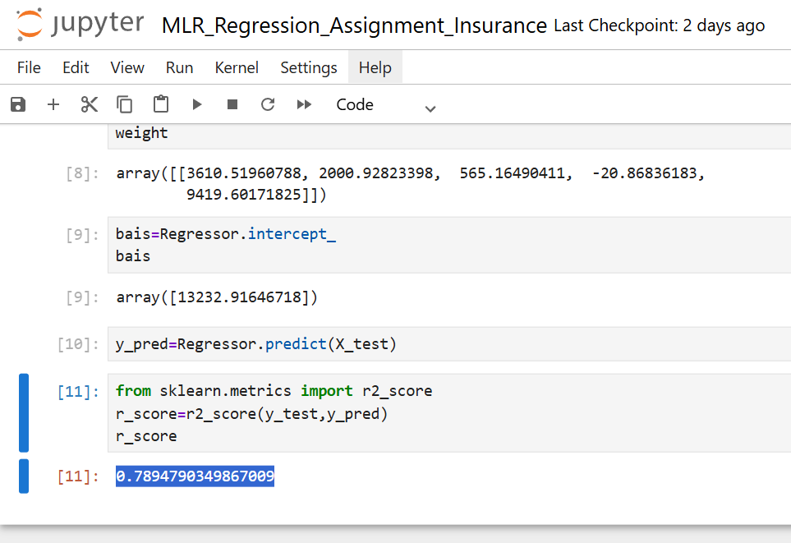
- Support Vector Machine - 0.628886376

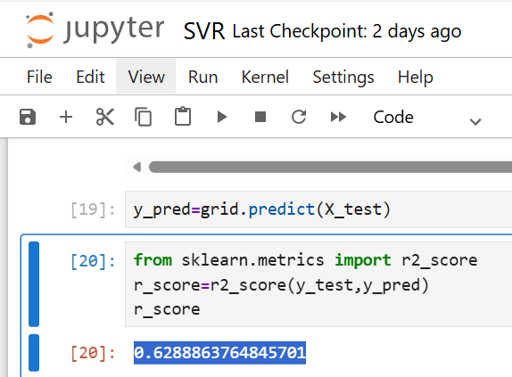

- Decision Tree – 0.73012
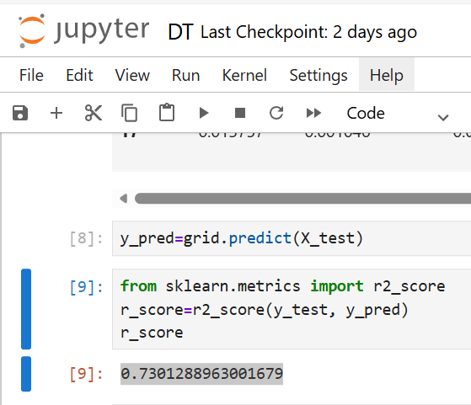

- Random Forest – 0.873472269
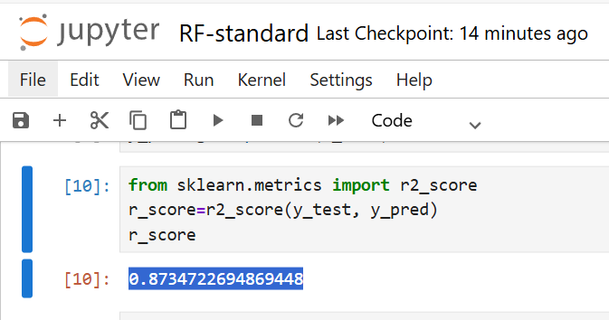

6.) Mention your final model, justify why u have chosen the same.
Random Forest was selected because:
- It achieved the highest R² Score (0.8735)
- Handles non-linear relationships effectively
- Reduces overfitting compared to Decision Trees
- Performs well with mixed data types
Conclusion
- The project successfully developed and evaluated multiple regression models for predicting insurance charges. Among the tested algorithms, Random Forest Regression demonstrated the best predictive performance and reliability. This model can now be deployed into production systems to support automated insurance premium calculations and strategic decision-making.

