Jenkins
מגישים :
שקד תורג'מן 206180440
ניב כהן 313948317
יובל שחר 209455112
צילומי מסך:
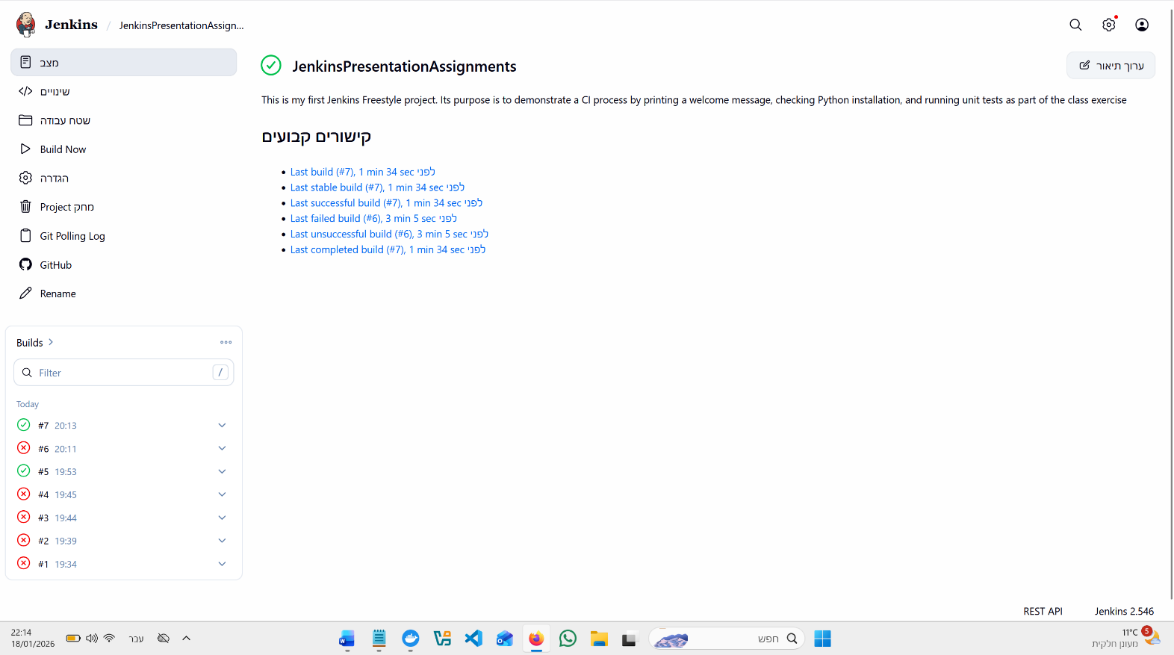

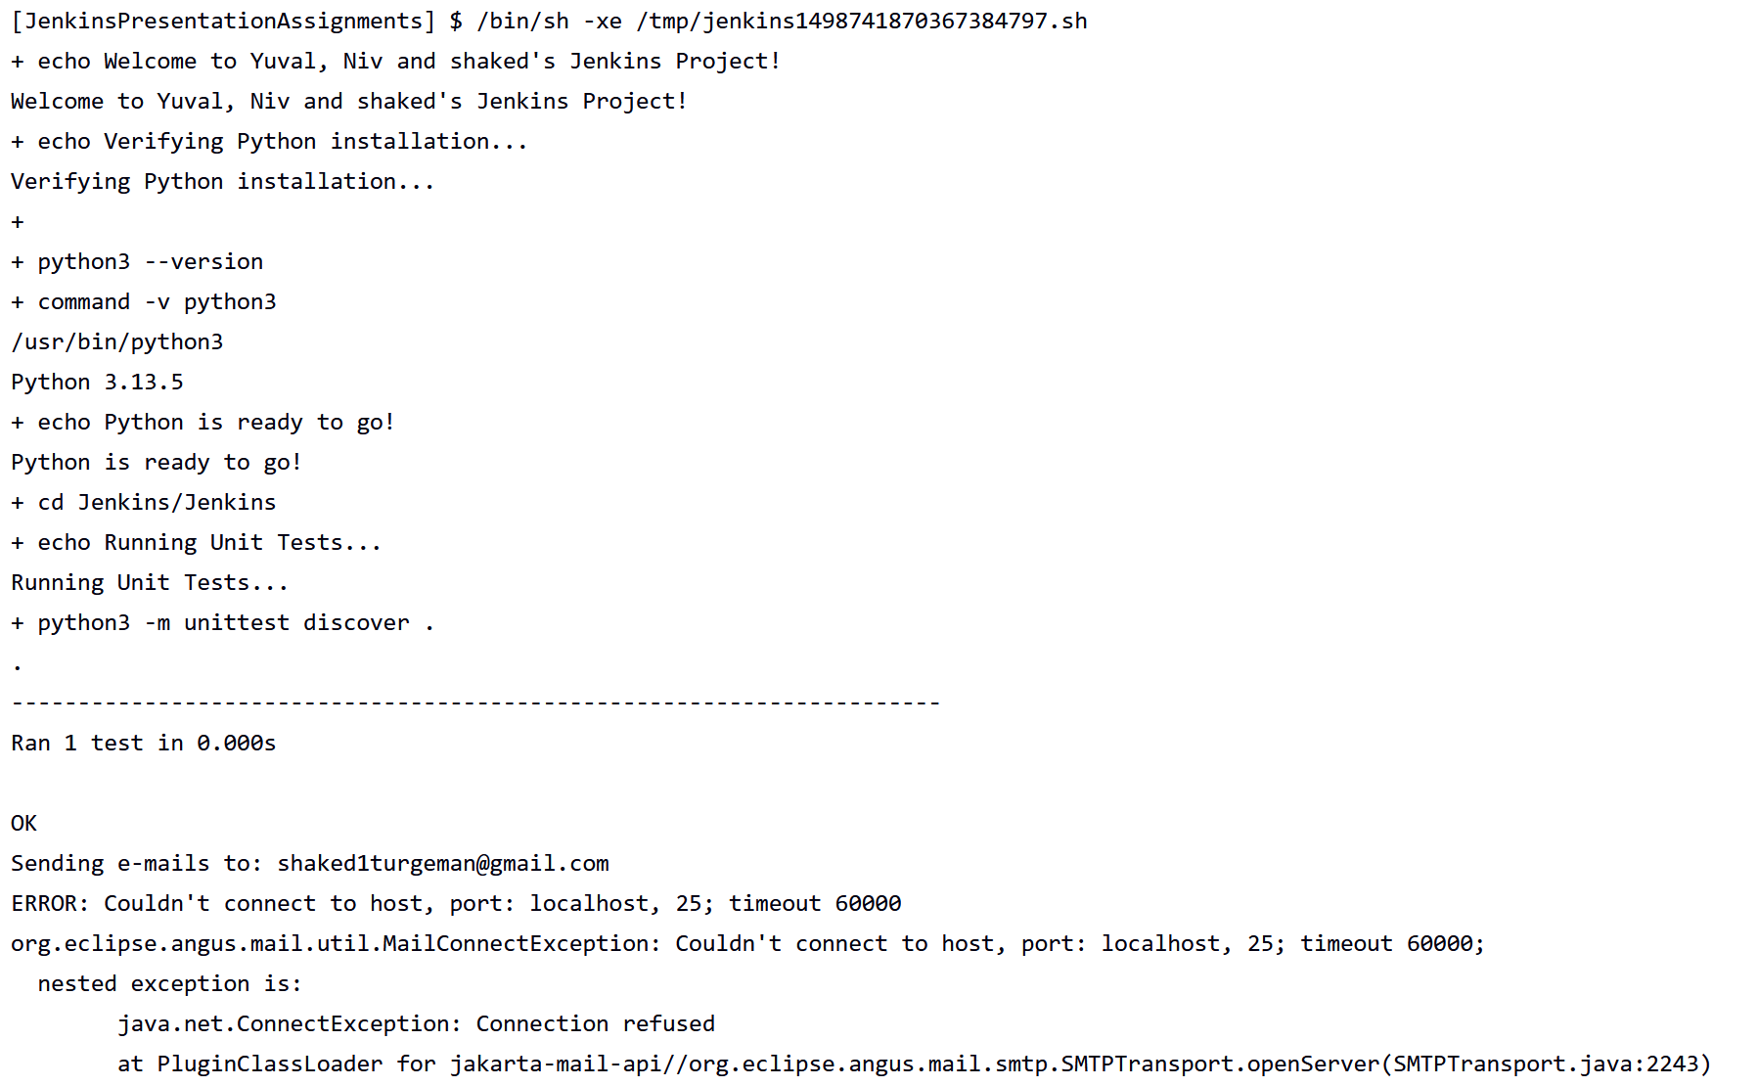
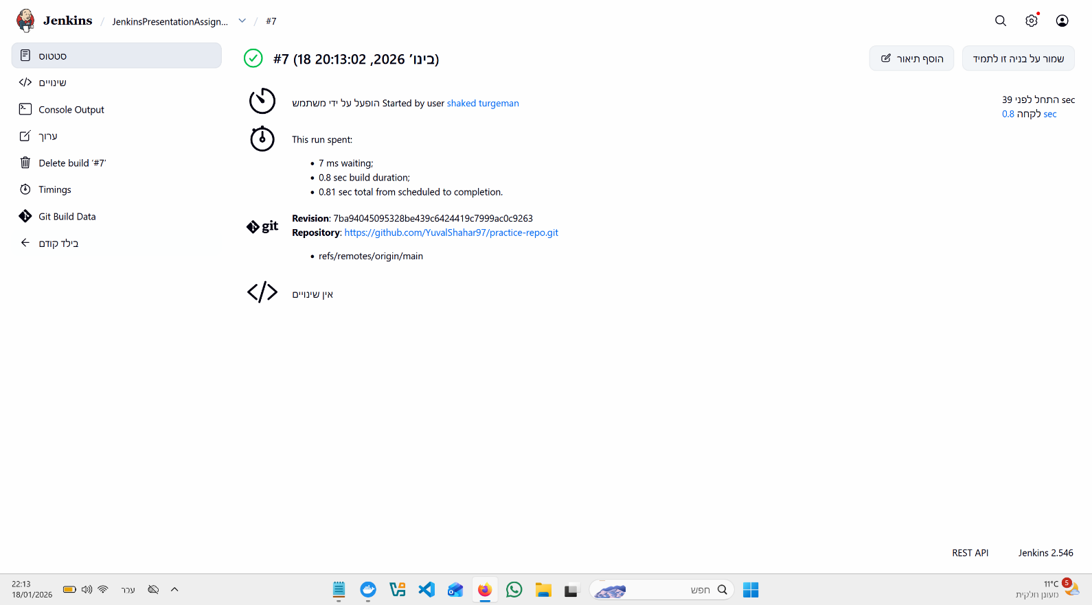

פלט הקונסול בג'נקינס:

Started by user shaked turgeman
Running as SYSTEM
Building in workspace /var/jenkins_home/workspace/JenkinsPresentationAssignments
[WS-CLEANUP] Deleting project workspace...
[WS-CLEANUP] Deferred wipeout is used...
[WS-CLEANUP] Done
The recommended git tool is: NONE
No credentials specified
Cloning the remote Git repository
Cloning repository https://github.com/YuvalShahar97/practice-repo.git
> git init /var/jenkins_home/workspace/JenkinsPresentationAssignments/Jenkins # timeout=10
Fetching upstream changes from https://github.com/YuvalShahar97/practice-repo.git
> git --version # timeout=10
> git --version # 'git version 2.47.3'
> git fetch --tags --force --progress -- https://github.com/YuvalShahar97/practice-repo.git +refs/heads/*:refs/remotes/origin/* # timeout=10
> git config remote.origin.url https://github.com/YuvalShahar97/practice-repo.git # timeout=10
> git config --add remote.origin.fetch +refs/heads/*:refs/remotes/origin/* # timeout=10
Avoid second fetch
> git rev-parse refs/remotes/origin/main^{commit} # timeout=10
Checking out Revision 7ba94045095328be439c6424419c7999ac0c9263 (refs/remotes/origin/main)
> git config core.sparsecheckout # timeout=10
> git checkout -f 7ba94045095328be439c6424419c7999ac0c9263 # timeout=10
Commit message: "Rename test_app.py to Jenkins/test_app.py"
> git rev-list --no-walk 7ba94045095328be439c6424419c7999ac0c9263 # timeout=10
[JenkinsPresentationAssignments] $ /bin/sh -xe /tmp/jenkins1498741870367384797.sh
+ echo Welcome to Yuval, Niv and shaked's Jenkins Project!
Welcome to Yuval, Niv and shaked's Jenkins Project!
+ echo Verifying Python installation...
Verifying Python installation...
+
+ python3 --version
+ command -v python3
/usr/bin/python3
Python 3.13.5
+ echo Python is ready to go!
Python is ready to go!
+ cd Jenkins/Jenkins
+ echo Running Unit Tests...
Running Unit Tests...
+ python3 -m unittest discover .
.
----------------------------------------------------------------------
Ran 1 test in 0.000s

OK
Sending e-mails to: shaked1turgeman@gmail.com
ERROR: Couldn't connect to host, port: localhost, 25; timeout 60000
org.eclipse.angus.mail.util.MailConnectException: Couldn't connect to host, port: localhost, 25; timeout 60000;
nested exception is:
java.net.ConnectException: Connection refused
at PluginClassLoader for jakarta-mail-api//org.eclipse.angus.mail.smtp.SMTPTransport.openServer(SMTPTransport.java:2243)
at PluginClassLoader for jakarta-mail-api//org.eclipse.angus.mail.smtp.SMTPTransport.protocolConnect(SMTPTransport.java:729)
at PluginClassLoader for jakarta-mail-api//jakarta.mail.Service.connect(Service.java:345)
at PluginClassLoader for jakarta-mail-api//jakarta.mail.Service.connect(Service.java:225)
at PluginClassLoader for jakarta-mail-api//jakarta.mail.Service.connect(Service.java:174)
at PluginClassLoader for jakarta-mail-api//jakarta.mail.Transport.send0(Transport.java:232)
at PluginClassLoader for jakarta-mail-api//jakarta.mail.Transport.send(Transport.java:102)
at PluginClassLoader for mailer//hudson.tasks.MailSender.run(MailSender.java:131)
at PluginClassLoader for mailer//hudson.tasks.Mailer.perform(Mailer.java:175)
at PluginClassLoader for mailer//hudson.tasks.Mailer.perform(Mailer.java:138)
at hudson.tasks.BuildStepMonitor$1.perform(BuildStepMonitor.java:20)
at hudson.model.AbstractBuild$AbstractBuildExecution.perform(AbstractBuild.java:818)
at hudson.model.AbstractBuild$AbstractBuildExecution.performAllBuildSteps(AbstractBuild.java:767)
at hudson.model.Build$BuildExecution.post2(Build.java:179)
at hudson.model.AbstractBuild$AbstractBuildExecution.post(AbstractBuild.java:711)
at hudson.model.Run.execute(Run.java:1865)
at hudson.model.FreeStyleBuild.run(FreeStyleBuild.java:44)
at hudson.model.ResourceController.execute(ResourceController.java:97)
at hudson.model.Executor.run(Executor.java:456)
Caused by: java.net.ConnectException: Connection refused
at java.base/sun.nio.ch.Net.pollConnect(Native Method)
at java.base/sun.nio.ch.Net.pollConnectNow(Unknown Source)
at java.base/sun.nio.ch.NioSocketImpl.timedFinishConnect(Unknown Source)
at java.base/sun.nio.ch.NioSocketImpl.connect(Unknown Source)
at java.base/java.net.SocksSocketImpl.connect(Unknown Source)
at java.base/java.net.Socket.connect(Unknown Source)
at PluginClassLoader for jakarta-mail-api//org.eclipse.angus.mail.util.SocketFetcher.createSocket(SocketFetcher.java:366)
at PluginClassLoader for jakarta-mail-api//org.eclipse.angus.mail.util.SocketFetcher.getSocket(SocketFetcher.java:243)
at PluginClassLoader for jakarta-mail-api//org.eclipse.angus.mail.smtp.SMTPTransport.openServer(SMTPTransport.java:2193)
... 18 more
Finished: SUCCESS

