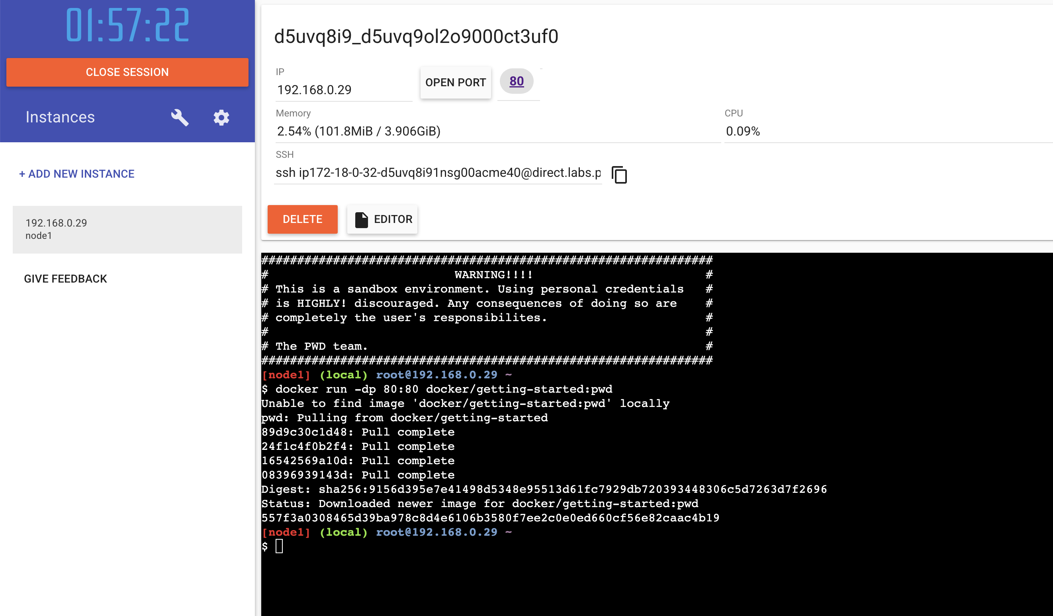
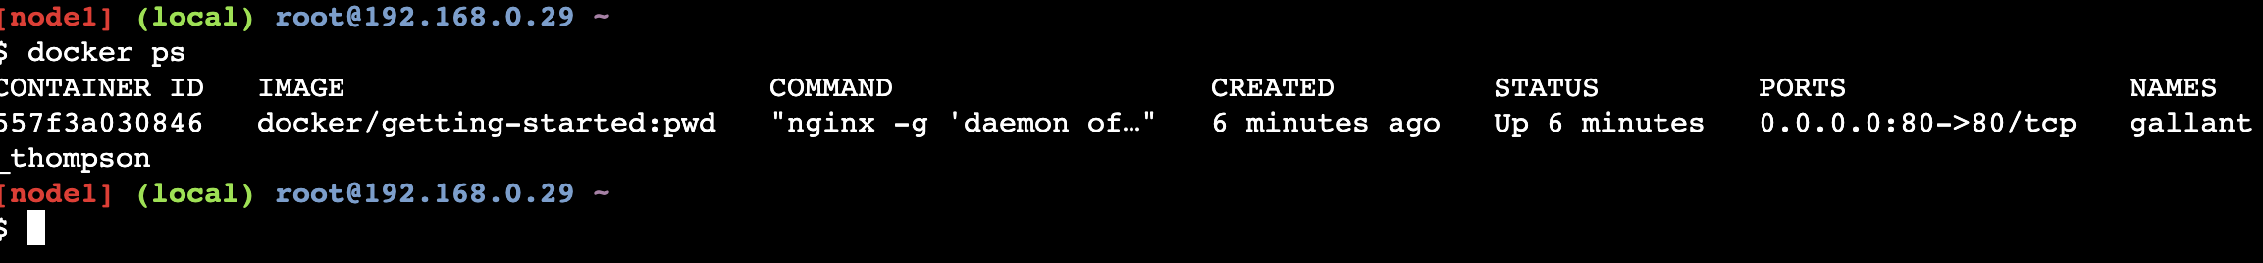
Screenshot shows:
docker run -dp 80:80 docker/getting-started:pwd
Explain:
This command creates and starts a new container based on the docker/getting-started:pwd image.
- -d: detached mode — runs in the background.
- -p 80:80: maps port 80 on the host to port 80 inside the container.
- docker/getting-started: the image name.
- :pwd: a tag for the specific version built for Play With Docker.

docker ps output.
Explain:
The docker ps command lists all running containers.
It shows the container ID, image name, status, and port mapping (for example, 0.0.0.0:80->80/tcp).
This means the container is running and accessible through port 80 on the host.
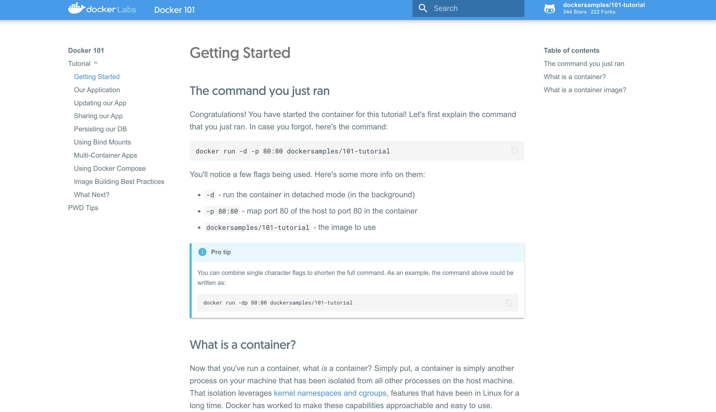

Play With Docker provides a quick link for exposed ports.
Clicking the “80” link opens a new browser tab showing the running web app (Docker’s Getting Started tutorial).
This demonstrates that the container is serving a webpage through port 80.
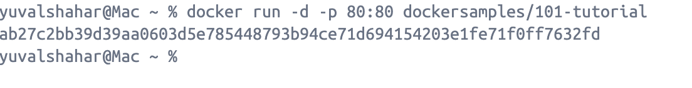
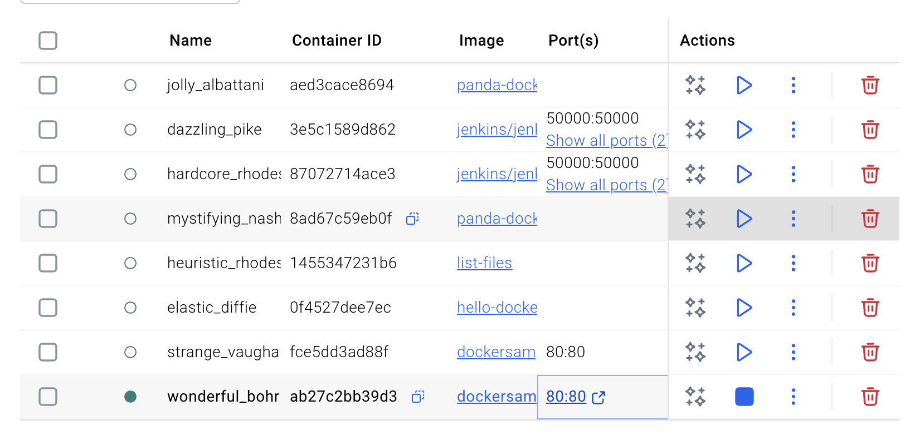

I ran the same command locally on my machine through Docker Desktop.
It downloads the image (if not already available), starts the container in detached mode, and maps port 80 on my computer to port 80 inside the container.
Screenshot shows: docker ps output or Docker Desktop UI listing the container.
Explain:
This confirms that the container is running on my local host.
The ports column again shows 0.0.0.0:80->80/tcp, meaning requests to http://localhost/ go to the container.

