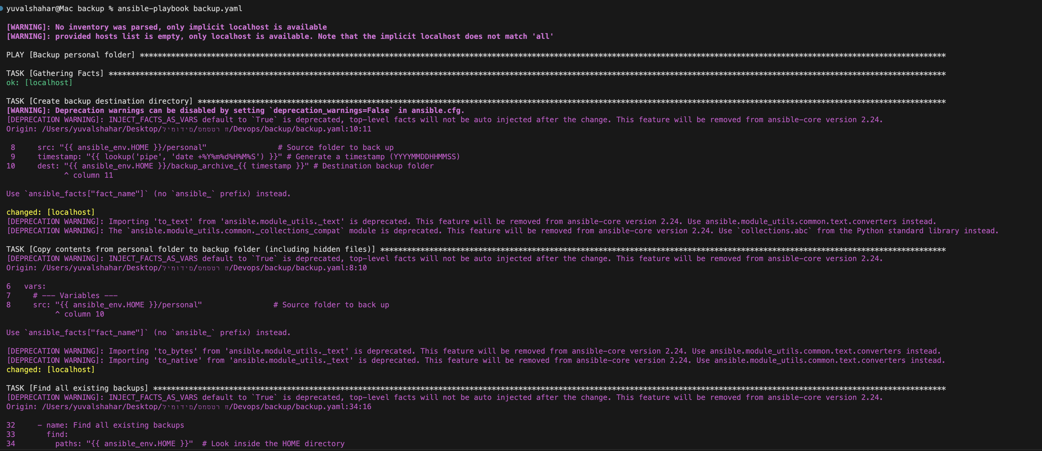

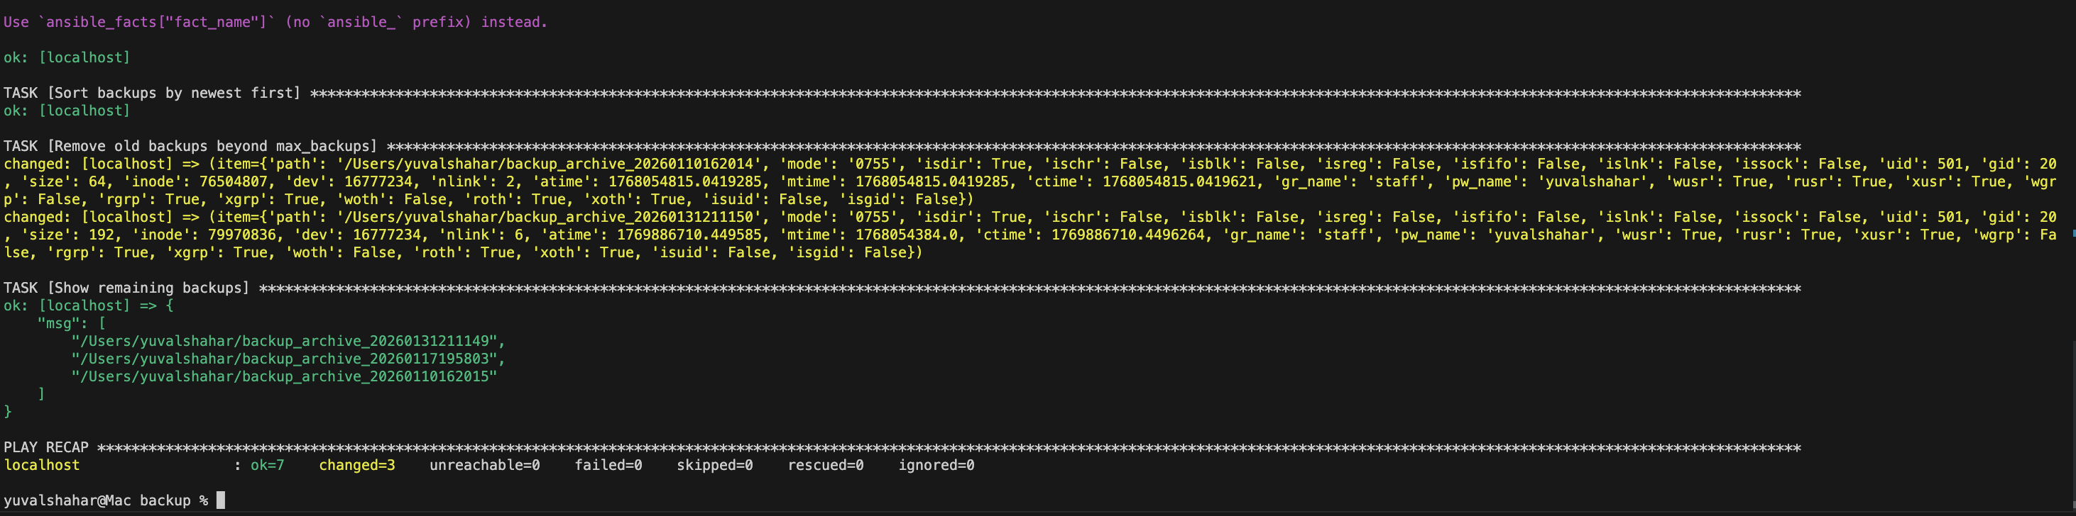

We can see that Ansible playbook ran successfully, creating a new timestamped backup folder in home directory and copying all contents from ~/personal, including hidden files. It then scanned for existing backups, kept the three most recent ones, and deleted older folders automatically. The output confirms everything completed without errors (ok=7 changed=3 failed=0). The warnings are only deprecation notices suggesting a newer syntax and don’t affect functionality. Overall, the backup and cleanup worked exactly as intended.

