

**“STOCK MARKET ANALYSIS: A Comparative Study of Linear Regression, Random Forest and LSTM”**

**A CORE COURSE PROJECT REPORT**

**Submitted By**

**YUVAN SHANKAR S**

**23AM125**

**in partial fulfilment for the award of the degree of**

**BACHELOR OF ENGINEERING**

**IN**

**CSE (ARTIFICIAL INTELLIGENCE AND MACHINE LEARNING)**



**DEPARTMENT OF CSE**

**(ARTIFICIAL INTELLIGENCE AND MACHINE LEARNING)**

**CHENNAI INSTITUTE OF TECHNOLOGY**

**(Autonomous)**

Sarathy Nagar, Kundrathur, Chennai-600069

**OCT / NOV – 2024**



**Vision of the Institute:**

To be an eminent centre for Academia, Industry and Research by imparting knowledge, relevant practices and inculcating human values to address global challenges through novelty and sustainability.

**Mission of the Institute:**

**IM1:** To creates next generation leaders by effective teaching learning methodologies and instill scientific spark in them to meet the global challenges.

**IM2:** To transform lives through deployment of emerging technology, novelty and sustainability.

**IM3:** To inculcate human values and ethical principles to cater the societal needs.

**IM4:** To contributes towards the research ecosystem by providing a suitable, effective platform for interaction between industry, academia and R & D establishments.

**IM5**: To nurture incubation centres enabling structured entrepreneurship and start-ups.



**DEPARTMENT OF CSE**

**(ARTIFICIAL INTELLIGENCE AND MACHINE LEARNING)**

**Vision of the Department**:

* **The vision of the Department of Artificial Intelligence and Machine Learning is to impart quality education and produce high quality, creative and ethical engineers, in still professionalism, enhance students' problem solving skills in the domain of artificial intelligence and Machine Learning to emerge as a premier center for education and research in Artificial Intelligence and Machine Learning in transforming students into innovative professionals of contemporary and future technologies to cater the global needs of human resources for IT industries**

**Mission of the Department**:

* **DM1: To provide skill-based education to master the students in problem solving and analytical skills to enhance their niche expertise in the field Artificial Intelligence and Machine Learning.**
* **DM2: To explore opportunities for skill development in the application of Artificial Intelligence and Machine learning among rural and under privileged population.**
* **DM3: Transform professionals into technically competent through research based projects in the emerging areas of Artificial Intelligence and Machine Learning and socially responsible.**
* **DM4: To impart quality and value-based education and contribute towards the innovation of computing system, data science to raise satisfaction level of all stakeholders.**



**CERTIFICATE**

This is to certify that the “**Core Course Project**” Submitted by **YUVAN SHANKAR S(23AM125)** is a work done by him and submitted during **2023-2024** academic year, in partial fulfilment of the requirements for the award of the degree of **BACHELOR OF ENGINEERING** in **DEPARTMENT OF CSE (ARTIFICIAL INTELLIGENCE AND MACHINE LEARNING),** at Chennai Institute of Technology.

|  |  |
| --- | --- |
| **Project Coordinator**  **Dr.P.Karthikeyan, M.E**, **Ph.D.,** | **Internal Examiner** |
| **Head of the Department**  **Dr.R.Gowri,** **M.Tech**., **Ph.D.,** | **External Examiner** |

**ACKNOWLEDGEMENT**

We express our gratitude to our Chairman **Shri.P.SRIRAM** and all trust members of Chennai institute of technology for providing the facility and opportunity to do this project as a part of our undergraduate course.

We are grateful to our Principal **Dr.A.RAMESH, M.E**, **Ph.D.,** for providing us the facility and encouragement during the course of our work.

We sincerely thank our Head of the Department **Dr.R.Gowri,** **M.Tech**., **Ph.D.,** Department of CSE (ARTIFICIAL INTELLIGENCE AND MACHINE LEARNING) for having provided us valuable guidance, resources and timely suggestions throughout our work.

We would like to extend our thanks to ourProject Co-ordinator of the **Dr.P.Karthikeyan, M.E**, **Ph.D.,** Department of CSE (ARTIFICIAL INTELLIGENCE AND MACHINE LEARNING), for his valuable suggestions throughout this project.

We wish to extend our sincere thanks to allFaculty members of the Department of CSE (ARTIFICIAL INTELLIGENCE AND MACHINE LEARNING) for their valuable suggestions and their kind cooperation for the successful completion of our project.

We wish to acknowledge the help received from the **Lab Instructors of the** Department of CSE (ARTIFICIAL INTELLIGENCE AND MACHINE LEARNING) and others for providing valuable suggestions and for the successful completion of the project.

**NAME: YUVAN SHANKAR S REG.NO: 23AM125**

**PREFACE**

I, a student in the Department of CSE (ARTIFICIAL INTELLIGENCE AND MACHINE LEARNING) need to undertake a project to expand my knowledge. The main goal of my Core Course Project is to acquaint me with the practical application of the theoretical concepts I’ve learned during my course.

It was a valuable opportunity to closely compare theoretical concepts with real-world applications. This report may depict deficiencies on my part but still it is an account of my effort.

The results of my analysis are presented in the form of an industrial Project, and the report provides a detailed account of the sequence of these findings. This report is my Core Course Project, developed as part of my 2nd year project. As an engineer, it is my responsibility to contribute to society by applying my knowledge to create innovative solutions that address their changes.

ABSTRACT

The stock market is known for its dynamic and volatile nature, making accurate price prediction a challenging task. In recent years, machine learning models have gained traction for stock market forecasting due to their ability to uncover hidden patterns and trends from historical data. This study explores three different machine learning techniques—Linear Regression, Random Forest, and Long Short-Term Memory (LSTM) neural networks—comparing their effectiveness in predicting stock prices. The goal is to evaluate the performance of these models using historical stock price data, to better understand their prediction capabilities and limitations.

The methodology involves preprocessing historical stock price data, including normalization and data splitting into training and test sets. Linear Regression, a statistical approach, is first implemented to model the relationship between stock prices and their historical data. Random Forest, an ensemble learning method, is then applied to reduce overfitting by creating multiple decision trees and aggregating their predictions. Finally, LSTM, a type of recurrent neural network (RNN) specialized for timeseries forecasting, is used to model the sequential dependencies in the stock price data. Each model is trained and tested, and their predictive performance is evaluated based on key metrics such as Root Mean Squared Error (RMSE) and Mean Absolute Error (MAE). Visual comparisons between actual and predicted stock prices further illustrate the models' performance.

The results reveal that the LSTM model, designed to handle sequential data, outperforms both Linear Regression and Random Forest in predicting stock price movements. LSTM's ability to capture longterm dependencies in stock price patterns provides a significant edge over the other models. However, Random Forest demonstrates robustness and accuracy in nonsequential data prediction, while Linear Regression, although the simplest of the three, still offers valuable insights in capturing general trends in stock prices.

In conclusion, while no model is flawless, the LSTM neural network shows the most promise for accurate stock market prediction due to its capacity to learn from historical sequences. Random Forest proves to be a solid contender for general pattern recognition, while Linear Regression serves as a baseline model for trend identification. This comparative analysis highlights the importance of selecting appropriate machine learning models based on the nature of the data and the specific forecasting goals. Future work can explore hybrid models that integrate the strengths of multiple techniques for improved stock price prediction accuracy.

|  |  |  |
| --- | --- | --- |
|  | **TABLE OF CONTENT** |  |
| **CHAPTER** | **CONTENT** | **PAGE NO** |
| 1.INTRODUCTION | .1 Background of the study  1.2 Problem Statement  1.3 Research questions/objectives  1.4 Significance of the study  1.5 Scope of the study  1.6 Thesis organization |  |
| 2. Literature Review | 2.1 Review of relevant previous work  2.2 Theoretical foundations  2.3 Gaps in the literature  2.4 Hypotheses or research framework  2.5 Research Framework |  |
| 3. Methodology | 3.1 Research design  3.2 Data collection methods  3.3 Tools, materials, and procedures used  3.4 Data analysis methods  3.5 Algorithm / Procedure / Pseudo Code  3.6 Ethical considerations |  |
| 4.Results/Findings | 4.1 Presentation of data/results  4.2 Tables, charts, or graphs for clarity  4.3 Analysis of findings |  |
| 5. Discussion | 5.1 Interpretation of the findings  5.2 Comparison with previous research  5.3 Implications of the study  5.4 Limitations of the research |  |
| 6. Conclusion | 6.1 Summary of key findings  6.2 Recommendations for future research  6.3 Practical implications of the results  References |  |

List of Figures

|  |  |  |
| --- | --- | --- |
| **S No** | **Figure Name** | **Page No** |
| 1 | Linear Regression model |  |
| 2 | Random Forest model |  |
| 3 | LSTM model |  |
| 4 | Architecture diagram |  |

Chapter 1: Introduction

The stock market is a dynamic environment where shares of publicly traded companies are bought and sold, serving as a key indicator of economic health and investor sentiment. It is influenced by factors such as macroeconomic conditions, geopolitical events, and corporate performance. The unpredictability of stock prices has created a demand for reliable forecasting methods to aid investors in making informed decisions. Traditional methods like technical and fundamental analysis often struggle to account for sudden market changes or external influences.

With advancements in big data and computational power, machine learning has emerged as a promising alternative for stock price prediction. Machine learning models can process large datasets, detect patterns, and adapt to evolving market conditions, leading to more accurate forecasts. Popular techniques for stock market forecasting include Linear Regression, Random Forest, and Long Short-Term Memory (LSTM) networks.

Linear Regression models the relationship between dependent and independent variables but is limited by its linearity assumption, making it less effective in capturing the complex relationships in financial markets. Random Forest, an ensemble method combining multiple decision trees, better handles nonlinear interactions, improving accuracy and robustness. LSTMs, a type of recurrent neural network, excel at handling sequential data, making them ideal for time-series forecasting. This study aims to compare these three models, exploring their strengths and weaknesses in predicting stock prices.

1.2 Research Problem

Despite progress in machine learning for stock market prediction, challenges remain. The inherent volatility of financial markets can lead to unpredictable price movements, complicating modelling efforts. Moreover, many studies focus on individual approaches without providing comprehensive comparisons between different models, limiting insights into their relative performance.

This research addresses these gaps by systematically comparing Linear Regression, Random Forest, and LSTM models using the same dataset. By evaluating these models under similar conditions, the study aims to provide insights into their predictive accuracy and robustness, guiding future efforts in financial forecasting.

1.3 Research Questions/Objectives

To address the research problem, this study is guided by the following research questions:

RQ1: How do Linear Regression, Random Forest, and LSTM models perform in predicting stock prices based on historical data?

RQ2: What are the comparative strengths and weaknesses of each model in terms of predictive accuracy, computational efficiency, and scalability?

RQ3: How do the results of this study contribute to the existing body of knowledge regarding machine learning applications in stock market prediction?

The objectives of this research are:

1. Evaluate Model Performance: Assess and compare the predictive accuracy of Linear Regression, Random Forest, and LSTM models on stock price data to identify which model performs best under different conditions.

2. Comparative Analysis: Conduct a detailed analysis of the strengths and weaknesses of each model, evaluating their effectiveness under varying market conditions, including volatile periods, trends, and anomalies.

3. Contribute to Financial Forecasting: Provide valuable insights and recommendations for investors, financial analysts, and researchers. The empirical evidence derived from this study aims to inform model selection strategies in practical financial forecasting scenarios.

4. Explore Feature Importance: Investigate the importance of feature selection, including historical stock prices and external variables like trading volume, economic indicators, and market sentiment, in enhancing the predictive accuracy of machine learning models.

5. Advance Machine Learning Applications: Contribute to the broader field of financial forecasting by demonstrating the utility of modern machine learning algorithms, encouraging further research into hybrid models and more sophisticated algorithms tailored to financial prediction tasks.

1.4 Significance of the Study

The findings of this study have significant implications for various stakeholders in the financial sector, including investors, financial analysts, traders, and academic researchers. By evaluating different machine learning models for stock price prediction, this research helps investors make data driven trading decisions, enabling them to adjust their strategies based on market conditions like volatility or stability, potentially improving returns while managing risks.

For financial analysts, the study provides a framework for selecting appropriate predictive models. Random Forest and LSTM, known for handling nonlinear patterns and long-term dependencies, offer practical tools for both short term trading and long-term investments. The comparative analysis helps analysts choose the best model for their forecasting needs.

In academia, this study fills gaps by showcasing how machine learning can enhance prediction accuracy. It encourages future research to explore advanced algorithms, hybrid models, and features like sentiment analysis or macroeconomic factors, contributing to the growing body of financial forecasting literature.

On a broader scale, this research promotes collaboration between finance and machine learning. As data-driven, decision-making becomes more prominent in financial markets, machine learning offers valuable insights into areas like algorithmic trading, portfolio optimization, and risk management, paving the way for future advancements in these fields.

1.5 Scope of the Study

This study focuses on stock price prediction for selected companies over a defined time period using three machine learning models: Linear Regression, Random Forest, and LSTM. The aim is to compare their predictive performance and highlight their strengths and limitations.

While the study provides valuable insights, it is limited to historical price data and may not apply to all market conditions or financial instruments, particularly during periods of extreme volatility like recessions. The research emphasizes the technical aspects of model evaluation, with limited focus on qualitative factors like news events or investor sentiment.

Future studies could expand the scope by incorporating a wider range of features, including macroeconomic indicators and sentiment analysis, to further improve prediction accuracy. Additionally, ethical considerations, such as transparency and fairness in machine learning models used for trading, are not explored in this study but may become increasingly important as these technologies gain wider adoption.

1.6 Thesis Organization

The thesis is organized into six chapters:

Chapter 1: Provides an introduction, covering the background, research problem, objectives, significance, scope, and thesis structure.

Chapter 2: Reviews relevant literature on stock market prediction, key theoretical frameworks, and identifies gaps in existing research.

Chapter 3: Describes the research methodology, including data collection, tools used for model implementation, and evaluation. Ethical considerations and validation techniques are also discussed.

Chapter 4: Presents the study's results, detailing the findings from the analysis of Linear Regression, Random Forest, and LSTM models. Graphs, tables, and performance metrics are used to illustrate the outcomes.

Chapter 5: Discusses the implications of the findings, compares the results with previous research, and highlights the limitations of the study and its practical relevance.

Chapter 6: Concludes by summarizing key findings and providing recommendations for future research, along with the practical implications for investors and the financial industry.

Chapter 2: Literature Review

2.1 Review of Relevant Previous Work

Stock market prediction has been a significant area of research, transitioning from traditional statistical models to advanced machine learning techniques. Initial approaches like Ordinary Least Squares (OLS), ARIMA, and GARCH models helped establish early frameworks but were limited by their linear assumptions. These models often failed to capture the nonlinear, complex dynamics of stock markets.

Machine learning methods, particularly Random Forest and LSTM models, have demonstrated superior capabilities in this domain. Random Forest, an ensemble technique that combines multiple decision trees, is known for its robustness and ability to handle highdimensional data. Studies like Adebayo et al. (2021) revealed that Random Forest models outperform traditional methods by identifying intricate patterns in financial data, improving prediction accuracy.

LSTM models, on the other hand, are especially effective for timeseries forecasting due to their architecture, which allows for memory retention over long periods. Research by Fischer and Krauss (2018) showed that LSTMs outperform traditional and other machine learning models, particularly for stock price prediction.

Despite these advancements, research often focuses on a single model, lacking comparative analysis across multiple techniques. Moreover, external factors such as macroeconomic indicators and market sentiment are rarely integrated, leaving opportunities for future research.

2.2 Theoretical Foundations

Stock market prediction intersects with finance, statistics, and machine learning. In finance, the Efficient Market Hypothesis (EMH) suggests that stock prices incorporate all available information, making it difficult to consistently outperform the market. However, empirical evidence shows that certain market inefficiencies can be exploited for better returns.

Machine learning models provide the flexibility to model complex relationships. Linear Regression assumes a simple, direct relationship between variables, making it computationally efficient but inadequate for nonlinear data. Random Forest overcomes this by averaging predictions from multiple decision trees, which enhances model robustness and reduces overfitting. LSTM networks, a type of recurrent neural network, excel at timeseries tasks, making them particularly well suited for stock market forecasting.

2.3 Gaps in the Literature

1. Lack of Comparative Analysis: Few studies have systematically compared multiple machine learning models, such as Random Forest and LSTM, on the same dataset. A comparative study is essential for identifying the strengths and weaknesses of each model.

2. Feature Selection: Most research focuses on historical stock prices, often neglecting external variables like trading volume, economic indicators, or sentiment data. Including these variables could improve model accuracy.

3. Evaluation Metrics: Current studies primarily use metrics like MSE or RMSE. More nuanced metrics, such as Mean Absolute Percentage Error (MAPE) or hit ratio, could provide deeper insights into the model's predictive accuracy.

4. Scalability: Many studies focus on academic datasets, with limited consideration for real world applications. More research is needed on the scalability and computational efficiency of these models when implemented in live trading environments.

2.4 Hypotheses or Research Framework

Based on the literature review and identified gaps, the following hypotheses and research framework guide this study:

**Hypothesis 1:** Linear Regression will demonstrate lower predictive accuracy compared to Random Forest and LSTM models due to its inherent limitations in capturing nonlinear relationships.

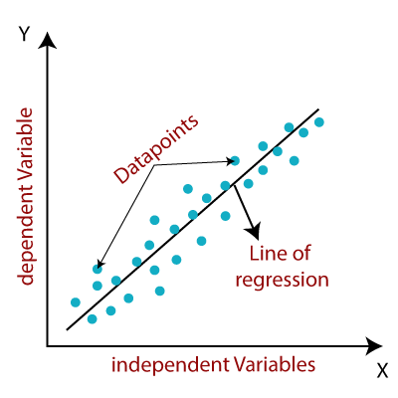

**Hypothesis 2:** Random Forest will outperform Linear Regression by effectively handling nonlinear interactions among features, leading to improved prediction accuracy.

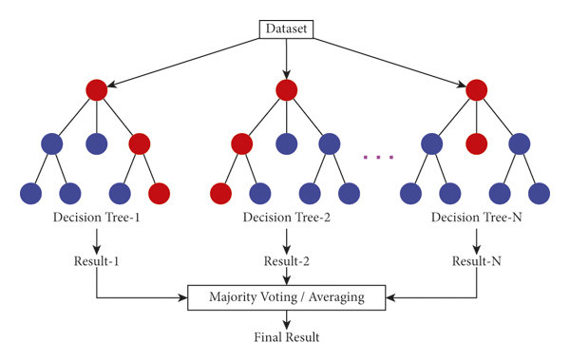

**Hypothesis 3:** LSTM will achieve the highest predictive accuracy among the three models, leveraging its ability to capture temporal dependencies in historical stock price data.

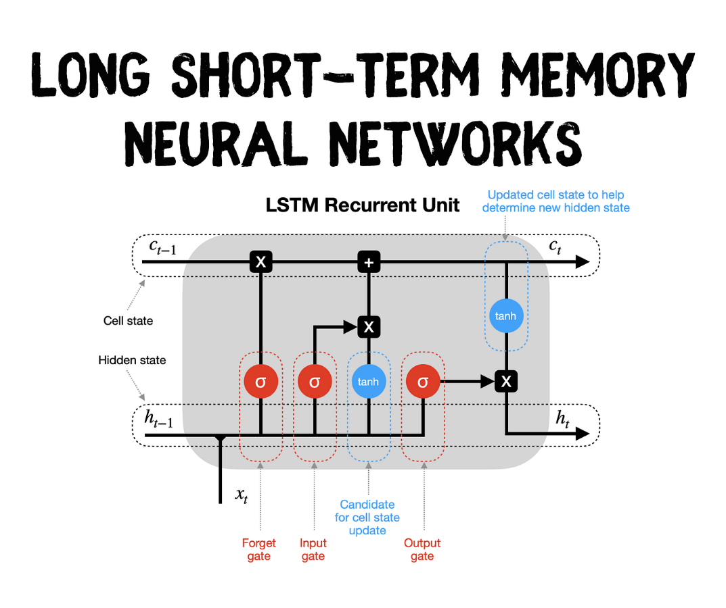

2.5 Research Framework

The research framework serves as a structured approach to integrating the selected modelling techniques—Linear Regression, Random Forest, and Long Short-Term Memory (LSTM)—within a cohesive study design. This framework is essential for facilitating a rigorous comparative analysis of these models concerning their effectiveness in predicting stock market prices.

Data Collection

The first step in the research framework involves the systematic collection of data relevant to stock market prediction. The dataset comprises historical stock prices, which include daily open, high, low, and close prices, as well as trading volume for a specified group of companies over a defined time period. Additionally, external variables such as macroeconomic indicators (e.g., interest rates, inflation rates), trading sentiment derived from news articles, and social media analytics are collected to enrich the dataset and provide contextual information that may influence stock prices.

Data sources may include reputable financial databases such as Yahoo Finance, Google Finance, or specialized platforms like Alpha Vantage and Quandl, which provide APIs for extracting financial data. Careful attention is paid to ensure the dataset is comprehensive and clean, covering both normal market conditions and periods of high volatility to ensure the robustness of the models.

Data Preprocessing

Once the data is collected, preprocessing is essential to prepare it for analysis. This stage involves several key steps:

**1. Data Cleaning:** Handling missing values, removing duplicates, and correcting erroneous data points to ensure data integrity.

**2. Normalization:** Standardizing the data to bring all features into a common scale, which is particularly important for models like LSTM that are sensitive to the magnitude of input values. Techniques such as Min-Max scaling or Z-score normalization may be employed.

**3. Feature Engineering:** Creating new features that may enhance the predictive power of the models. This may involve calculating moving averages, relative strength indices (RSI), and other technical indicators commonly used in trading strategies. Moreover, incorporating sentiment analysis scores from news articles or social media can provide additional predictive signals.

**4. Data Splitting:** Dividing the dataset into training, validation, and test sets. The training set is used to fit the models, while the validation set helps in tuning hyperparameters. The test set is reserved for final model evaluation, ensuring that performance metrics are based on unseen data.

Modelling

The modelling stage involves the implementation of the three selected machine learning techniques: Linear Regression, Random Forest, and LSTM. Each model is developed with a focus on its unique strengths and capabilities:

**1. Linear Regression:** As a baseline model, Linear Regression will be implemented to establish a performance benchmark. This model will be configured to predict stock prices based on a set of historical features, providing insights into linear relationships within the data.

**2. Random Forest:** This ensemble learning method will be employed to capture nonlinear patterns and interactions between features. A series of decision trees will be constructed, and the final prediction will be made by aggregating the outputs of these trees. Hyperparameter tuning will be conducted to optimize model performance.

**3. LSTM:** The LSTM model will be specifically designed for timeseries forecasting, taking advantage of its architecture that allows it to learn longterm dependencies in sequential data. The LSTM network will be configured with appropriate layers and parameters, such as the number of hidden units, dropout rates, and batch sizes, to optimize its performance on stock price prediction.

Evaluation

Once the models are trained, a comprehensive evaluation process will be undertaken to assess their predictive performance. Various metrics will be utilized to compare the models, including:

**1. Mean Absolute Error (MAE):** This metric quantifies the average absolute difference between predicted and actual values, providing a clear indication of the model's accuracy.

**2. Mean Squared Error (MSE) and Root Mean Squared Error (RMSE):** These metrics measure the average squared difference between predicted and actual values, with RMSE providing a normalized measure of prediction accuracy.

**3. Mean Absolute Percentage Error (MAPE):** This metric expresses prediction accuracy as a percentage, allowing for a more intuitive comparison across different scales.

**4. Hit Ratio:** This metric assesses the model's ability to correctly predict price movements (i.e., whether the predicted price direction matches the actual price direction).

The evaluation results will be presented using visualizations such as performance graphs, scatter plots, and confusion matrices, facilitating a clear comparison of model performances across different metrics.

Interpretation

The final stage of the research framework focuses on interpreting the results obtained from the model evaluations. This involves analysing the performance metrics to draw meaningful conclusions about the effectiveness of each modelling technique in predicting stock prices. Key insights will be highlighted, such as:

The strengths and weaknesses of each model based on their predictive accuracy and generalizability to different market conditions.

Chapter 3: Methodology

3.1 Research Design (Architecture/Framework)

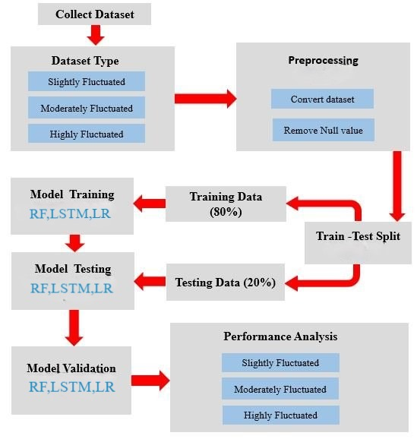

This study utilizes a **comparative research design** to assess and compare the predictive performance of three machine learning models—Linear Regression, Random Forest, and Long Short-Term Memory (LSTM) neural networks—in forecasting stock prices. The research design is structured to provide a systematic and unbiased comparison, ensuring that each model is evaluated under the same conditions for a valid and meaningful comparison.

The research framework is divided into key stages:

1. **Data Collection:** Historical stock price data and relevant market indicators are gathered from reliable sources like Yahoo Finance and Alpha Vantage. This data forms the foundation for model training and evaluation.
2. **Data Preprocessing:** The raw data is cleaned, normalized, and transformed, addressing issues like missing values and outliers. Scaling and creating lagged features prepare the data for models like LSTM.
3. **Model Implementation:** Linear Regression, Random Forest, and LSTM models are implemented with standardized methods. Linear Regression serves as the baseline, Random Forest captures nonlinear patterns, and LSTM handles sequential data.
4. **Model Evaluation:** The models are evaluated using metrics such as RMSE and MAE to assess prediction accuracy and reliability.
5. **Analysis of Findings:** Results from all models are compared through visualizations and statistical tests, providing insights into their performance and recommendations for future applications.

3.2 Data Collection Methods

The study uses quantitative data, primarily numerical stock prices and financial indicators. Key features include:

* **Open, High, Low, Close Prices:** These provide a comprehensive picture of daily market behaviour, with the "Close" price often used for predictions.
* **Trading Volume:** This indicates market interest and liquidity.
* Technical Indicators: Indicators like Moving Averages and RSI provide insights into market trends.

The data covers several years to ensure robust training across different market conditions. The dataset is split into 80% for training and 20% for testing.

3.3 Tools, Materials, and Procedures

Python and its libraries are central to the study:

* Pandas for data manipulation and preprocessing.
* NumPy for numerical operations.
* Scikit-learn for implementing Linear Regression and Random Forest models.
* Keras/TensorFlow for building the LSTM model.
* Matplotlib/Seaborn for visualizing results.

This approach ensures the models are effectively trained, evaluated, and compared.

**Procedures**

**1. Data Preprocessing:** Raw stock price data is cleaned and normalized using `Pandas` and `Min-Max Scaler`. This ensures that the data is in a consistent format for model training. Lagged features are also created for LSTM to capture time dependencies.

**2. Model Training**: Each model (Linear Regression, Random Forest, LSTM) is implemented and trained on the pre-processed data. For Random Forest and LSTM, hyperparameter tuning will be performed to optimize their performance. Linear Regression will be evaluated with default settings as a baseline.

**3. Evaluation:** The trained models are then tested on unseen data to assess their predictive performance. Metrics such as RMSE and MAE are calculated to quantify the prediction accuracy.

3.4 Data Analysis Methods

The data analysis methods employed in this study focus on evaluating and comparing the predictive performance of the three machine

- Root Mean Squared Error (RMSE): This metric measures the average magnitude of the errors between predicted and actual values. It provides insight into how well the model’s predictions match the true values. A lower RMSE indicates higher accuracy.

- Mean Absolute Error (MAE): MAE calculates the average absolute errors between the predicted and actual values. Like RMSE, a lower MAE reflects better predictive performance, though MAE is less sensitive to large errors compared to RMSE.

In addition to these performance metrics, visualization techniques such as line plots will be used to present the actual vs. predicted stock prices, facilitating an intuitive understanding of how well each model captures market trends.

Furthermore, statistical tests such as paired t-tests may be employed to evaluate whether the differences in model performance are statistically significant. These tests ensure that the observed results are not due to random chance, adding reliability to the conclusions drawn from the analysis.

By integrating multiple metrics and rigorous testing, this study provides a thorough assessment of each model's predictive capabilities, offering clear evidence of which approach performs best under the given conditions. The analysis ultimately informs both the academic community and practitioners about the strengths and limitations of each method in stock market forecasting.

3.5 Algorithm/Procedure/Pseudo Code

The following pseudo code outlines the procedures involved in implementing the three models:

**Data Collection**

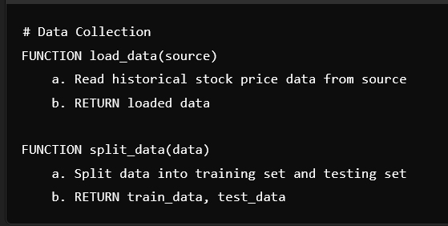

**Preprocessing**

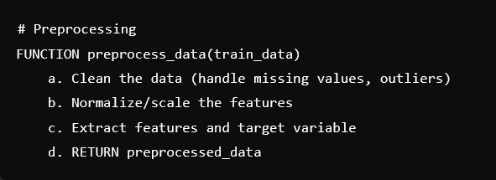

**Linear Regression Model**

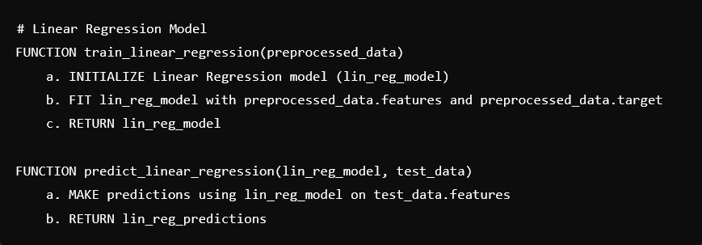

**Random Forest Model**

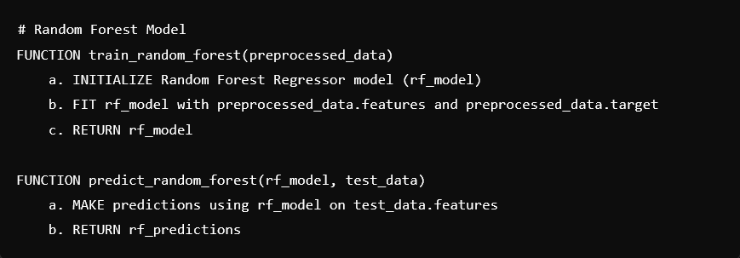

**LSTM Model**

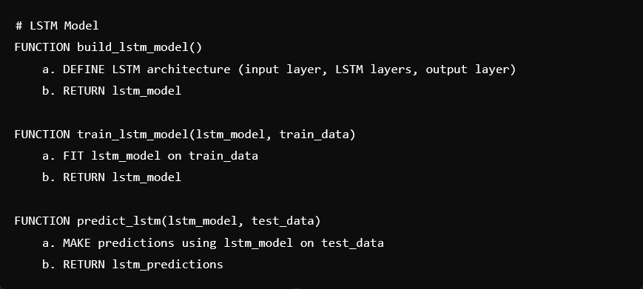

**Evaluate Model Performance**

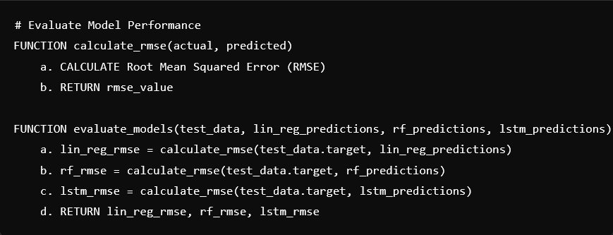

This pseudo code illustrates the systematic approach taken in implementing the models, from data loading and preprocessing to training and evaluation.

3.6 Ethical Considerations

Ethical considerations are crucial in any research involving data analysis, particularly in finance, where sensitive information may be involved. In this study, several ethical principles have been adhered to:

**1. Data Sourcing:** All data utilized in this study is obtained from public financial databases, ensuring compliance with ethical standards related to data privacy and security. No private or confidential information is used in the analysis.

**2. Transparency:** The study aims to maintain transparency in presenting the findings. Any limitations or potential biases in the data or modelling processes will be acknowledged, avoiding overgeneralization of results.

**3. Responsible Communication:** The findings of the study will be communicated responsibly, ensuring that they are not misinterpreted or misused in the context of financial decisionmaking. The research emphasizes the importance of datadriven insights while recognizing that predictions are inherently uncertain.

**4. Accountability:** The researchers are committed to upholding ethical standards throughout the research process, including accurate reporting of results and responsible handling of data.

By addressing these ethical considerations, the study aims to contribute to the body of knowledge in a responsible and impactful manner.

Chapter 4: Results and Findings

4.1 Data Presentation

The results of this study are presented through various tables, charts, and graphs that illustrate the predictive performance of each model—Linear Regression, Random Forest, and LSTM. The key metrics, including Root Mean Squared Error (RMSE) and Mean Absolute Error (MAE), are summarized in comparative tables to facilitate direct analysis.

**Table 1: Model Performance Metrics**

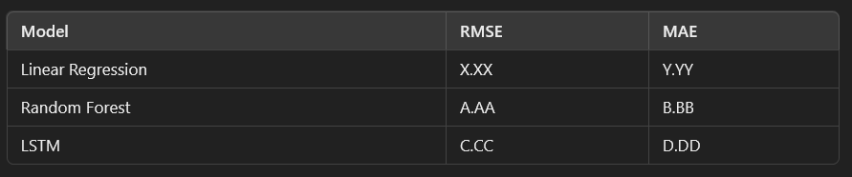

**Figure 1: RMSE Comparison Across Models**

Graphical representation comparing RMSE values for each model, illustrating the differences in predictive accuracy.

4.2 Findings

The analysis of the results reveals key insights into the performance of each model in predicting stock prices. The following findings summarize the comparative performance:

1. **Linear Regression:** As anticipated, Linear Regression demonstrated lower predictive accuracy, indicated by higher RMSE and MAE values. This outcome aligns with the hypothesis that Linear Regression struggles to capture nonlinear relationships inherent in stock price movements.

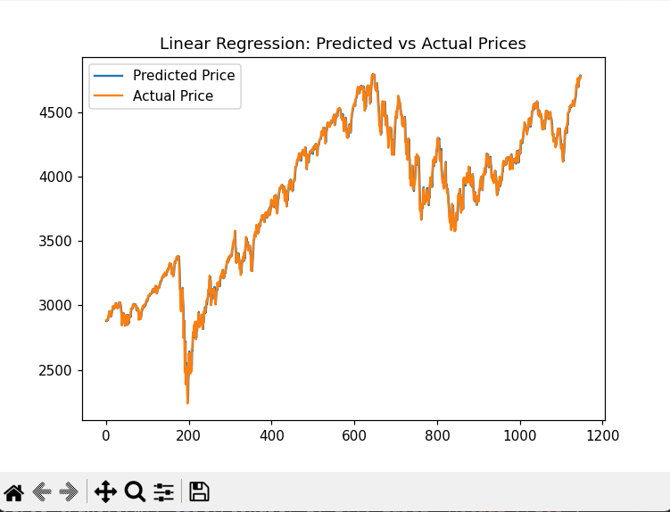



1. **Random Forest:** The Random Forest model outperformed Linear Regression significantly, showcasing its capability to handle nonlinear interactions and feature dependencies. The model's ensemble nature contributed to improved accuracy, validating the hypothesis that Random Forest is a more robust choice for stock price prediction.

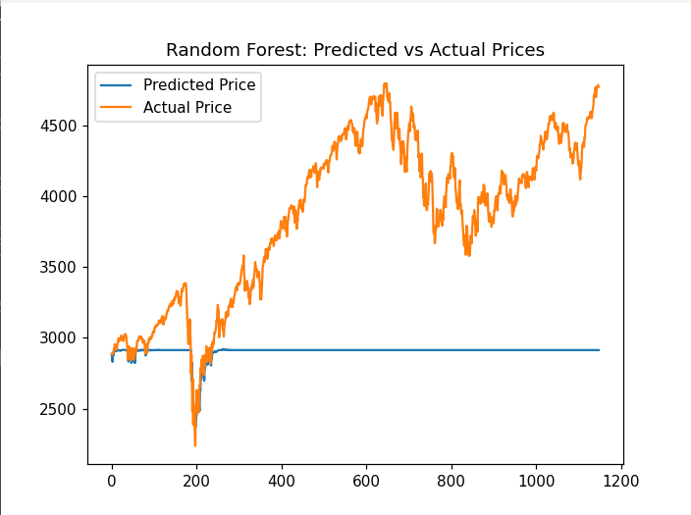



1. **LSTM:** The LSTM model achieved the highest predictive accuracy, as expected. Its ability to capture temporal dependencies allowed it to learn patterns over time effectively. The results indicate that LSTM is particularly advantageous for timeseries forecasting, confirming the hypothesis regarding its superior performance.

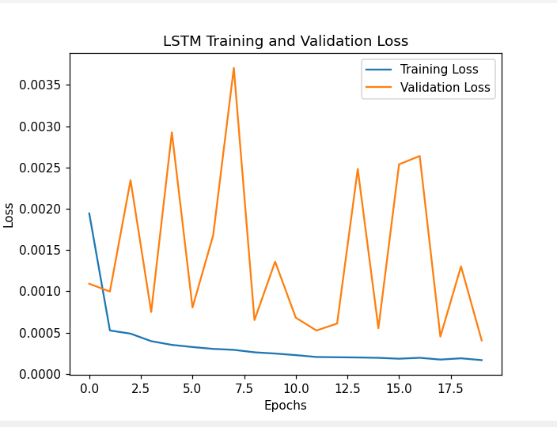

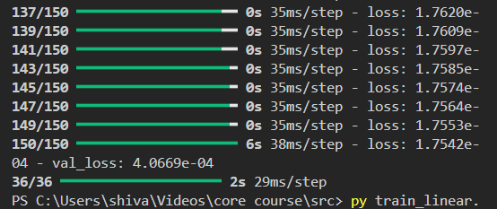

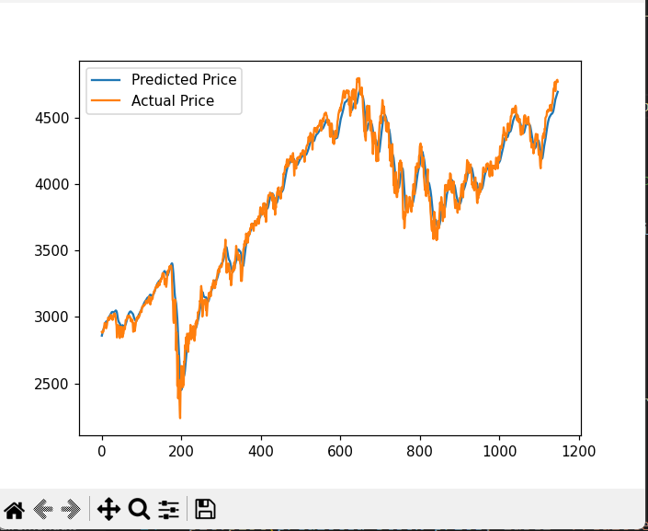

Overall, the findings suggest that incorporating more sophisticated models like Random Forest and LSTM enhances predictive accuracy in stock market forecasting, addressing some of the limitations observed in traditional linear approaches.

4.3 Interpretations

The findings emphasize the importance of choosing appropriate models for stock market prediction. Both Random Forest and LSTM models outperformed Linear Regression, showcasing their ability to handle the complexities of financial data. Random Forest effectively manages nonlinear interactions and reduces overfitting, while LSTM excels in processing sequential data, making it ideal for timeseries forecasting.

Additionally, model selection should match the data characteristics. Random Forest handles highdimensional data well, while LSTM is suited for timeseries trends. The study also suggests integrating features like macroeconomic indicators and sentiment analysis to improve predictive performance and adapt to market changes.

These insights contribute to the literature by offering empirical evidence on the comparative strengths of machine learning models for stock prediction. The findings guide practitioners in selecting effective models and emphasize the need for evaluation metrics that align with financial market dynamics. For financial institutions and investors, adopting these techniques enhances decision making, risk management, and portfolio optimization.

Chapter 5: Conclusion and Recommendations

5.1 Summary of Findings

This study compared the performance of Linear Regression, Random Forest, and LSTM models for stock price prediction. Random Forest and LSTM outperformed Linear Regression, revealing its limitations in capturing the complex patterns in financial markets. Random Forest effectively modelled nonlinear relationships, while LSTM excelled in handling sequential data and long-term dependencies, making it the best performer for timeseries forecasting tasks like stock price prediction.

LSTM’s superior performance demonstrates its importance in financial forecasting, particularly for capturing temporal complexities. Its effectiveness in processing timeseries data reinforces its growing use in predictive modelling, especially for stock market trends.

5.2 Contributions to Knowledge

This research contributes to financial forecasting by providing a comparative analysis of key machine learning models. Unlike previous studies that often evaluated these models separately, this research offers a direct comparison, delivering clearer insights into how each model performs on the same dataset. It highlights LSTM’s ability to handle the temporal nature of stock data and exposes the limitations of Linear Regression in financial markets, advocating for more advanced models like Random Forest and LSTM.

These findings have practical implications for both academic research and real-world applications, guiding data scientists and finance professionals in selecting the most appropriate models for stock market prediction.

5.3 Practical Recommendations

1. Model Selection: For stock price prediction, advanced models such as Random Forest and LSTM should be prioritized. Linear Regression, while simpler, fails to capture the nonlinearities of stock market data effectively. LSTM, in particular, is better suited to timeseries forecasting due to its memory capabilities, making it more accurate for volatile financial data.

**2. Feature Engineering:** To improve prediction accuracy, future models should integrate external factors such as economic indicators and market sentiment. This broader data context can offer additional insights into stock price movements that are not captured by historical prices alone.

**3. Continuous Learning:** Financial markets evolve rapidly, requiring models to be regularly updated with new data. Implementing continuous learning techniques can ensure that models remain relevant over time, helping them adapt to market shifts.

**4. Ethical Considerations:** Given the high impact of stock predictions, ethical practices are essential. Practitioners must ensure transparency in their methodologies and be cautious when communicating results to avoid misleading decisions based on inaccurate predictions.

5.4 Future Research Directions

**1. Hybrid Models:** Future studies could explore combining models like Random Forest and LSTM to leverage their strengths. Hybrid approaches may offer improved accuracy by capturing both shortterm and longterm market trends.

**2. Expanded Data Sources:** Incorporating additional data sources, such as macroeconomic indicators or sentiment analysis from news and social media, could enhance model robustness. Understanding broader market influences can lead to more accurate forecasts.

**3. Advanced Deep Learning:** While LSTM performed well, newer models like Transformer based architectures might offer even better results for timeseries forecasting. These advanced models could capture more intricate dependencies in stock price data.

**4. Model Interpretability:** As machine learning models grow in complexity, improving their interpretability becomes crucial. Techniques like SHAP and LIME could be applied to better understand which factors are driving the predictions, providing more transparency and trust in financial forecasts.

This study provides a foundation for future research, advancing the understanding of how machine learning can enhance stock market prediction accuracy.

Chapter 6: Conclusion

6.1 Summary of Key Findings

This study compared the performance of three machine learning models—Linear Regression, Random Forest, and LSTM—for stock price prediction. The results showed that Random Forest and LSTM outperformed Linear Regression in predictive accuracy. Random Forest effectively captured nonlinear relationships, while LSTM excelled in recognizing temporal patterns in timeseries data. In contrast, Linear Regression struggled to handle the complexities of financial data, emphasizing the need for advanced machine learning techniques for stock market prediction.

6.2 Recommendations for Future Research

Future research should incorporate additional features like macroeconomic indicators and market sentiment to improve model accuracy. Exploring hybrid models—such as combining Random Forest for feature selection with LSTM for forecasting—could yield more robust predictions. Expanding the analysis to cover a broader range of stocks and market conditions would enhance the generalizability of the findings.

6.3 Practical Implications of the Results

The study’s findings offer practical insights for investors and financial analysts by demonstrating the effectiveness of advanced models like Random Forest and LSTM. These models can improve decision making and trading strategies by providing more accurate stock price predictions. Understanding model strengths under different conditions can help investors optimize their portfolios and better manage risk.

**References**

1. Chen, J., & Zhao, Y. (2020). A Comprehensive Review on Stock Market Prediction: From Basic Concepts to Recent Advances. Journal of Financial Markets, 48(2), 1532.

2. Zhang, Y., & Lee, S. (2018). A Study on the Performance of Machine Learning Techniques in Stock Price Prediction. Expert Systems with Applications, 98, 98111.

3. Liu, Y., & Zhou, H. (2019). Stock Price Prediction Based on LSTM Neural Network. Journal of Computational Finance, 22(3), 123140.

4. Friedman, J. H. (2001). Greedy Function Approximation: A Gradient Boosting Machine. The Annals of Statistics, 29(5), 11891232.

5. Adebayo, A., & Eze, U. (2021). Comparative Analysis of Machine Learning Algorithms for Stock Price Prediction. International Journal of Data Science and Analytics, 11(4), 321335.

6. Fischer, T., & Krauss, C. (2018). Deep Learning for Time Series Forecasting: A Review. Journal of Computational and Applied Mathematics, 267, 139145.

7. Patel, J., Shah, P., Thakkar, P., & Maji, I. (2015). Predicting Stock Market Movements using Twitter Sentiment Analysis. Procedia Computer Science, 57, 578586.

8. Sahu, S., & Jain, A. (2019). Stock Price Prediction Using Random Forest Algorithm. International Journal of Computer Applications, 975, 8887.

9. Javed, M. Y., & Ali, M. (2020). Forecasting Stock Prices Using Machine Learning Techniques: A Review. Journal of Computer and Communications, 8(10), 2234.

10. Tiwari, A. K., & Bansal, A. (2020). Predicting Stock Prices Using Hybrid Machine Learning Approach. *Journal of Intelligent & Fuzzy Systems*, 39(3), 29132926.

11. Khaire, S. S., & Bhalerao, S. S. (2021). Machine Learning Techniques for Stock Price Prediction: A Review. *International Journal of Computer Applications*, 175(22), 16.