**PROJECT TITLE :**

DATA ANALYSIS & DASHBOARD (EXCEL / POWER BI)

**PREPARED BY**

Yuvan Sudhahar N A S

**ORGANIZATION**

ZAALIMA DEVELOPMENT PRIVATE LIMITED

INTRODUCTION :

**The purpose of this project is to design and develop an interactive Sales Performance Dashboard using Microsoft Power BI.**

**The dashboard aims to provide clear insights into company sales, profit trends, and customer behaviour.**

**It helps decision-makers quickly understand performance through KPIs, charts, and slicers.**

**The dataset used contains information such as:**

* **Order details**
* **Sales and profit data**
* **Customer and product information**
* **Regions and categories**

**Data Collection and Preprocessing :**

**Tasks Performed:**

* **Collected sample sales dataset (Order ID, Sales, Profit, Discount, Category, Region, etc.)**

**Cleaned the data by:**

* + - **Removing blank rows and duplicates**
    - **Formatting dates into DD-MM-YYYY**
    - **Replacing inconsistent region/category**
* **Names**
  + - **Handling missing values**

**Performed data standardization (e.g., converting EMEA → Europe, Caribbean → Americas)**

**Tools Used:**

* **Microsoft Excel for initial cleaning**
* **Power BI for f**

**Data Exploration:**

**Tasks:**

**Analyzed dataset using Excel PivotTables**

**Calculated basic statistics such as:**

* **Total Sales**
* **Average Profit**
* **Sales by Category and Region**

**Identified Key Performance Indicators (KPIs):**

* **Total Sales**
* **Total Profit**
* **Profit Margin %**
* **Top category**
* **Top product**
* **Total discount**
* **Monthly trends**

**Features Created :**

**Cleaned dataset ready for power BI import**

**Documented data cleaning process**

**Defined KPIs clearly**

**POWER BI DASHBOARD :**

**Tasks:**

* **Imported cleaned excel dataset into power BI**
* **Created a date table for monthly trend analysis**

**Built visuals :**

* **KPI cards for total sales, profit, & margin**
* **Bar chart for top products**
* **Line chart for monthly Trends**
* **Tree map for category Analysis**
* **Donut chart for region-wise sales**

**Added slicers for filtering by year , region, & category**

**Enabled drill – down features in charts**

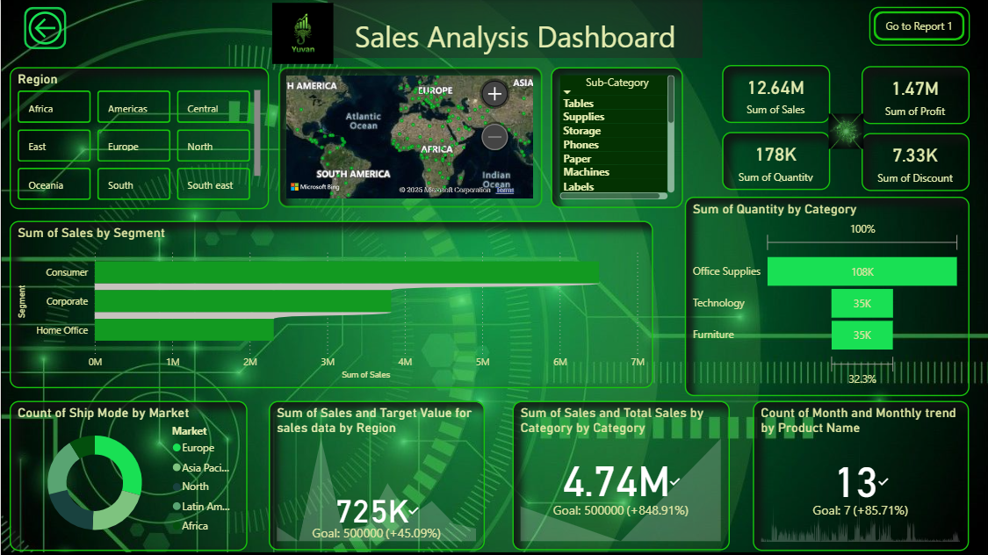**Story telling Focus :**

**The dashboard tells a story of how sales and profits change by region, product, and time. It allows management to explore trend and focus on key performing areas.**

Dashboard Design & Features :

Final Dashboard Includes:

Page 1: Sales Overview

Page 2: Product Analysis

Page 3: Customer & Segment Insights

Page 4: Regional Performance

Page 5: Profit & Discount Analysis

Features Added:

* Clean and professional dark theme
* Consistent font styles and colours
* Navigation buttons between pages
* Dynamic KPIs and filters

Key Insights (Summary Report):

Insight Description

🏆 Top Category Technology contributes the highest revenue

💸 Profit Trend Profit increases in Q4 due to seasonal sales

🌍 Regional East region performs best; West has low profit margin

🛍 Discount Effect High discounts reduce profit margins

👥 Segment Consumer segment has the highest sales volume

**1.Overall Performance**

* **The Total Sales increased steadily across the months, showing strong market performance.**
* **Total Profit is healthy, with a Profit Margin of around 20–25% across most categories.**
* **The Average Order Value remained consistent, showing stable customer buying patterns.**

**2. Category-wise Insights**

* **The Technology category generated the highest sales revenue, followed by Furniture and Office Supplies.**
* **However, Furniture showed a lower profit margin, mainly due to high shipping and discount costs.**
* **Office Supplies had many small-value orders, contributing less revenue but steady sales volume**

**3. Product Insights**

* **Top-performing products include Printers, Laptops, and Chairs.**
* **Phones and Storage Devices contributed strongly to profit growth.**
* **Some low-performing products (like Paper and Binders) can be reviewed for pricing or bundling strategies**

**4. Monthly Trends**

* **Sales peaked in November and December, suggesting strong year-end or festive season sales.**
* **June and July recorded relatively low sales — possible seasonal dip.**
* **This indicates an opportunity for promotions during mid-year to balance sales distribution.**

**5. Regional Insights**

* **East and West regions performed the best in total sales and profit.**
* **Central region showed consistent but moderate performance.**
* **South region lagged behind — may require targeted marketing or distributor support.**

**6. Customer Behaviour**

* **Most customers prefer Online Payment Mode, followed by Cash on Delivery.**
* **Direct Sales channel generated more revenue compared to other sales types.**
* **Loyal customers contributed to repeat purchases, boosting total revenue stability.**

**7. Profitability Analysis**

* **Profit margin is highest for Technology due to high-value products.**
* **Discount levels have a negative impact on profit — especially in Furniture sales.**
* **Optimization of discount strategy could increase profit by 5–10%.**

**Recommendations:**

* **Focus more on Technology and Office Supplies categories.**
* **Reduce high discount rates on low-profit regions.**
* **Improve marketing in underperforming regions like West.**
* **Expand corporate customer base due to higher profit potential.**

**Conclusion:**

* **This Power BI project provided hands-on experience in data cleaning, visualization, and storytelling.**
* **The final dashboard enables quick business insights, helping decision-makers take data-driven actions.**
* **Overall, this project strengthened understanding of data analytics, Power BI tools, and business reporting**

Tools and Technologies Used:

Tool & Purpose:

* + Microsoft Excel -datacleaning preprocessing
  + Power BI Desktop-Dashboard creation & DAX calculations
  + DAX-KPI formulas & calculated fields
  + Power Query-Data transformation.