9. ReactJS-HOL

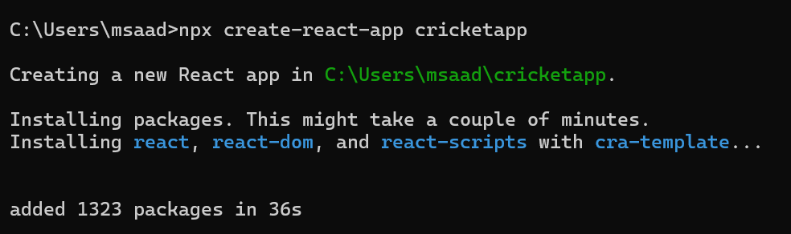
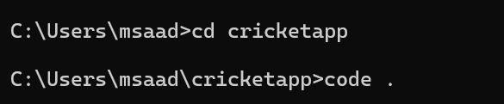

Folder Structure:
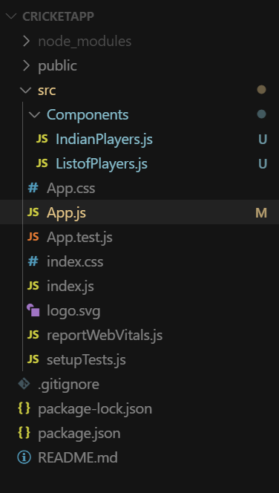

ListofPlayers.js
import React from 'react';

const ListofPlayers = () => {
const players = [
{ name: "Virat Kohli", score: 100 },
{ name: "Rohit Sharma", score: 85 },
{ name: "Hardik Pandya", score: 40 },
{ name: "KL Rahul", score: 75 },
{ name: "Rishabh Pant", score: 60 },
{ name: "Shreyas Iyer", score: 90 },
{ name: "Shubman Gill", score: 50 },
{ name: "Suryakumar Yadav", score: 95 },
{ name: "Jasprit Bumrah", score: 35 },
{ name: "Mohammed Siraj", score: 70 },
{ name: "Ravindra Jadeja", score: 45 }
];

const filteredPlayers = players.filter(player => player.score >= 70);
return (
<div>
<h2>Players with Score ≥ 70</h2>
<ul>
{filteredPlayers.map((player, index) => (
<li key={index}>{player.name} - {player.score}</li>
))}
</ul>
</div>
);
};
export default ListofPlayers;
IndianPlayers.js
import React from 'react';
const IndianPlayers = () => {
const team = ["Virat", "Rohit", "Hardik", "Pant", "Bumrah", "Iyer"];

const [odd1, even1, odd2, even2, odd3, even3] = team;
const T20players = ["Kohli", "Surya", "Gill"];
const RanjiTrophyPlayers = ["Sarfaraz", "Shaw", "Ishan"];
const allPlayers = [...T20players, ...RanjiTrophyPlayers];
return (
<div>
<h2>Odd Team Players</h2>
<ul>
<li>{odd1}</li>
<li>{odd2}</li>
<li>{odd3}</li>
</ul>

<h2>Even Team Players</h2>
<ul>
<li>{even1}</li>
<li>{even2}</li>
<li>{even3}</li>
</ul>

<h2>All Players (Merged)</h2>
<ul>
{allPlayers.map((player, index) => (
<li key={index}>{player}</li>
))}
</ul>
</div>
);
};
export default IndianPlayers;

App.js
import React from 'react';
import ListofPlayers from './Components/ListofPlayers';
import IndianPlayers from './Components/IndianPlayers';

function App() {
const flag = true; // Change to false to switch view

return (
<div className="App">
{flag ? <ListofPlayers /> : <IndianPlayers />}
</div>
);
}
export default App;

Output:
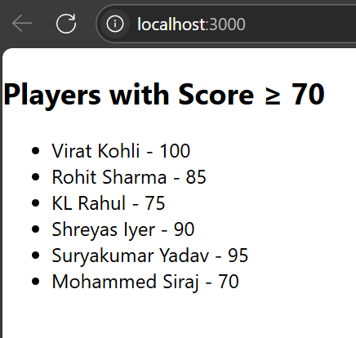

10. ReactJS-HOL
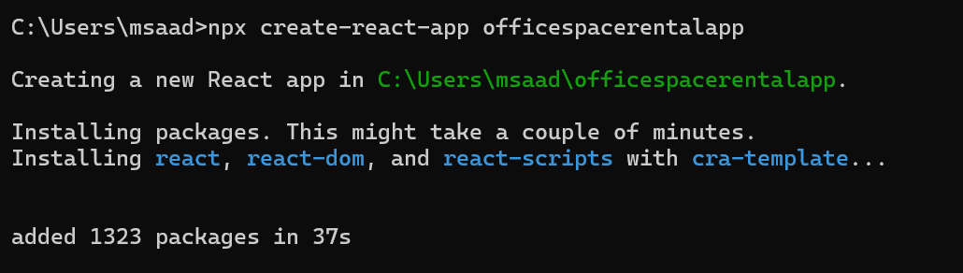
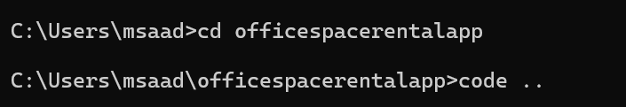

App.js
import React from 'react';

function App() {
// Heading element using JSX
const heading = <h1>Office Space Rentals</h1>;

// Office image URL (you can use any placeholder)
const imageUrl = "https://via.placeholder.com/300x150?text=Office+Space";

// Single office object
const office1 = {
name: "Indiranagar Workspace",
rent: 55000,
address: "1st Floor, ABC Building, Indiranagar, Bangalore"
};

// Array of office objects
const offices = [
{
name: "Koramangala Hub",
rent: 45000,
address: "2nd Floor, XYZ Towers, Koramangala, Bangalore"
},
{
name: "Whitefield Corporate Park",
rent: 75000,
address: "Tech Park, Whitefield, Bangalore"
},
{
name: "MG Road View Office",
rent: 60000,
address: "3rd Floor, MG Complex, Bangalore"
}
];

return (
<div style={{ padding: "20px", fontFamily: "Arial" }}>
{heading}

{/* Image element using JSX attribute */}
<img src={imageUrl} alt="Office Space" style={{ width: "300px", height: "150px", marginBottom: "20px" }} />

{/* Display single office */}
<h2>{office1.name}</h2>
<p>
<strong>Rent:</strong>{' '}
<span style={{ color: office1.rent < 60000 ? "red" : "green" }}>
₹{office1.rent}
</span>
</p>
<p><strong>Address:</strong> {office1.address}</p>

<hr />

{/* Loop through office list */}
<h2>Available Office Spaces:</h2>
{offices.map((office, index) => (
<div key={index} style={{ border: "1px solid #ccc", padding: "10px", margin: "10px 0", borderRadius: "8px" }}>
<h3>{office.name}</h3>
<p>
<strong>Rent:</strong>{' '}
<span style={{ color: office.rent < 60000 ? "red" : "green" }}>
₹{office.rent}
</span>
</p>
<p><strong>Address:</strong> {office.address}</p>
</div>
))}
</div>
);
}

export default App;

Output:
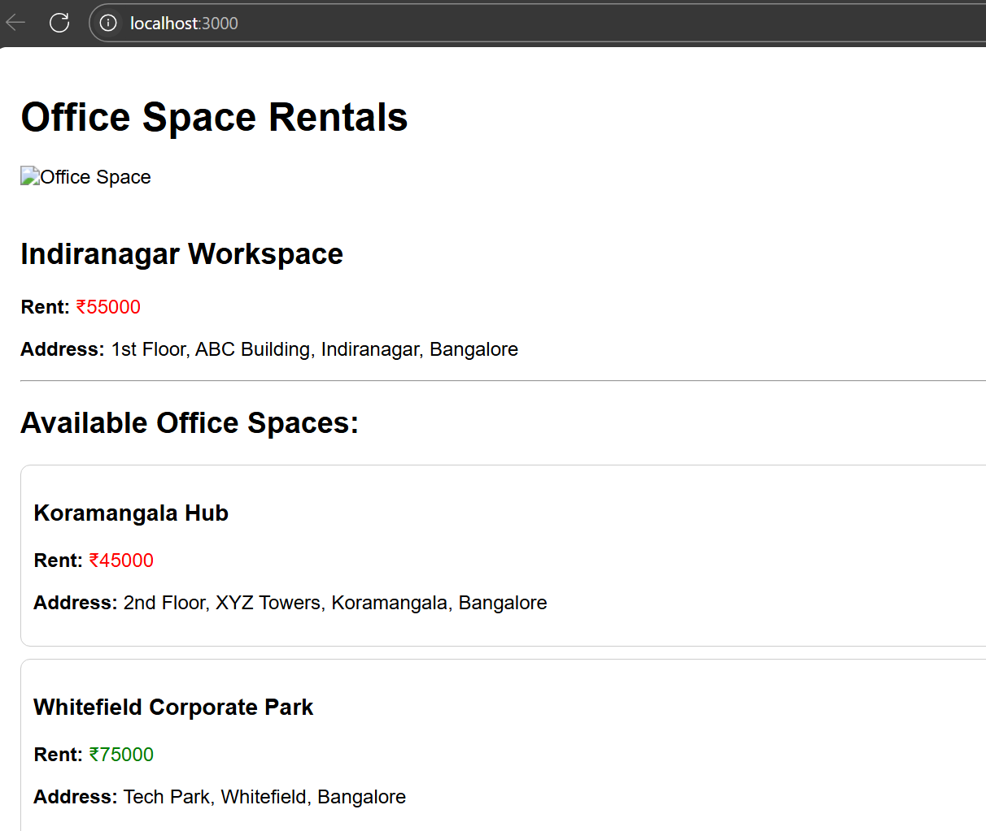

11. ReactJS-HOL
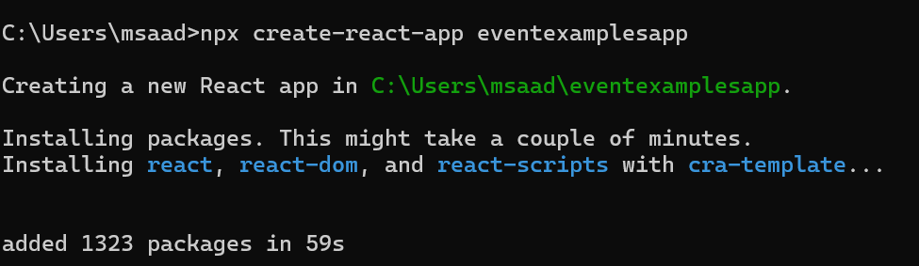
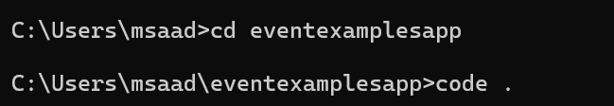

Folder Structure:
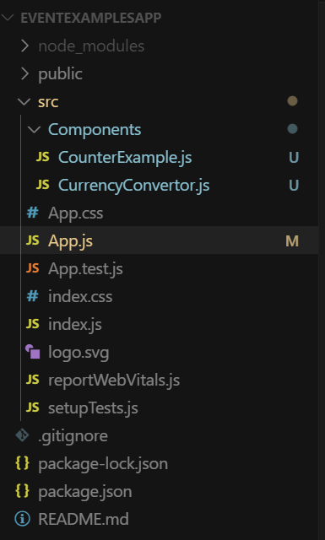

CounterExample.js
import React, { Component } from 'react';

class CounterExample extends Component {
constructor(props) {
super(props);
this.state = {
count: 0
};
}

increment = () => {
this.setState({ count: this.state.count + 1 });
this.sayHello();
};

decrement = () => {
this.setState({ count: this.state.count - 1 });
};

sayHello = () => {
alert("Hello! You clicked Increment.");
};

sayWelcome = (msg) => {
alert(`Welcome Message: ${msg}`);
};

handleSyntheticEvent = (e) => {
e.preventDefault(); // Synthetic event usage
alert("I was clicked (Synthetic Event)");
};

render() {
return (
<div>
<h2>Counter: {this.state.count}</h2>
<button onClick={this.increment}>Increment</button>
<button onClick={this.decrement}>Decrement</button>
<br /><br />
<button onClick={() => this.sayWelcome("Welcome to the Event Example!")}>Say Welcome</button>
<br /><br />
<button onClick={this.handleSyntheticEvent}>Synthetic Click</button>
</div>
);
}
}

export default CounterExample;

CurrencyConverter.js
import React, { Component } from 'react';

class CurrencyConvertor extends Component {
constructor(props) {
super(props);
this.state = {
rupees: '',
euros: ''
};
}

handleChange = (e) => {
this.setState({ rupees: e.target.value });
};

handleSubmit = (e) => {
e.preventDefault();
const euroValue = (parseFloat(this.state.rupees) / 90).toFixed(2); // Approx 1 Euro = 90 INR
this.setState({ euros: euroValue });
};

render() {
return (
<div>
<h2>Currency Converter</h2>
<form onSubmit={this.handleSubmit}>
<label>Indian Rupees: </label>
<input type="number" value={this.state.rupees} onChange={this.handleChange} />
<button type="submit">Convert</button>
</form>
{this.state.euros && (
<p>Equivalent in Euros: €{this.state.euros}</p>
)}
</div>
);
}
}

export default CurrencyConvertor;

App.js
import React from 'react';
import CounterExample from './Components/CounterExample';
import CurrencyConvertor from './Components/CurrencyConvertor';

function App() {
return (
<div className="App" style={{ padding: "20px" }}>
<h1>React Event Examples</h1>
<CounterExample />
<hr />
<CurrencyConvertor />
</div>
);
}

export default App;

Output:
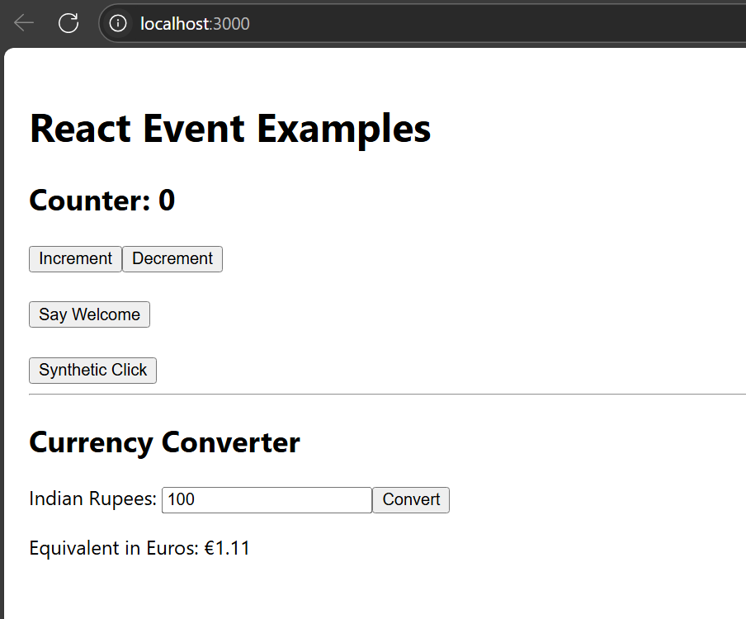

12. ReactJS-HOL
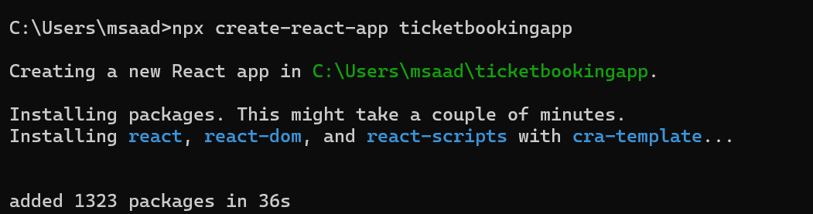
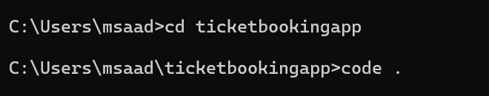

FolderStructure
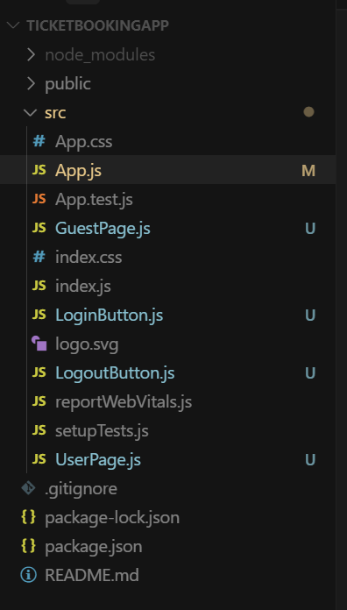

Guestpage.js
function GuestPage() {
return <h2>Welcome Guest! Browse flights below.</h2>;
}
export default GuestPage;

UserPage.js
function UserPage() {
return <h2>Welcome User! You can now book your tickets.</h2>;
}
export default UserPage;

LoginButton.js
function LoginButton({ onClick }) {
return <button onClick={onClick}>Login</button>;
}
export default LoginButton;

LogoutButton.js
function LogoutButton({ onClick }) {
return <button onClick={onClick}>Logout</button>;
}
export default LogoutButton;

App.js
import React, { useState } from 'react';
import GuestPage from './GuestPage';
import UserPage from './UserPage';
import LoginButton from './LoginButton';
import LogoutButton from './LogoutButton';

function App() {
const [isLoggedIn, setIsLoggedIn] = useState(false);

const handleLogin = () => setIsLoggedIn(true);
const handleLogout = () => setIsLoggedIn(false);

let content;
let button;

if (isLoggedIn) {
content = <UserPage />;
button = <LogoutButton onClick={handleLogout} />;
} else {
content = <GuestPage />;
button = <LoginButton onClick={handleLogin} />;
}

return (
<div>
<h1>Flight Ticket Booking App</h1>
{button}
{content}
</div>
);
}
export default App;

Output:
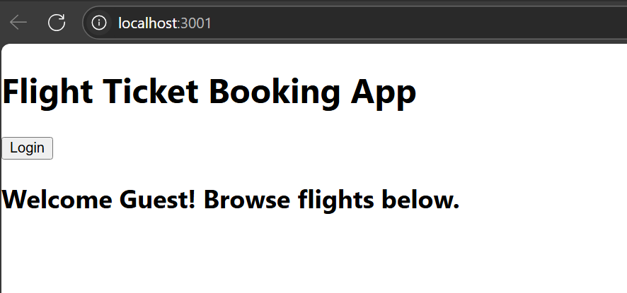

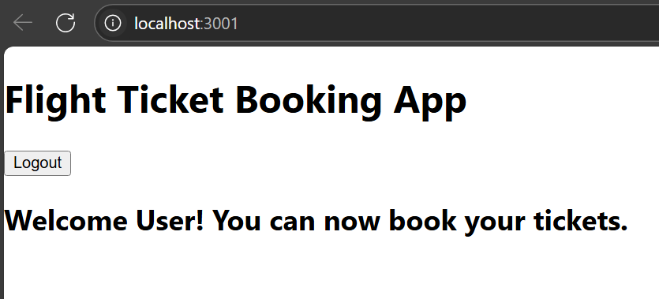

13. ReactJS-HOL
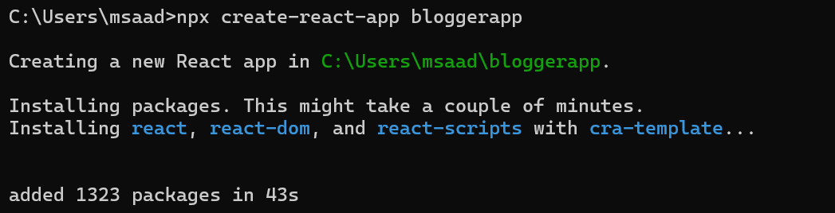
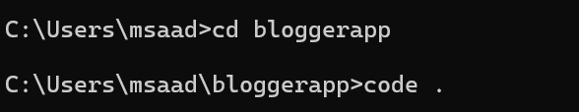

Folder Structure:
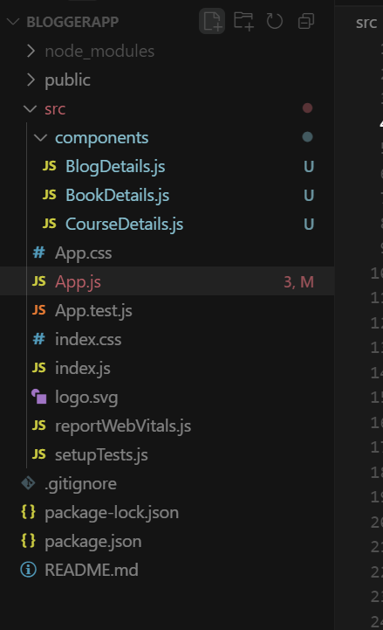

BookDetails.js
function BookDetails() {
return (
<div>
<h2>Book Details</h2>
<p><strong>Master React</strong></p>
<p>670</p>
<p><strong>Deep Dive into Angular 11</strong></p>
<p>800</p>
<p><strong>Mongo Essentials</strong></p>
<p>450</p>
</div>
);
}
export default BookDetails;

BlogDetails.js
function BlogDetails() {
return (
<div>
<h2>Blog Details</h2>
<p><strong>React Learning</strong></p>
<p><em>Stephen Biz</em></p>
<p>Welcome to learning React!</p>
<p><strong>Installation</strong></p>
<p><em>Schwezdenier</em></p>
<p>You can install React from npm.</p>
</div>
);
}

export default BlogDetails;
CourseDetails.js
function CourseDetails() {
return (
<div>
<h2>Course Details</h2>
<p><strong>Angular</strong></p>
<p>4/5/2021</p>
<p><strong>React</strong></p>
<p>6/3/2020</p>
</div>
);
}

export default CourseDetails;

App.js
import React from 'react';
import BookDetails from './components/BookDetails';
import BlogDetails from './components/BlogDetails';
import CourseDetails from './components/CourseDetails';

function App() {
return (
<div style={{ padding: '20px' }}>
<h1 style={{ textAlign: 'center' }}>Blogger App</h1>

<div style={{ display: 'flex', justifyContent: 'space-around', marginTop: '40px' }}>
<div style={{ borderRight: '3px solid green', paddingRight: '20px' }}>
<CourseDetails />
</div>

<div style={{ borderRight: '3px solid green', paddingRight: '20px', paddingLeft: '20px' }}>
<BookDetails />
</div>

<div style={{ paddingLeft: '20px' }}>
<BlogDetails />
</div>
</div>
</div>
);
}
export default App;

Output:

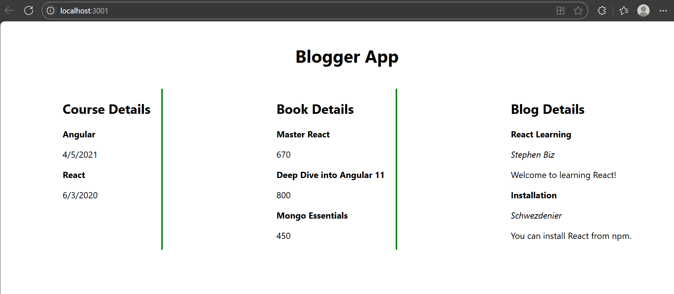

________________________________ThankYou____________________

