Objectives
- Explain React components
- Identify the differences between components and JavaScript functions
- Identify the types of components
- Explain class component
- Explain function component
- Define component constructor
- Define render() function

In this hands-on lab:
- Create a class component
- Create multiple components
- Render a component

Create a react app for Student Management Portal named StudentApp and create a component named Home which will display the Message “Welcome to the Home page of Student Management Portal”. Create another component named About and display the Message “Welcome to the About page of the Student Management Portal”. Create a third component named Contact and display the Message “Welcome to the Contact page of the Student Management Portal”. Call all the three components.

- Create a React project named “StudentApp” type the following command in terminal of Visual studio:

- Create a new folder under Src folder with the name “Components”. Add a new file named “Home.js”

- Type the following code in Home.js

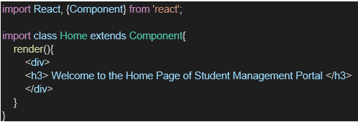

- Under Src folder add another file named “About.js”

- Repeat the same steps for Creating “About” and “Contact” component by adding a new file as ”About.js”, “Contact.js” under “Src” folder and edit the code as mentioned for “Home” Component.

- Edit the App.js to invoke the Home, About and Contact component as follows:

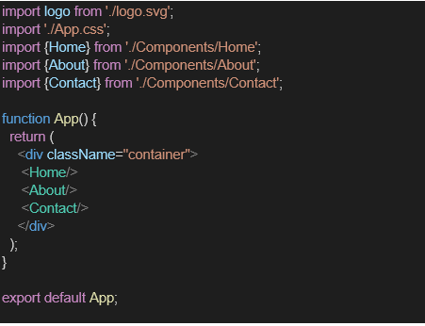

- In command Prompt, navigate into StudentApp and execute the code by typing the following command:

- Open browser and type “localhost:3000” in the address bar:

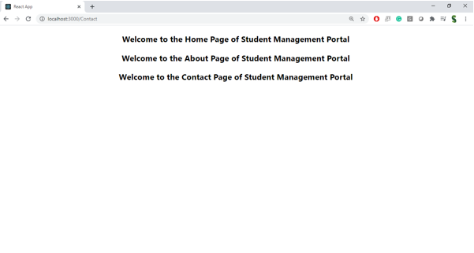

Explain React Components:
Components are the building blocks of a React application.
They allow you to split the UI into independent, reusable pieces.

Differences Between Components and JavaScript Functions:
Feature | React Components | JavaScript Functions
Purpose | Build UI in React | Perform logic or return values
Return | JSX (UI markup) | Data or values
Lifecycle Methods | Available (in class components) | Not available
Integration with React | Can maintain state, props, and render views | Cannot directly work with JSX or React state

Types of Components:
Class Components – Use ES6 classes, support lifecycle methods.
Function Components – Simpler, use hooks for state/lifecycle.

Explain Class Component:
A class that extends React.Component.
Must have a render() method that returns JSX.

class Home extends React.Component {
render() {
return <h1>Welcome to Home</h1>;
}
}

Explain Function Component:
A simple JavaScript function that returns JSX.
Can use React Hooks like useState, useEffect.
function Home() {
return <h1>Welcome to Home</h1>;
}

Define Component Constructor:
Special method in class component used for initializing state and binding methods.
constructor(props) {
super(props);
this.state = { name: 'Student' };
}

Define render() Function:
Used inside class components.
Must return JSX content to be displayed.

