Objectives
- Explain the need and Benefits of component life cycle
- Identify various life cycle hook methods
- List the sequence of steps in rendering a component

In this hands-on lab:
- Implement componentDidMount() hook
- Implementing componentDidCatch() life cycle hook.

- Create a new react application using create-react-app tool with the name as “blogapp”
- Open the application using VS Code
- Create a new file named as Post.js in src folder with following properties

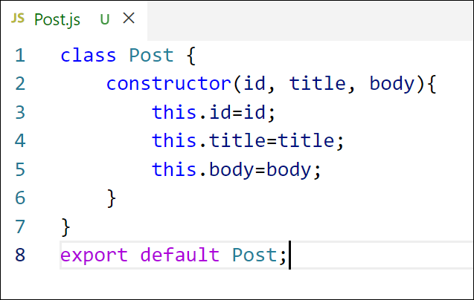
Figure 2: Post class
- Create a new class based component named as Posts inside Posts.js file

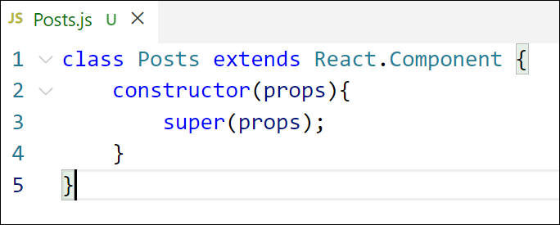
Figure 3: Posts Component

- Initialize the component with a list of Post in state of the component using the constructor

- Create a new method in component with the name as loadPosts() which will be responsible for using Fetch API and assign it to the component state created earlier. To get the posts use the url (https://jsonplaceholder.typicode.com/posts)

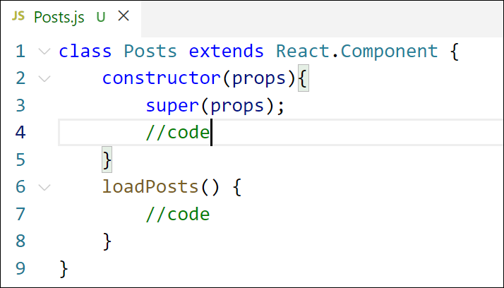
Figure 4: loadPosts() method
- Implement the componentDidMount() hook to make calls to loadPosts() which will fetch the posts

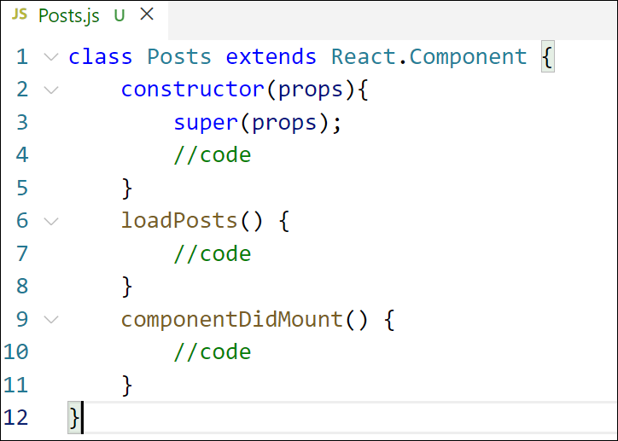
Figure 5: componentDidMount() hook
- Implement the render() which will display the title and post of posts in html page using heading and paragraphs respectively.
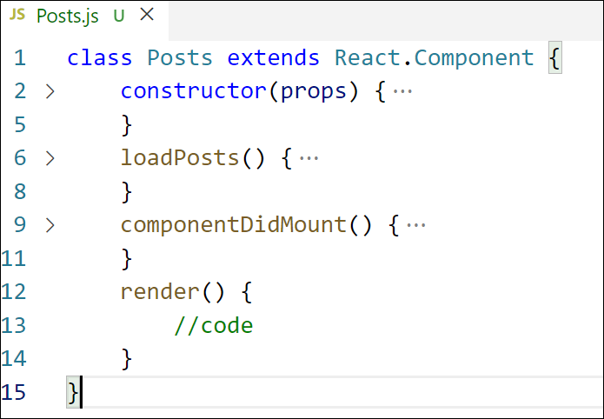
Figure 6: render() method

- Define a componentDidCatch() method which will be responsible for displaying any error happing in the component as alert messages.

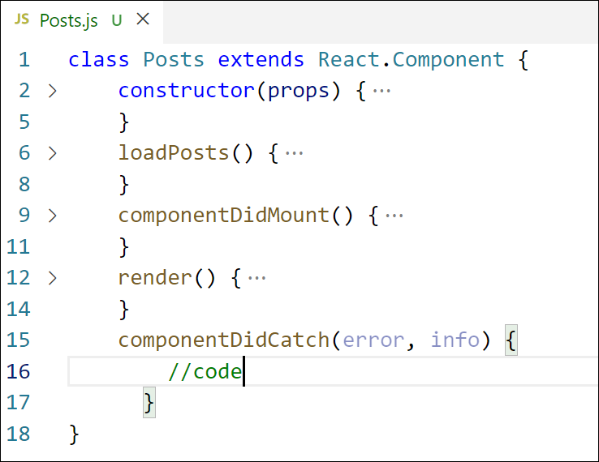
Figure 7: componentDidCatch() hook
- Add the Posts component to App component.
- Build and Run the application using npm start command.

Need for Lifecycle Methods:
React components go through different phases (mounting, updating, unmounting). Lifecycle methods allow developers to hook into these phases to perform actions like:
Fetching data from APIs.
Managing DOM interactions.
Setting timers or intervals.
Performing cleanup tasks.

Benefits:
Controlled Component Behavior: You can control what happens at each stage of the component's life.
Data Fetching: Fetch external data when the component loads (componentDidMount).
Memory Management: Clean up listeners/timers during unmounting (componentWillUnmount).
Error Handling: Catch and handle runtime errors gracefully (componentDidCatch).
Optimization: Update only when necessary using methods like shouldComponentUpdate.

2. Identify Various Lifecycle Hook Methods
React lifecycle methods are mainly divided into 3 phases:

Mounting Phase (when component is created):
constructor()
static getDerivedStateFromProps()
render()
componentDidMount()

Updating Phase (when props/state changes):
static getDerivedStateFromProps()
shouldComponentUpdate()
render()
getSnapshotBeforeUpdate()
componentDidUpdate()

Unmounting Phase (when component is removed):
componentWillUnmount()

Error Handling Phase:
componentDidCatch(error, info)

3. List the Sequence of Steps in Rendering a Component

🧭 Component Lifecycle Execution Order:

Mounting (First render)
constructor()
getDerivedStateFromProps()
render()
componentDidMount()

Updating (Re-render on state/props change)
getDerivedStateFromProps()
shouldComponentUpdate()
render()
getSnapshotBeforeUpdate()
componentDidUpdate()

Unmounting
componentWillUnmount()

Error Handling (if something fails)
componentDidCatch(error, info)
