2. Microservices with API gateway

Creating Microservices for account and loan
In this hands on exercises, we will create two microservices for a bank. One microservice for handing accounts and one for handling loans.
Each microservice will be a specific independent Spring RESTful Webservice maven project having it's own pom.xml. The only difference is that, instead of having both account and loan as a single application, it is split into two different applications. These webservices will be a simple service without any backend connectivity.
Follow steps below to implement the two microservices:

Account Microservice
- Create folder with employee id in D: drive
- Create folder named 'microservices' in the new folder created in previous step. This folder will contain all the sample projects that we will create for learning microservices.
- Open https://start.spring.io/ in browser
- Enter form field values as specified below:
  - Group: com.cognizant
  - Artifact: account
- Select the following modules
  - Developer Tools > Spring Boot DevTools
  - Web > Spring Web
- Click generate and download the zip file
- Extract 'account' folder from the zip and place this folder in the 'microservices' folder created earlier
- Open command prompt in account folder and build using mvn clean package command
- Import this project in Eclipse and implement a controller method for getting account details based on account number. Refer specification below:
  - Method: GET
  - Endpoint: /accounts/{number}
  - Sample Response. Just a dummy response without any backend connectivity.

{ number: "00987987973432", type: "savings", balance: 234343 }

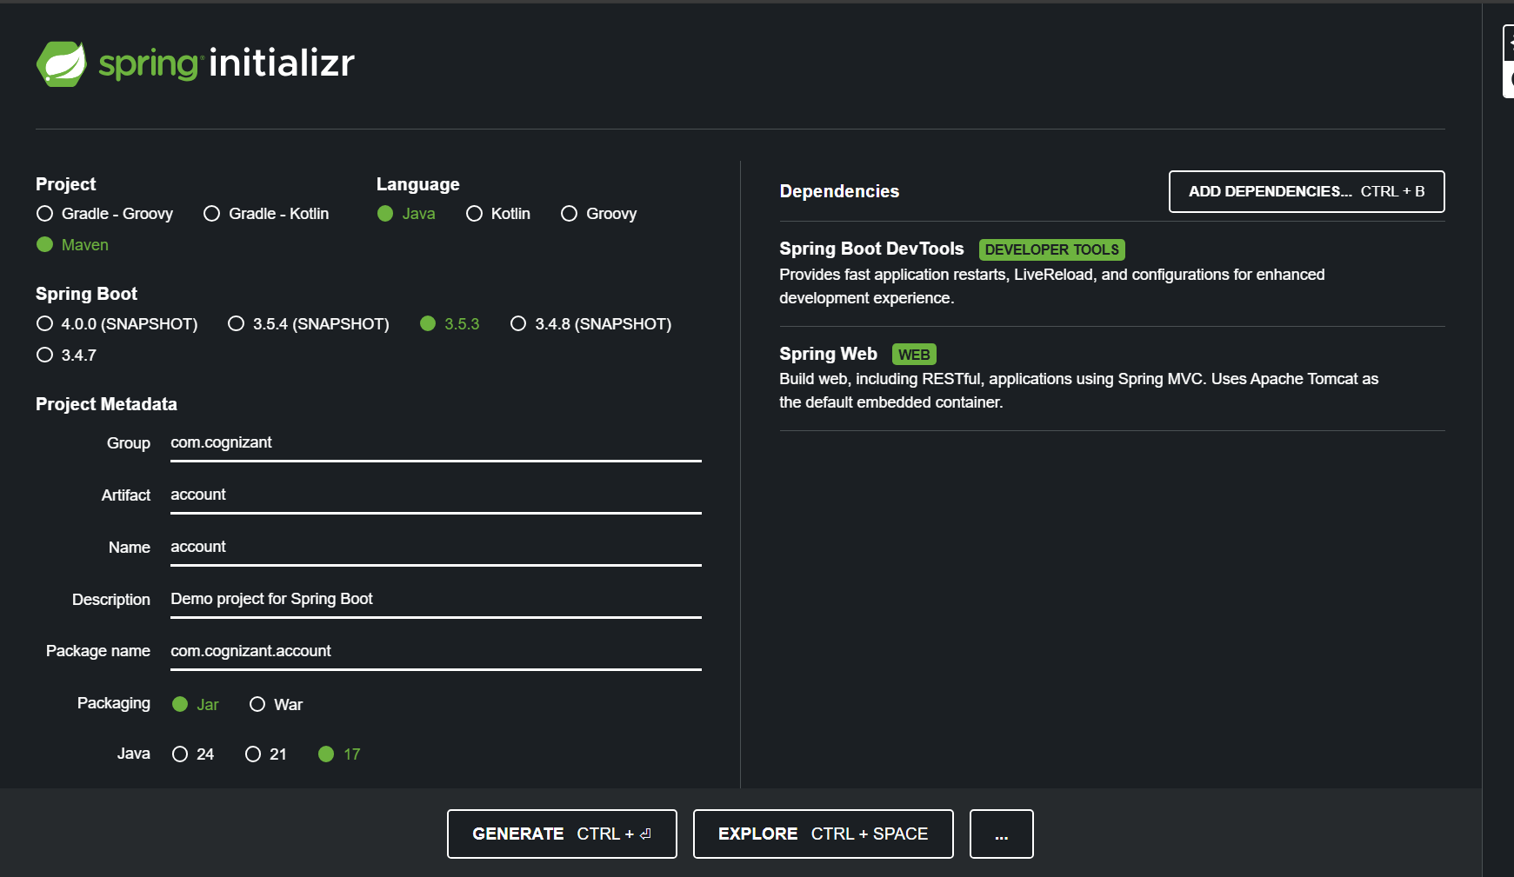

Create a folder in D drive
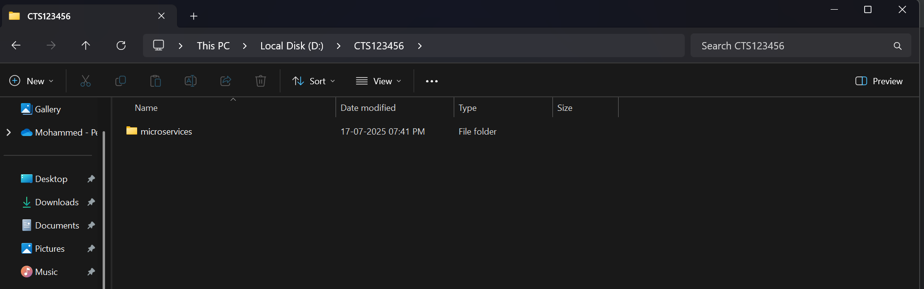

Create a folder named microservices inside the created folder

Then, extract the spring initializr file and paste it inside the “microservices” folder
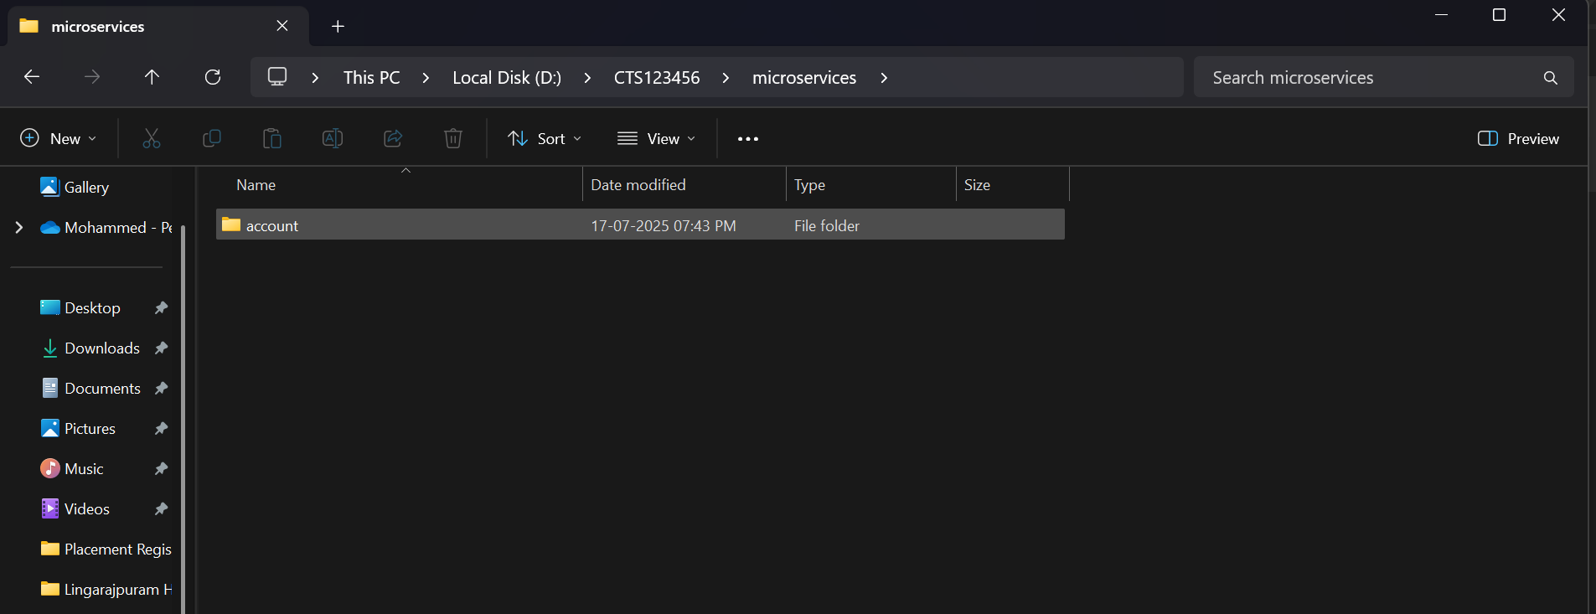

Folder Structure:
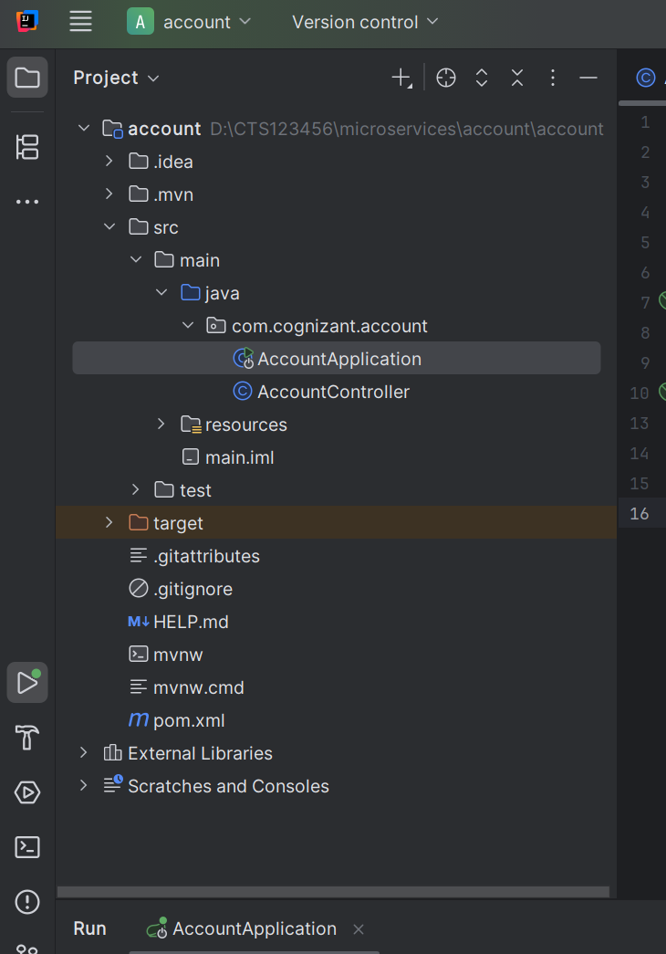

AccountController.java
package com.cognizant.account;
import org.springframework.web.bind.annotation.*;
@RestController
@RequestMapping("/accounts")
public class AccountController {
@GetMapping("/{number}")
public Account getAccount(@PathVariable String number) {
return new Account(number, "savings", 234343);
}
record Account(String number, String type, double balance) {}
}

Then, run AccountApplication.java and go to localhost:8080/accounts/123456
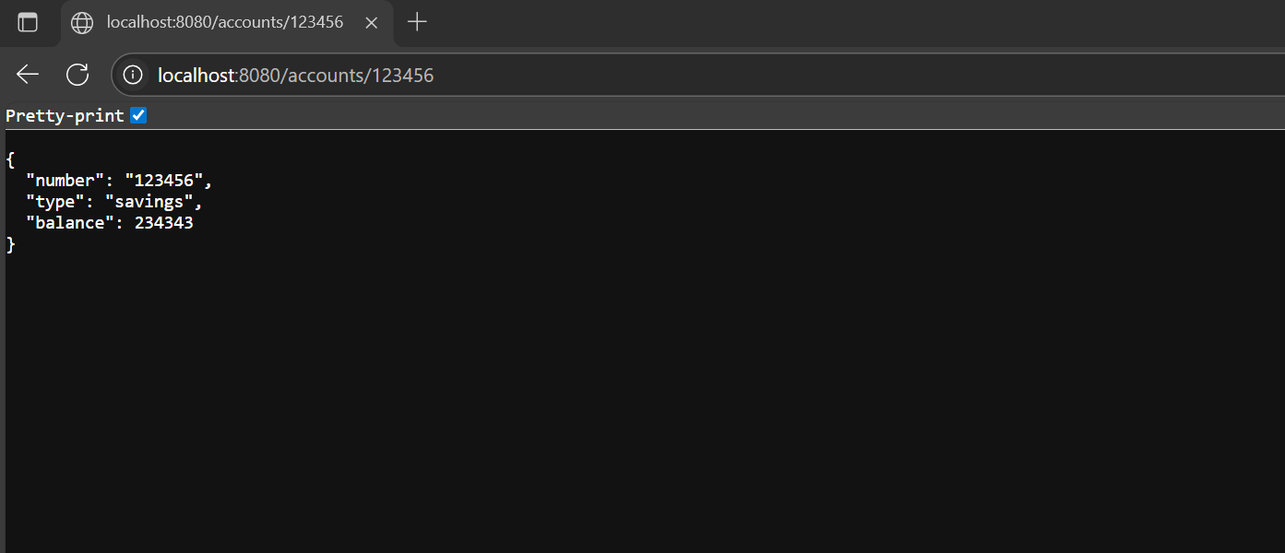

Creating Loan microservice:
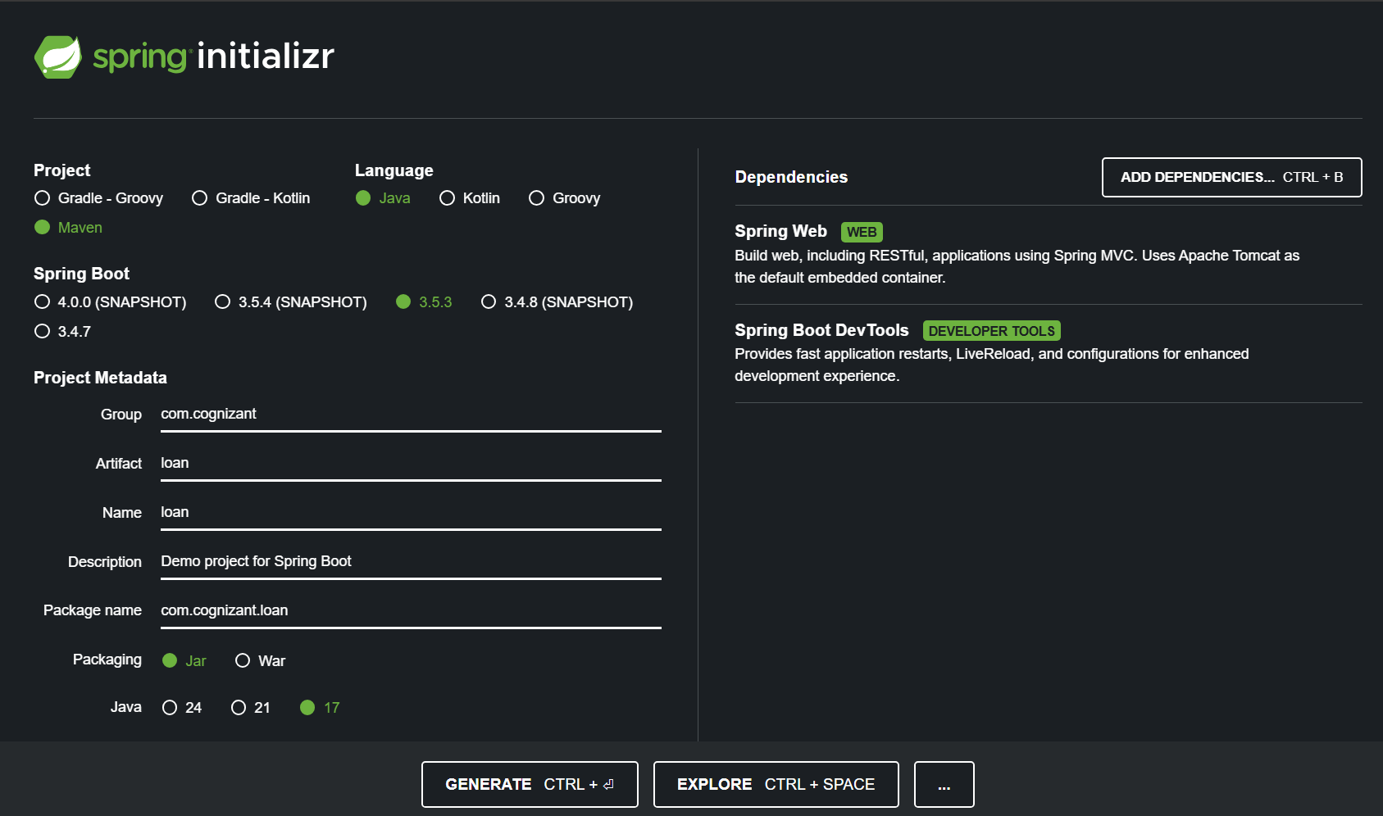
Then move it to the same old folder,
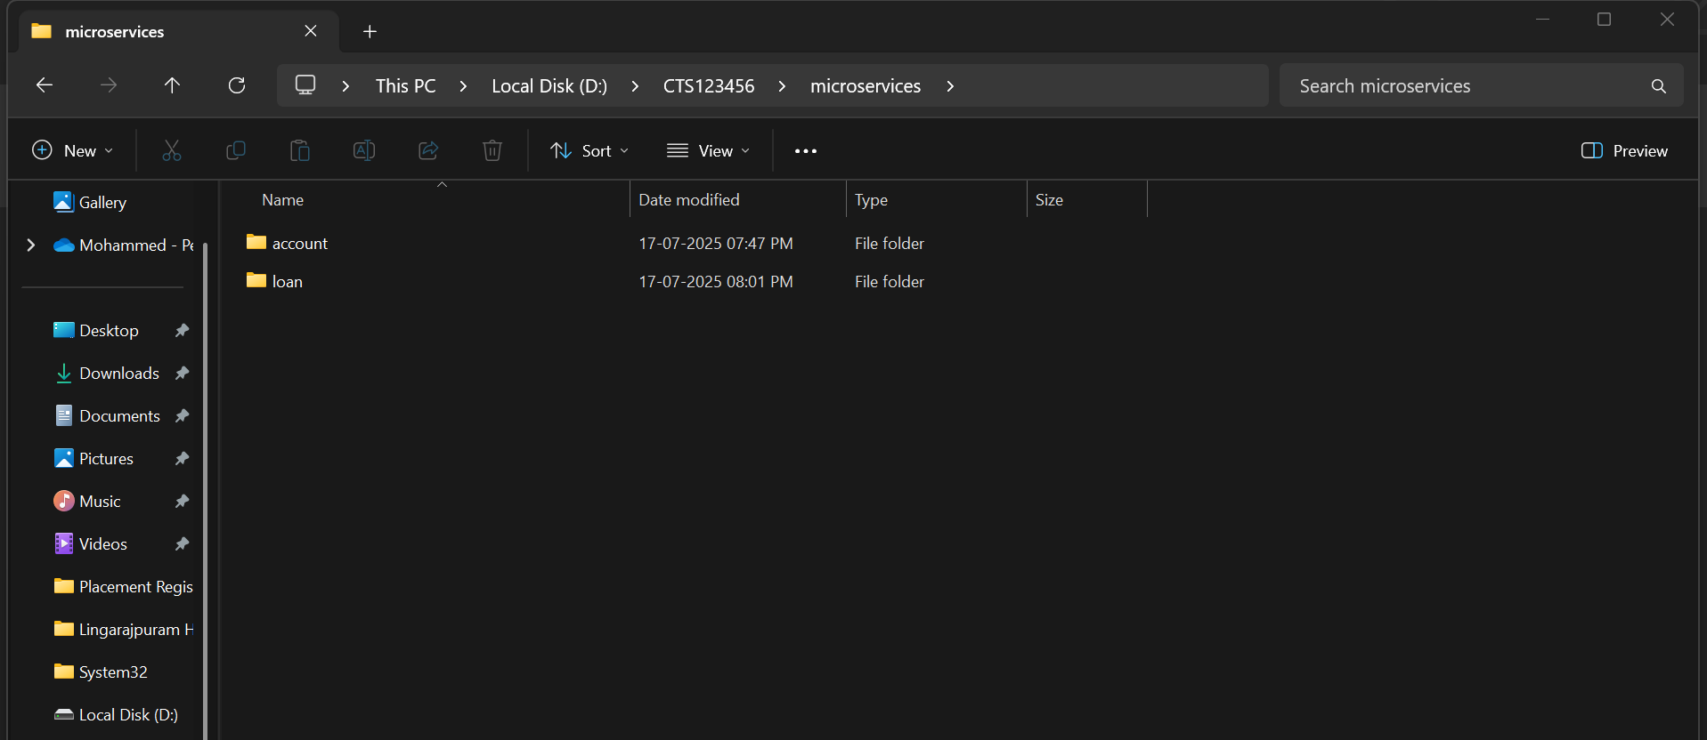

Set custom port for the loans project by adding server.port=8081
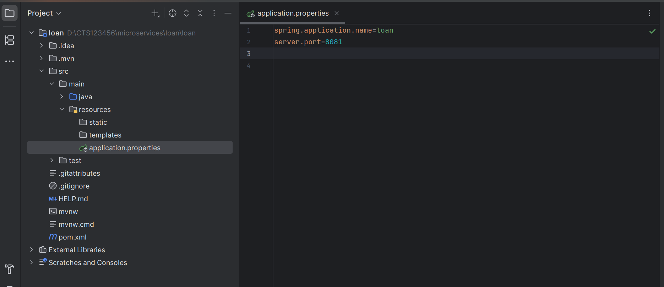
Folder structure:
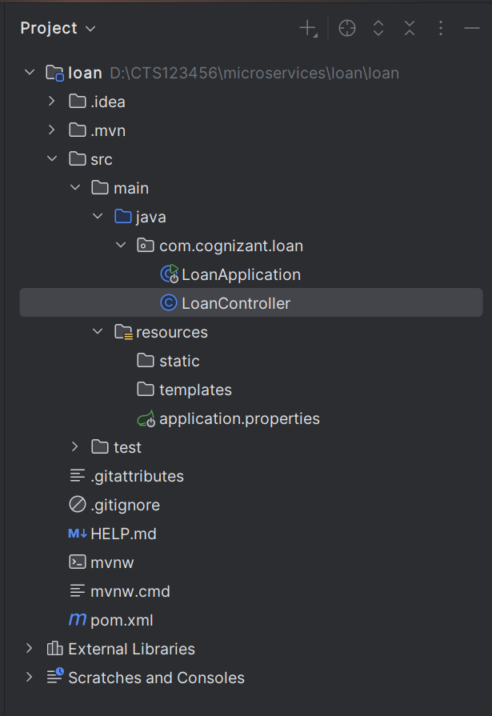
LoanController.java
package com.cognizant.loan;
import org.springframework.web.bind.annotation.*;
@RestController
@RequestMapping("/loans")
public class LoanController {
@GetMapping("/{number}")
public Loan getLoan(@PathVariable String number) {
return new Loan(number, "car", 400000, 3258, 18);
}
record Loan(String number, String type, double loan, double emi, int tenure) {}
}

Run LoanApplication.java and go to http://localhost:8081/loans/H123456
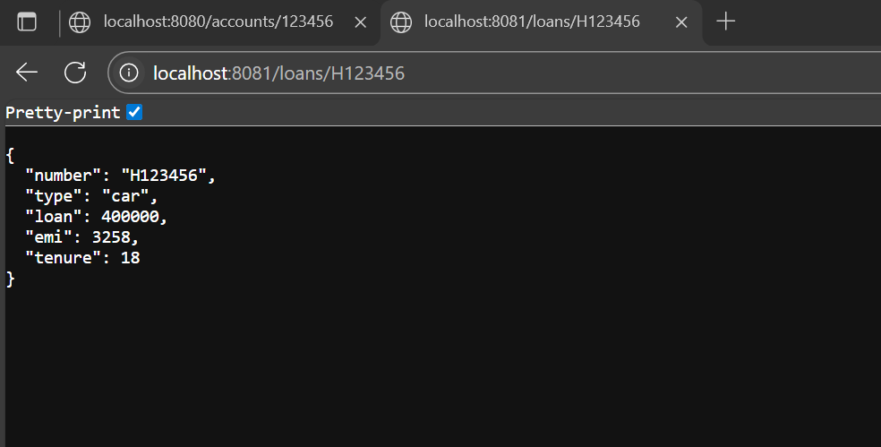

I now have two microservices,
- Account on port 8080
- Loan on port 8081

_________________________ThankYou_____________________

