1. spring-rest-handson

Hands on 1
Create a Spring Web Project using Maven

Folder Structure:
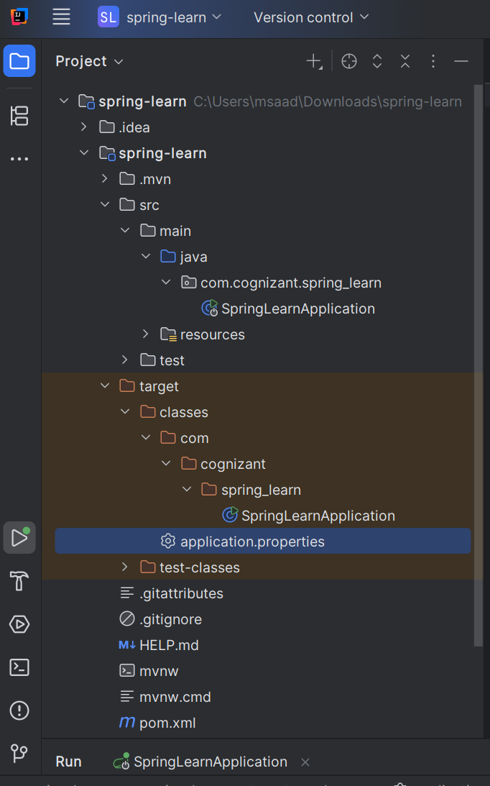

Spring Initializr:
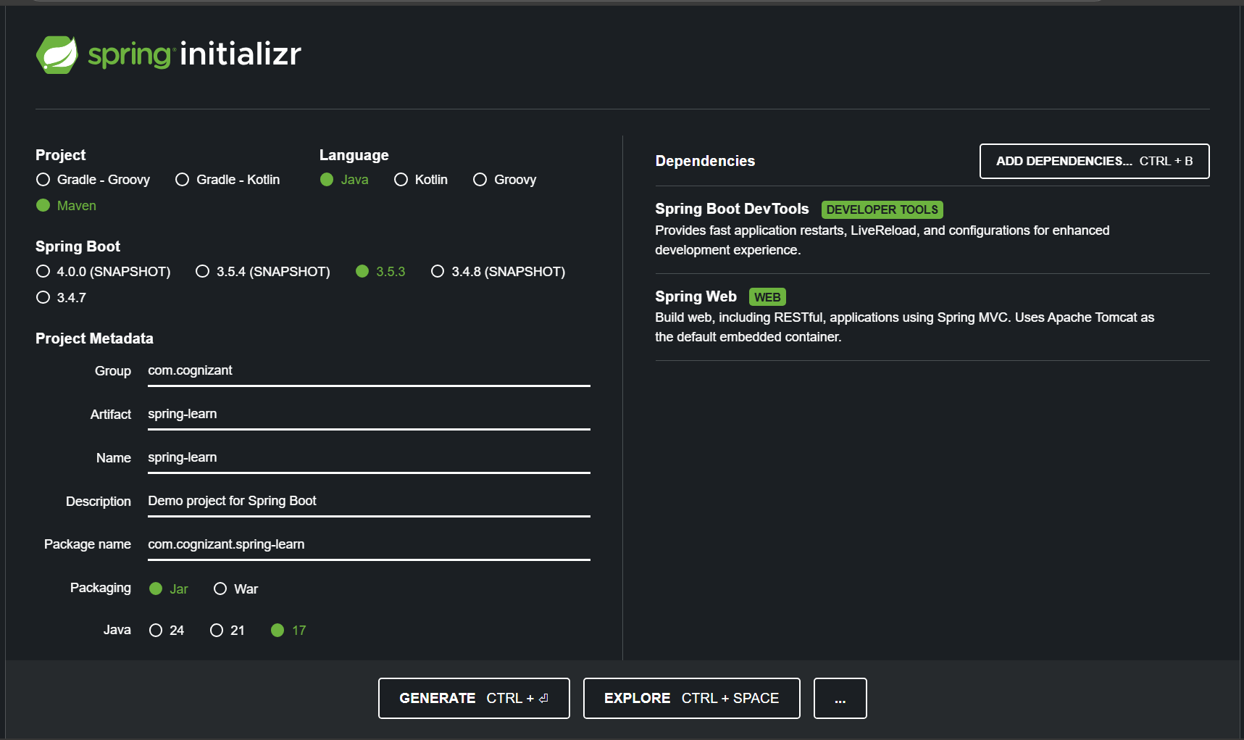

Pom.xml:
<?xml version="1.0" encoding="UTF-8"?>
<project xmlns="http://maven.apache.org/POM/4.0.0" xmlns:xsi="http://www.w3.org/2001/XMLSchema-instance"
xsi:schemaLocation="http://maven.apache.org/POM/4.0.0 https://maven.apache.org/xsd/maven-4.0.0.xsd">
<modelVersion>4.0.0</modelVersion>
<parent>
<groupId>org.springframework.boot</groupId>
<artifactId>spring-boot-starter-parent</artifactId>
<version>3.5.3</version>
<relativePath/> <!-- lookup parent from repository -->
</parent>
<groupId>com.cognizant</groupId>
<artifactId>spring-learn</artifactId>
<version>0.0.1-SNAPSHOT</version>
<name>spring-learn</name>
<description>Demo project for Spring Boot</description>
<url/>
<licenses>
<license/>
</licenses>
<developers>
<developer/>
</developers>
<scm>
<connection/>
<developerConnection/>
<tag/>
<url/>
</scm>
<properties>
<java.version>17</java.version>
</properties>
<dependencies>
<dependency>
<groupId>org.springframework.boot</groupId>
<artifactId>spring-boot-starter-web</artifactId>
</dependency>
<dependency>
<groupId>org.springframework.boot</groupId>
<artifactId>spring-boot-devtools</artifactId>
<scope>runtime</scope>
<optional>true</optional>
</dependency>
<dependency>
<groupId>org.springframework.boot</groupId>
<artifactId>spring-boot-starter-test</artifactId>
<scope>test</scope>
</dependency>
</dependencies>
<build>
<plugins>
<plugin>
<groupId>org.springframework.boot</groupId>
<artifactId>spring-boot-maven-plugin</artifactId>
</plugin>
</plugins>
</build>
</project>

SpringLearnApplication.java
package com.cognizant.spring_learn;
import org.springframework.boot.SpringApplication;
import org.springframework.boot.autoconfigure.SpringBootApplication;
import org.slf4j.Logger;
import org.slf4j.LoggerFactory;
@SpringBootApplication
public class SpringLearnApplication {
private static final Logger LOGGER = LoggerFactory.getLogger(SpringLearnApplication.class);
public static void main(String[] args) {
LOGGER.info("START");
SpringApplication.run(SpringLearnApplication.class, args);
LOGGER.info("END");
}
}

application.properties :
spring.application.name=spring-learn

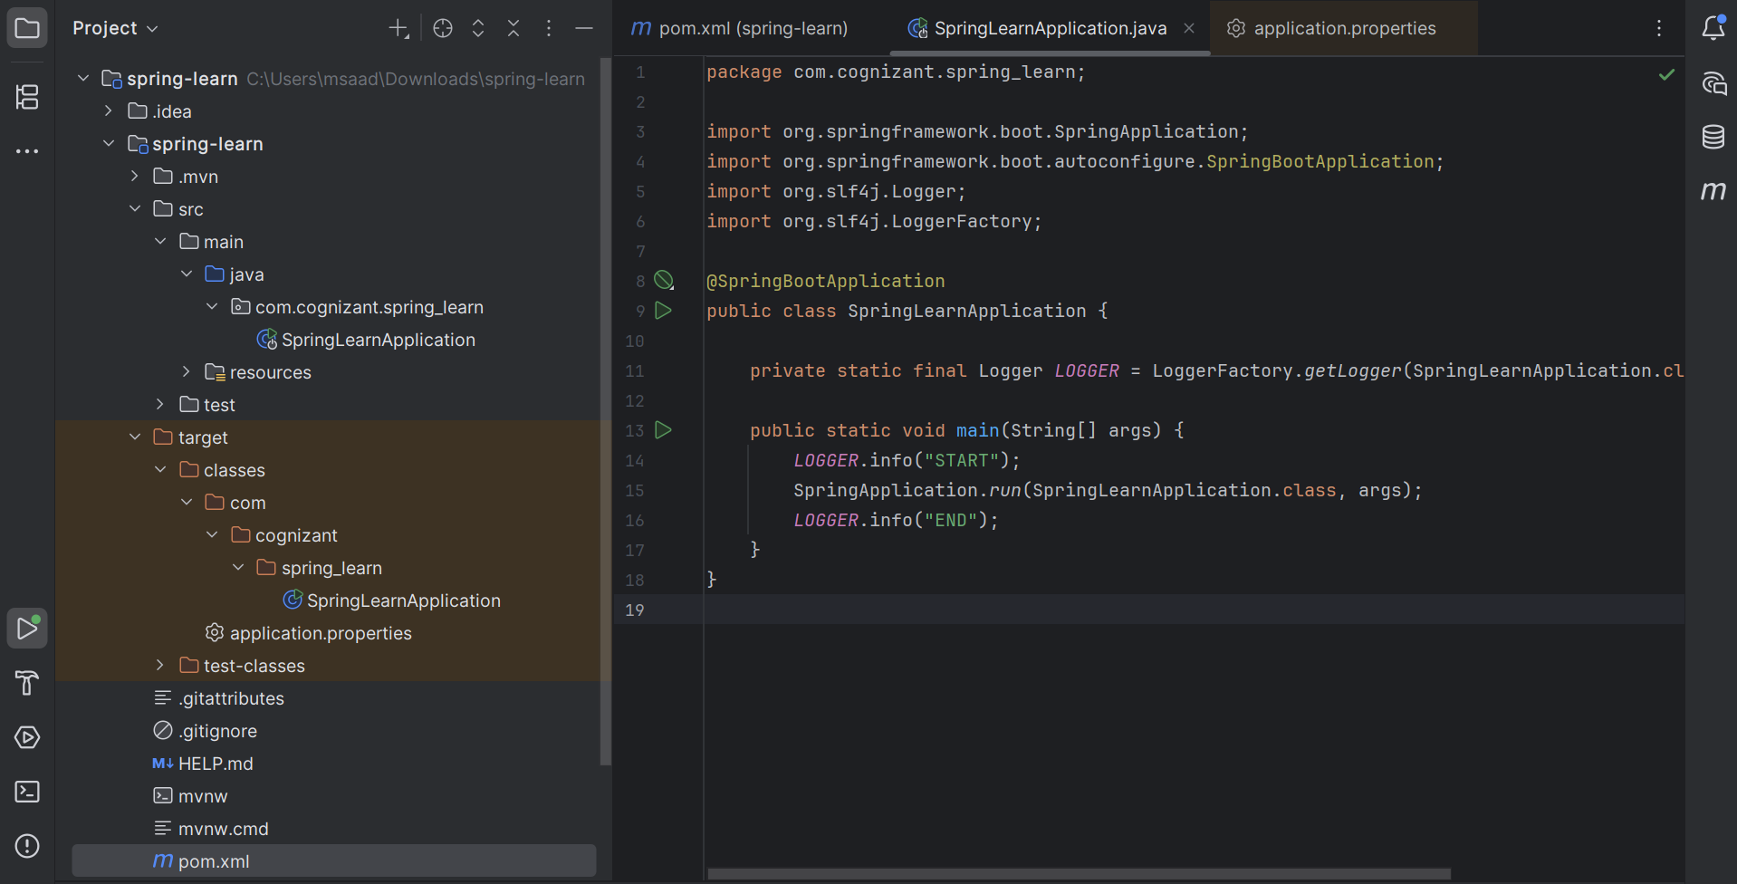

Output:
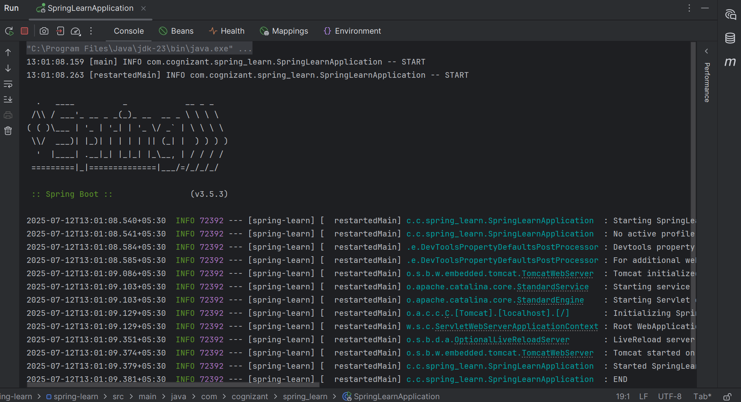

Hands on 4
Spring Core – Load Country from Spring Configuration XML
An airlines website is going to support booking on four countries. There will be a drop down on the home page of this website to select the respective country. It is also important to store the two-character ISO code of each country.
Code | Name
US | United States
DE | Germany
IN | India
JP | Japan
Above data has to be stored in spring configuration file. Write a program to read this configuration file and display the details.

Folder Structure:
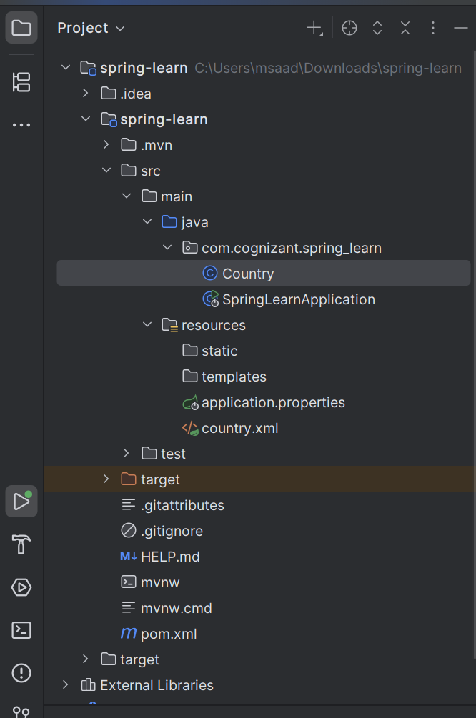

Country.java
package com.cognizant.spring_learn;
import org.slf4j.Logger;
import org.slf4j.LoggerFactory;
public class Country {
private static final Logger LOGGER = LoggerFactory.getLogger(Country.class);
private String code;
private String name;
public Country() {
LOGGER.debug("Inside Country Constructor.");
}
public String getCode() {
LOGGER.debug("Inside getCode()");
return code;
}
public void setCode(String code) {
LOGGER.debug("Inside setCode()");
this.code = code;
}
public String getName() {
LOGGER.debug("Inside getName()");
return name;
}
public void setName(String name) {
LOGGER.debug("Inside setName()");
this.name = name;
}
@Override
public String toString() {
return "Country [code=" + code + ", name=" + name + "]";
}
}

country.xml (src/main/resources)
<?xml version="1.0" encoding="UTF-8"?>
<beans xmlns="http://www.springframework.org/schema/beans"
xmlns:xsi="http://www.w3.org/2001/XMLSchema-instance"
xsi:schemaLocation="http://www.springframework.org/schema/beans
https://www.springframework.org/schema/beans/spring-beans.xsd">
<bean id="country" class="com.cognizant.spring_learn.Country">
<property name="code" value="IN"/>
<property name="name" value="India"/>
</bean>
</beans>

application.properties (src/main/resources)
spring.application.name=spring-learn
logging.level.com.cognizant.spring_learn=DEBUG

SpringLearnApplication.java
package com.cognizant.spring_learn;
import org.springframework.boot.SpringApplication;
import org.springframework.boot.autoconfigure.SpringBootApplication;
import org.slf4j.Logger;
import org.slf4j.LoggerFactory;
import org.springframework.context.ApplicationContext;
import org.springframework.context.support.ClassPathXmlApplicationContext;
@SpringBootApplication
public class SpringLearnApplication {
private static final Logger LOGGER = LoggerFactory.getLogger(SpringLearnApplication.class);
public void displayCountry() {
LOGGER.info("START");
ApplicationContext context = new ClassPathXmlApplicationContext("country.xml");
Country country = context.getBean("country", Country.class);
LOGGER.debug("Country : {}", country.toString());
LOGGER.info("END");
}
public static void main(String[] args) {
LOGGER.info("START");
SpringApplication.run(SpringLearnApplication.class, args);
SpringLearnApplication app = new SpringLearnApplication();
app.displayCountry();
LOGGER.info("END");
}
}

pom.xml
<?xml version="1.0" encoding="UTF-8"?>
<project xmlns="http://maven.apache.org/POM/4.0.0" xmlns:xsi="http://www.w3.org/2001/XMLSchema-instance"
xsi:schemaLocation="http://maven.apache.org/POM/4.0.0 https://maven.apache.org/xsd/maven-4.0.0.xsd">
<modelVersion>4.0.0</modelVersion>
<parent>
<groupId>org.springframework.boot</groupId>
<artifactId>spring-boot-starter-parent</artifactId>
<version>3.5.3</version>
<relativePath/> <!-- lookup parent from repository -->
</parent>
<groupId>com.cognizant</groupId>
<artifactId>spring-learn</artifactId>
<version>0.0.1-SNAPSHOT</version>
<name>spring-learn</name>
<description>Demo project for Spring Boot</description>
<url/>
<licenses>
<license/>
</licenses>
<developers>
<developer/>
</developers>
<scm>
<connection/>
<developerConnection/>
<tag/>
<url/>
</scm>
<properties>
<java.version>17</java.version>
</properties>
<dependencies>
<dependency>
<groupId>org.springframework.boot</groupId>
<artifactId>spring-boot-starter-web</artifactId>
</dependency>
<dependency>
<groupId>org.springframework.boot</groupId>
<artifactId>spring-boot-devtools</artifactId>
<scope>runtime</scope>
<optional>true</optional>
</dependency>
<dependency>
<groupId>org.springframework.boot</groupId>
<artifactId>spring-boot-starter-test</artifactId>
<scope>test</scope>
</dependency>
</dependencies>
<build>
<plugins>
<plugin>
<groupId>org.springframework.boot</groupId>
<artifactId>spring-boot-maven-plugin</artifactId>
</plugin>
</plugins>
</build>
</project>

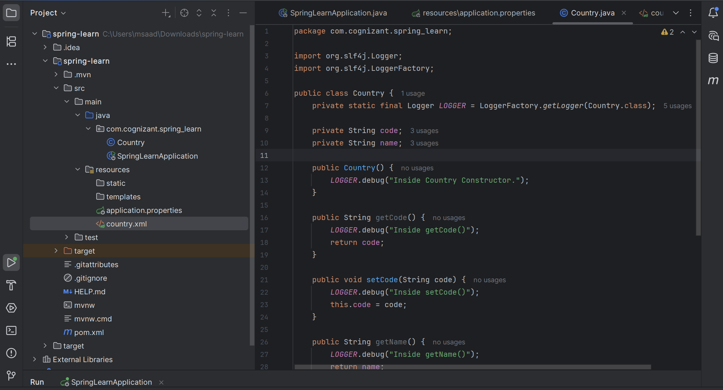

Output:
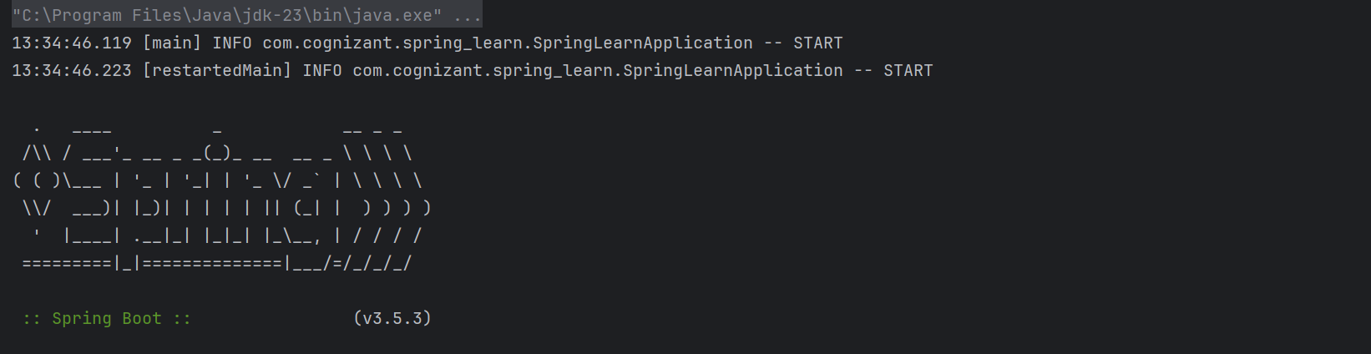
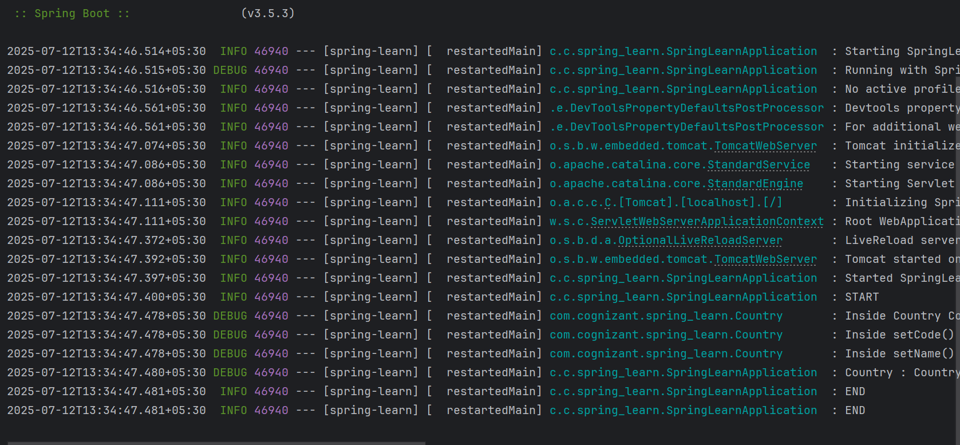
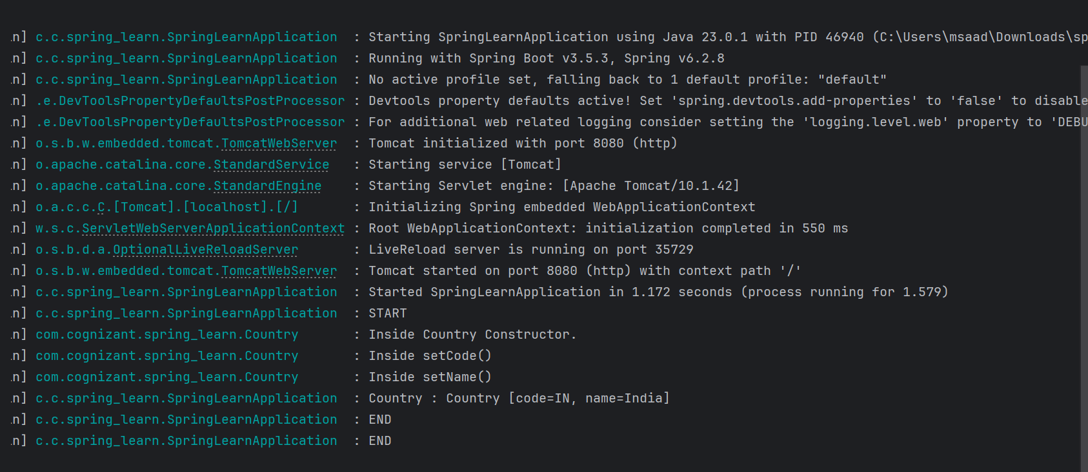

____________________________ThankYou_________________

