2. spring-rest-handson

Hello World RESTful Web Service
Write a REST service in the spring learn application created earlier, that returns the text "Hello World!!" using Spring Web Framework. Refer details below:
Method: GET
URL: /hello
Controller: com.cognizant.spring-learn.controller.HelloController
Method Signature: public String sayHello()
Method Implementation: return hard coded string "Hello World!!"
Sample Request: http://localhost:8083/hello
Sample Response: Hello World!!

Folder Structure:
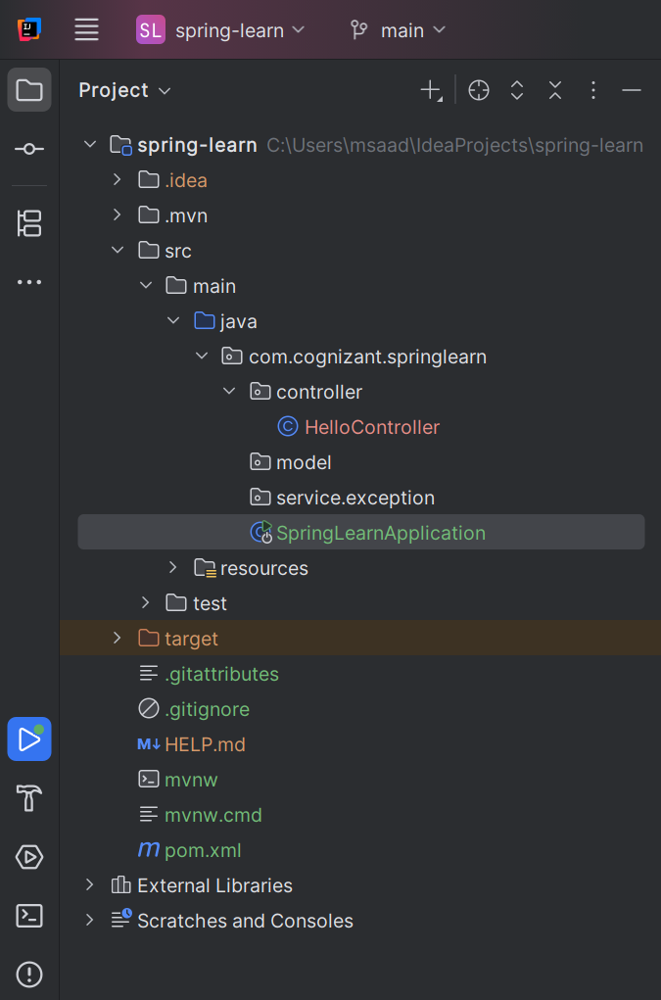
HelloController.java
package com.cognizant.springlearn.controller;
import org.slf4j.Logger;
import org.slf4j.LoggerFactory;
import org.springframework.web.bind.annotation.GetMapping;
import org.springframework.web.bind.annotation.RestController;
@RestController
public class HelloController {
private static final Logger LOGGER = LoggerFactory.getLogger(HelloController.class);
@GetMapping("/hello")
public String sayHello() {
LOGGER.info("START - sayHello()");
LOGGER.info("END - sayHello()");
return "Hello World!!";
}
}

SpringLearnApplication.java
package com.cognizant.springlearn;
import org.springframework.boot.SpringApplication;
import org.springframework.boot.autoconfigure.SpringBootApplication;
@SpringBootApplication
public class SpringLearnApplication {
public static void main(String[] args) {
SpringApplication.run(SpringLearnApplication.class, args);
}
}

Run the SpringLearnApplication.java

Then, open any browser and type: http://localhost:8080/hello

Output:
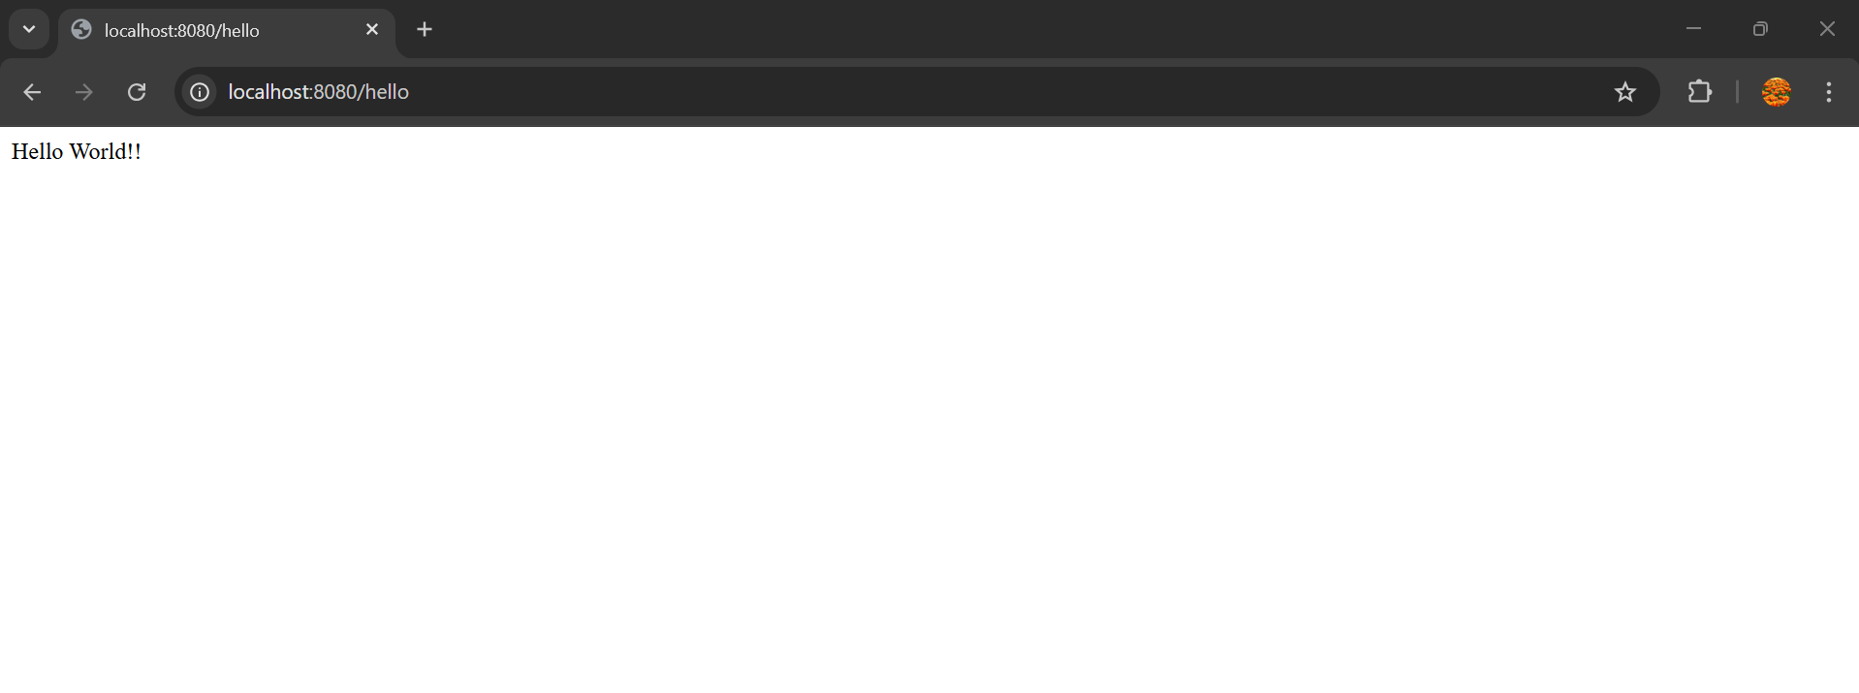

REST - Country Web Service
Write a REST service that returns India country details in the earlier created spring learn application.
URL: /country
Controller: com.cognizant.spring-learn.controller.CountryController
Method Annotation: @RequestMapping
Method Name: getCountryIndia()
Method Implementation: Load India bean from spring xml configuration and return
Sample Request: http://localhost:8083/country
Sample Response:
{
"code": "IN",
"name": "India"
}

Folder Structure:
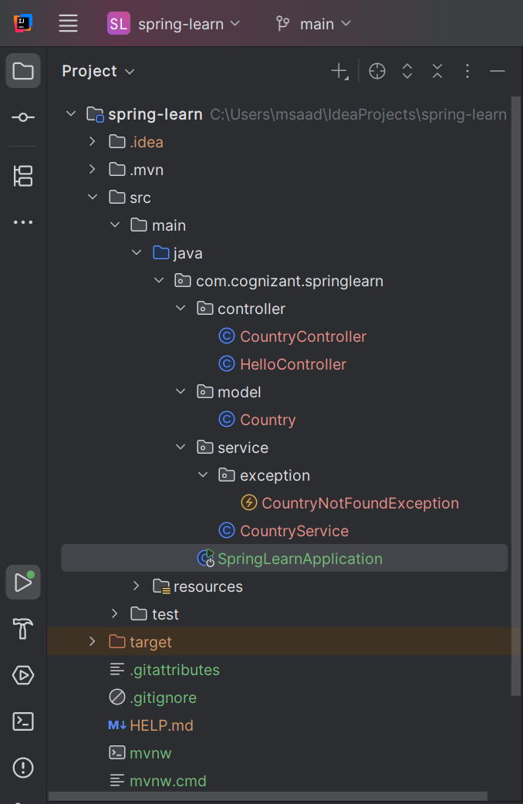

Create 4 packages,
1)controller
2)model
3)service
4)service.exception

CountryController.java (in controller package)
package com.cognizant.springlearn.controller;
import com.cognizant.springlearn.model.Country;
import com.cognizant.springlearn.service.CountryService;
import com.cognizant.springlearn.service.exception.CountryNotFoundException;
import org.springframework.beans.factory.annotation.Autowired;
import org.springframework.web.bind.annotation.*;
import java.util.List;
@RestController
public class CountryController {
@Autowired
private CountryService countryService;
// GET: /country → returns India
@GetMapping("/country")
public Country getCountryIndia() {
return new Country("IN", "India");
}
// GET: /countries → returns all countries
@GetMapping("/countries")
public List<Country> getAllCountries() {
return countryService.getAllCountries();
}
// GET: /countries/{code} → returns a country by code
@GetMapping("/countries/{code}")
public Country getCountry(@PathVariable String code) throws CountryNotFoundException {
return countryService.getCountry(code);
}
}

Country.java (in model package)
package com.cognizant.springlearn.model;
public class Country {
private String code;
private String name;
public Country() {}
public Country(String code, String name) {
this.code = code;
this.name = name;
}
public String getCode() {
return code;
}
public void setCode(String code) {
this.code = code;
}
public String getName() {
return name;
}
public void setName(String name) {
this.name = name;
}
}

CountryService.java (in service package)
package com.cognizant.springlearn.service;
import com.cognizant.springlearn.model.Country;
import com.cognizant.springlearn.service.exception.CountryNotFoundException;
import org.springframework.stereotype.Service;
import java.util.Arrays;
import java.util.List;
@Service
public class CountryService {
private static final List<Country> countries = Arrays.asList(
new Country("IN", "India"),
new Country("US", "United States"),
new Country("JP", "Japan"),
new Country("DE", "Germany")
);
public Country getCountry(String code) throws CountryNotFoundException {
return countries.stream()
.filter(c -> c.getCode().equalsIgnoreCase(code))
.findFirst()
.orElseThrow(() -> new CountryNotFoundException("Country not found"));
}
public List<Country> getAllCountries() {
return countries;
}
}

CountryNotFoundException.java (in service.exception package)
package com.cognizant.springlearn.service.exception;
import org.springframework.http.HttpStatus;
import org.springframework.web.bind.annotation.ResponseStatus;
@ResponseStatus(value = HttpStatus.NOT_FOUND, reason = "Country not found")
public class CountryNotFoundException extends Exception {
public CountryNotFoundException(String message) {
super(message);
}
}

Now, run the SPringLearnApplication.java
Then, go to any browser and type,
- http://localhost:8080/countries (to display all countries)

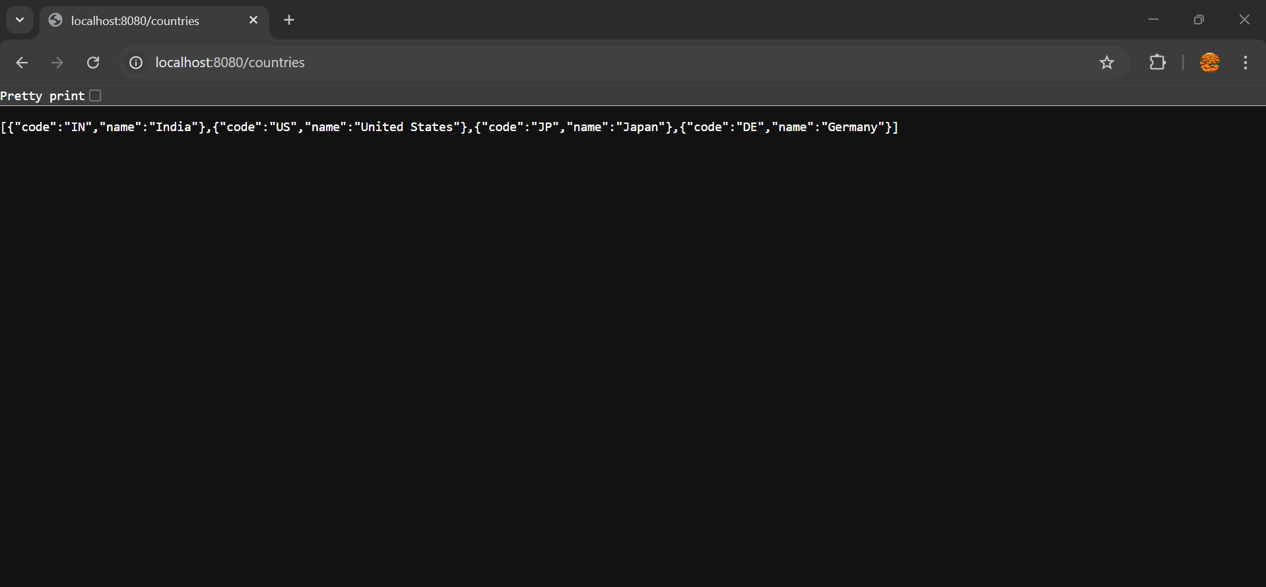

- http://localhost:8080/countries/in (to display specific country)

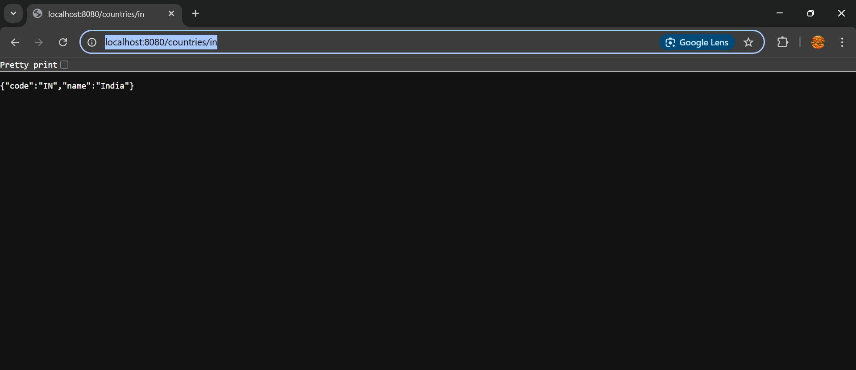
REST - Get country based on country code
Write a REST service that returns a specific country based on country code. The country code should be case insensitive.
Controller: com.cognizant.spring-learn.controller.CountryController
Method Annotation: @GetMapping("/countries/{code}")
Method Name: getCountry(String code)
Method Implemetation: Invoke countryService.getCountry(code)
Service Method: com.cognizant.spring-learn.service.CountryService.getCountry(String code)

The folder structure and all the packages and classes remain the same which are used for the exercise above which is REST- Country Web Service

Output:
http://localhost:8080/countries/in
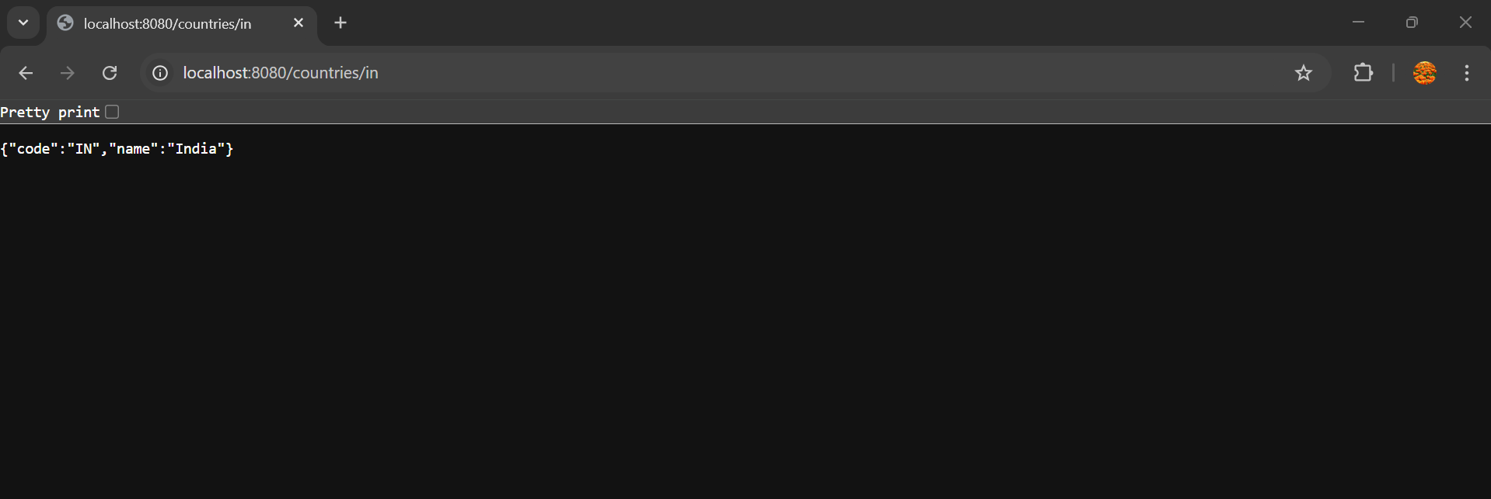

http://localhost:8080/countries/us
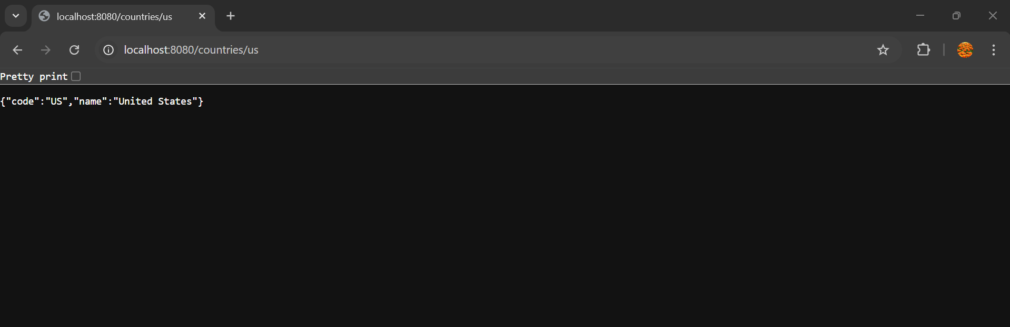

http://localhost:8080/countries/jp
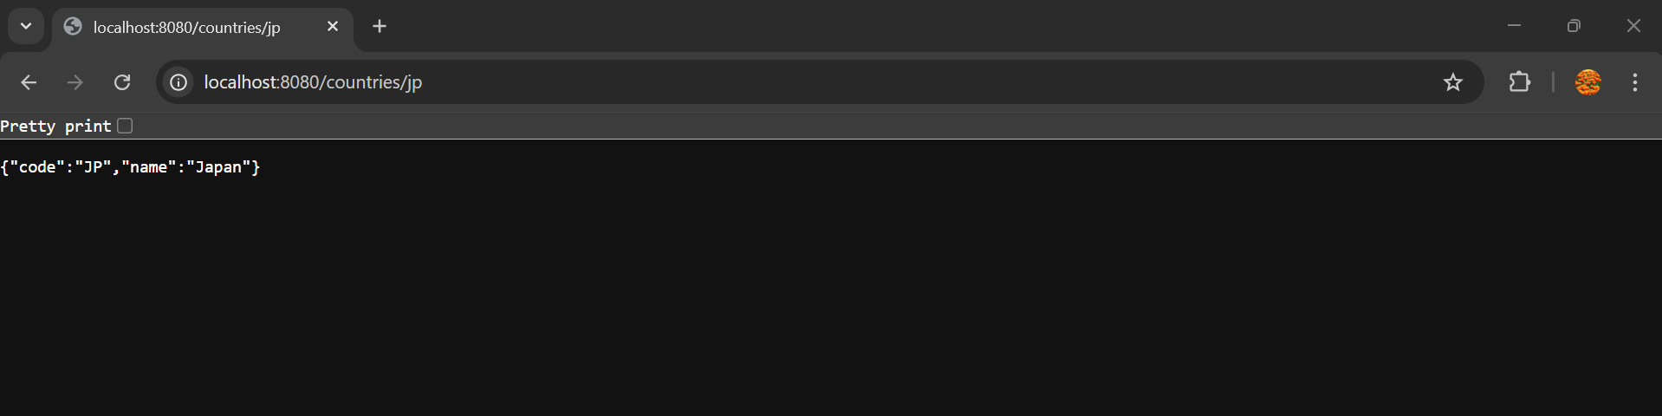

_________________ThankYou___________________

