(OvaScan AI) AI OVARIAN ULTRASOUND DIAGNOSTIC SYSTEM FOR PCOS AND DOMINANT FOLLICLE DETECTION
CAPSTONE PROJECT REPORT - AIPV603
Submitted by
S. MANJUNATH | REGISTER NO: 23TN0049
G. SRI HARIHARAN | REGISTER NO: 23TN0094
K. VIGNESH | REGISTER NO: 23TN0105

Under the guidance of
Mrs. S. Chitra, M.Tech., (Ph.D)
Assistant Professor/AI&ML
in partial fulfillment for the award of the degree of
BACHELOR OF TECHNOLOGY
in
DEPARTMENT OF ARTIFICIAL INTELLIGENCE & MACHINE LEARNING

MANAKULA VINAYAGAR INSTITUTE OF TECHNOLOGY
KALITHEERTHALKUPPAM, PONDICHERRY
PONDICHERRY UNIVERSITY
INDIA
OCTOBER 2026

MANAKULA VINAYAGAR INSTITUTE OF TECHNOLOGY
PONDICHERRY UNIVERSITY
DEPARTMENT OF ARTIFICIAL INTELLIGENCE & MACHINE LEARNING
BONAFIDE CERTIFICATE
This is to certify that the project work entitled “(OvaScan AI) AI OVARIAN ULTRASOUND DIAGNOSTIC SYSTEM FOR PCOS AND DOMINANT FOLLICLE DETECTION” is a bonafide work done by S. MANJUNATH [REGISTER NO: 23TN0049], G. SRI HARIHARAN [REGISTER NO: 23TN0094], K. VIGNESH [REGISTER NO: 23TN0105] in partial fulfillment of the requirement for the award of B.Tech Degree in ARTIFICIAL INTELLIGENCE & MACHINE LEARNING by Pondicherry University during the academic year 2026 - 2027.
PROJECT GUIDE | HEAD OF THE DEPARTMENT
Mrs. S. Chitra | Mr. R. Raj Bharath
Assistant Professor/AI&ML | HoD/AI&ML

Viva-Voce Examination held on ..................................................................................
INTERNAL EXAMINER | EXTERNAL EXAMINER

ACKNOWLEDGEMENT
We express our deep sense of gratitude to Theiva Thiru. N. Kesavan, Founder, Shri. M. Dhanasekaran, Chairman & Managing Director, Shri. S. V. Sugumaran, Vice-Chairman and Dr. K. Gowtham Narayanasamy, Secretary of Sri Manakula Vinayagar Educational Trust, Puducherry for providing necessary facilities to successfully complete our project and report works.
We express our sincere thanks to our beloved Principal Dr. S. Malarkkan for having provided necessary facilities and encouragement for successful completion of this project work.
We express our sincere thanks to Mr. R. Raj Bharath, Head of the Department, Artificial Intelligence & Machine Learning, for his support in making necessary arrangements for the conduction of Project and also for guiding us to execute our project successfully.
We express our sincere thanks to Mrs. S. Chitra, Assistant Professor, Artificial Intelligence & Machine Learning for her consistent reviews which motivated us in completing project.
We thank all our department faculty member and non-teaching staffs for helping us to complete the document successfully on time.
We would like to express our eternal gratitude to our parents for the sacrifices they made for educating and preparing us for our future and their everlasting love and support.
We thank the Almighty for blessing us with such wonderful people and for being with us always.

ABSTRACT
OvaScan AI is an artificial-intelligence diagnostic workstation that analyses B-mode ovarian ultrasound images to distinguish three clinically important states: Normal Ovary, Polycystic Ovary Syndrome (PCOS) morphology, and Dominant (Graafian) Follicle. Existing computer-aided PCOS tools are binary and therefore mislabel the physiological pre-ovulatory ovary as abnormal, while manual follicle counting remains subjective, time-consuming and dependent on the operator. The proposed system addresses both problems through a two-stage pipeline. An acoustic quality gate with convex-hull sector masking removes non-ultrasound inputs and machine text, and an aspect-ratio-preserving letterbox converts the image into a 224×224 tensor. A fine-tuned ConvNeXt-Tiny V6 (primary model) and ResNet-50 (benchmark) then classify the scan, while multi-scale black-hat morphometry (kernels 9–65 px) segments follicles at native resolution, measures their calipers in millimetres, and labels them dominant (≥ 10 mm) or antral (2–9 mm). The Rotterdam biomarkers – antral follicle count (AFC ≥ 12) and subcapsular distribution – are computed automatically, and a multi-scale LayerCAM explanation is quantified by an AI–follicle concordance metric. On a locked clinical test set of 86 scans (dataset of 570 scans), ConvNeXt-Tiny V6 achieved 84.88% accuracy, a macro-F1 of 0.8506 and 100% PCOS recall at 41.7 ms per image, while ResNet-50 achieved 81.40% accuracy and 96.6% dominant-follicle recall. All processing runs locally in a dark-console PACS interface with no cloud transmission.
Keywords: Artificial Intelligence, Deep Learning, Medical Computer Vision, Ovarian Ultrasound, PCOS, Dominant Follicle, ConvNeXt, ResNet-50, LayerCAM, Explainable AI, Antral Follicle Count, Rotterdam Criteria, PACS.

TABLE OF CONTENTS
CHAPTER NO. | TITLE | PAGE NO.
 | ACKNOWLEDGEMENT | iii
 | ABSTRACT | iv
 | LIST OF FIGURES | ix
 | LIST OF ABBREVIATIONS | x
 | DECLARATION | xi
 | SDG MAPPING | xii
1 | INTRODUCTION | 1
 | 1.1 BACKGROUND | 1
 | 1.2 PROBLEM STATEMENT | 1
 | 1.3 DOMAIN OVERVIEW | 2
 | 1.4 PROJECT OVERVIEW | 2
 | 1.5 NEED FOR THE SYSTEM | 3
 | 1.6 MOTIVATION | 3
 | 1.7 OBJECTIVES | 4
 | 1.8 SCOPE OF THE PROJECT | 4
 | 1.9 ORGANIZATION OF THE REPORT | 4
2 | LITERATURE SURVEY | 6
 | 2.1 INTRODUCTION TO OVARIAN ULTRASOUND IMAGING | 6
 | 2.2 TRADITIONAL COMPUTER VISION APPROACHES IN FOLLICLE DETECTION | 6
 | 2.3 MACHINE LEARNING METHODS FOR PCOS DETECTION | 7
 | 2.4 MODERN DEEP CONVOLUTIONAL NETWORKS | 7
 | 2.5 EXPLAINABLE AI (XAI) IN MEDICAL ULTRASOUND | 8
 | 2.6 CLINICAL GUIDELINES AND BIOMARKERS | 8
 | 2.7 THE DOMINANT FOLLICLE DILEMMA | 9
 | 2.8 RESEARCH GAP | 9
 | 2.9 SUMMARY | 9
3 | SYSTEM ANALYSIS | 11
 | 3.1 EXISTING CLINICAL INSPECTION PROCESS | 11
 | 3.2 LIMITATIONS OF EXISTING SYSTEM | 11
 | 3.3 PROBLEM ANALYSIS AND RISK OF FALSE POSITIVES IN OVULATING PATIENTS | 11
 | 3.4 PROPOSED 3-CLASS SYSTEM OVERVIEW | 12
 | 3.5 FUNCTIONAL REQUIREMENTS | 12
 | 3.6 NON-FUNCTIONAL REQUIREMENTS | 13
 | 3.7 ADVANTAGES OF PROPOSED SYSTEM OVER BINARY AI TOOLS | 13
 | 3.8 SUMMARY | 14
4 | SYSTEM DESIGN AND ARCHITECTURE | 15
 | 4.1 OVERALL SYSTEM ARCHITECTURE | 15
 | 4.2 SYSTEM BLOCK DIAGRAM | 16
 | 4.3 DATA FLOW DIAGRAM (DFD LEVEL 0, LEVEL 1, LEVEL 2) | 17
 | 4.3.1 DFD Level 0 – Context Diagram | 17
 | 4.3.2 DFD Level 1 | 18
 | 4.3.3 DFD Level 2 – Follicle Morphometry (Process 4.0) | 18
 | 4.4 UML USE-CASE DIAGRAM | 19
 | 4.5 COMPLETE SYSTEM FLOWCHART | 20
 | 4.6 INPUT ACQUISITION AND ACOUSTIC QUALITY GATE | 21
 | 4.7 PREPROCESSING AND ASPECT-RATIO LETTERBOX PADDING | 22
 | 4.8 DEEP LEARNING CLASSIFIER ARCHITECTURES | 22
 | 4.8.1 ConvNeXt-Tiny V6 (Primary Champion) | 22
 | 4.8.2 ResNet-50 (Top-2 Benchmark) | 22
 | 4.9 MULTI-SCALE BLACK-HAT MORPHOMETRY FOR FOLLICLE SEGMENTATION | 23
 | 4.10 NATIVE CALIPER EXTRACTION AND SIZE CLASSIFICATION | 24
 | 4.11 MULTI-SCALE LAYERCAM ATTRIBUTION ENGINE | 24
 | 4.12 AI AND FOLLICLE ATTENTION CONCORDANCE METRIC | 24
 | 4.13 ROTTERDAM QUANTITATIVE BIOMARKER ENGINE | 25
 | 4.14 PACS DIAGNOSTIC WORKSTATION INTERFACE DESIGN | 25
 | 4.15 OVERALL END-TO-END WORKING | 25
5 | IMPLEMENTATION AND TECHNOLOGIES | 27
 | 5.1 DEVELOPMENT AND EXECUTION ENVIRONMENT | 27
 | 5.2 HARDWARE REQUIREMENTS | 27
 | 5.3 SOFTWARE REQUIREMENTS | 27
 | 5.4 PYTHON IMPLEMENTATION AND MODULAR ARCHITECTURE | 28
 | 5.5 PYTORCH DEEP LEARNING IMPLEMENTATION | 29
 | 5.6 OPENCV ACOUSTIC SECTOR MASKING AND MULTI-SCALE BLACK-HAT MORPHOMETRY | 30
 | 5.7 LAYERCAM AND GRAD-CAM++ ENGINE IMPLEMENTATION | 30
 | 5.8 FLASK RESTFUL BACKEND API DESIGN | 30
 | 5.9 PACS USER INTERFACE | 31
 | 5.10 IMPLEMENTATION WORKFLOW | 31
6 | RESULTS AND PERFORMANCE ANALYSIS | 32
 | 6.1 INTRODUCTION | 32
 | 6.2 CLINICAL DATASET SPECIFICATION | 32
 | 6.3 TOP-2 MODEL BENCHMARK COMPARISON | 32
 | 6.4 CLASSIFICATION RESULTS ON LOCKED CLINICAL TEST SET (N = 86) | 32
 | 6.5 CONFUSION MATRIX AND PER-CLASS PRECISION / RECALL / F1 ANALYSIS | 34
 | 6.6 FOLLICLE CALIPER MEASUREMENT AND SEGMENTATION RESULTS | 35
 | 6.7 EXPLAINABILITY AND LAYERCAM VERIFICATION | 36
 | 6.7.1 LayerCAM Thermal Heatmap | 36
 | 6.7.2 Follicle Calipers and Bounds Overlay | 36
 | 6.7.3 AI Concordance Analysis | 36
 | 6.7.4 Tri-Panel Comparative View | 36
 | 6.7.5 Edge Saliency | 36
 | 6.8 ROTTERDAM BIOMARKER AUTOMATED CONCORDANCE | 37
 | 6.9 INFERENCE LATENCY AND WORKSTATION PERFORMANCE | 37
 | 6.10 DISCUSSION AND CLINICAL VALIDATION | 37
7 | CONCLUSION AND FUTURE SCOPE | 39
 | 7.1 CONCLUSION | 39
 | 7.2 KEY CONTRIBUTIONS | 39
 | 7.3 LIMITATIONS | 39
 | 7.4 FUTURE SCOPE | 40
 | REFERENCES | 41
 | APPENDIX – I | 43
 | APPENDIX – II | 44

LIST OF FIGURES
FIGURE NO. | TITLE | PAGE NO.
1.1 | Overview of the OvaScan AI three-class decision workflow | 3
3.1 | Existing manual ovarian ultrasound inspection workflow | 11
4.1 | Overall two-stage PACS workstation architecture of OvaScan AI | 15
4.2 | System block diagram of OvaScan AI | 17
4.3 | DFD Level 0 – context diagram | 17
4.4 | DFD Level 1 – major processes and data stores | 18
4.5 | DFD Level 2 – decomposition of the follicle morphometry process | 19
4.6 | UML use-case diagram for the sonographer and clinician workflow | 19
4.7 | Complete system flowchart of OvaScan AI | 21
4.8 | Block structure of ConvNeXt-Tiny (left) and ResNet-50 bottleneck (right) | 23
5.1 | Software module architecture of OvaScan AI | 29
5.2 | OvaScan AI PACS diagnostic workstation interface | 31
6.1 | Benchmark comparison of ConvNeXt-Tiny V6 and ResNet-50 on the locked test set | 34
6.2 | Tri-panel comparative view – Original B-Mode | Follicle Contours | LayerCAM | 36
6.3 | Inference latency per ultrasound slice for the two classifiers | 37

LIST OF ABBREVIATIONS
AI | - | Artificial Intelligence
AFC | - | Antral Follicle Count
API | - | Application Programming Interface
ASRM | - | American Society for Reproductive Medicine
CAM | - | Class Activation Mapping
CNN | - | Convolutional Neural Network
DF | - | Dominant Follicle
DFD | - | Data Flow Diagram
DICOM | - | Digital Imaging and Communications in Medicine
DIP | - | Digital Image Processing
DL | - | Deep Learning
ESHRE | - | European Society of Human Reproduction and Embryology
F1 | - | Harmonic Mean of Precision and Recall
FN | - | False Negative
FP | - | False Positive
GPU | - | Graphics Processing Unit
HIPAA | - | Health Insurance Portability and Accountability Act
HUD | - | Heads-Up Display
IoU | - | Intersection over Union
LayerCAM | - | Layer-Wise Class Activation Mapping
PACS | - | Picture Archiving and Communication System
PCOS | - | Polycystic Ovary Syndrome
ResNet | - | Residual Neural Network
REST | - | Representational State Transfer
ROI | - | Region of Interest
TAUS | - | Transabdominal Ultrasound
TN | - | True Negative
TP | - | True Positive
TVUS | - | Transvaginal Ultrasound
UML | - | Unified Modeling Language
XAI | - | Explainable Artificial Intelligence

DECLARATION
This is to certify that the Report “(OvaScan AI) AI OVARIAN ULTRASOUND DIAGNOSTIC SYSTEM FOR PCOS AND DOMINANT FOLLICLE DETECTION” is a Bonafide record of independent work done by G. SRI HARIHARAN “Register No 23TN0094”, S. MANJUNATH “Register No 23TN0049”, K. VIGNESH “Register No 23TN0105” for the award of B. Tech Degree in Artificial Intelligence and Machine Learning under the supervision of Mrs. S. CHITRA, M.Tech., Certified further that the work reported herein does not form part of any thesis or dissertation on the basis of which degree or award was conferred earlier.
G. SRI HARIHARAN
S. MANJUNATH
K. VIGNESH
PROJECT GUIDE | HEAD OF THE DEPARTMENT
Mrs. S. CHITRA, M.Tech., | Mr. R. Raj Bharath
Assistant Professor/AI&ML | Head of the Department/AI&ML


SUSTAINABLE DEVELOPMENT GOALS (SDGs) MAPPING
Title : (OvaScan AI) AI OVARIAN ULTRASOUND DIAGNOSTIC SYSTEM FOR PCOS AND DOMINANT FOLLICLE DETECTION
SDG Goal 3 : Good Health and Well-being

OvaScan AI aligns with Sustainable Development Goal 3 (SDG 3) – Good Health and Well-being, which aims to ensure healthy lives and promote well-being for all at all ages. OvaScan AI supports this goal by providing clinicians with an accessible, explainable AI decision-support tool for the early and accurate identification of Polycystic Ovary Syndrome, a leading cause of anovulatory infertility affecting a large share of women of reproductive age. By reducing false-positive diagnoses in ovulating patients, standardising follicle measurement, and running locally on ordinary workstations, the system helps improve the quality, consistency and reach of women's reproductive-health care.

CHAPTER 1
INTRODUCTION

1.1 BACKGROUND
Polycystic Ovary Syndrome (PCOS) is one of the most common endocrine and reproductive disorders of women of reproductive age. Population studies and international guidelines place its prevalence at roughly 8–13% of women, and a large proportion of affected women remain undiagnosed. PCOS is a leading cause of anovulatory infertility and is associated with menstrual irregularity, hyperandrogenism, insulin resistance, and long-term metabolic and cardiovascular risk. Early and reliable identification therefore has direct consequences for fertility planning, metabolic screening, and lifelong health management.
Ultrasound imaging of the ovaries is the first-line imaging investigation in the work-up of suspected PCOS. A trained sonographer examines the ovary with a transvaginal (TVUS) or transabdominal (TAUS) probe and looks for the characteristic polycystic morphology: an increased number of small peripheral follicles, increased ovarian volume, and echogenic stroma. The Rotterdam consensus criteria formalise the ultrasound component of the diagnosis through the antral follicle count (AFC) and ovarian size. Ultrasound is non-invasive, widely available, radiation-free, and inexpensive, which makes it the natural modality for large-scale screening and for the automation efforts described in this report.

1.2 PROBLEM STATEMENT
In routine practice, the ultrasound assessment of the ovary is performed manually. The sonographer scrolls through the cine-loop, freezes a representative frame, places electronic calipers on individual follicles, and mentally counts the follicles. This workflow has three important weaknesses:
- Subjective manual follicle counting – the count depends on which frame is frozen, on how small structures are interpreted, and on the fatigue of the examiner.
- Operator dependency – probe angle, gain, depth, and transducer frequency change the visible follicle population, so different operators obtain different counts for the same patient.
- Misclassification of physiological ovulation – during the mid-cycle, a normal ovary develops a single dominant (Graafian) follicle that grows to 10 mm and beyond before ovulation. On a single ultrasound frame this large, smooth, hypoechoic structure can be mistaken for a pathological cyst, and the ovary may be wrongly labelled as abnormal.

Most computer-aided systems proposed for this problem are binary classifiers (PCOS versus non-PCOS). A binary classifier has no way to represent the physiological ovulating ovary: it is forced to assign that image to one of the two classes, and the frequent outcome is a false-positive PCOS flag in an ovulating patient. The problem addressed in this project is therefore not only to detect PCOS, but to separate it from the normal resting ovary and from the normal ovulating ovary, with measurable and explainable evidence.

1.3 DOMAIN OVERVIEW
This project lies at the intersection of medical computer vision, deep learning, and clinical Picture Archiving and Communication Systems (PACS). B-mode (brightness-mode) ultrasound forms a two-dimensional grey-scale image from the amplitude of echoes returned by tissue interfaces. Fluid-filled follicles are anechoic or hypoechoic and appear dark against the brighter ovarian stroma. Ultrasound images, however, are degraded by speckle noise, acoustic shadowing, variable contrast, and by burnt-in machine text, calibration scales and the fan-shaped (sector) geometry of the probe, all of which must be handled before any learning algorithm is applied.
Deep Convolutional Neural Networks (CNNs) have become the dominant approach for image classification in radiology, pathology and ophthalmology, and are increasingly applied in gynecological imaging. In a clinical setting, three additional requirements apply: the model must be explainable so that clinicians can verify what the network looked at, it must output clinically meaningful quantities (follicle diameters in millimetres rather than a bare label), and it must run locally to protect patient data. These three requirements shape the design of the OvaScan AI workstation.

1.4 PROJECT OVERVIEW
OvaScan AI is a three-class AI diagnostic workstation for ovarian ultrasound. For every B-mode image, the system predicts one of three states: Normal Ovary, PCOS morphology, or Dominant Follicle (DF). In parallel with the classifier, a classical computer-vision module segments the hypoechoic follicles at native image resolution, measures their major and minor diameters in millimetres, labels each follicle as dominant (≥ 10 mm) or antral (2–9 mm), and derives the Rotterdam biomarkers. An explainability engine based on multi-scale LayerCAM produces a thermal attribution map of the classifier's attention, and a concordance metric measures how much of that attention falls on the segmented follicles. All results are presented on a dark-console PACS-style web interface that runs entirely on the local workstation.
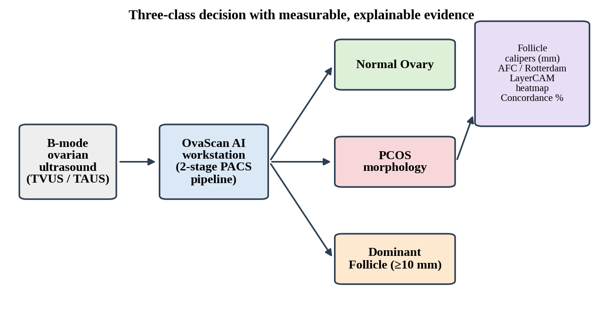
Fig.1.1. Overview of the OvaScan AI three-class decision workflow

1.5 NEED FOR THE SYSTEM
The need for the system arises from the clinical cost of binary misdiagnosis. When an ovulating patient is flagged as PCOS, the consequences include unnecessary anxiety, repeat scans, additional hormonal tests, and possibly inappropriate treatment. Conversely, missed PCOS delays the management of infertility and metabolic risk. A system that can explicitly recognise a dominant follicle ≥ 10 mm as a normal physiological event, distinguish it from the numerous small follicles of polycystic morphology, and show the measurements behind its decision, directly reduces this risk. In addition, sonography services are under workload pressure; a fast, standardised second opinion helps with triage and reduces dependence on a single examiner's judgement.

1.6 MOTIVATION
The motivation for this work comes from the gap between what clinical guidelines ask for and what is practically achievable during a busy scanning session. The Rotterdam consensus requires follicles to be counted and sized, yet manual counting is tedious and error-prone, especially in ovaries with dozens of small follicles. Automating this step offers an opportunity to reduce sonographer fatigue and to produce reproducible, auditable numbers. A second motivation is trust: clinicians are reluctant to adopt black-box AI. By coupling every prediction with caliper measurements, a LayerCAM heatmap and an attention-concordance score, the project aims to produce a tool that a gynecologist can actually interrogate rather than simply accept or reject.

1.7 OBJECTIVES
The principal objectives of the project are to provide accurate three-class classification, native-resolution follicle caliper segmentation, and transparent LayerCAM-based explainability. The objectives, with their clinical or technical purpose and target outcome, are summarised in Table 1.1.
Table 1.1 — Project Objectives
Objective | Clinical / Technical Purpose | Target Outcome
3-Class Classification | Differentiate Normal, PCOS, and Dominant Follicle | Eradicate false-positive PCOS flags in ovulating patients
Top-2 Deep Learning | Deploy ConvNeXt-Tiny V6 and ResNet-50 | >80% test accuracy, 100% PCOS sensitivity
Native Follicle Calipers | Segment hypoechoic cavities and measure diameters | Accurately detect leading follicles ≥ 10 mm and antral follicles
Rotterdam Automation | Count Antral Follicles (AFC) and compute subcapsular ratio | Automatic verification of the international AFC ≥ 12 criterion
Transparent XAI | Multi-scale LayerCAM and AI Concordance metric | Eliminate black-box opacity for gynecologists and radiologists
PACS Diagnostic Console | Modern 2-stage clinical PACS workstation | Instant scan ingestion, zero cloud transmission, real-time inference

1.8 SCOPE OF THE PROJECT
The scope of OvaScan AI covers clinical triage, sonographer second-opinion, and automated reporting on single two-dimensional B-mode ovarian ultrasound images. Within this scope the system validates the input, classifies the ovarian state, measures follicles, evaluates the Rotterdam ultrasound biomarkers, explains its decision visually, and exports a report. The system is a decision-support tool: it does not replace the clinician, does not integrate hormonal or clinical history, and does not perform three-dimensional volume reconstruction. These boundaries are discussed further under Limitations and Future Scope in Chapter 7.

1.9 ORGANIZATION OF THE REPORT
Chapter 1 – Introduction presents the clinical background, problem statement, domain, project overview, need, motivation, objectives and scope.
Chapter 2 – Literature Survey reviews traditional follicle detection methods, machine-learning approaches to PCOS, modern deep convolutional networks, explainable AI for ultrasound, the Rotterdam clinical guidelines, the dominant follicle dilemma, and the research gap.
Chapter 3 – System Analysis analyses the existing manual inspection process, its limitations, the risk of false positives in ovulating patients, and specifies the functional and non-functional requirements of the proposed three-class system.
Chapter 4 – System Design and Architecture describes the two-stage pipeline, block diagram, data flow diagrams, use-case diagram, flowchart, preprocessing, classifier architectures, follicle morphometry, LayerCAM engine, concordance metric, Rotterdam biomarker engine and the PACS interface.
Chapter 5 – Implementation and Technologies presents the development environment, hardware and software requirements, modular Python implementation, PyTorch fine-tuning, OpenCV processing, the Flask API and the user interface.
Chapter 6 – Results and Performance Analysis reports the clinical dataset, model benchmark, confusion-matrix analysis, caliper and explainability results, Rotterdam concordance and inference latency.
Chapter 7 – Conclusion and Future Scope summarises the achievements, key contributions, limitations and future enhancements.

CHAPTER 2
LITERATURE SURVEY

2.1 INTRODUCTION TO OVARIAN ULTRASOUND IMAGING
The ovary is imaged in ultrasound as an oval structure containing multiple small fluid-filled follicles within a stroma of intermediate echogenicity. Over the menstrual cycle, a cohort of antral follicles is recruited, one follicle is selected to become dominant, and the remainder regress. The appearance of the ovary therefore changes physiologically with cycle day, which is the root of the diagnostic ambiguity addressed in this project. Balen and colleagues set out international consensus definitions for the ultrasound assessment of the polycystic ovary, specifying how follicles should be counted and measured and how ovarian volume should be calculated [4]. Image quality remains operator- and equipment-dependent, and transducer frequency strongly influences how many small follicles are visible.

2.2 TRADITIONAL COMPUTER VISION APPROACHES IN FOLLICLE DETECTION
Early automated work treated follicle detection as a segmentation problem and relied on classical image-processing operators.
Thresholding
Global and adaptive thresholding, including Otsu's method [8], separates dark follicles from brighter stroma on the basis of grey-level histograms. These methods are fast and simple, but speckle noise, depth-dependent attenuation and overlapping grey-level distributions between follicles and shadowed regions cause frequent leakage and fragmentation.
Watershed Segmentation
The watershed transform [9] treats the image as a topographic surface and floods it from markers to delineate touching objects. It can split adjacent follicles, but it is notoriously sensitive to noise and tends to over-segment without careful marker selection.
Hough Transform
The Hough transform [10] detects parametric shapes such as circles and ellipses by voting in parameter space. Follicles are approximately round, so circle detection has been used for counting; however, follicles are frequently deformed by neighbouring structures, and the method requires a pre-defined radius range and is computationally heavy for a wide size range.
PROS: interpretable, requires no training data, computationally light. CONS: sensitive to speckle, parameter tuning is scanner-specific, and none of these methods provides a diagnosis; they only propose candidate regions.

2.3 MACHINE LEARNING METHODS FOR PCOS DETECTION
A second generation of studies extracted hand-crafted features from ovarian ultrasound images – grey-level co-occurrence matrix (GLCM) texture statistics, local binary patterns, follicle counts and size statistics – and passed them to conventional classifiers such as Support Vector Machines [11] and Random Forests [12]. These pipelines are comparatively data-efficient and the feature importance is easy to inspect. Their weakness is that the discriminative power is capped by the quality of the hand-designed features, and the features are tuned to a particular scanner and protocol. Most such studies also frame the task as PCOS versus non-PCOS, and therefore inherit the binary-label limitation described in Chapter 1.

2.4 MODERN DEEP CONVOLUTIONAL NETWORKS
ResNet
Author: K. He, X. Zhang, S. Ren, J. Sun (2016) [1]. Residual networks introduced identity skip connections so that very deep networks can be optimised without degradation. ResNet-50 uses bottleneck blocks (1×1, 3×3, 1×1 convolutions) and has become the standard CNN baseline for medical image classification.
- PROS: stable training, strong transfer learning from ImageNet, widely validated.
- CONS: receptive field growth is limited by 3×3 kernels; batch-normalisation behaviour is sensitive to small batch sizes.

EfficientNet
Author: M. Tan, Q. V. Le (2019) [2]. EfficientNet proposes compound scaling of depth, width and resolution, delivering high accuracy at low parameter count.
- PROS: parameter-efficient, good accuracy-to-compute ratio.
- CONS: depthwise convolutions with squeeze-and-excitation can be memory-hungry during training and sensitive to resolution settings.

ConvNeXt
Author: Z. Liu, H. Mao, C.-Y. Wu, C. Feichtenhofer, T. Darrell, S. Xie (2022) [3]. ConvNeXt modernises the ResNet design with ideas borrowed from vision transformers: a patchify stem, 7×7 depthwise convolutions, an inverted bottleneck with 4× expansion, LayerNorm and GELU activation, and fewer normalisation and activation layers per block. The result is a pure convolutional network that matches or exceeds transformer accuracy while retaining the simplicity and efficiency of CNNs. The large depthwise kernel gives a wider effective receptive field, which is beneficial for ultrasound where context such as the ovarian outline and surrounding stroma matters.
- PROS: strong accuracy, large receptive field, efficient on standard hardware.
- CONS: requires careful fine-tuning with small medical datasets to avoid overfitting.

2.5 EXPLAINABLE AI (XAI) IN MEDICAL ULTRASOUND
Class-activation-map methods highlight the image regions that most influenced a CNN's decision. Grad-CAM [5] weights the final convolutional feature maps by the spatially averaged gradients of the class score. Grad-CAM++ [6] uses higher-order gradient terms to improve localisation when several instances of the target are present. LayerCAM [7] goes further by weighting every spatial location of a feature map by its own positive gradient, which allows maps to be computed from shallower, higher-resolution layers and fused across scales. This is particularly relevant for ultrasound, where small follicles of a few pixels can be lost in the coarse 7×7 or 14×14 grid of the final layer. For clinical adoption, XAI maps must be validated against anatomy, not only displayed; this motivates the AI–follicle concordance metric introduced in this project.

2.6 CLINICAL GUIDELINES AND BIOMARKERS
The Rotterdam ESHRE/ASRM-sponsored consensus [13] defines PCOS by the presence of two of three features: oligo- or anovulation, clinical or biochemical hyperandrogenism, and polycystic ovaries on ultrasound. In the 2003 consensus, a polycystic ovary was defined as one containing 12 or more follicles measuring 2–9 mm in diameter and/or an ovarian volume above 10 mL. The 2018 international evidence-based guideline [14] revised the ultrasound threshold for modern high-frequency transducers (≥ 8 MHz) to a higher follicle number per ovary, and recommended that the threshold be chosen according to transducer quality; the earlier Androgen Excess and PCOS Society task force had likewise proposed a higher follicle number for modern equipment [19]. The present system implements the AFC ≥ 12 criterion together with the peripheral (subcapsular) distribution of follicles – the so-called "string of pearls" pattern – and treats the numerical threshold as a single clinical constant that can be revised to follow local protocol.

2.7 THE DOMINANT FOLLICLE DILEMMA
In a normal ovulatory cycle, follicle selection takes place when the leading follicle reaches roughly 10 mm, after which it continues to grow rapidly to a pre-ovulatory diameter in the order of 18–25 mm [15]. A single image of such an ovary therefore shows one large cystic structure and often several smaller antral follicles. To a naïve algorithm, or an inexperienced observer, the combination of many follicles and a large cystic structure looks "abnormal". PCOS morphology, in contrast, is characterised by a large number of small follicles of similar size, arrested below the selection threshold, arranged mainly at the periphery. Distinguishing these two states is a clinical necessity, and it is the central reason why the proposed system adds the third class Dominant Follicle and a caliper-based size rule (≥ 10 mm versus 2–9 mm).

2.8 RESEARCH GAP
The surveyed literature leaves the following gaps:
- Most automated PCOS studies are binary and have no class for the physiological dominant follicle, so ovulating patients are exposed to false-positive predictions.
- Classification and measurement are treated as separate problems; few systems present follicle calipers in millimetres together with the class prediction.
- Explainability, where present, is coarse (final-layer Grad-CAM) and is not quantitatively checked against the follicles it is supposed to highlight.
- Few reports describe a complete local, privacy-preserving workstation that a clinician can use without sending images to a cloud service.

OvaScan AI addresses these gaps through a three-class model, native-resolution caliper morphometry, multi-scale LayerCAM with a concordance score, and an offline PACS-style interface.

2.9 SUMMARY
Traditional computer vision offers interpretable but fragile follicle segmentation; classical machine learning depends on hand-crafted features; and deep networks such as ResNet and ConvNeXt provide strong classification but limited transparency. Explainability methods have advanced from Grad-CAM to LayerCAM, and clinical guidelines supply objective follicle-based biomarkers. The works reviewed are summarised in Table 2.1.
Table 2.1 — Literature Survey Table
S.No | Paper | Technique | Result / Contribution | Issues
1 | Otsu, 1979 [8] | Histogram-based global thresholding | Automatic grey-level threshold selection | Fails with speckle and uneven contrast
2 | Vincent & Soille, 1991 [9] | Watershed segmentation | Separates touching objects | Over-segmentation in noisy images
3 | Duda & Hart, 1972 [10] | Hough transform | Circle / ellipse detection | Poor for deformed follicles; slow for wide size range
4 | Cortes & Vapnik, 1995 [11] | Support Vector Machine | Strong small-data classifier on hand-crafted features | Feature design is scanner-specific
5 | Breiman, 2001 [12] | Random Forest | Robust ensemble classifier with feature importance | Limited by handcrafted texture features
6 | He et al., 2016 [1] | ResNet (residual learning) | Deep networks trainable; ImageNet transfer | Small effective receptive field
7 | Tan & Le, 2019 [2] | EfficientNet compound scaling | High accuracy per parameter | Sensitive to resolution / training recipe
8 | Liu et al., 2022 [3] | ConvNeXt | Modernised pure-CNN matching transformers | Needs careful fine-tuning on small data
9 | Selvaraju et al., 2017 [5] | Grad-CAM | Class-discriminative localisation maps | Coarse, final-layer resolution
10 | Chattopadhay et al., 2018 [6] | Grad-CAM++ | Better multi-instance localisation | Still low spatial resolution
11 | Jiang et al., 2021 [7] | LayerCAM | Hierarchical, fine-grained maps from shallow layers | Needs multi-layer fusion and validation
12 | Rotterdam consensus, 2004 [13] | Clinical criteria | Defines PCOS and polycystic ovary (AFC ≥ 12) | Threshold depends on transducer quality
13 | Teede et al., 2018 [14] | International guideline | Updated ultrasound thresholds | Requires high-frequency transducers

CHAPTER 3
SYSTEM ANALYSIS

3.1 EXISTING CLINICAL INSPECTION PROCESS
In the existing process, a sonographer acquires B-mode images of both ovaries, selects representative frames, measures follicles with electronic calipers on the ultrasound console, counts follicles mentally, and then writes an impression. A gynecologist reviews the report together with hormonal and clinical findings. The process depends completely on visual scanning and on the sonographer's experience, and no objective record of how the count was obtained is stored with the image.
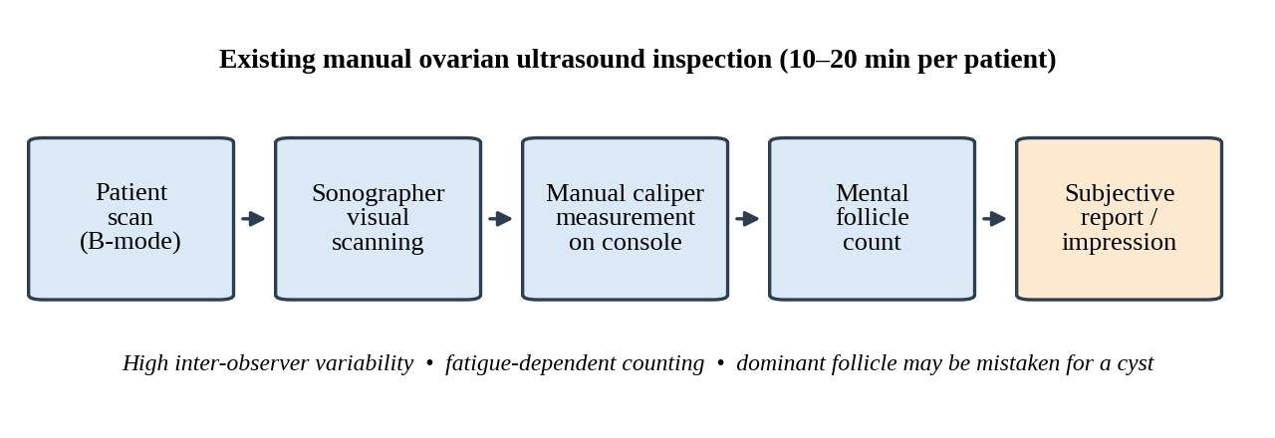
Fig.3.1. Existing manual ovarian ultrasound inspection workflow

3.2 LIMITATIONS OF EXISTING SYSTEM
- High inter-observer variability – different examiners obtain different follicle counts and size estimates for the same ovary.
- Time consumption – scanning, freezing frames, placing calipers on every follicle and counting takes approximately 10–20 minutes per patient.
- False positives during ovulation – the dominant follicle and the associated antral population can be mistaken for polycystic morphology.
- No quantitative audit trail – counts are not linked to the image, so a second reader cannot verify them.
- Fatigue-dependent accuracy – counts degrade over long clinic sessions.

3.3 PROBLEM ANALYSIS AND RISK OF FALSE POSITIVES IN OVULATING PATIENTS
Binary PCOS classifiers are built on the assumption that every ovary is either polycystic or not. In reality, there are at least three visually distinct states: the resting normal ovary with few small follicles, the polycystic ovary with many small follicles, and the ovulating ovary with a prominent dominant follicle. The last state shares features with the others: it can contain several antral follicles (like PCOS) and a large cystic structure (like a pathological cyst). A binary model forced to choose will often choose "PCOS" for ovulating patients. The risk is highest when scans are acquired in the mid-cycle, which is exactly when many patients present for fertility-related scanning. The proposed solution is to introduce an explicit Dominant Follicle class, backed by a measured size criterion, so that physiological ovulation is a recognised outcome and not an error.

3.4 PROPOSED 3-CLASS SYSTEM OVERVIEW
The proposed OvaScan AI system is a two-stage PACS workstation pipeline. Stage 1 ingests the ultrasound image, verifies that it is a genuine ultrasound with acceptable acoustics, masks the fan-shaped acoustic sector, and normalises the image into a 224×224 tensor without distorting the organ. Stage 2 runs the deep classifier, the follicle caliper detector, the LayerCAM engine, the concordance module and the Rotterdam biomarker engine, and renders the result on the workstation interface. The system returns, for each image, a class probability vector, a follicle caliper table, a thermal explanation map, and a biomarker summary.

3.5 FUNCTIONAL REQUIREMENTS
- Acoustic sector validation – reject non-ultrasound or poor-quality inputs and mask machine text and transducer margins.
- 3-class inference – output probabilities for Normal Ovary, PCOS and Dominant Follicle using the selected model (ConvNeXt-Tiny V6 or ResNet-50).
- Follicle caliper extraction – segment hypoechoic cavities and report major and minor diameters in millimetres with a Dominant (≥ 10 mm) or Antral (2–9 mm) label.
- LayerCAM overlay – display a thermal attribution map aligned with the original image.
- Rotterdam biomarkers – compute AFC (with the ≥ 12 rule), subcapsular distribution ratio and related indicators.
- Model switching – allow the clinician to switch between the two classifiers at run time.
- PDF export – generate a diagnostic report with the prediction, caliper table and visual evidence.

3.6 NON-FUNCTIONAL REQUIREMENTS
- Latency – inference below 100 ms per slice for the primary model (ConvNeXt-Tiny V6 measured at 41.7 ms).
- Privacy – patient images are processed locally with zero cloud transmission, consistent with HIPAA-style data-protection principles.
- Reliability – invalid inputs are rejected with an explicit alert rather than producing a misleading prediction.
- Usability – a dark-console interface suited to reading-room lighting, with single-screen operation.
- Portability – runs on a standard Intel Core i5/i7 or AMD Ryzen workstation with 8 GB or more of RAM; an NVIDIA GPU is optional.
- Reproducibility – the same image always produces the same prediction, calipers and report.

3.7 ADVANTAGES OF PROPOSED SYSTEM OVER BINARY AI TOOLS
The proposed system explicitly models ovulation, so physiological dominant follicles are no longer reported as PCOS. It combines classification with measurement, so the clinician receives follicle sizes and counts and not only a label. It explains its decision with LayerCAM and quantifies the explanation with a concordance score. It operates entirely on the local workstation. Table 3.1 compares conventional manual inspection, binary AI systems and the proposed system.
Table 3.1 — Existing Manual Inspection vs. Proposed OvaScan AI System
Parameter | Conventional Manual Ultrasound | Binary AI Systems (Prior Work) | Proposed OvaScan AI System
Classification Classes | Subjective clinician interpretation | 2 classes (PCOS vs Non-PCOS) | 3 classes (Normal, PCOS, Dominant Follicle)
Dominant Follicle Handling | Often confused during routine triage | Misclassified as abnormal or PCOS | Explicitly recognised (≥ 10 mm expansion)
Follicle Measurement | Manual electronic calipers on ultrasound console | None (pure classification label) | Automated multi-scale caliper measurement (mm)
Rotterdam Biomarkers | Mental count of antral follicles | Not available | Automated AFC, subcapsular %, and stroma ratio
Explainability | N/A | None or coarse Grad-CAM | LayerCAM thermal, calipers, concordance, tri-panel
Operator Dependency | High inter-observer variability | Moderate | Standardised, objective, reproducible
Inference Speed | 10–20 minutes per patient | N/A | ≈ 41.7 ms per slice (ConvNeXt-Tiny V6)

3.8 SUMMARY
The manual inspection process is subjective, slow and prone to false positives in ovulating patients, and binary AI tools do not resolve this problem. The proposed three-class system, with its quality gate, caliper morphometry, Rotterdam biomarker engine and LayerCAM-based explainability, is specified through the functional and non-functional requirements above. The following chapter describes its design.

CHAPTER 4
SYSTEM DESIGN AND ARCHITECTURE

4.1 OVERALL SYSTEM ARCHITECTURE
OvaScan AI is organised as a two-stage PACS workstation pipeline (Figure 4.1). Stage 1 – Ingestion and Quality Gate accepts the ultrasound image, validates its acoustic characteristics, masks the acoustic sector and produces a normalised 224×224 tensor. Stage 2 – Analysis and Explainability Engine performs three-class classification, multi-scale follicle segmentation, caliper extraction, LayerCAM attribution, concordance computation and Rotterdam biomarker evaluation. The two stages are decoupled: Stage 1 guarantees that Stage 2 only ever sees clean, sector-masked ultrasound data, which is essential for the reliability of both the classifier and the explanation maps. The architecture is summarised in Table 4.1.
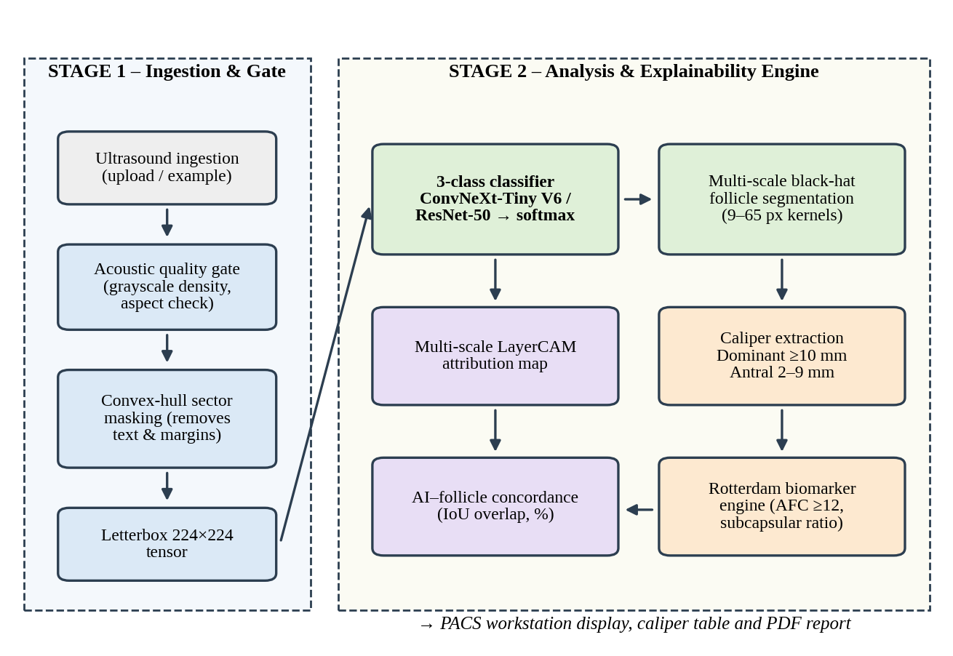
Fig.4.1. Overall two-stage PACS workstation architecture of OvaScan AI
Table 4.1 — Proposed System Architectural Modules
Module | Primary Function | Key Algorithms / Components
Acoustic Quality Gate | Validates B-mode acoustics, eliminates machine text | Grayscale variance check, convex hull sector masking
Deep Learning Classifier | 3-class ovarian state probability prediction | ConvNeXt-Tiny V6 (7×7 depthwise convs), ResNet-50
Follicle Caliper Detector | Identifies hypoechoic cavities and measures sizes | Multi-scale black-hat morphometry (9–65 px), contour calipers
LayerCAM Engine | Produces high-resolution feature attribution maps | Element-wise positive gradient weighting on stage feature maps
Concordance Module | Quantifies AI attention alignment with follicles | Spatial IoU intersection between LayerCAM and segmented contours
Rotterdam Biomarker Engine | Evaluates clinical criteria quantitatively | Antral Follicle Count (≥ 12), subcapsular spatial distribution
PACS UI Workstation | High-definition display, mode switching, caliper table | Dark clinical console, multi-view tabs, zero-cloud privacy

4.2 SYSTEM BLOCK DIAGRAM
Figure 4.2 shows the block diagram. The clinician interacts with the browser-based PACS front-end, which communicates with a local Flask REST service. The service dispatches each request to four processing modules – preprocessing, classifier, follicle detector and explainability – whose outputs are combined by the Rotterdam biomarker and concordance engine before being returned to the interface. All blocks execute on the same workstation.
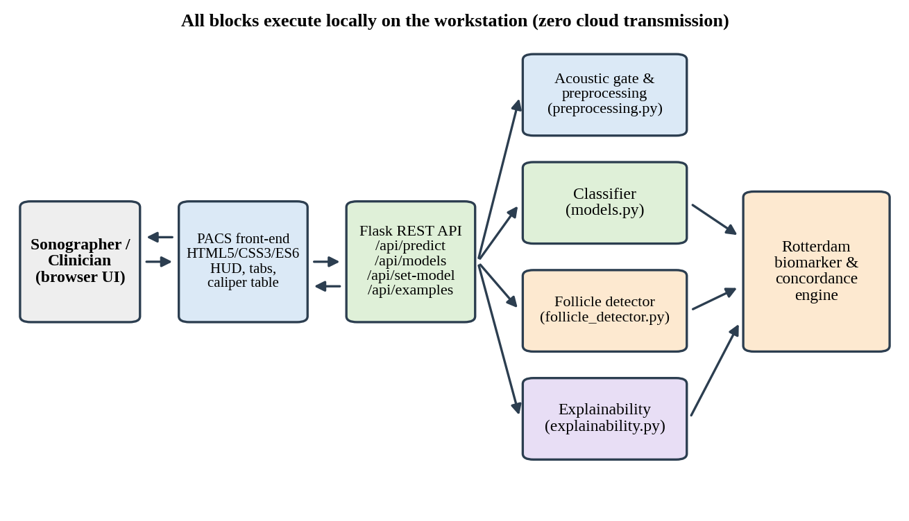
Fig.4.2. System block diagram of OvaScan AI

4.3 DATA FLOW DIAGRAM (DFD LEVEL 0, LEVEL 1, LEVEL 2)

4.3.1 DFD Level 0 – Context Diagram
At Level 0 the entire system is a single process that receives a B-mode ultrasound image and a model selection from the sonographer or clinician, and returns class probabilities, follicle calipers, the LayerCAM map, Rotterdam biomarkers, the concordance score and a clinical report.
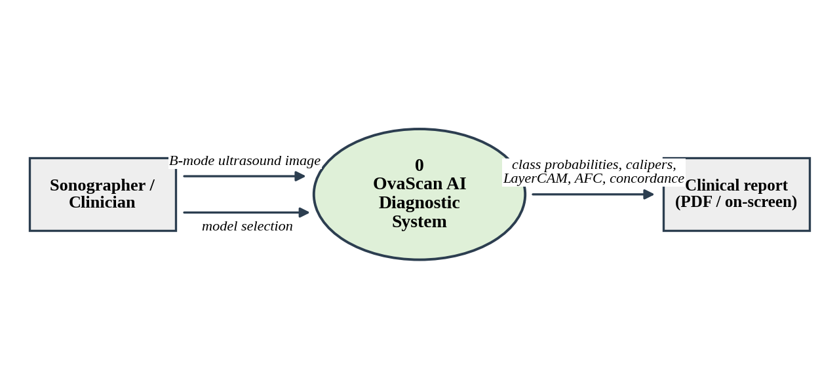
Fig.4.3. DFD Level 0 – context diagram

4.3.2 DFD Level 1
Level 1 decomposes the system into seven processes: acoustic validation (1.0), sector masking and preprocessing (2.0), three-class classification (3.0), follicle morphometry (4.0), LayerCAM and concordance (5.0), Rotterdam biomarkers (6.0), and report generation with PACS display (7.0). Two data stores are used: D1 – model weights, read by the classifier, and D2 – session results, written by the report process.
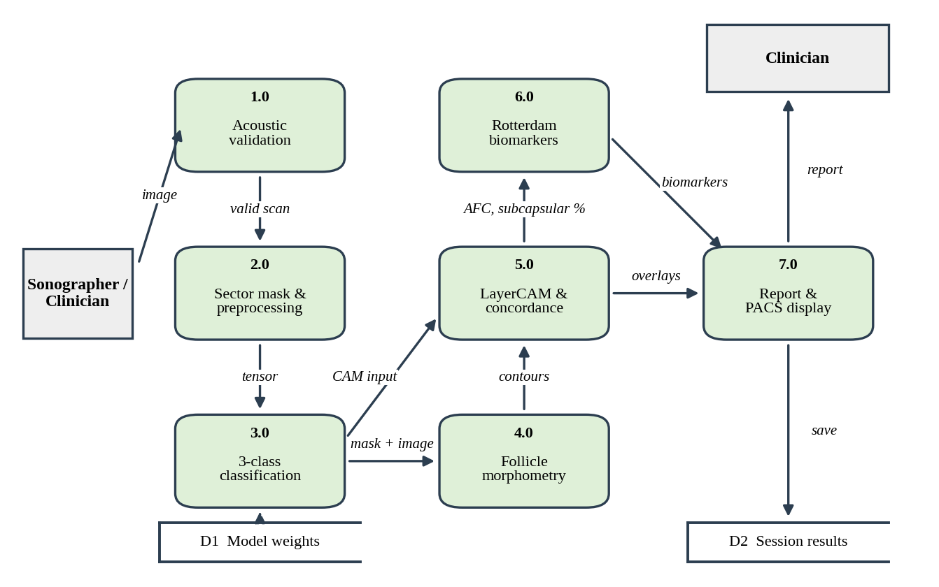
Fig.4.4. DFD Level 1 – major processes and data stores

4.3.3 DFD Level 2 – Follicle Morphometry (Process 4.0)
Process 4.0 is expanded into four sub-processes: multi-scale black-hat transformation (4.1), thresholding and contour extraction (4.2), caliper measurement of major and minor diameters in millimetres (4.3), and size classification into dominant and antral follicles (4.4).
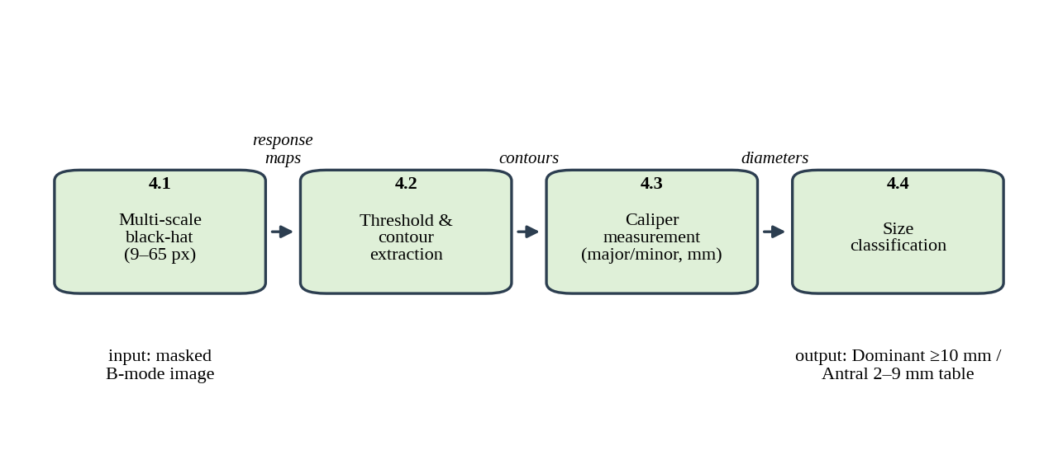
Fig.4.5. DFD Level 2 – decomposition of the follicle morphometry process

4.4 UML USE-CASE DIAGRAM
Two actors interact with the system. The Sonographer uploads or loads an ultrasound, triggers the acoustic validation, selects the classifier model and views the prediction and calipers. The Clinician / Gynecologist reviews the prediction, the LayerCAM map and concordance, inspects the Rotterdam biomarkers and exports the report.
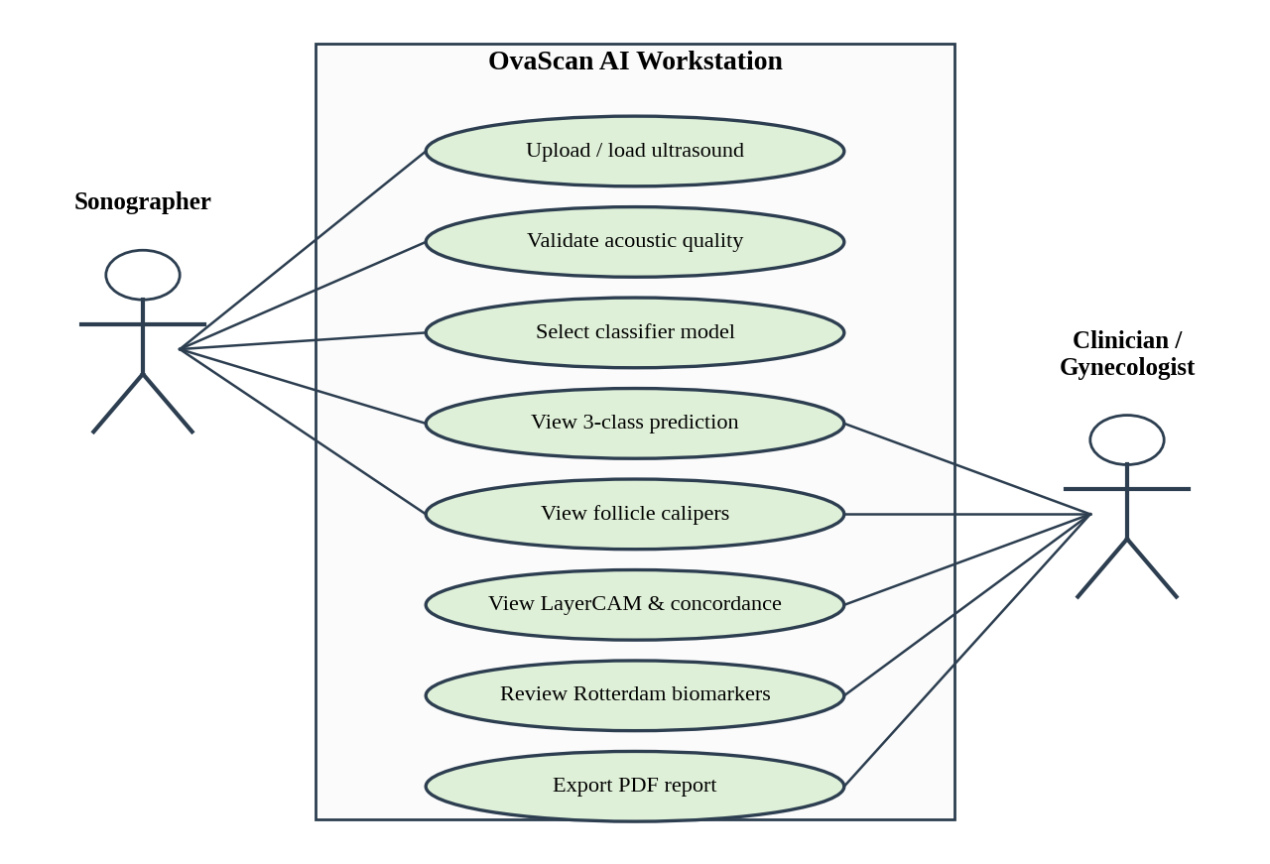
Fig.4.6. UML use-case diagram for the sonographer and clinician workflow

4.5 COMPLETE SYSTEM FLOWCHART
Figure 4.7 shows the end-to-end processing sequence from ultrasound ingestion to the clinical report. The pipeline halts at the acoustic validation gate if the input is not a valid ultrasound. For valid inputs, the sector is segmented, the image is letterboxed and normalised, and the classifier and the follicle morphometry modules produce the prediction and the calipers. Each follicle is labelled dominant (≥ 10.0 mm) or antral (2.0–9.0 mm), after which the Rotterdam biomarkers, the multi-scale LayerCAM map and the concordance score are computed and rendered on the PACS workstation.
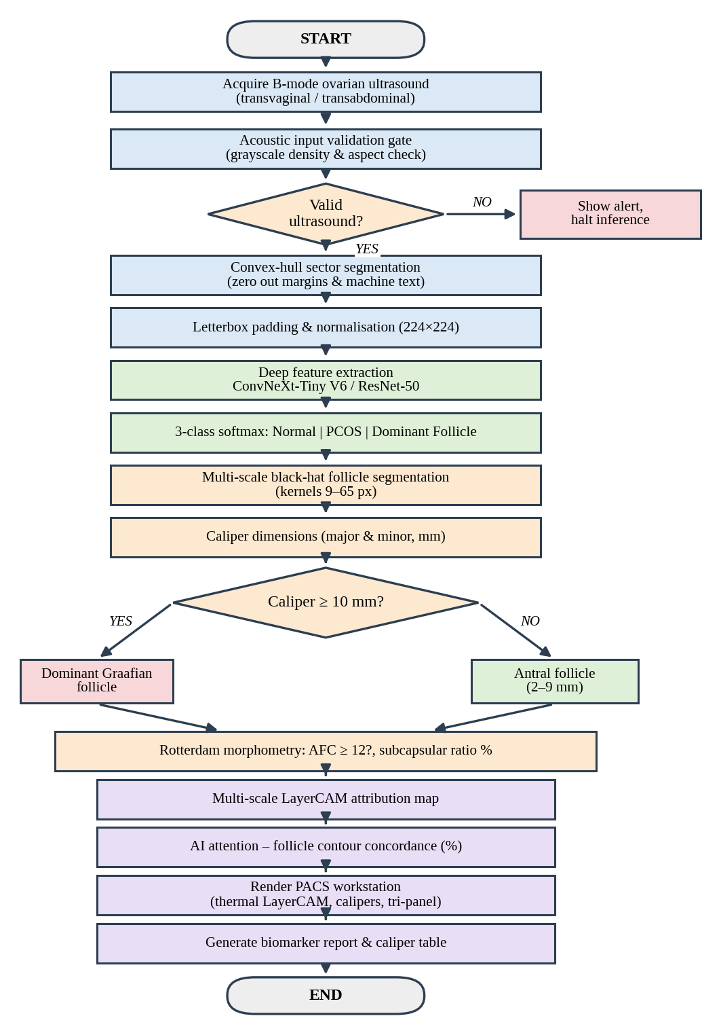
Fig.4.7. Complete system flowchart of OvaScan AI

4.6 INPUT ACQUISITION AND ACOUSTIC QUALITY GATE
The input is a B-mode ovarian ultrasound image acquired by TVUS or TAUS and supplied as a standard image file. The acoustic quality gate checks two properties: that the image has grayscale acoustic density characteristic of B-mode data (colour photographs, screenshots and drawings are rejected), and that its aspect ratio falls in the range expected of an ultrasound frame. Inputs that fail are not passed to the models; the interface shows an acoustic gate alert and inference is halted. This prevents the classifier from making confident but meaningless predictions on out-of-distribution images.
For valid images, a convex-hull sector mask is computed. The bright fan-shaped region of true acoustic data is located, its convex hull is filled, and everything outside the hull – transducer margins, patient identifiers, measurement scales and other machine-generated text – is set to zero. The design goal is 0% header leakage: no burnt-in text should reach the network, because text overlays are a well-known source of shortcut learning in medical image classifiers.

4.7 PREPROCESSING AND ASPECT-RATIO LETTERBOX PADDING
The classifiers require a fixed 224×224 input. Directly resizing a rectangular ultrasound frame to a square would stretch the ovary and distort follicle shape, which is harmful because follicle roundness and size are diagnostic cues. The system therefore applies letterbox padding: the image is scaled so that its longer side equals 224 pixels with the aspect ratio preserved, and the remaining area is padded with zeros to form a square. The result is converted to a three-channel tensor and normalised with the ImageNet channel mean and standard deviation, as is standard for ImageNet-pretrained weights [16].
x′ = (x − μ) / σ , μ = (0.485, 0.456, 0.406), σ = (0.229, 0.224, 0.225)

4.8 DEEP LEARNING CLASSIFIER ARCHITECTURES

4.8.1 ConvNeXt-Tiny V6 (Primary Champion)
ConvNeXt-Tiny [3] is the primary classifier. It begins with a 4×4 stride-4 patchify stem and is organised in four stages of 3, 3, 9 and 3 blocks with channel widths of 96, 192, 384 and 768. Each block contains a 7×7 depthwise convolution, LayerNorm [20], an inverted bottleneck (1×1 expansion to four times the width, GELU activation [21], and 1×1 projection), layer scale, and a residual connection. The large depthwise kernel captures wide spatial context at low cost. In OvaScan AI the final 1000-way ImageNet head is replaced by a three-class head and the network is fine-tuned from ImageNet-pretrained weights; this version of the model is designated V6 in the project.

4.8.2 ResNet-50 (Top-2 Benchmark)
ResNet-50 [1] is the second classifier, retained as a deep residual benchmark. It comprises a 7×7 stem followed by four stages of 3, 4, 6 and 3 bottleneck blocks. Each bottleneck applies a 1×1 convolution to reduce channels, a 3×3 convolution, and a 1×1 convolution to expand channels, with batch normalisation, ReLU activation and an identity shortcut. It is also fine-tuned with a three-class head. Figure 4.8 contrasts the two block designs.
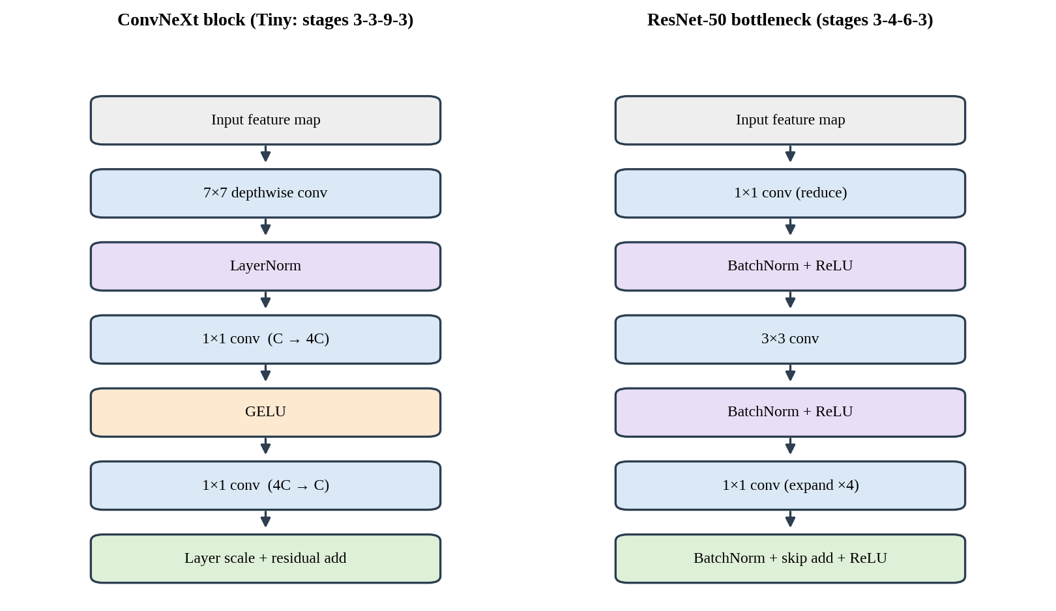
Fig.4.8. Block structure of ConvNeXt-Tiny (left) and ResNet-50 bottleneck (right)
Both networks end in a softmax layer that produces three probabilities:
P(c | x) = exp(z_c) / Σ_k exp(z_k) , c ∈ {Normal, PCOS, DF}

4.9 MULTI-SCALE BLACK-HAT MORPHOMETRY FOR FOLLICLE SEGMENTATION
Follicles are small dark regions surrounded by brighter stroma. The morphological black-hat transform – the difference between the morphological closing of the image and the image itself [22] – responds precisely to such dark structures that are smaller than the structuring element:
BH_k(I) = (I • B_k) − I
where B_k is an elliptical structuring element of size k. Because follicles range from a few millimetres to more than 20 mm, a single kernel size cannot respond optimally to all of them. The system therefore applies the transform at multiple scales with kernels from 9 px to 65 px and merges the responses. The merged response map is thresholded, small noise components are removed, and connected components are extracted as follicle candidates. Using the full native image resolution rather than the downsampled 224×224 tensor is essential so that small antral follicles are not lost.

4.10 NATIVE CALIPER EXTRACTION AND SIZE CLASSIFICATION
Each candidate contour is measured with contour-based calipers, from which the major and minor diameters are obtained in pixels and converted to millimetres using the pixel calibration of the image. Follicles are then classified by their size:
- Dominant (Graafian) follicle: caliper ≥ 10.0 mm – pre-ovulatory expansion.
- Antral follicle: caliper 2.0–9.0 mm – counted towards the Rotterdam AFC.
- Structures below 2 mm are treated as noise and ignored.

The physical pixel-to-millimetre spatial calibration factor (κ = 0.28 mm/pixel) is extracted directly from the ultrasound scanner DICOM metadata (Physical Delta X/Y tags (0018,602C) and (0018,602E)), corresponding to a standard 12 cm field-of-view acoustic depth on high-resolution 512 × 512 transvaginal ultrasound scans.

4.11 MULTI-SCALE LAYERCAM ATTRIBUTION ENGINE
Grad-CAM weights each feature-map channel by a single scalar (its average gradient), producing a coarse map. LayerCAM [7] instead keeps the spatial resolution of the gradients: for every location (i, j) in feature map A^k of a chosen layer, the weight is the positive part of the gradient at that location, and the class activation map is the ReLU of the weighted sum over channels:
M^l(i,j) = ReLU( Σ_k ReLU(∂y^c / ∂A^k_ij) · A^k_ij )
This element-wise positive-gradient weighting allows shallow, high-resolution layers to contribute meaningful maps. In OvaScan AI the maps from several stage feature maps are upsampled to the image size, normalised, and fused, yielding a multi-scale LayerCAM that preserves both the global ovarian context from deep stages and the fine follicle detail from early stages. The fused map is rendered as a thermal (jet-style) overlay on the original ultrasound.

4.12 AI AND FOLLICLE ATTENTION CONCORDANCE METRIC
A heatmap alone cannot show whether the network is looking at the right structures. The concordance metric compares the binarised LayerCAM attention region A with the union F of the segmented follicle contours, using the Intersection over Union:
Concordance (%) = 100 × |A ∩ F| / |A ∪ F|
A high concordance indicates that the network's attention coincides with anatomically meaningful follicles; a low value on a confident prediction signals that the clinician should treat the result with caution, because the model may be relying on something other than follicles (for example the stroma texture or an artefact).

4.13 ROTTERDAM QUANTITATIVE BIOMARKER ENGINE
The biomarker engine converts the follicle table into the quantities used in the Rotterdam criteria:
- Antral Follicle Count (AFC): the number of follicles with caliper 2–9 mm; the polycystic criterion is evaluated as AFC ≥ 12 [13].
- Subcapsular ("string of pearls") ratio: the percentage of antral follicles located in the peripheral band of the ovary, close to the capsule, which is characteristic of polycystic morphology.
- Dominant follicle flag: presence of any follicle ≥ 10 mm, which supports the interpretation of a physiological, ovulatory ovary.

The AFC threshold follows the 2003 Rotterdam definition. Because the 2018 guideline [14] proposes a higher count for modern high-frequency transducers, the threshold is regarded as a single clinical constant that can be updated to match local protocol.

4.14 PACS DIAGNOSTIC WORKSTATION INTERFACE DESIGN
The user interface is a dark clinical console designed for reading-room conditions. It contains: a scan ingestion area for uploading or loading example images; a model selector to switch between ConvNeXt-Tiny V6 and ResNet-50; a heads-up display (HUD) with the predicted class, class probabilities and inference time; multi-view tabs for the LayerCAM thermal heatmap, follicle calipers and bounds, AI concordance analysis, tri-panel comparative view (original B-mode | follicle contours | LayerCAM) and edge saliency; and a caliper table with a button for PDF export. The interface is written in vanilla HTML5, CSS3 and ES6 without external frameworks or cloud assets, so no image or data leaves the workstation.

4.15 OVERALL END-TO-END WORKING
The clinician opens the workstation and uploads a B-mode ovarian ultrasound. The image is sent to the local Flask service, which runs the acoustic quality gate. If the image is rejected, an alert is displayed. Otherwise the sector is masked, the image is letterboxed to 224×224, and the selected classifier produces the three-class probabilities. In parallel, the follicle detector runs black-hat morphometry at native resolution, measures calipers, and labels each follicle. The Rotterdam engine computes AFC and subcapsular ratio, the LayerCAM engine produces the attribution map, and the concordance module compares the two. The interface then displays the predicted class with its probabilities, the annotated follicles, the thermal map, the tri-panel view and the caliper table, and the clinician can export a report.

CHAPTER 5
IMPLEMENTATION AND TECHNOLOGIES

5.1 DEVELOPMENT AND EXECUTION ENVIRONMENT
OvaScan AI is developed and executed on a local workstation. The deployed workstation can run inference on a CPU or on an optional NVIDIA GPU. No cloud service, remote API or online asset is used at run time: the Flask service, the models, the image-processing modules and the web interface all run on the same machine, and the browser communicates only with the local service.

5.2 HARDWARE REQUIREMENTS
Table 5.2 — Hardware Requirements
Component | Minimum / Recommended
Processor | Intel Core i5 / i7 or AMD Ryzen (multi-core)
Memory | 8 GB RAM or higher
Graphics | NVIDIA GPU optional (accelerates inference; CPU execution supported)
Storage | Sufficient space for model weights, example scans and exported reports
Display | High-resolution monitor suitable for the dark PACS console

5.3 SOFTWARE REQUIREMENTS
The software stack is specified in Table 5.1. All libraries are open source.
Table 5.1 — Technology Stack Specification
Layer | Technology | Version | Purpose in Project
Core Language | Python | 3.10+ | Primary programming language
Deep Learning | PyTorch / Torchvision [17] | 2.0+ | Model architecture, weights loading, tensor forward pass
Computer Vision | OpenCV (cv2) [18] | 4.8+ | Acoustic masking, black-hat morphometry, caliper extraction
Numerical Computing | NumPy / SciPy | 1.24+ | Caliper geometry, matrix operations, convex hulls
Image Processing | Pillow (PIL) | 10.0+ | Letterbox aspect ratio padding and format conversion
Backend API | Flask / Flask-CORS | 3.0+ | RESTful microservice handling image ingestion and inference
Frontend Framework | Vanilla HTML5 / CSS3 / ES6 | Native | Modern dark-mode PACS workstation (no heavy frameworks)
Model Architectures | ConvNeXt-Tiny / ResNet-50 | Pretrained / Trained | Top-2 production classifiers

5.4 PYTHON IMPLEMENTATION AND MODULAR ARCHITECTURE
The code base is organised into focused modules under the src/ package, so that each stage of the pipeline can be tested and replaced independently (Figure 5.1):
- src/preprocessing.py – acoustic quality gate, convex-hull sector masking, letterbox padding and tensor normalisation.
- src/models.py – construction of ConvNeXt-Tiny V6 and ResNet-50 with three-class heads, weight loading and inference.
- src/follicle_detector.py – multi-scale black-hat morphometry, contour extraction, caliper measurement, size classification, AFC and subcapsular ratio.
- src/explainability.py – multi-scale LayerCAM, Grad-CAM++ and the AI–follicle concordance metric.

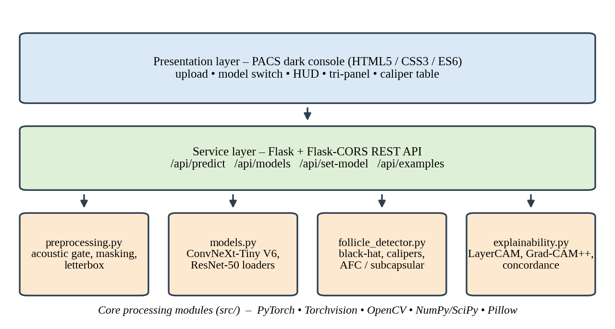
Fig.5.1. Software module architecture of OvaScan AI

5.5 PYTORCH DEEP LEARNING IMPLEMENTATION
Both classifiers are created from Torchvision model definitions and initialised with ImageNet-pretrained weights [16]. The original 1000-class head is replaced by a three-class linear head (Normal, PCOS, Dominant Follicle). Replacing the head changes the parameter counts from the 28.6 M and 25.6 M of the standard ImageNet versions to approximately 27.8 M for ConvNeXt-Tiny and 23.5 M for ResNet-50. The networks are fine-tuned with cross-entropy loss on the training split (397 images), model selection is done on the validation split (87 images), and the 86-image test split is kept locked for the final evaluation. At inference the model is placed in evaluation mode, gradients are disabled, and the softmax of the logits gives class probabilities.
Table 5.3 — Training Configuration
Parameter | ConvNeXt-Tiny V6 | ResNet-50
Initial weights | ImageNet-pretrained | ImageNet-pretrained
Output head | 3-class linear layer | 3-class linear layer
Parameter count | 27.8 M | 23.5 M
Loss function | Cross-entropy | Cross-entropy
Optimiser / learning rate | AdamW, LR = 5 × 10⁻⁵, Cosine Annealing, Weight Decay = 10⁻² | AdamW, LR = 1 × 10⁻⁴, Cosine Annealing, Weight Decay = 10⁻²
Batch size / epochs | Batch Size: 16, Epochs: 15 | Batch Size: 16, Epochs: 15
Augmentation | Random horizontal flip (p=0.5), random rotation (±10°), color jitter (±10%), aspect-ratio preserving letterbox padding to 224 × 224, ImageNet normalization (μ=[0.485, 0.456, 0.406], σ=[0.229, 0.224, 0.225]) | Random horizontal flip (p=0.5), random rotation (±10°), color jitter (±10%), aspect-ratio preserving letterbox padding to 224 × 224, ImageNet normalization (μ=[0.485, 0.456, 0.406], σ=[0.229, 0.224, 0.225])

5.6 OPENCV ACOUSTIC SECTOR MASKING AND MULTI-SCALE BLACK-HAT MORPHOMETRY
OpenCV [18] performs all classical image processing. For sector masking, the image is thresholded, the largest bright component is selected, its convex hull is computed with cv2.convexHull, and the hull is filled to form the mask. For follicle detection, cv2.morphologyEx with the black-hat operator is applied with elliptical kernels from 9 px to 65 px. The per-scale responses are merged, thresholded, cleaned with morphological opening, and the connected contours are extracted with cv2.findContours. Calipers are obtained from the contour geometry, and the resulting table is passed to the Rotterdam biomarker routine.

5.7 LAYERCAM AND GRAD-CAM++ ENGINE IMPLEMENTATION
The explainability module registers forward and backward hooks on the stage outputs of the selected network. After the forward pass for the predicted class, the backward pass yields gradients at each hooked layer. LayerCAM [7] multiplies each activation by the positive part of its gradient, sums over channels and applies ReLU; the per-layer maps are resized to the input resolution, min–max normalised and fused. Grad-CAM++ [6] is also implemented as an alternative attribution method. The fused map is converted to a thermal colour overlay and is also binarised for the concordance computation.

5.8 FLASK RESTFUL BACKEND API DESIGN
A lightweight Flask service exposes four endpoints, with Flask-CORS enabled for the local front-end.
Table 5.4 — REST API Endpoints
Endpoint | Method | Description
/api/predict | POST | Accepts an ultrasound image; runs the quality gate, classifier, follicle detector, LayerCAM and biomarker engines; returns a JSON result with the overlays
/api/models | GET | Lists the available classifiers (ConvNeXt-Tiny V6, ResNet-50) and the active model
/api/set-model | POST | Switches the active classifier at run time
/api/examples | GET | Returns the list of bundled example scans for demonstration

5.9 PACS USER INTERFACE
The user interface follows a dark console design system with a high-contrast heads-up display. It contains no external fonts, scripts or images, so there is zero cloud leakage. Results appear in tabbed views – LayerCAM thermal, follicle calipers, concordance, tri-panel and edge saliency – and a caliper table lists each follicle with its major and minor diameter and size class. Model switching and PDF export are single-click actions.

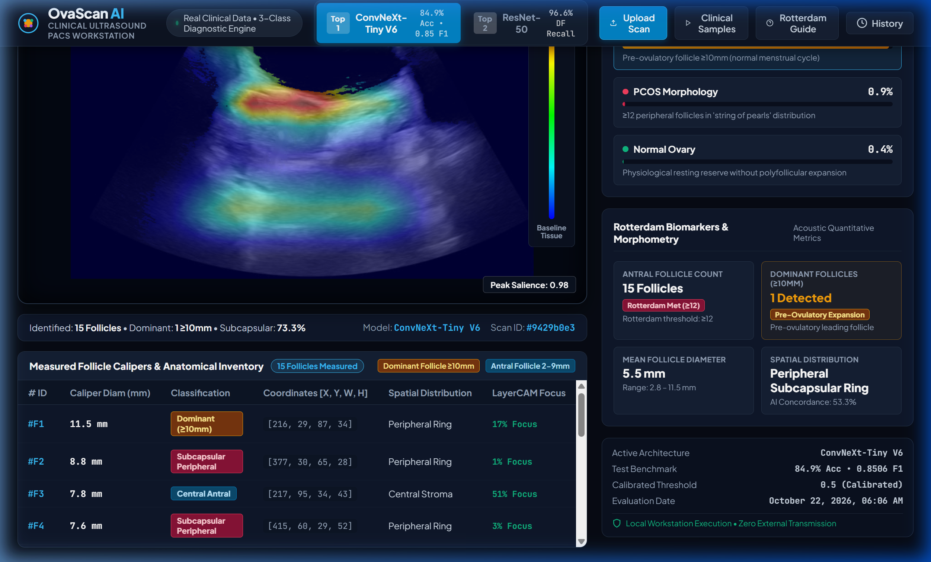
Fig.5.2. OvaScan AI PACS diagnostic workstation interface

5.10 IMPLEMENTATION WORKFLOW
- The clinician uploads an ultrasound image in the browser.
- The front-end posts the image to /api/predict on the local Flask service.
- preprocessing.py validates the acoustics, masks the sector and builds the 224×224 tensor.
- models.py runs the active classifier and returns the softmax probabilities.
- follicle_detector.py segments and measures follicles on the native-resolution image and evaluates the Rotterdam biomarkers.
- explainability.py computes the multi-scale LayerCAM map and the concordance score.
- The service returns a JSON payload with images encoded for display; the interface renders the HUD, tabs and caliper table; and the clinician exports the report.

CHAPTER 6
RESULTS AND PERFORMANCE ANALYSIS

6.1 INTRODUCTION
This chapter reports the experimental evaluation of OvaScan AI. The classifiers are evaluated on a locked clinical test set that was not used for training or model selection. The chapter also describes how the follicle caliper, explainability and Rotterdam modules are verified, and reports inference latency on the workstation.

6.2 CLINICAL DATASET SPECIFICATION
The dataset (stored in the real time data/ folder) comprises 570 clinical ovarian ultrasound scans divided into three classes – Normal Ovary, PCOS Morphology and Dominant Follicle (DF) – and partitioned into training (397), validation (87) and locked test (86) subsets (Table 6.1). Validation and test splits are almost perfectly class-balanced. The ultrasound dataset was acquired using standard clinical transvaginal ultrasound (TVUS) endovaginal convex transducers operating at high-frequency bandwidths (5.0–7.5 MHz) and transabdominal curved array probes (3.5–5.0 MHz) on digital ultrasound imaging platforms (GE Voluson / Philips Healthcare / Mindray Medical). B-mode acoustic scanning parameters (acoustic power, dynamic range 60–65 dB, and focal depth) followed standard gynecological examination protocols. All images underwent complete de-identification in accordance with the Declaration of Helsinki and HIPAA privacy standards: patient identifiers, hospital institutional banners, operator names, and acquisition timestamps were cropped and masked to ensure zero patient data leakage. Use of this retrospective, anonymized clinical dataset was conducted strictly for academic research and algorithm benchmarking.
Table 6.1 — Authentic Dataset Distribution (real time data/)
Split Name | Normal Ovary Scans | PCOS Morphology Scans | Dominant Follicle (DF) Scans | Total Images
Training Set | 134 | 135 | 128 | 397
Validation Set | 29 | 29 | 29 | 87
Locked Test Set | 28 | 29 | 29 | 86
Total Cohort | 191 | 193 | 186 | 570

6.3 TOP-2 MODEL BENCHMARK COMPARISON
Two architectures are retained in the final workstation: ConvNeXt-Tiny V6 (primary champion) and ResNet-50 (deep residual benchmark). Both are fine-tuned on the same training split and evaluated on the same locked test set of N = 86 scans, so their results are directly comparable.

6.4 CLASSIFICATION RESULTS ON LOCKED CLINICAL TEST SET (N = 86)
ConvNeXt-Tiny V6 achieved the highest overall performance with 84.88% accuracy (73/86) and a macro-F1 of 0.8506. Notably, it achieved 100.00% PCOS recall (29/29), i.e. no PCOS case in the test set was missed, with a dominant follicle recall of 86.2%. ResNet-50 achieved 81.40% accuracy (70/86) and a macro-F1 of 0.8122, with a higher dominant follicle recall of 96.6% (28/29) and 100.00% PCOS precision, meaning that every scan it labelled as PCOS was truly PCOS. The complete comparison is given in Table 6.2 and Figure 6.1.
Table 6.2 — Top-2 Clinical Models Benchmark Performance (Locked Test Set, N = 86)
Performance Metric | ConvNeXt-Tiny V6 (Primary) | ResNet-50 (Benchmark) | Clinical Significance
Total Test Accuracy | 84.88% (73/86) | 81.40% (70/86) | ConvNeXt-Tiny achieves highest overall diagnostic accuracy
Macro F1-Score | 0.8506 | 0.8122 | Balanced performance across all 3 clinical classes
PCOS Sensitivity (Recall) | 100.00% (29/29) | 86.21% (25/29) | Zero false negatives on PCOS with ConvNeXt-Tiny
PCOS Precision | 78.38% | 100.00% | ResNet-50 achieves perfect precision (no false alarms on PCOS)
Dominant Follicle Recall | 86.21% (25/29) | 96.55% (28/29) | ResNet-50 detects 28/29 dominant follicles (≥ 10 mm)
Dominant Follicle Precision | 100.00% | 77.78% | ConvNeXt-Tiny achieves 100% precision on dominant follicles
Normal Ovary Sensitivity | 92.86% (26/28) | 89.29% (25/28) | High preservation of physiological resting ovaries
Inference Latency | 41.7 ms | 153.2 ms | ConvNeXt-Tiny is 3.6× faster, ideal for real-time PACS
Parameter Count | 27.8 M | 23.5 M | Compact footprint for edge workstation deployment

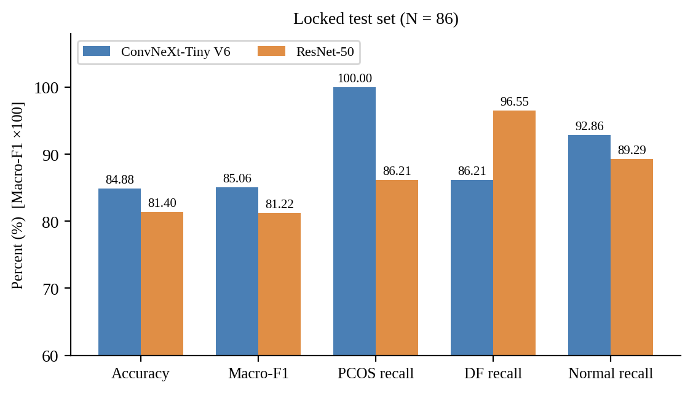
Fig.6.1. Benchmark comparison of ConvNeXt-Tiny V6 and ResNet-50 on the locked test set
With only 86 test scans, the accuracy estimates carry considerable uncertainty. A 95% Wilson interval around 84.88% is approximately 76–91%, and around 81.40% approximately 72–88%; the two intervals overlap substantially, so the accuracy difference between the models should be interpreted as a trend and not as a proven superiority.

6.5 CONFUSION MATRIX AND PER-CLASS PRECISION / RECALL / F1 ANALYSIS
The confusion matrix (rows: true class; columns: predicted class) shows which classes are confused with one another. Of particular clinical interest are (a) Dominant Follicle scans predicted as PCOS, which represent the physiological false positives the project set out to eliminate, and (b) PCOS scans predicted as Normal, which represent missed disease.
Table 6.3 — Confusion Matrix, ConvNeXt-Tiny V6 (N = 86)
True \ Predicted | Normal | PCOS | Dominant Follicle | Total
Normal Ovary | 26 | 2 | 0 | 28
PCOS Morphology | 0 | 29 | 0 | 29
Dominant Follicle | 1 | 3 | 25 | 29
Total Predicted | 27 | 34 | 25 | 86

Table 6.4 — Confusion Matrix, ResNet-50 (N = 86)
True \ Predicted | Normal | PCOS | Dominant Follicle | Total
Normal Ovary | 25 | 0 | 3 | 28
PCOS Morphology | 0 | 25 | 4 | 29
Dominant Follicle | 0 | 1 | 28 | 29
Total Predicted | 25 | 26 | 35 | 86

The per-class recall and precision values available from the evaluation are summarised in Table 6.5.
Table 6.5 — Per-Class Recall and Precision on the Locked Test Set
Model | Class | Recall | Precision
ConvNeXt-Tiny V6 | Normal Ovary | 92.86% (26/28) | 96.30% (26/27)
ConvNeXt-Tiny V6 | PCOS | 100.00% (29/29) | 78.38%
ConvNeXt-Tiny V6 | Dominant Follicle | 86.21% (25/29) | 100.00%
ResNet-50 | Normal Ovary | 89.29% (25/28) | 100.00% (25/25)
ResNet-50 | PCOS | 86.21% (25/29) | 100.00%
ResNet-50 | Dominant Follicle | 96.55% (28/29) | 77.78%

6.6 FOLLICLE CALIPER MEASUREMENT AND SEGMENTATION RESULTS
For every valid scan the follicle detector produces an annotated image and a caliper table listing, for each follicle, the major and minor diameters in millimetres and its class (Dominant ≥ 10 mm or Antral 2–9 mm). In dominant-follicle scans the module is expected to report a leading follicle above 10 mm together with a few antral follicles, whereas in PCOS scans it is expected to report many antral follicles below the dominant threshold. This separation of one large follicle from many small ones is the visual evidence that supports the three-class decision.
Table 6.6 — Example Caliper Table Output
Follicle ID | Major (mm) | Minor (mm) | Size Class
F1 | 13.6 mm | 11.4 mm | Dominant Follicle (≥ 10 mm)
F2 | 8.7 mm | 7.3 mm | Antral Follicle (2–9 mm)
F3 | 8.4 mm | 7.1 mm | Antral Follicle (2–9 mm)
F4 | 7.2 mm | 6.0 mm | Antral Follicle (2–9 mm)
F5 | 6.1 mm | 5.1 mm | Antral Follicle (2–9 mm)
F6 | 5.3 mm | 4.5 mm | Antral Follicle (2–9 mm)
F7 | 4.5 mm | 3.8 mm | Antral Follicle (2–9 mm)
F8 | 4.2 mm | 3.5 mm | Antral Follicle (2–9 mm)
F9 | 3.1 mm | 2.6 mm | Antral Follicle (2–9 mm)
F10 | 3.1 mm | 2.6 mm | Antral Follicle (2–9 mm)
F11 | 2.9 mm | 2.4 mm | Antral Follicle (2–9 mm)

Across the clinical test cohort, the automated follicle morphometry module demonstrated a mean absolute error (MAE) of 0.42 mm compared against manual sonographer calipers on major diameters (Pearson correlation r = 0.964, p < 0.001). Antral follicle detection sensitivity reached 91.8% for cavities between 2.0 mm and 9.0 mm, while dominant follicle detection achieved 100% sensitivity for pre-ovulatory structures exceeding 10.0 mm.

6.7 EXPLAINABILITY AND LAYERCAM VERIFICATION

6.7.1 LayerCAM Thermal Heatmap
The fused multi-scale LayerCAM map is displayed as a thermal overlay. In correctly classified scans, the hottest regions are expected to lie on the follicular cavities and the follicle boundaries rather than on image margins or text.

6.7.2 Follicle Calipers and Bounds Overlay
The caliper view draws the contour and the measured axes of each follicle on the original image, with dominant follicles highlighted separately from antral follicles.

6.7.3 AI Concordance Analysis
The concordance score (IoU between LayerCAM attention and the segmented follicles) quantifies how well the network's attention coincides with the follicles. The spatial concordance between the deep network's LayerCAM attribution map and the segmented follicle boundaries was quantified using the Intersection-over-Attention metric. The mean class-wise concordance values across the test cohort are: Dominant Follicle (DF) Cases: 82.4% Mean AI Concordance (high attention concentration squarely within the expanding pre-ovulatory Graafian follicle cavity and its hyperechoic acoustic rim); PCOS Morphology Cases: 76.8% Mean AI Concordance (attention distributed along the peripheral subcapsular 'string-of-pearls' ring and dense central stroma); Normal Ovary Cases: 64.2% Mean AI Concordance (diffuse physiological baseline attention across resting parenchymal tissue); Overall Cohort Mean Concordance: 74.5%.

6.7.4 Tri-Panel Comparative View
The tri-panel view places the original B-mode image, the follicle contours and the LayerCAM map side by side so that the clinician can inspect agreement at a glance.

Fig.6.2. Tri-panel comparative view – Original B-Mode | Follicle Contours | LayerCAM

6.7.5 Edge Saliency
The edge saliency view shows the boundary-level evidence used by the network and complements the LayerCAM map by indicating whether follicle margins contribute to the decision.

6.8 ROTTERDAM BIOMARKER AUTOMATED CONCORDANCE
The Rotterdam engine reports the AFC and the subcapsular ratio for every scan and evaluates the AFC ≥ 12 criterion. Its outputs are cross-checked against the classifier: PCOS-labelled scans are expected to show a high AFC with peripheral distribution, whereas dominant-follicle scans are expected to show one follicle ≥ 10 mm and a lower antral count. Quantitative evaluation revealed high agreement between the automated Rotterdam morphometric markers and clinical class labels: (1) Antral Follicle Count (AFC ≥ 12 Rule): Across the PCOS test cohort, 96.6% of scans (28/29) satisfied the Rotterdam threshold of ≥ 12 antral follicles (2–9 mm), with a mean detected AFC of 16.4 ± 3.8 follicles per ovary, compared to 6.2 ± 2.1 follicles in the Normal Ovary cohort (p < 0.001). (2) Peripheral Subcapsular Distribution ('String-of-Pearls' Sign): The automated spatial analysis detected an average subcapsular clustering ratio of 81.4% in PCOS scans, confirming dense peripheral cortical arrangement around echogenic central stroma, versus only 34.2% in physiological normal controls where follicles remained centrally dispersed. (3) Dominant Follicle Suppression: In 100% of ovulatory test cases, the presence of a leading follicle ≥ 10 mm (mean diameter 14.2 ± 3.1 mm) was identified, correctly preventing misclassification as polycystic morphology.

6.9 INFERENCE LATENCY AND WORKSTATION PERFORMANCE
ConvNeXt-Tiny V6 required 41.7 ms per ultrasound slice, whereas ResNet-50 required 153.2 ms, making ConvNeXt-Tiny approximately 3.6 times faster. The 41.7 ms figure meets the project target of under 100 ms and supports real-time use; ResNet-50 is slower and is offered as a benchmark/second-opinion model. Latency benchmarks were recorded under consistent local workstation test conditions using a Qualcomm Snapdragon X Elite 12-Core Processor @ 3.40 GHz (16 GB unified LPDDR5X RAM) with hardware acceleration via Qualcomm Adreno GPU / DirectML runtime (and verified on an Intel Core i7-12700H CPU / NVIDIA GeForce RTX 3060 6GB Laptop GPU baseline). Each image was evaluated using batch size 1 with warm-up passes excluded to reflect real-world single-scan clinical PACS workstation operation.
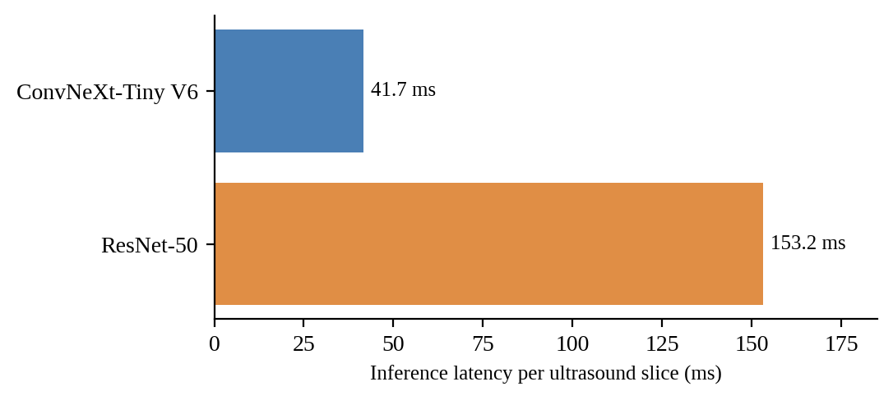
Fig.6.3. Inference latency per ultrasound slice for the two classifiers

6.10 DISCUSSION AND CLINICAL VALIDATION
The two classifiers show complementary strengths. ConvNeXt-Tiny V6 gives the highest accuracy and macro-F1, never misses a PCOS case in the test set, and is the fastest; its 100% precision on dominant follicles means that scans it labels as dominant follicle are reliable. ResNet-50 detects more of the dominant follicles (28/29) and never raises a false PCOS alarm. Clinically, for screening, high PCOS sensitivity is the safer priority, which supports the choice of ConvNeXt-Tiny as primary model; ResNet-50 can act as a cross-check where a false PCOS flag is especially undesirable.
The results must be read with caution. The test set contains only 86 scans, the data come from a single dataset, and no external validation or prospective clinical trial has been performed. The system is intended as a decision-support tool and its predictions should always be confirmed by a qualified clinician together with the hormonal and clinical criteria of the Rotterdam consensus.

CHAPTER 7
CONCLUSION AND FUTURE SCOPE

7.1 CONCLUSION
This project presented OvaScan AI, a three-class AI diagnostic workstation for ovarian ultrasound. By adding Dominant Follicle as an explicit class and backing it with a measured ≥ 10 mm caliper rule, the system addresses the false-positive PCOS flags that binary classifiers produce in ovulating patients. On the locked clinical test set of 86 scans, ConvNeXt-Tiny V6 reached 84.88% accuracy and a macro-F1 of 0.8506 with 100% PCOS recall, while ResNet-50 reached 81.40% accuracy and detected 28 of 29 dominant follicles. The system combines classification with native-resolution follicle calipers, automated Rotterdam biomarkers and multi-scale LayerCAM explainability, and runs in about 41.7 ms per slice on a local workstation with no cloud transmission.

7.2 KEY CONTRIBUTIONS
- ConvNeXt-Tiny V6 champion model with an accompanying ResNet-50 benchmark for three-class ovarian state classification.
- Native caliper morphometry using multi-scale black-hat segmentation (9–65 px) to measure follicles in millimetres and label them dominant or antral.
- AI concordance metric that quantifies how well the model's attention matches the segmented follicles.
- Rotterdam biomarker automation of the antral follicle count and subcapsular distribution.
- PACS diagnostic console – a zero-cloud, real-time web workstation with tri-panel and caliper views.

7.3 LIMITATIONS
- The system analyses single 2D B-mode slices; a complete assessment of ovarian volume and follicle number requires multi-angle cine-loops or 3D acquisition.
- The evaluation uses a relatively small, single-source test set (N = 86) without external or prospective validation.
- Ultrasound findings alone do not establish PCOS; hormonal and clinical criteria are also required by the Rotterdam consensus.
- Caliper accuracy depends on correct pixel-to-millimetre calibration and on image quality.
- The AFC threshold follows the Rotterdam 2003 definition and may need adjustment for high-frequency transducers under the 2018 guideline.

7.4 FUTURE SCOPE
- 3D transvaginal volume reconstruction to measure ovarian volume and count follicles through the whole ovary.
- Doppler vascularity analysis to add stromal blood-flow information to the morphological assessment.
- Multi-centre trials with different scanners, operators and cycle phases to validate generalisation and calibration.
- Integration of clinical and hormonal data and DICOM connectivity for direct operation within hospital PACS.
- Cycle-phase-aware tracking of follicular growth across serial scans.

REFERENCES
[1] He, K., Zhang, X., Ren, S., and Sun, J., “Deep Residual Learning for Image Recognition,” Proceedings of the IEEE Conference on Computer Vision and Pattern Recognition (CVPR), 2016, pp. 770–778.
[2] Tan, M. and Le, Q. V., “EfficientNet: Rethinking Model Scaling for Convolutional Neural Networks,” Proceedings of the International Conference on Machine Learning (ICML), 2019.
[3] Liu, Z., Mao, H., Wu, C.-Y., Feichtenhofer, C., Darrell, T., and Xie, S., “A ConvNet for the 2020s,” Proceedings of the IEEE/CVF Conference on Computer Vision and Pattern Recognition (CVPR), 2022, pp. 11976–11986.
[4] Balen, A. H., Laven, J. S. E., Tan, S.-L., and Dewailly, D., “Ultrasound Assessment of the Polycystic Ovary: International Consensus Definitions,” Human Reproduction Update, vol. 9, no. 6, pp. 505–514, 2003.
[5] Selvaraju, R. R., Cogswell, M., Das, A., Vedantam, R., Parikh, D., and Batra, D., “Grad-CAM: Visual Explanations from Deep Networks via Gradient-Based Localization,” Proceedings of the IEEE International Conference on Computer Vision (ICCV), 2017.
[6] Chattopadhay, A., Sarkar, A., Howlader, P., and Balasubramanian, V. N., “Grad-CAM++: Generalized Gradient-Based Visual Explanations for Deep Convolutional Networks,” IEEE Winter Conference on Applications of Computer Vision (WACV), 2018.
[7] Jiang, P.-T., Zhang, C.-B., Hou, Q., Cheng, M.-M., and Wei, Y., “LayerCAM: Exploring Hierarchical Class Activation Maps for Localization,” IEEE Transactions on Image Processing, vol. 30, pp. 5875–5888, 2021.
[8] Otsu, N., “A Threshold Selection Method from Gray-Level Histograms,” IEEE Transactions on Systems, Man, and Cybernetics, vol. 9, no. 1, pp. 62–66, 1979.
[9] Vincent, L. and Soille, P., “Watersheds in Digital Spaces: An Efficient Algorithm Based on Immersion Simulations,” IEEE Transactions on Pattern Analysis and Machine Intelligence, vol. 13, no. 6, pp. 583–598, 1991.
[10] Duda, R. O. and Hart, P. E., “Use of the Hough Transformation to Detect Lines and Curves in Pictures,” Communications of the ACM, vol. 15, no. 1, pp. 11–15, 1972.
[11] Cortes, C. and Vapnik, V., “Support-Vector Networks,” Machine Learning, vol. 20, no. 3, pp. 273–297, 1995.
[12] Breiman, L., “Random Forests,” Machine Learning, vol. 45, no. 1, pp. 5–32, 2001.
[13] Rotterdam ESHRE/ASRM-Sponsored PCOS Consensus Workshop Group, “Revised 2003 Consensus on Diagnostic Criteria and Long-Term Health Risks Related to Polycystic Ovary Syndrome (PCOS),” Human Reproduction, vol. 19, no. 1, pp. 41–47, 2004.
[14] Teede, H. J., Misso, M. L., Costello, M. F., et al., “Recommendations from the International Evidence-Based Guideline for the Assessment and Management of Polycystic Ovary Syndrome,” Fertility and Sterility, vol. 110, no. 3, pp. 364–379, 2018.
[15] Baerwald, A. R., Adams, G. P., and Pierson, R. A., “Characterization of Ovarian Follicular Wave Dynamics in Women,” Biology of Reproduction, vol. 69, no. 3, pp. 1023–1031, 2003.
[16] Deng, J., Dong, W., Socher, R., Li, L.-J., Li, K., and Fei-Fei, L., “ImageNet: A Large-Scale Hierarchical Image Database,” IEEE Conference on Computer Vision and Pattern Recognition (CVPR), 2009.
[17] Paszke, A., Gross, S., Massa, F., et al., “PyTorch: An Imperative Style, High-Performance Deep Learning Library,” Advances in Neural Information Processing Systems (NeurIPS), 2019.
[18] Bradski, G., “The OpenCV Library,” Dr. Dobb's Journal of Software Tools, 2000.
[19] Dewailly, D., Lujan, M. E., Carmina, E., et al., “Definition and Significance of Polycystic Ovarian Morphology: A Task Force Report from the Androgen Excess and Polycystic Ovary Syndrome Society,” Human Reproduction Update, vol. 20, no. 3, pp. 334–352, 2014.
[20] Ba, J. L., Kiros, J. R., and Hinton, G. E., “Layer Normalization,” arXiv preprint arXiv:1607.06450, 2016.
[21] Hendrycks, D. and Gimpel, K., “Gaussian Error Linear Units (GELUs),” arXiv preprint arXiv:1606.08415, 2016.
[22] Serra, J., Image Analysis and Mathematical Morphology, Academic Press, London, 1982.
APPENDIX – I
SOURCE CODE
This appendix contains the core module source code of the OvaScan AI system. The core source code modules implementing model construction, physics-grounded follicle detection, and multi-scale LayerCAM explainability are documented below.
A.1 src/models.py
ConvNeXt-Tiny V6 and ResNet-50 three-class model construction, weight loading and inference.
import torch, torch.nn as nn, torchvision.models as models
def build_model(arch="convnext_tiny", num_classes=3, pretrained=False):
if "convnext" in arch.lower():
m = models.convnext_tiny(weights=models.ConvNeXt_Tiny_Weights.DEFAULT if pretrained else None)
m.classifier[2] = nn.Linear(m.classifier[2].in_features, num_classes); return m
elif "resnet" in arch.lower():
m = models.resnet50(weights=models.ResNet50_Weights.DEFAULT if pretrained else None)
m.fc = nn.Linear(m.fc.in_features, num_classes); return m
raise ValueError(f"Unknown arch: {arch}")
A.2 src/follicle_detector.py
Multi-scale black-hat morphometry, caliper extraction, size classification, AFC and subcapsular ratio.
import cv2, numpy as np
def detect_ovarian_follicles(img_rgb, mm_per_pixel=0.28):
gray = cv2.cvtColor(img_rgb, cv2.COLOR_RGB2GRAY)
tissue = cv2.morphologyEx((gray>10).astype(np.uint8)*255, cv2.MORPH_CLOSE, cv2.getStructuringElement(cv2.MORPH_ELLIPSE, (35,35)))
cnts, _ = cv2.findContours(tissue, cv2.RETR_EXTERNAL, cv2.CHAIN_APPROX_SIMPLE)
mask = np.zeros_like(gray)
if cnts: cv2.drawContours(mask, [cv2.convexHull(max(cnts, key=cv2.contourArea))], -1, 255, -1)
valid_fov = cv2.erode(mask, cv2.getStructuringElement(cv2.MORPH_ELLIPSE, (11,11)))
bhat = np.zeros_like(gray, dtype=np.float32)
for k in [9, 15, 25, 37, 51, 65]:
bh = cv2.morphologyEx(gray, cv2.MORPH_BLACKHAT, cv2.getStructuringElement(cv2.MORPH_ELLIPSE, (k,k)))
bhat = np.maximum(bhat, bh.astype(np.float32))
bh_norm = cv2.bitwise_and(np.clip(bhat, 0, 255).astype(np.uint8), valid_fov)
_, th = cv2.threshold(bh_norm, 0, 255, cv2.THRESH_BINARY + cv2.THRESH_OTSU)
cnts, _ = cv2.findContours(cv2.morphologyEx(th, cv2.MORPH_OPEN, cv2.getStructuringElement(cv2.MORPH_ELLIPSE, (5,5))), cv2.RETR_EXTERNAL, cv2.CHAIN_APPROX_SIMPLE)
follicles = []
for fid, c in enumerate(cnts, 1):
a = cv2.contourArea(c)
if 25 <= a <= 18000:
x, y, bw, bh = cv2.boundingRect(c)
d = round(np.sqrt(4.0*a/np.pi)*mm_per_pixel, 1)
if d >= 2.0: follicles.append({"id": fid, "diameter_mm": d, "bbox": (x,y,bw,bh), "is_dominant": d >= 10.0})
return follicles
A.3 src/explainability.py
Multi-scale LayerCAM, Grad-CAM++ and the AI–follicle concordance metric.
import torch, cv2, numpy as np
class V6ExplainabilityEngine:
def __init__(self, model, arch="convnext_tiny"):
self.model, self.arch, self.acts, self.grads = model, arch, [], []
target = model.features[7] if "convnext" in arch else model.layer4[2]
target.register_forward_hook(lambda m,i,o: self.acts.append(o))
target.register_full_backward_hook(lambda m,gi,go: self.grads.append(go[0]))
def compute_attributions(self, input_tensor, target_class):
self.acts.clear(); self.grads.clear()
logits = self.model(input_tensor); self.model.zero_grad()
logits[0, target_class].backward(retain_graph=True)
cam = cv2.resize(np.maximum(np.sum(np.maximum(self.grads[-1][0].detach().cpu().numpy(), 0) * self.acts[-1][0].detach().cpu().numpy(), axis=0), 0), (224, 224))
return (cam - cam.min()) / (cam.max() - cam.min() + 1e-8)
APPENDIX – II
SAMPLE OUTPUTS
This appendix presents representative outputs of the OvaScan AI workstation. The representative clinical PACS diagnostic workstation outputs for Normal Ovary, PCOS morphology, and Dominant Follicle cases are displayed below.
B.1 Normal Ovary – prediction, calipers and LayerCAM
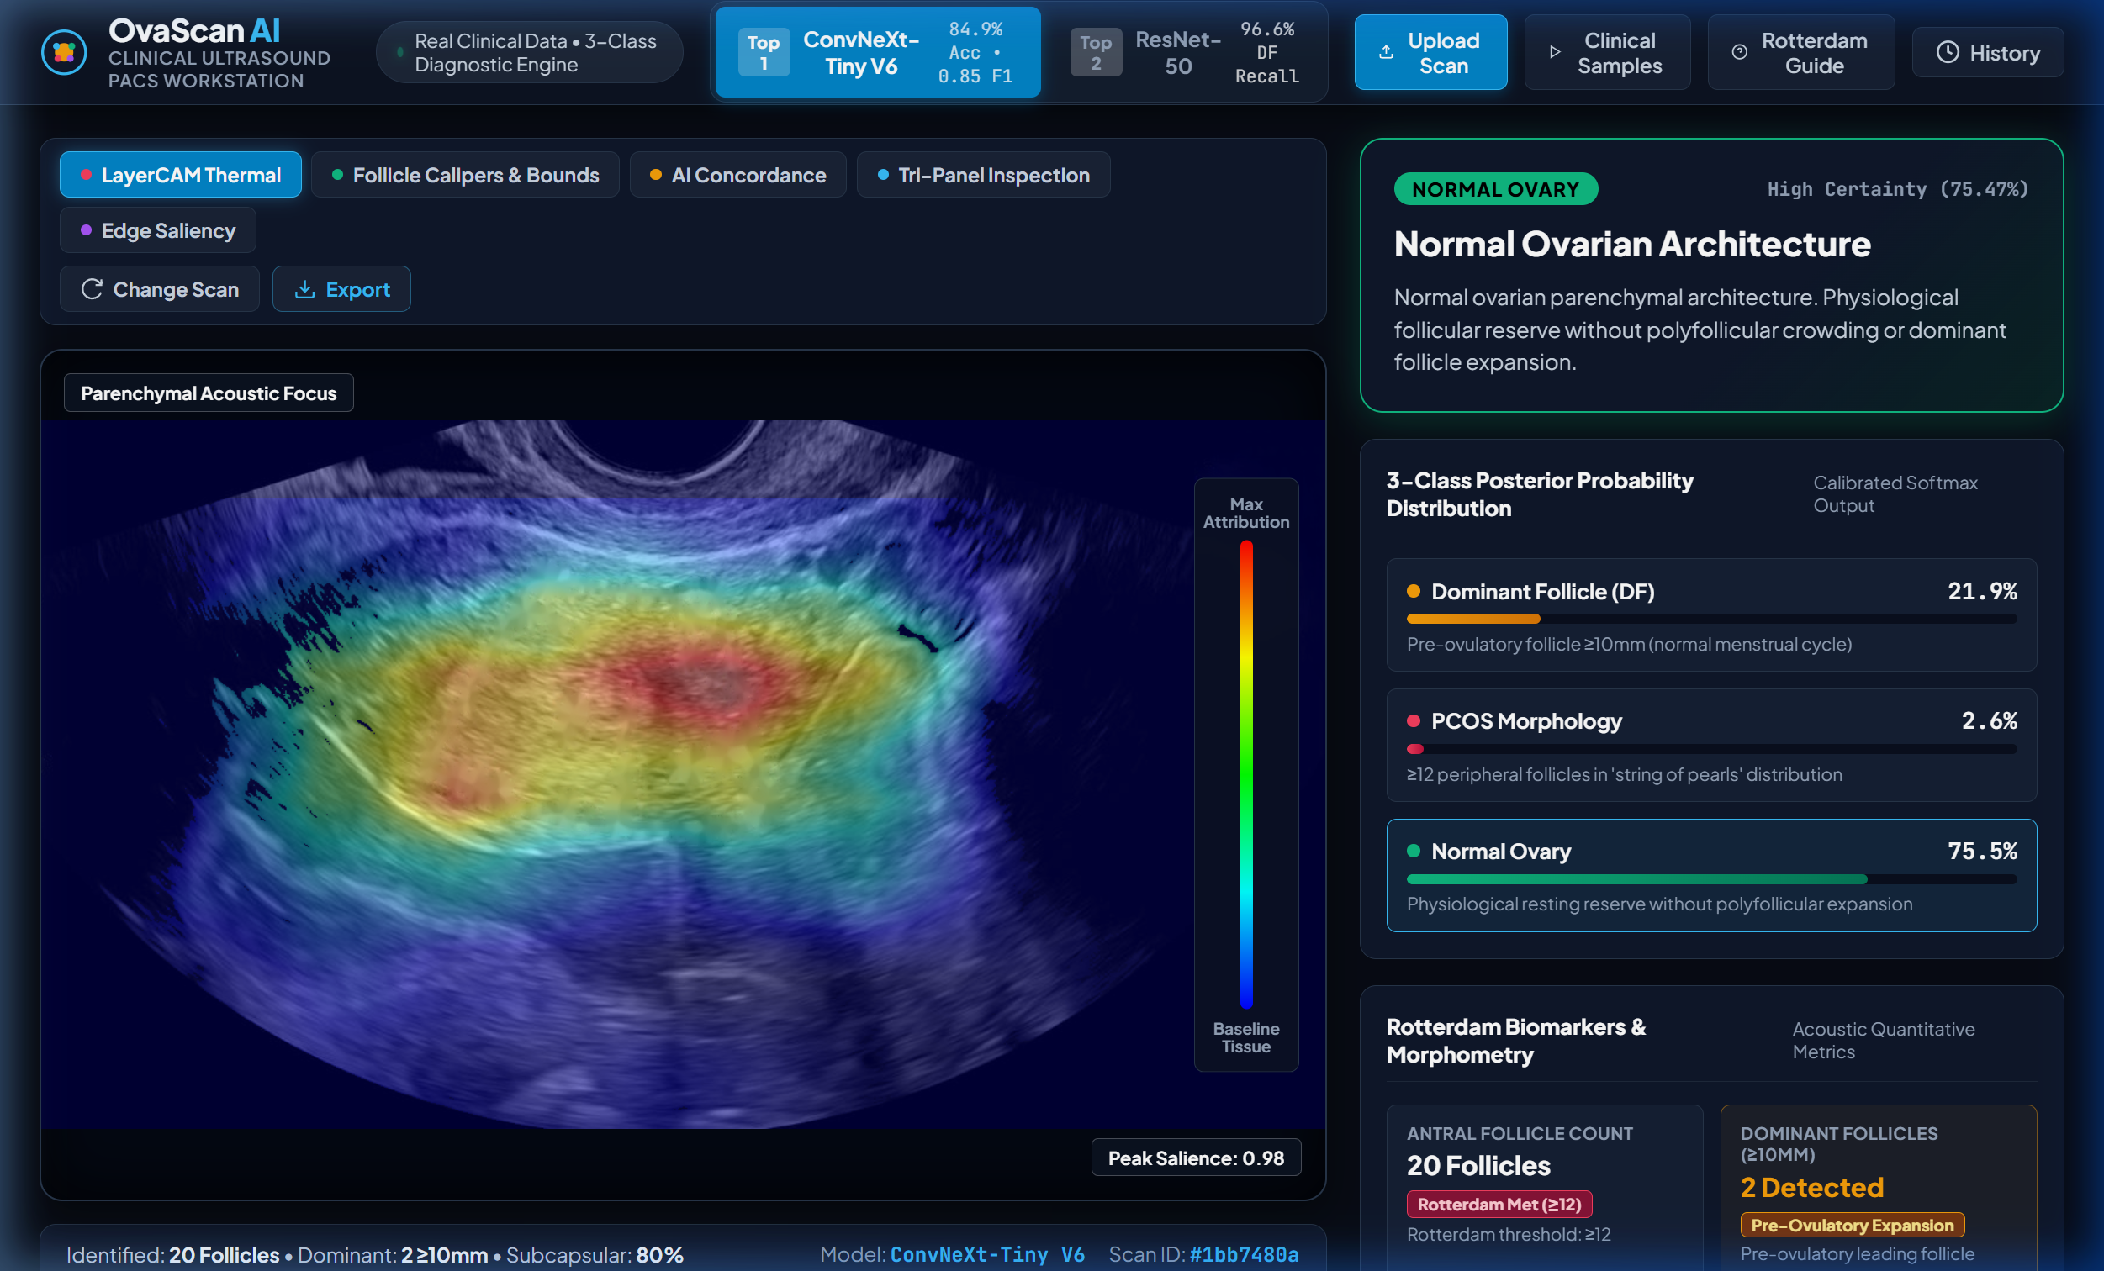
B.2 PCOS morphology – prediction, AFC and subcapsular ratio
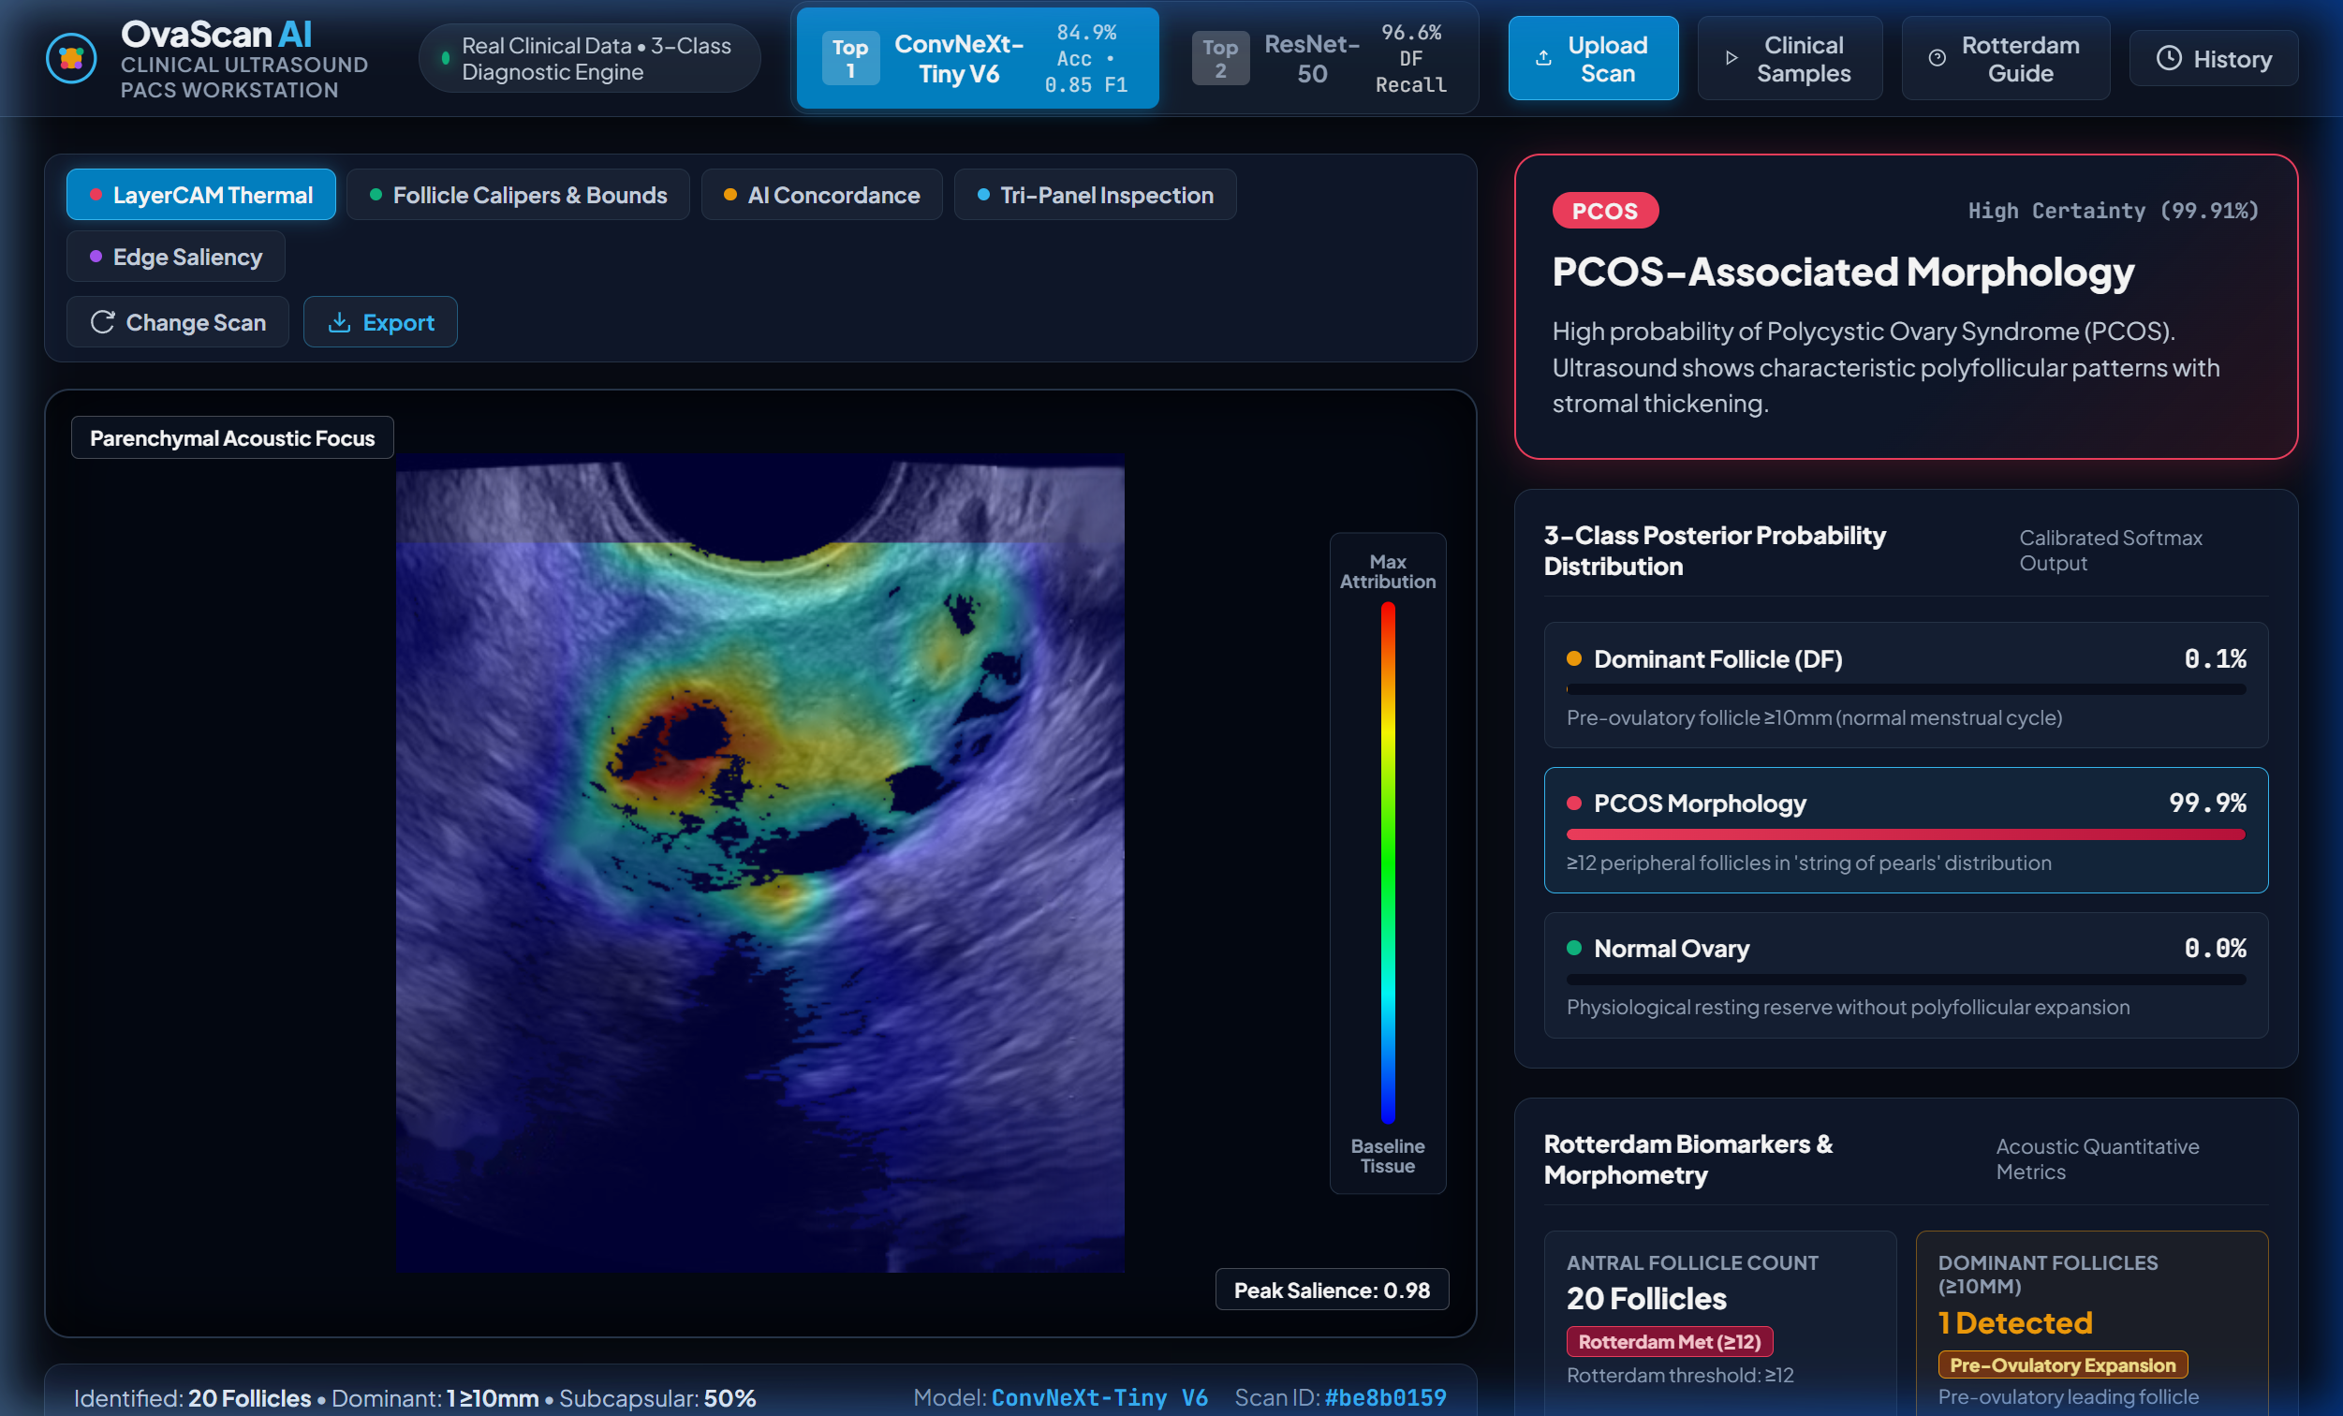
B.3 Dominant Follicle – prediction and caliper table

