# Project Report

**Project Title:** Stock Price Trend Prediction using LSTM

**Intern Name:**  V Yuvan Krishnan

## 1. Introduction

Stock price prediction is one of the most popular and valuable applications of deep learning in the finance sector. The dynamic and non-linear nature of stock prices makes traditional models less effective, whereas Recurrent Neural Networks (RNNs), especially LSTM (Long Short-Term Memory) networks, are well-suited for modeling sequential data. This project focuses on forecasting Apple Inc.’s stock closing prices using LSTM and improving performance by integrating technical indicators such as Moving Average (MA20) and Relative Strength Index (RSI).

## 2. Abstract

The objective of this project is to predict future stock prices using past trends and technical indicators. We utilized the Yahoo Finance API (`yfinance`) to collect historical stock data of AAPL from 2015 to 2024. After applying data preprocessing and feature engineering (MA20, RSI), the dataset was normalized and used to train an LSTM model. The model was evaluated using standard regression metrics: MAE, RMSE, and R² Score. Visualizations such as predicted vs actual prices, MA20 overlay, and RSI charts helped validate the model’s predictive power.

## 3. Tools Used

- Programming Language: Python  
- Libraries/Frameworks:  
 - Data Handling: Pandas, NumPy  
 - Visualization: Matplotlib  
 - Model Building: TensorFlow/Keras  
 - API: yfinance  
 - Evaluation: scikit-learn

## 4. Steps Involved in Building the Project

a) Data Collection

- Used `yfinance` to download Apple (AAPL) stock data from 2015 to 2024.  
- Extracted closing price (`Close`) and calculated MA20 and RSI as additional features.

b) Data Preprocessing

- Handled missing values from RSI and MA calculations.  
- Normalized features using MinMaxScaler.  
- Created sequences of 60 days of data for LSTM input.

c) Model Building

- Built a Sequential LSTM model with:  
 - Two LSTM layers (50 units each)  
 - One Dense output layer  
- Compiled with Mean Squared Error (MSE) loss and Adam optimizer.

d) Model Training

- Trained on 80% of the data, tested on 20%.  
- Epochs: 15, Batch Size: 32.

e) Evaluation & Metrics

- Achieved the following:  
 - MAE: 5.38  
 - RMSE: 7.06  
 - R² Score: 0.9301

f) Visualization:

**-Actual vs Predicted Stock Prices**

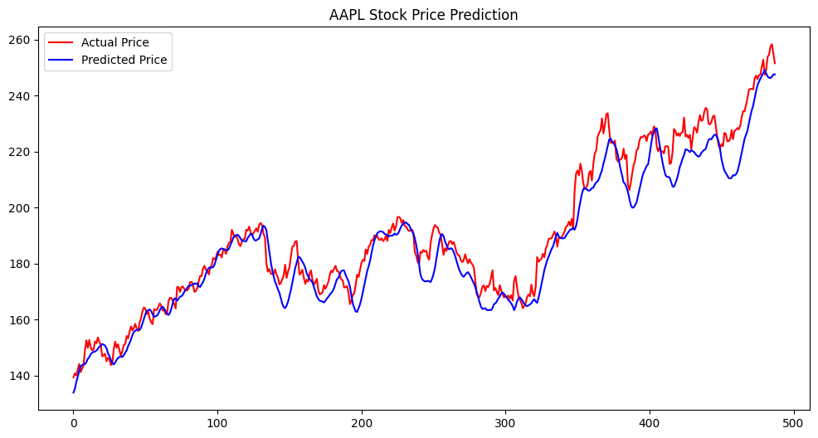

- **20-day Moving Average with Closing Price**

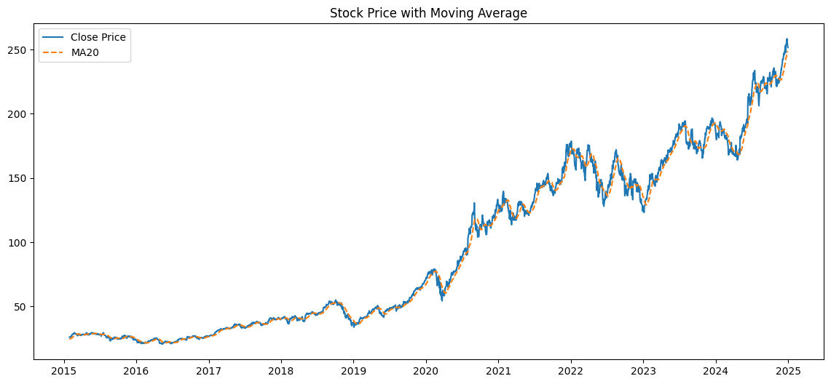

**- RSI with 30/70 overbought-oversold thresholds**

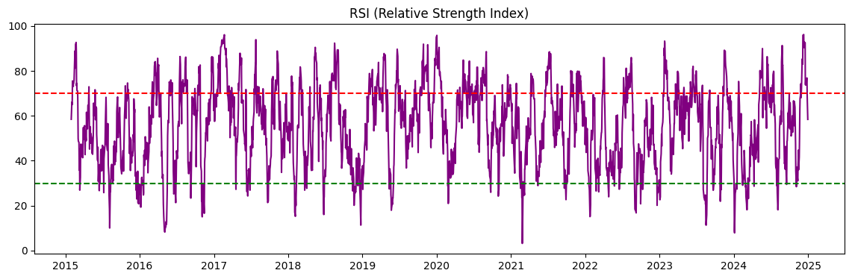

## 5. Conclusion

This project demonstrates how LSTM networks can effectively capture temporal patterns in stock data. The integration of technical indicators significantly boosted model performance. The final R² score of 0.93 indicates a strong correlation between predicted and actual values. This project can be further enhanced by incorporating news sentiment, macroeconomic indicators, or deploying as a live dashboard using Streamlit.