
SRS DOCUMENT
FOR
E
-
COMMERCE
(
Online Dress store management system
)
By
Stephen raj S
Santhosh Kumar K
Yogeeshwaran
J
Yuvanshankar
kannnan


Table of content
. Introduction
1
. Purpose
1.1
1.2
. Scope
. Objective
1.3
. Overall Description
2
. Product Perspective
2.1
. Hardware Requirements
2.2
. Software Requirements
2.3
. Functional Requirement
2.4
. Online dress store Management
2.5
. Non
2.6
-
function Requirement
2
.
6
.
1
.
Usability
2
.
6
.
2
.
Availability
2
.
6
.
3
.
Efficiency
2
.
6
.
4
.
Accuracy
2
.
6
.
5
.
Performance
2
.
6
.
6
.
Reliability
3
. User Characterstics
4
. Diagram
4.1
. Use Case Diagram
4.2
. Class Diagram
4.3
. Component Diagram
4.4
. Sequence Diagram
4.5
. Data Flow Diagram

1.INTRODUCTION
1.1.Purpose
This document is meant to delineate the features of OSS, so as to serve as

a guide to the developers on one hand and a software validation document for the prospective client on the other. The Online Shopping System (OSS) for item shop web application is intended to provide complete solutions for vendors as well as customers through a single get way using the internet . It will enable vendors to setup online shops, customer to browse through the shop and purchase them online without having to visit the shop physically. The administration module will enable system administrator to approve and reject requests for new shops and maintain various lists of shop category.
1.2
.SCOPE
T
his system allows the customer’s to maintain their cart for add or remove the product
over the internet.
1.3
.OVERVIEW
This system provides an easy solution for customers to buy the product without going to
the shop and also to shop owner to sale the product. This proposed system can be used by
any naïve users and it does not require any educational level, experience or technical
expertise in computer field but it will be of good use if user has the good knowledge of
how to operate a computer.
2
. OVERALL DESCRIPTION
2.1
. Product Perspective
The Online dress store Management web application is intended to
provide vendors to setup online shops, customer to browse through the shop and
purchase them online without having to visit the shop physically. The
administration module will enable a system administrator to approve and reject
requests for new shops and
maintain various lists of shop
category.
2.2
. Hardware Requirements
•
Ram Size
:

4
GB Or 8GB
•
Processor:
64
bit
•
Operating System :
Windows 7/10
2.3
. Software Requirements
•
Javascript
•
HTML
•
CSS

4.FUNCTIONAL REQUIREMENT
This section provides requirement overview of the system. Various functional modules that can be implemented by the system will be
2.4.1 Registration If customer wants to buy the product then he/she must be registered, unregistered user can’t go to the shopping cart.
2.4.2 Login Customer logins to the system by entering valid user id and password for the shopping.
2.4.3 Changes to Cart Changes to cart means the customer after login or registration can make order or cancel order of the product from the shopping cart.
2.4.4 Payment In this system we are dealing the mode of payment by Cash. We will extend this to credit card, debit card etc in the future.
2.4.5 Logout After ordering or surfing for the product customer has to logout.
2.4.6 Report Generation After ordering for the product, the system will sent one copy of the bill to the customer’s Email-address and another one for the system data base.
2.6
.Non
-
Functional Requirements:
Following Non
-
Functional Requirements will be there in the insurance to the internet:
(
i) Secure access to consumer’s confidential data.
(
ii) 24X7 availability.
(
iii) Better component design to get better performance at peak time.
(
iv) Flexible service based architecture will be highly desirable for future
Requirements define system properties and constraints.
Various other Non
-
Functional Requirements are:
❖
Reliability
❖
Efficiency
❖
Performance
❖
Reusability
❖
Availability
❖
Accuracy
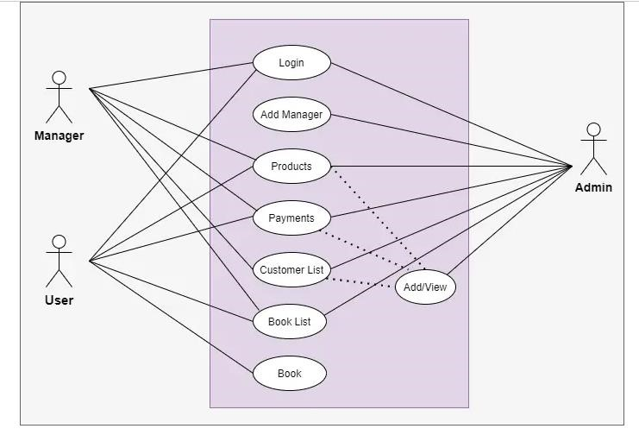
4
.DIAGRAMS
USECASE DIAGRAM
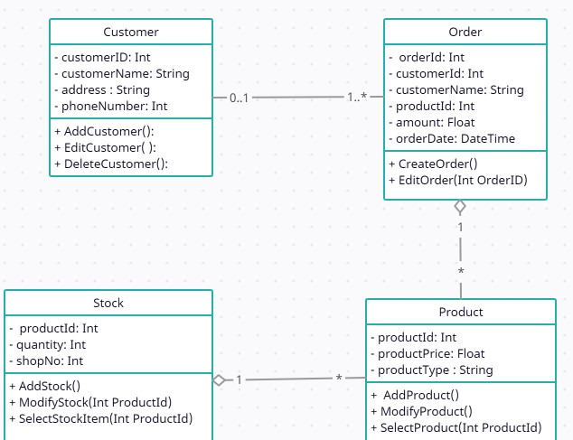
CLASS DIAGRAM
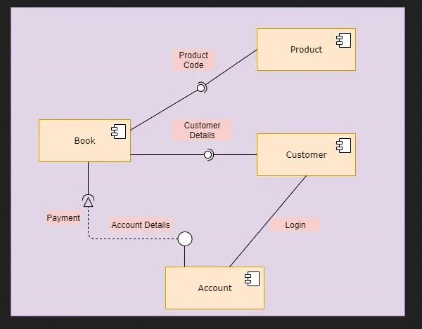
COMPONENT DIAGRAM
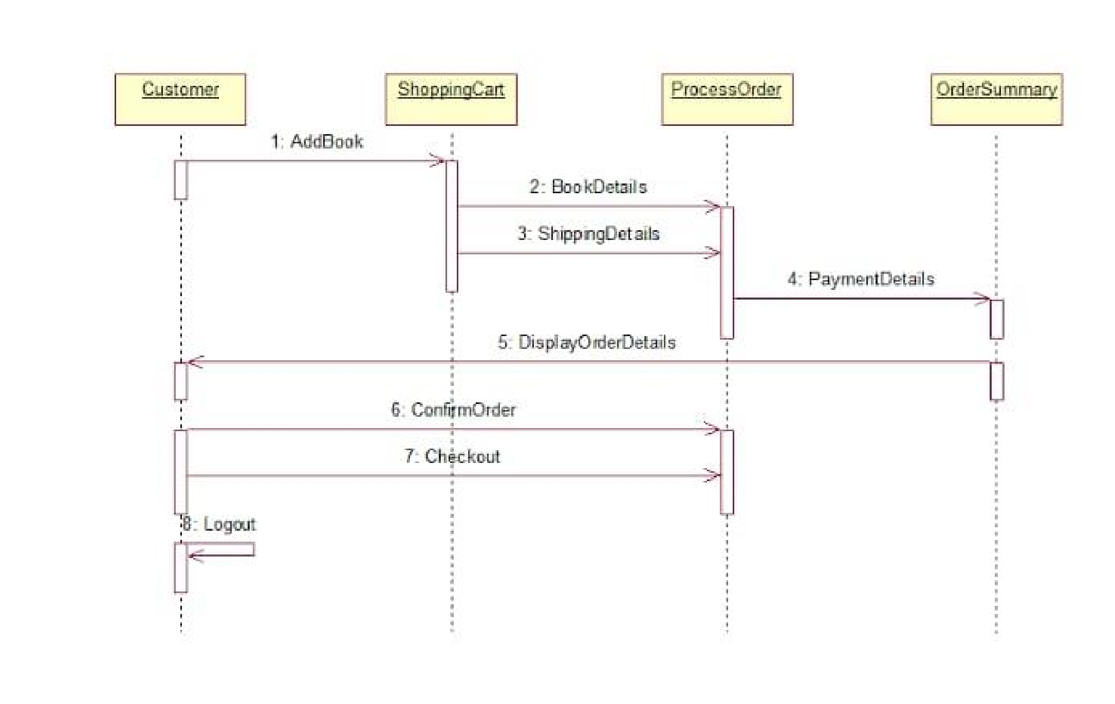
Sequence Diagram
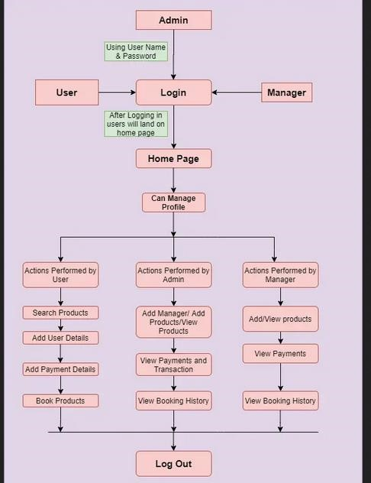
DATAFLOW DIAGRAM


Submission
Github
https://github.com/Yuvanshankar2
002
/S
-
R
_
S
-
for
-
E
-
COMMERCE




