Feature Proposal: AR Companion

Title: "AR Companion" - A Personalized Onboarding Guide for First-Time Users  
  
By: Venna V Yuvan  
Roll: AP22110010679  
Role: Product Management Intern Applicant  
Company: Flam

# Problem Statement

AR creation tools, while exciting, can often be overwhelming for first-time users. Upon launching the Flam app, users are faced with a range of features and creative options, but may not understand where to begin, what the possibilities are, or how to get comfortable with AR interactions. This leads to a drop-off in engagement early in the funnel and prevents users from experiencing the full potential of Flam.

# Proposed Solution: "AR Companion"

The AR Companion is a friendly, interactive, holographic guide that appears in the AR environment to help onboard new users. This guide introduces features in a playful, contextual, and humanized way, providing support at just the right moments.

# Key Features

1. Interactive Walkthroughs:  
 - The AR Companion greets first-time users and introduces basic features step-by-step (e.g., how to place objects, add effects, record, or share).  
 - Short, modular lessons (like tooltips in 3D) are available on-demand or during use.  
  
2. Context-Aware Suggestions:  
 - Based on what the user is doing (or not doing), the companion can offer nudges like:  
 > "Want to try a 3D filter? Just tap here!"  
 > "You're doing great! Try adding a song next."  
  
3. Gamified Progress:  
 - Users unlock achievements by completing onboarding steps, which encourages exploration.  
 - Optional mini-challenges, like "Create your first AR selfie" or "Make your first remix."  
  
4. Customizable Companion:  
 - Users can choose the appearance of their guide (cute creature, stylized human, abstract AI orb, etc.).  
 - As users level up, the companion evolves.

# Target Users

- First-time Users: Especially Gen Z users encountering AR creation tools for the first time.  
- Returning Users: Who churned early or need re-engagement with new features.

# Outcomes & Benefits

- Improved First-Time User Experience: Users learn by doing, with gentle guidance.  
- Higher Activation Rates: Increased number of users completing initial actions (e.g., creating a scene, sharing content).  
- Increased Retention: The emotional bond with the companion, plus better understanding of the app, drives repeat use.  
- Brand Personality: Flam becomes more fun, friendly, and accessible.  
 Strategic Fit

This feature strongly aligns with Flam’s mission to democratize AR creation. By lowering the learning curve and encouraging playful exploration, Flam can convert more casual users into confident creators.

# Future Extensions

- Voice Commands: Companion responds to verbal cues ("How do I add effects?")  
- Creator Tips: Pro users get advanced feature tips via the companion  
- Community Companion Skins: Partner with creators for custom companion avatars

# Success Metrics

- % of first-time users completing onboarding  
- Increase in day-1 and day-7 retention  
- Average time spent during first session  
- Qualitative feedback via NPS: "The guide helped me get started"

This is my proposal.

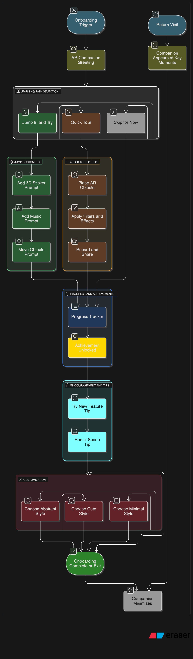

Let’s jot down the Companion steps:

**Screen Layout Plan (5 Screens)**

**Screen 1: Welcome Onboarding**

* Background: Flam app welcome screen with camera access prompt.
* Companion: Floating avatar (orb or stylized figure).
* Tooltip: “ Hi there! I’m your AR Companion. Let’s explore together!”
* CTA Button: “Let’s Go!”

**Screen 2: First Interaction Prompt**

* Background: AR view from the phone (empty room or desk surface).
* UI: “+” button to add object.
* Tooltip: “Try placing your first object! Tap the + icon below.”
* Companion: Hovering in lower-left or right corner.

**Screen 3: Object Placed**

* Background: A simple AR object (like a smiley emoji or balloon) appears on surface.
* Tooltip: “ Nice! Now try moving or resizing it.”
* Optional prompt: “Need help? Say ‘How do I move this?’”

**Screen 4: Add Audio or Effect**

* Background: AR object + audio icon or filter bar at bottom.
* Tooltip: “ Let’s add a vibe. Choose music or a filter!”
* Gamification UI: “ Badge: Creative Explorer Unlocked!”

**Screen 5: Final Scene + Share Prompt**

* Background: Final edited AR scene.
* Tooltip: “ You’re ready to share! Tap the arrow to post.”
* Companion: “You did amazing! More fun awaits…”

