OVERVIEW OF SCHEMATICS

POWER SECTION

SENSOR INTERFACES:

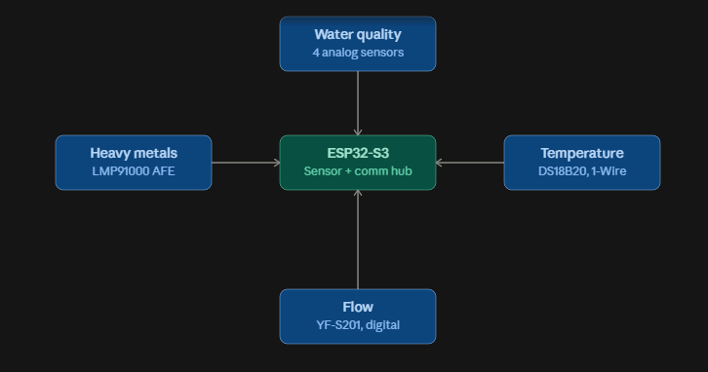

I2C — ADS1115 (16-bit ADC for pH, TDS, turbidity, ORP)
- SDA → ESP32-S3 GPIO8
- SCL → ESP32-S3 GPIO9
- VDD → 3.3V (buck converter rail)
- GND → common ground
- I2C address: 0x48 (default, ADDR pin tied to GND)
- AIN0 → pH probe, AIN1 → TDS probe, AIN2 → turbidity sensor, AIN3 → ORP probe — each through its own signal-conditioning stage before reaching the ADC input
- ESP32's built-in ADC: it's noisy and nonlinear near the rails, which defeats the purpose of needing microvolt-level precision for pH/ORP
I2C — LMP91000 (electrochemical AFE, heavy-metal sensing)
- SDA/SCL → shared I2C bus (same lines as ADS1115)
- VDD → 3.3V (buck converter rail)
- GND → common ground
- I2C address: 0x4D (default) — shares the bus with the ADS1115 at a different address, no conflict
- Connects to a 3-electrode cell: working, reference, and counter electrodes
1-Wire — DS18B20 (temperature)
- Data → ESP32-S3 GPIO4
- VDD → 3.3V (buck converter rail)
- GND → common ground
- Requires a 4.7kΩ pull-up resistor between Data and 3.3V
Digital, interrupt-driven — YF-S201 (flow sensor)
- Signal (pulse out) → ESP32-S3 GPIO34
- VCC → 5V (buck converter rail) — Hall-effect sensors need 5V, not 3.3V
- GND → common ground
- Configured as an interrupt input that counts pulses rather than being polled; pulse frequency is proportional to flow rate
GPIO — Actuator outputs (for completeness, since they share the same control unit)
- Valve 1 / Valve 2 control → GPIO5 / GPIO6 (via MOSFET gate, flyback diode across each valve coil)
- Pump control (PWM) → GPIO7
- UV ballast control (relay) → GPIO15

