

INSTAGRAM

**ANALYSIS**

Presented By :

Yuvaraj Shivamurti

Table of Contents

Intoduction 01

[Database Overview](https://medium.com/@avi22nayak/instagram-user-analytics-71546190a6c8#71fe) 02

SQL Queries 03

[Insights](https://medium.com/@avi22nayak/instagram-user-analytics-71546190a6c8#cfdd) 04

[Conclusion](https://medium.com/@avi22nayak/instagram-user-analytics-71546190a6c8#f33e) 05

[Links](https://medium.com/@avi22nayak/instagram-user-analytics-71546190a6c8#7841) 06

Presented By

Yuvaraj shivamurti

Introduction to Instagram

Instagram is a popular social media platform designed primarily for sharing photos, videos, and connecting with friends, brands, and communities worldwide. Here’s an overview:

1. **Launch and Ownership**
   * Instagram was launched in October 2010 by Kevin Systrom and Mike Krieger.
   * Acquired by Facebook (now Meta Platforms) in April 2012.
2. **Core Features**
   * **Profile**: Your personal space to showcase posts, bio, and links.
   * **Feed**: A scrollable timeline featuring posts from people you follow.
   * **Stories**: Temporary 24-hour posts in the form of photos or short videos.
   * **Reels**: Short, creative, and entertaining videos (15–90 seconds).
   * **Direct Messages (DMs)**: Private messaging for conversations.
3. **Main Uses**
   * **Personal Use**: Sharing moments, hobbies, and connecting with friends.
   * **Professional Use**: Showcasing work, building a personal brand, and networking.
   * **Business Use**: Marketing, advertising, and reaching target audiences.
4. **Monetization**
   * Creators and businesses can earn through brand collaborations, ad revenue, and product promotions.
   * Features like Instagram Shopping allow businesses to sell directly on the platform.

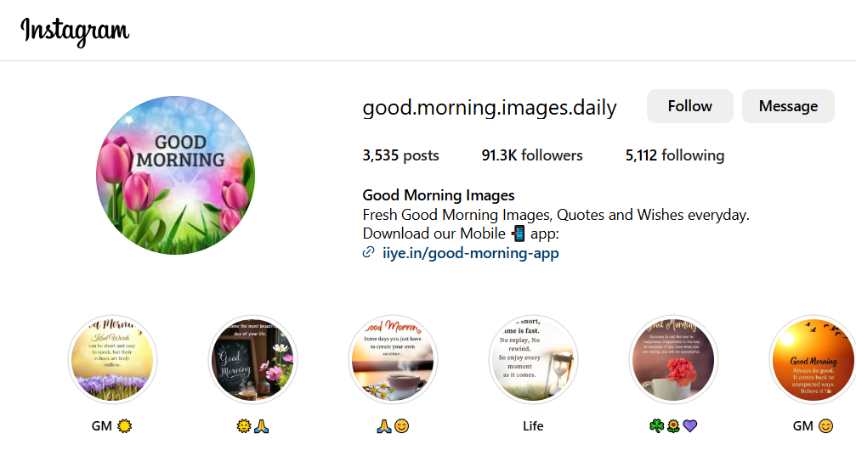

Database Overview

**Source of Database:**  
<https://1drv.ms/u/c/56b5dc68913e2033/EcJQ5L1R-7JCr-EdPith0cQBZ1IBpOplnCVvbu-U-6NiNg?e=hpTfSR>

Schema of the Database:

Users

 email

bio

created_at

username (varchar 100)

user_id

 

comments

 comment_id

post_id

user_id

comment_text (varchr 300)

created_at

Posts

 user_id

|  |  |  |  |  |
| --- | --- | --- | --- | --- |
| * post_id   caption | |  |  | |
|  | | |
| image_url ( varchar 200 )  created_at | |  |  | |
|  | |  |  | |

|  |  |
| --- | --- |
|  |  |

|  |
| --- |
|  |

Likes

 like_id

post_id

user_id

liked_at

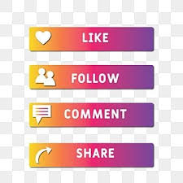 

Followes

follow_id

follower_id

following_id

followed_at

Question modes

**BASIC - Queries include : SELECT, GROUP BY, WHERE, ORDER BY, LIMIT, DESC,ASC.**

**Moderate - Queries Include : JOINS, GROUP BY, ORDER BY, LIMIT.**

**Advance - Queries Include : CTE (COMMON TABLE EXPRESSION).**

LAVEL – BASIC

Inputs Right Answer Icon PNG Transparent With ... Outputs



1. Count the total number of users.

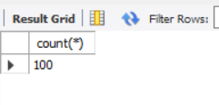



1. Find all posts user_id = 10.

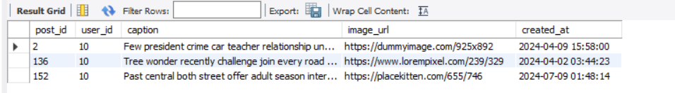



1. List all likes on post_id = 5.

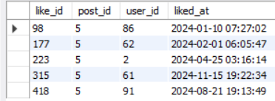



1. Count the top 5 old users.

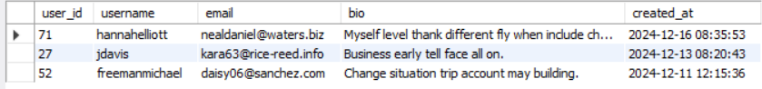



1. Show all comments on post_id = 12.

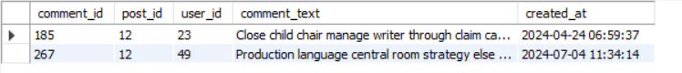



LAVEL – MODERATE

1. Find the top 5 most-liked posts.

* Input > Output

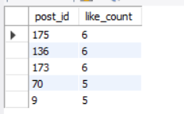

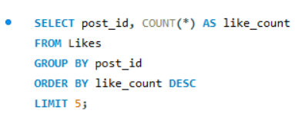

1. List all users who follow this following = 49.

* Input > Output

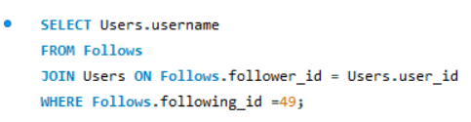

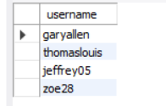

1. Retrieve posts along with the number of comments they have received.

* Input

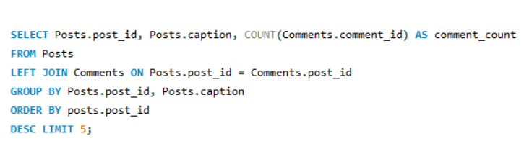

* Output

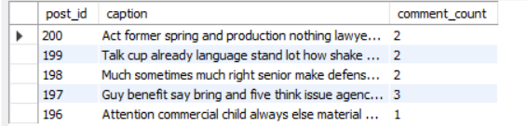

4. Find users who have not created any posts.

* Input  **>** Output

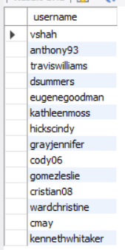

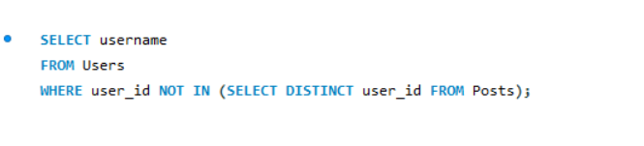



5. Find mutual followers (users following each other).

* Input

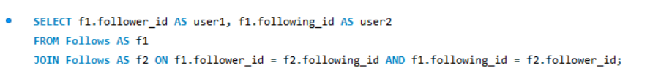

* Output

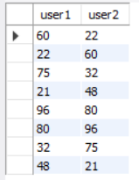

* Output 

LAVEL – ADVANCE

1. Find posts with the highest engagement “ likes & comments ”

* Input

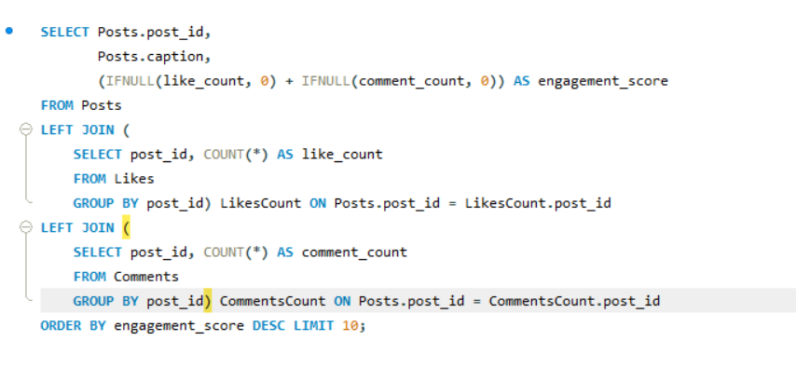

* Output

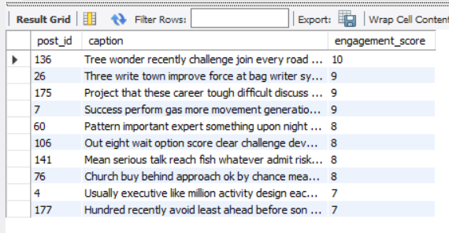

* Insights

**What we done:** This query calculates the "engagement score" for each post by adding the number of likes and comments, then identifies the top 10 posts with the highest engagement

1. **Identify the top 3 users who received the most likes across all their posts.**

* Input

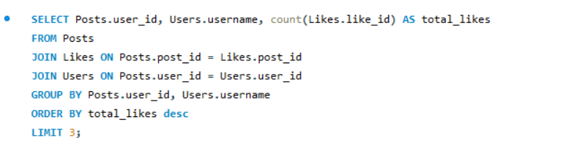

* Output

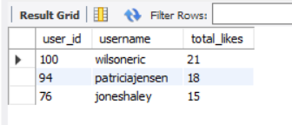

1. Identify inactive users no posts, no comments, and no likes.

* Input

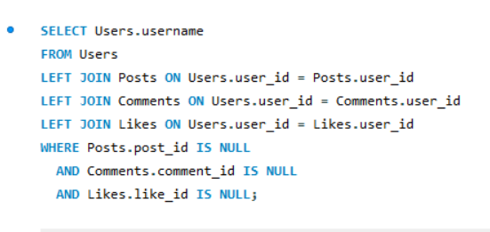

* Output

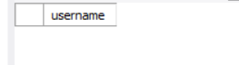

1. Find posts that have more likes than comments.

* Input

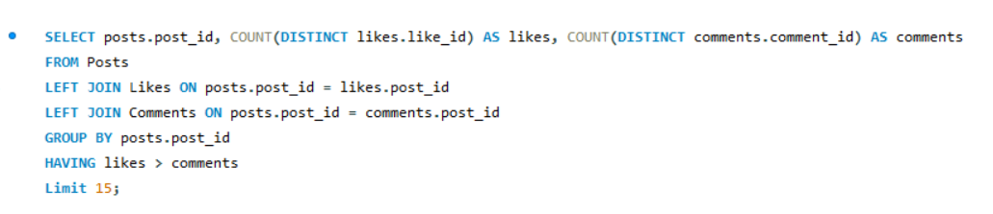

* Output

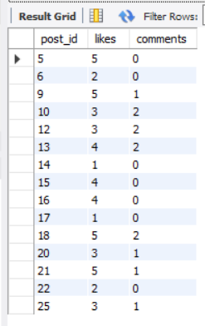



* Insights

Understand which posts resonate with audiences at a glance.

1. Find the most active users based on total actions posts, likes, comments.

* Input

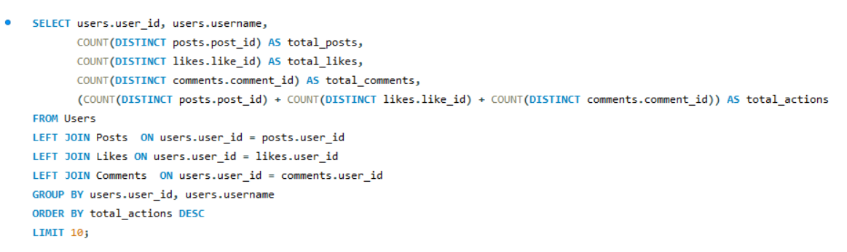

* Output

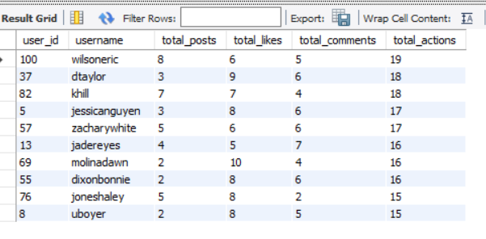

* **Insight**

Identify the most engaged users by combining their contributions across all activities.

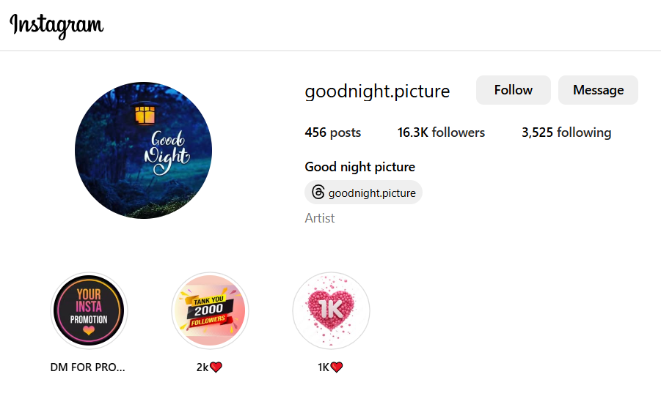

Conclusion

The project shows how SQL is a powerful tool for managing and analyzing data on social media. It helps improve user experience, find trends, and make better decisions for growing the platform.

Links

WhatsApp link:

<https://t.ly/xdmUc>

LinkedIn link:

<https://www.linkedin.com/in/yuvaraj-shivamurti-13929228b?lipi=urn%3Ali%3Apage%3Ad_flagship3_profile_view_base_contact_details%3B5AmZ0FEZRLedpoaOwux5xA%3D%3D>

GitHub link:

<https://t.ly/Le9KS>