2 Requirement Analysis

Project: Automated Network Request Management

2.1 Functional Requirements

User Module
Users should be able to:
- Submit network requests.
- Select the appropriate request type.
- Provide necessary information.
- View request status.
- Receive notifications.

Approver Module
Approvers should be able to:
- Review submitted requests.
- Approve or reject requests.
- Add comments.

Network Administrator Module
Administrators should be able to:
- Monitor all requests.
- Assign tasks.
- Track SLA performance.
- Generate reports.

2.2 Request Types

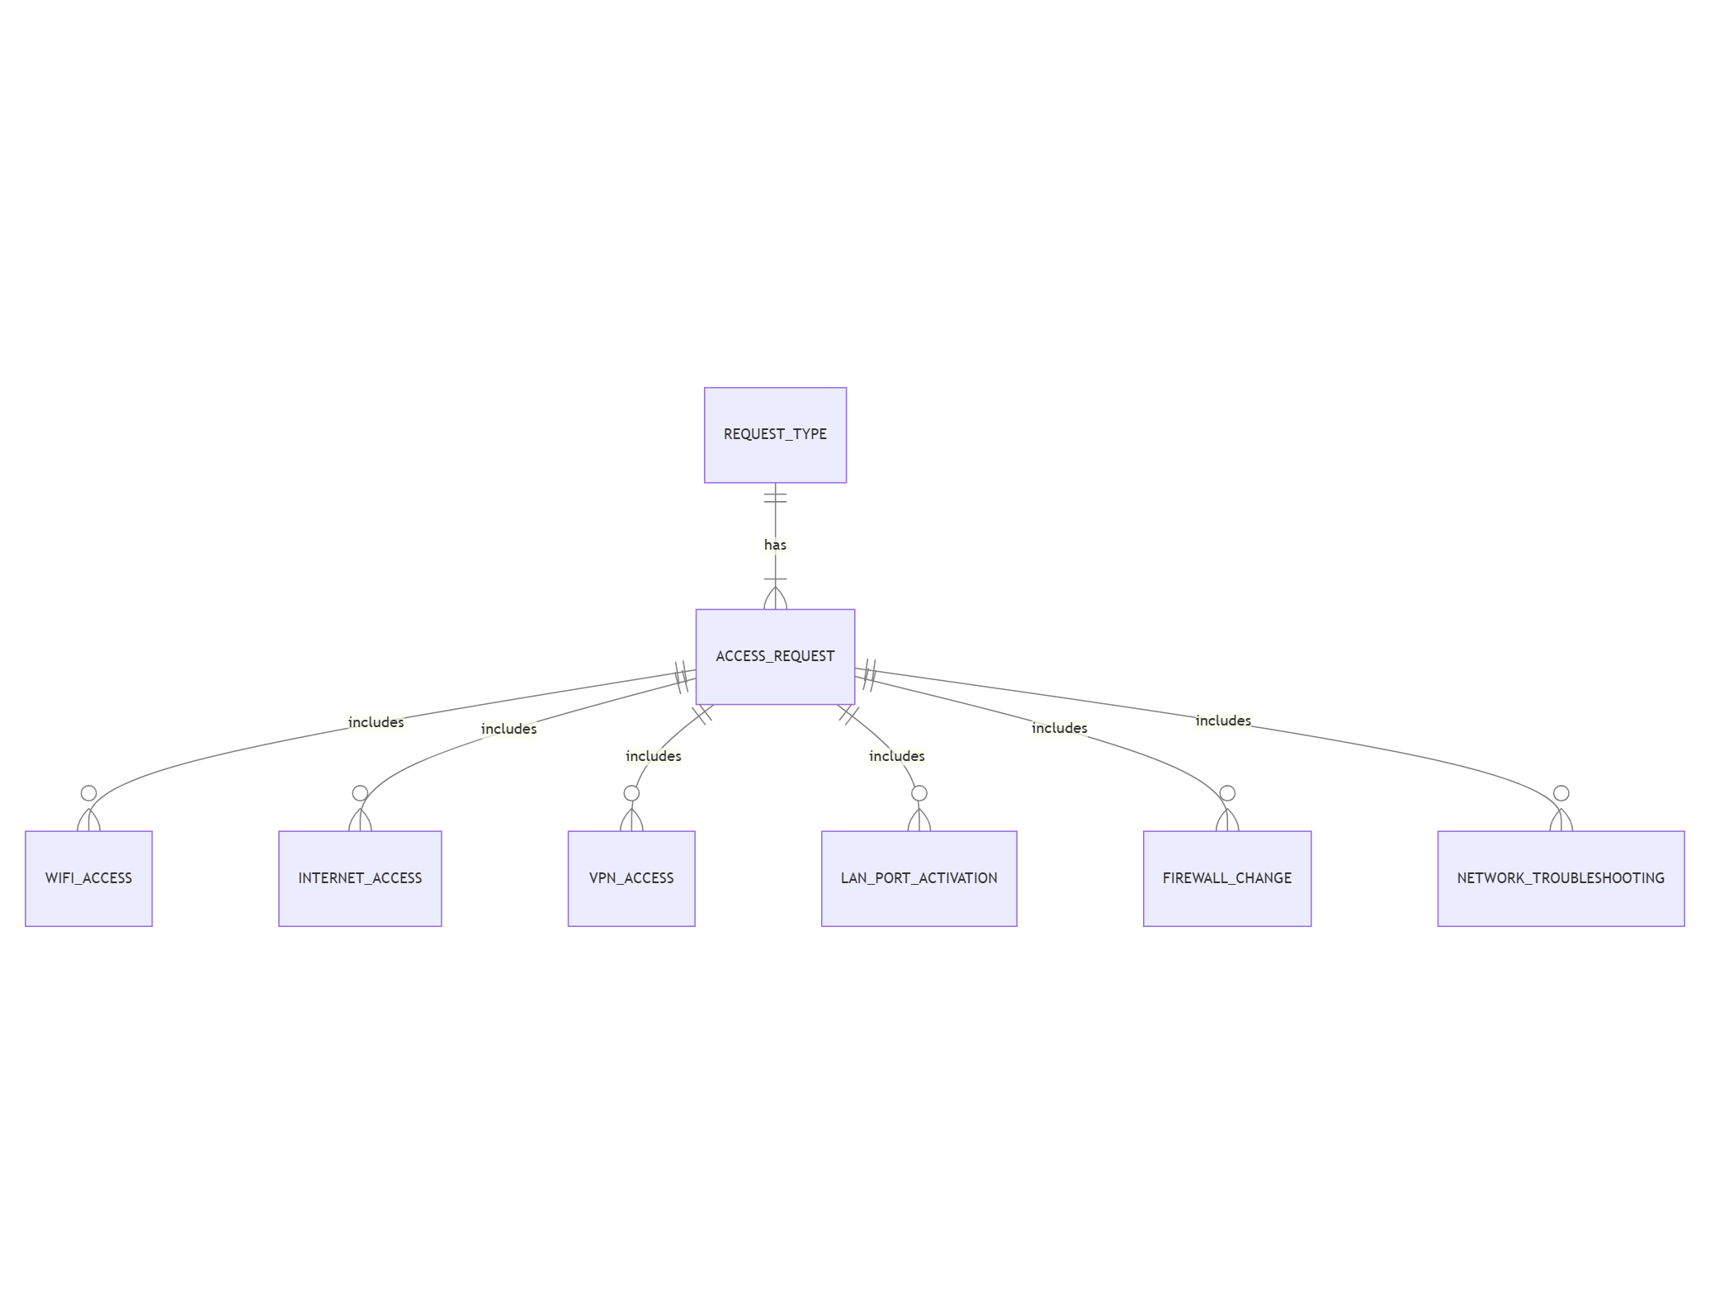

1.VPN Access
- Grant remote access to company resources.

2.Firewall Change
- Modify firewall rules.

3. IP Address Allocation
- Allocate new IP addresses.

4. Network Troubleshooting
- Resolve connectivity issues.

5. Wi-Fi Access
- Provide wireless network access.

6. Port Configuration
- Configure switch ports.

2.3 Stakeholders

Stakeholder | Responsibility
End User | Submit requests
Approver | Approve/Reject requests
Network Admin | Execute tasks
ServiceNow Admin | Maintain system

