3 Project Design Phase
Project: Automated Network Request Management

3.1 ER Diagram

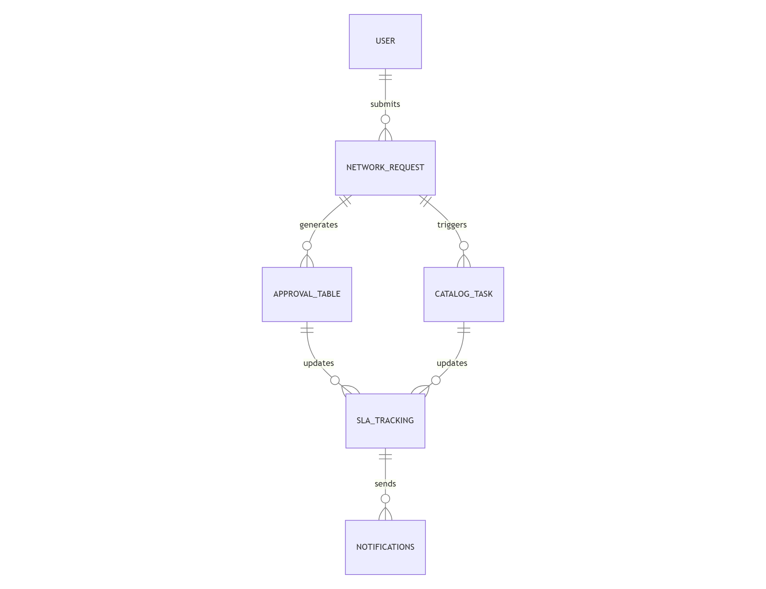

3.2 Data Model Table and Design

Entity | Description | Relationships
User | Employee requesting network services | One User → Many Requests
Network Request | Main request table | Parent table
Approval | Stores manager decisions | One Request → One/Many Approvals
Catalog Task | Tasks assigned to IT teams | One Request → Many Tasks
SLA Tracking | Tracks request completion | One Request → One SLA
Notifications | Email alerts | One Request → Many Notifications
Reports | Dashboard metrics | Derived from Requests

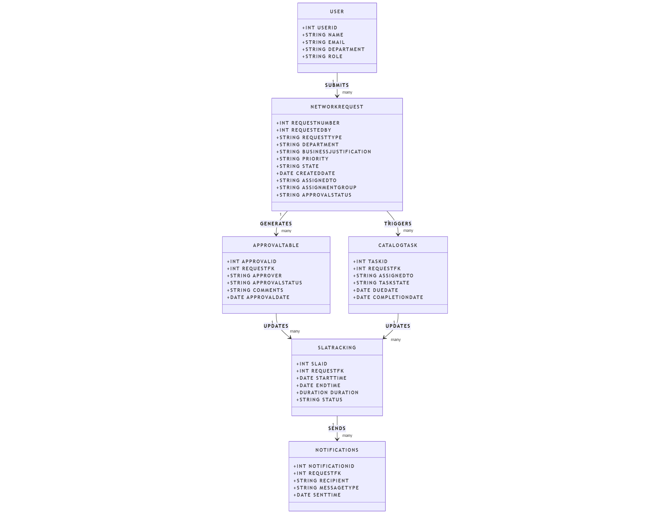

3.3 Modules

Request Submission Module
Allows users to create requests through a Record Producer.

Dynamic Form Module
Displays fields according to selected request type.

Approval Module
Routes requests to appropriate approvers.

Notification Module
Sends automated emails.

SLA Module
Tracks response and resolution times.

Reporting Module
Provides performance analytics.

3.3 Database Design

Network Request Table Fields

Field Name | Purpose
Request Number | Unique identifier
Requested By | User name
Request Type | Category
Access Level | Access privilege
Device Type | Device category
Device Name | Device identification
IP Address | Network address
Department | User department
Business Justification | Request reason
Priority | Urgency level
State | Current status

3.4 Design Considerations
- User-friendly interface
- Easy navigation
- Modular architecture
- Maintainability
- Scalability

