5 Project Development Phase
Project: Automated Network Request Management.

5.1 Development Environment
Modules used:
- Record Producer
- Custom Table
- Catalog Client Scripts
- UI Policies
- Flow Designer
- Notifications
- SLA Definitions
- Reports
- Dashboards

5.2 Custom Table Creation and Configure Variables:

Field Label | Column Name | Data Type | Description
Request Number | number | Auto Number | Unique identifier
Requested By | requested_by | Reference → User | Logged-in user
Request Type | request_type | Reference → request_type | VPN, Firewall, WiFi, LAN, Internet Access
Department | department | Reference → Department | User department
Business Justification | justification | String (4000) | Why access is required
Priority | priority | Choice | Low, Medium, High, Critical
Status | state | Choice | Open, In Progress, Awaiting Approval, Completed, Rejected
Approval Status | approval | Choice | Requested, Approved, Rejected
Assigned Group | assignment_group | Reference → Group | Respective Network team
Requested Date | requested_date | Date/Time | Creation time
Assigned to | assigned_to | Reference → User | Team Heads

Screenshot:

- Network Request[x_1877518_automa_0_network_request]:
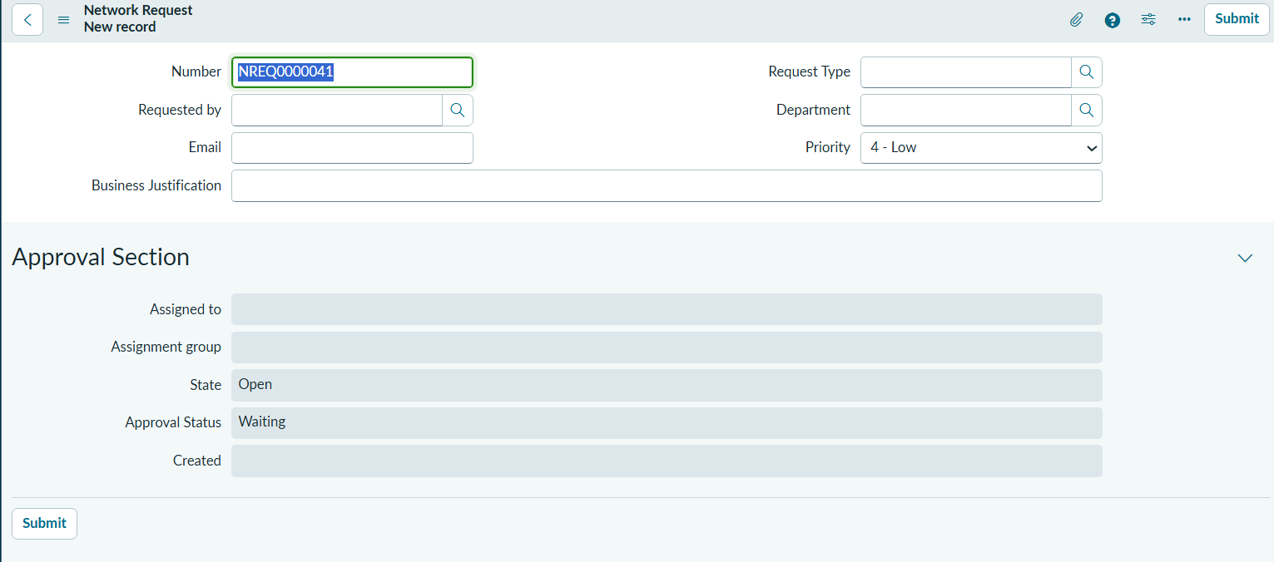
- Request Type[x_1877518_automa_0_request_type]:

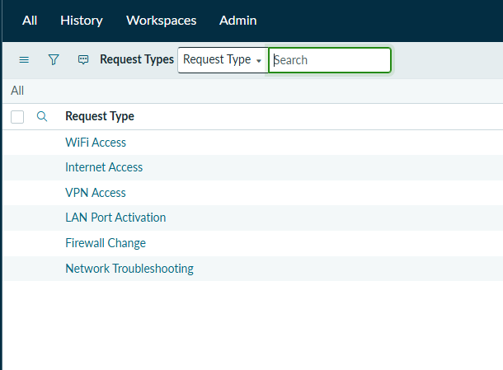

5.3 Record Producer Creation:

Screenshot:
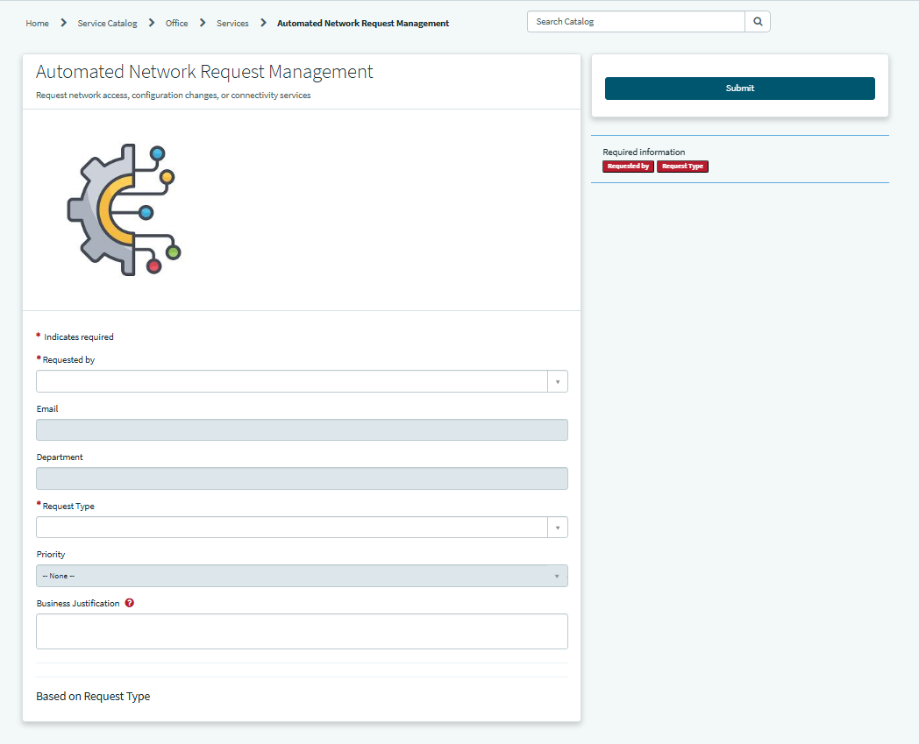

5.4 Create UI Policies:

Request Type | Show Fields
VPN Access | Access Level, Device Type, Device Name, Start Date, End Date
Firewall Change | IP Address, Port Number
WiFi Access | Device Type, Device Name
Internet Access | Website URL
LAN Port Activation | Building, Floor, Desk Number, Port Number
Network Troubleshooting | Device Type, Device Name, Issue Description

Screenshot:

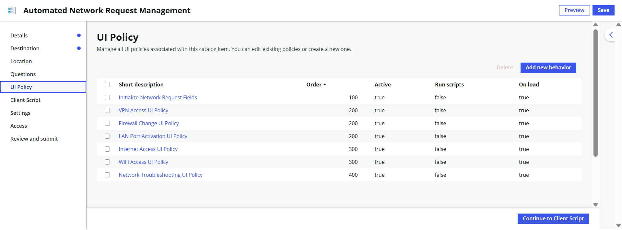

5.5 Assignment Group and Approver:

Network Request Type | Priority | Assignment Group | Approver
VPN Access | 3 | Network Operations Team | Network Operations Team Head
Firewall Change | 1 | Network Security Team | Network Security Team Head
WiFi Access | 5 | Network Operations Team | Network Operations Team Head
Internet Access | 3 | Network Security Team | Network Security Team Head
LAN Port Activation | 4 | Network Support Team | Network Support Team Head
Network Troubleshooting | 2 | Network Support Team | Network Support Team Head

Screenshot:
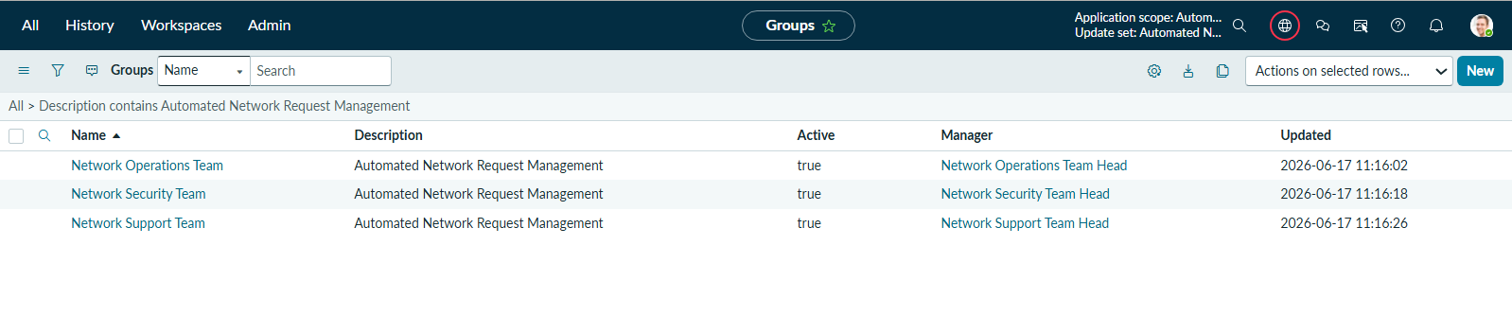

5.6 Approval Flow:

Flow Overview
The Automated Network Request Management System uses ServiceNow Flow Designer to automate the complete lifecycle of a network request, from submission to closure. The flow eliminates manual intervention by automatically routing requests for approval, creating tasks, sending notifications, and tracking SLA compliance.

Flow Description
- Request Submission
The process begins when a user submits a network request through the Record Producer. The user selects a request type and provides the required information such as device details, department, priority, and business justification.
- Request Creation
Once submitted, a new record is created in the Network Request table. The request is assigned a unique request number and its initial state is set to Pending Approval.
- Approval Routing
The Flow Designer automatically determines the appropriate approver based on the selected request type and routes the request for approval.
- Approval Decision
The approver reviews the request and performs one of the following actions:

Approved
  - Request status changes to Approved.
  - An approval notification email is sent to the requester.
  - A network implementation task is automatically created and assigned to the Network Administrator.
  - SLA tracking begins.

Rejected
  - Request status changes to Rejected.
  - A rejection email containing comments is sent to the requester.
  - The process terminates without creating any implementation task.

- Task Execution
The Network Administrator completes the assigned network task such as VPN configuration, firewall modification, IP allocation, Wi-Fi access provisioning, or troubleshooting.
- Task Completion
Once the task is completed:
  - Task status is updated to Closed Complete.
  - Request status is updated to Completed.
  - A completion notification is sent to the requester.

- SLA Monitoring
Throughout the process, SLA metrics are monitored to ensure requests are completed within predefined time limits.

Diagram:

