6 Project Documentation

Project: Automated Network Request Management
Below is a detailed content that you can directly use for your Automated Network Request Management using ServiceNow project report.

PROJECT REPORT

1. INTRODUCTION

1.1 Project Overview
Automated Network Request Management (ANRM) is a ServiceNow-based workflow automation system developed to streamline the process of handling network-related service requests within an organization. Traditional network request processes often rely on emails, spreadsheets, and manual approvals, leading to delays, lack of transparency, and inefficient resource management.
This project provides a centralized self-service portal where employees can submit various network requests. The system automatically routes requests through predefined approval workflows, generates tasks for IT teams, tracks Service Level Agreements (SLAs), sends notifications, and provides reports and dashboards for monitoring overall performance.
The project was implemented using ServiceNow modules such as Record Producers, Flow Designer, Approval Engine, Catalog Tasks, Service Portal, Notifications, Reports, and Dashboards.

Supported Network Request Types
- VPN Access Request
- Firewall Rule Change Request
- Network Drive Access Request
- Wi-Fi Access Request
- Network Device Configuration Request
- IP Address Allocation Request

1.2 Purpose
The purpose of this project is to:
- Eliminate manual processing of network requests.
- Reduce approval delays.
- Standardize request handling procedures.
- Improve request tracking and visibility.
- Automate task assignment.
- Monitor SLA compliance.
- Provide centralized reporting and analytics.

2. IDEATION PHASE

2.1 Problem Statement
Organizations often process network requests manually through emails and spreadsheets. This results in:
- Long processing times.
- Missing approvals.
- Inconsistent documentation.
- Poor visibility of request status.
- Difficulty tracking SLA compliance.
- Increased workload for IT administrators.
There is a need for an automated system that centralizes request management and reduces manual intervention.

2.2 Empathy Map Canvas

Users: Employees, Managers, Network Administrators, IT Support Teams

Think
- I need my network access quickly.
- I want to know the status of my request.
- I want a simple request submission process.

Feel
- Frustrated by delays.
- Confused about approval status.
- Concerned about request completion time.

Say
- "Where is my request?"
- "Who should approve this?"
- "Why is this taking so long?"

Do
- Submit network requests.
- Track approvals.
- Follow up with IT teams.

Pain Points
- Manual approvals
- Delayed communication
- Lack of transparency

Gains
- Faster approvals
- Automated tracking
- Better user experience

2.3 Brainstorming
Potential solutions considered:
Problem | Solution
Manual request submission | Self-service portal
Approval delays | Automated approval flows
No status visibility | Real-time tracking
Missed tasks | Automatic task creation
SLA violations | SLA monitoring
Lack of reporting | Dashboards and reports

3. REQUIREMENT ANALYSIS

3.1 Customer Journey Map
Stage | User Action | System Response
Request Submission | User submits request | Request created
Validation | System validates inputs | Data verified
Approval | Manager approves/rejects | Approval recorded
Task Assignment | Task assigned to IT | Work begins
Completion | Request fulfilled | Status updated
Monitoring | User tracks progress | Dashboard updated

3.2 Solution Requirement

Functional Requirements
- User authentication
- Request submission
- Dynamic forms
- Approval workflows
- Task creation
- SLA tracking
- Email notifications
- Reports and dashboards

Non-Functional Requirements
- Availability
- Reliability
- Scalability
- Security
- Maintainability
- Performance

3.3 Data Flow Diagram
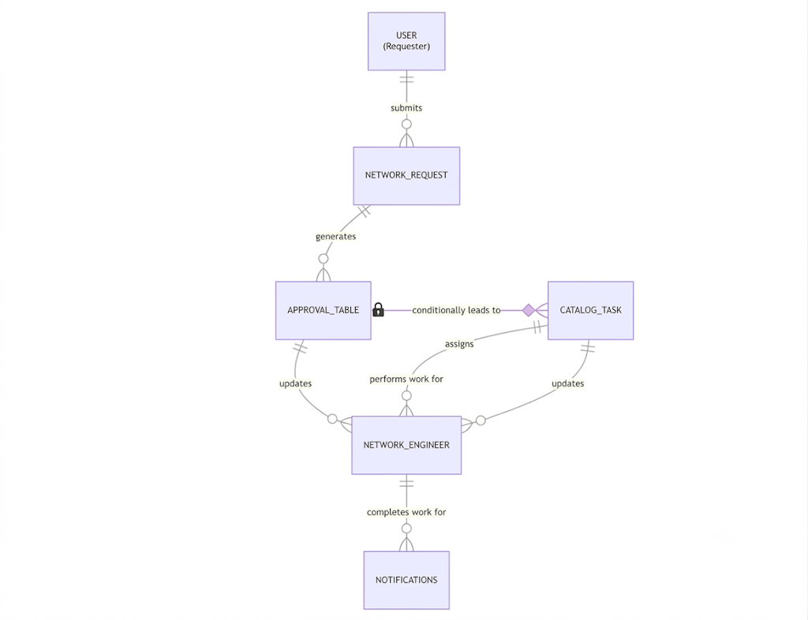

3.4 Technology Stack
Component | Technology
Platform | ServiceNow
Workflow Engine | Flow Designer
UI | Service Portal
Database | ServiceNow Tables
Notifications | Email Notifications
Approval Engine | ServiceNow Approvals
Reporting | Reports & Dashboards
SLA Management | Task SLA

4. PROJECT DESIGN

4.1 Problem Solution Fit
Problem | Proposed Solution
Manual request handling | Automated workflows
Delayed approvals | Dynamic approval routing
Lack of visibility | Real-time status tracking
Manual task assignment | Auto-generated tasks
No monitoring | Dashboards and reports

4.2 Proposed Solution
The proposed system automates the complete lifecycle of network requests from submission to closure.
Workflow:
- User submits request.
- System validates information.
- Approval request is generated.
- Manager approves or rejects.
- IT task is automatically created.
- SLA timer begins.
- Notifications are sent.
- Request is completed.
- Reports are updated.

4.3 Solution Architecture

User

|

Service Portal

|

Record Producer

|

u_network_request

|

Flow Designer

|
request_engineer(store additional details of request)
|
|
-----------------------------------

| | | |

Approval Tasks SLA Notifications

|

Reports & Dashboards

5. PROJECT PLANNING & SCHEDULING

5.1 Project Planning
Phase | Activity
Week 1 | Requirement Gathering
Week 2 | Data Modeling
Week 3 | Record Producer Development
Week 4 | Approval Flow Development
Week 5 | Task Automation
Week 6 | SLA Configuration
Week 7 | Service Portal Development
Week 8 | Reports and Dashboards
Week 9 | Testing
Week 10 | Documentation

6. FUNCTIONAL AND PERFORMANCE TESTING

6.1 Performance Testing
Test Case | Expected Result | Status
Submit request | Request created | Pass
Approve request | Status updated | Pass
Reject request | Notification sent | Pass
Generate task | Task created | Pass
SLA tracking | Timer activated | Pass
Dashboard update | Data refreshed | Pass

7. RESULTS

7.1 Output Screenshots

- Record Producer Form:
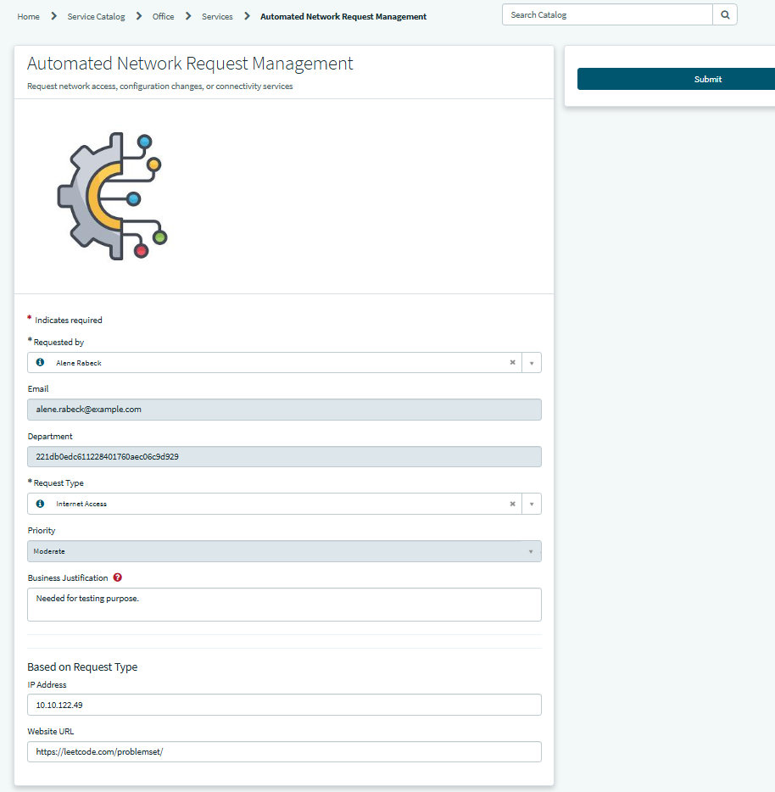

- Approval Screen:
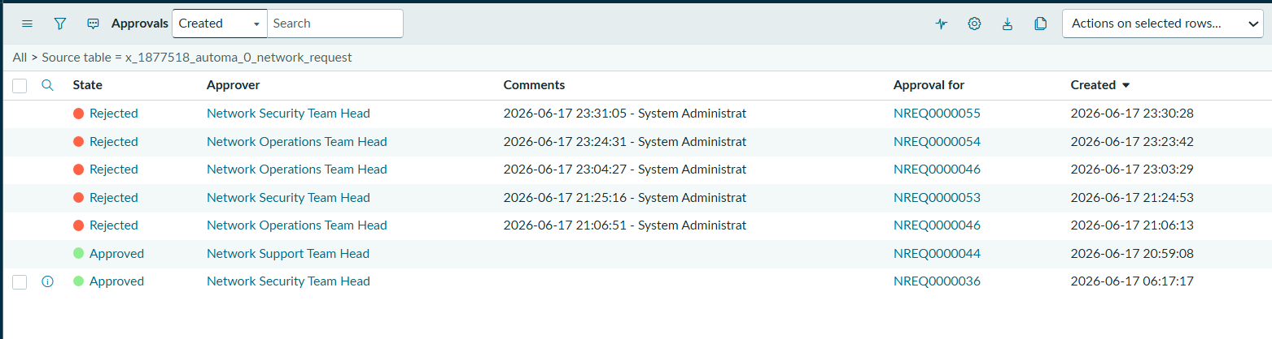

- SLA Tracking:
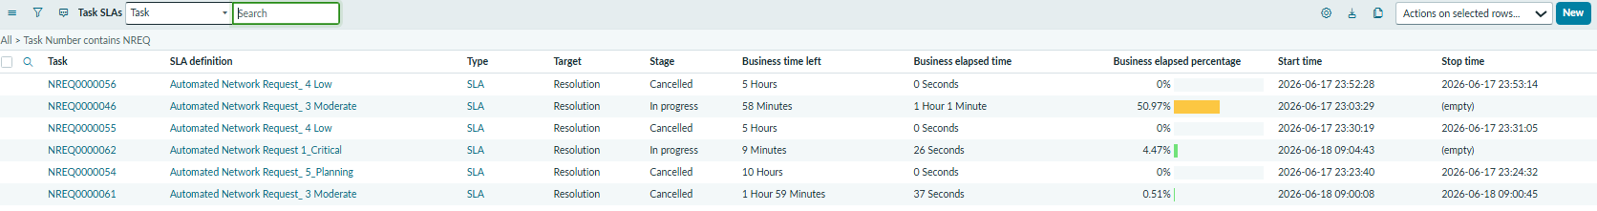
- Email Notifications:
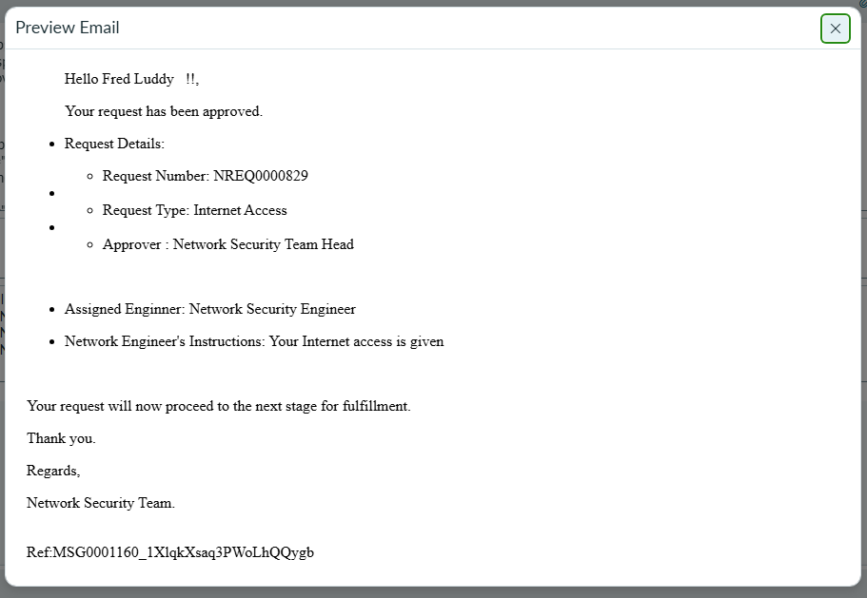

- Dashboards

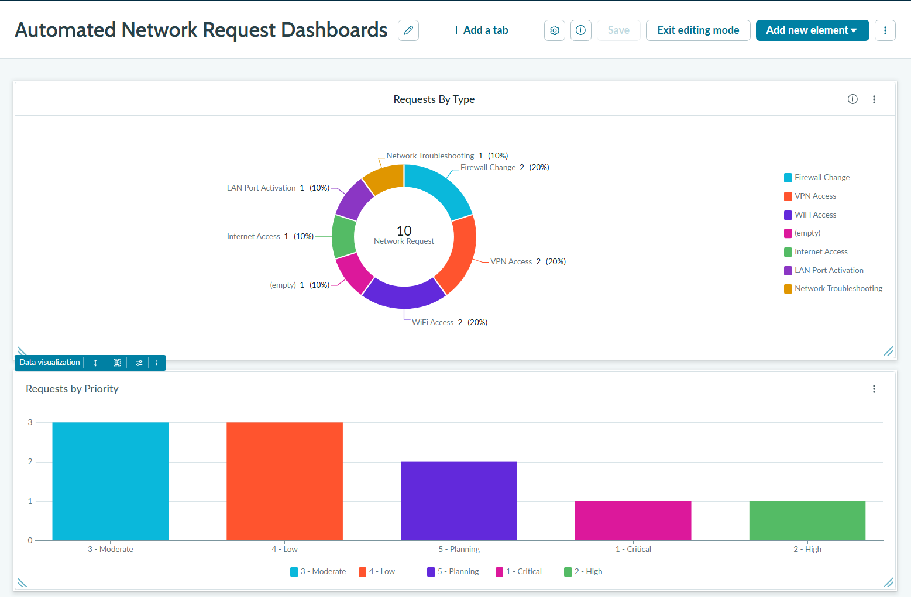
- Network Engineer assigned requests:
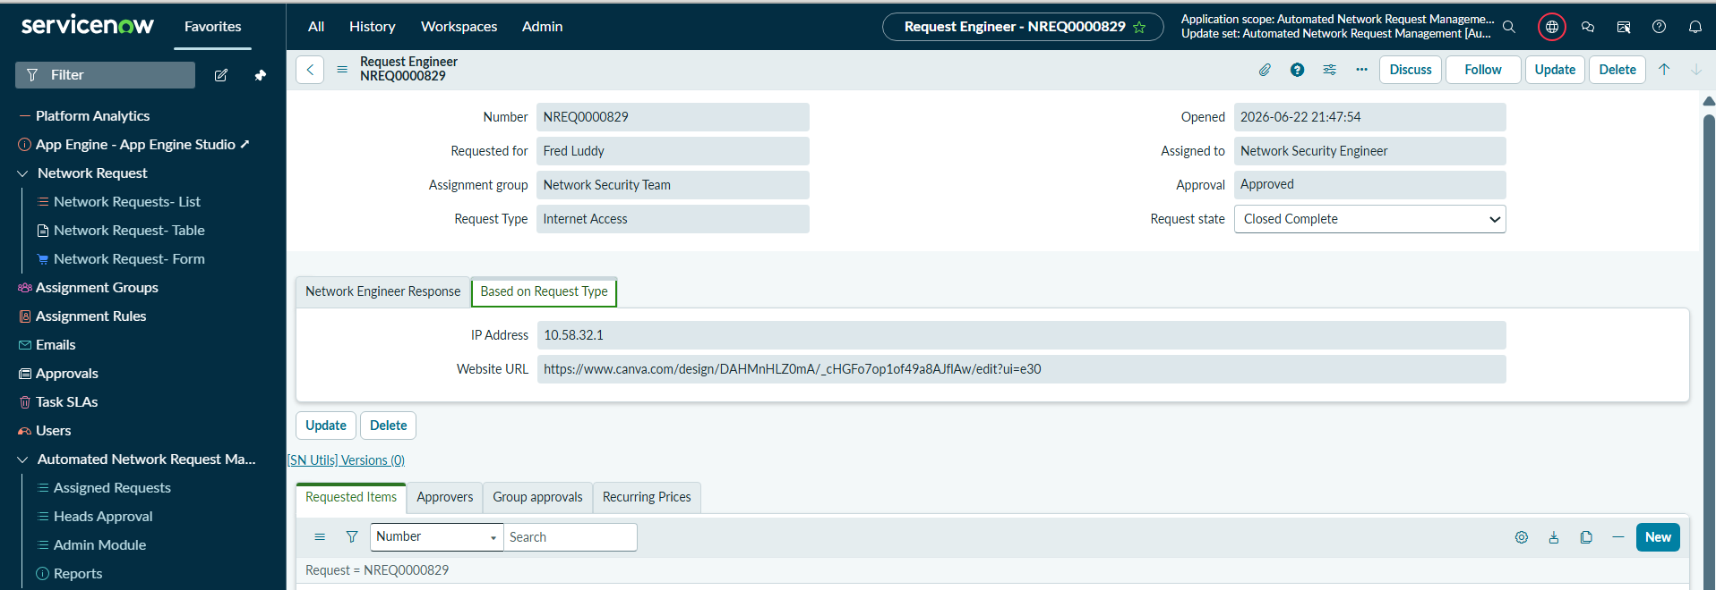

- Flow Designer:

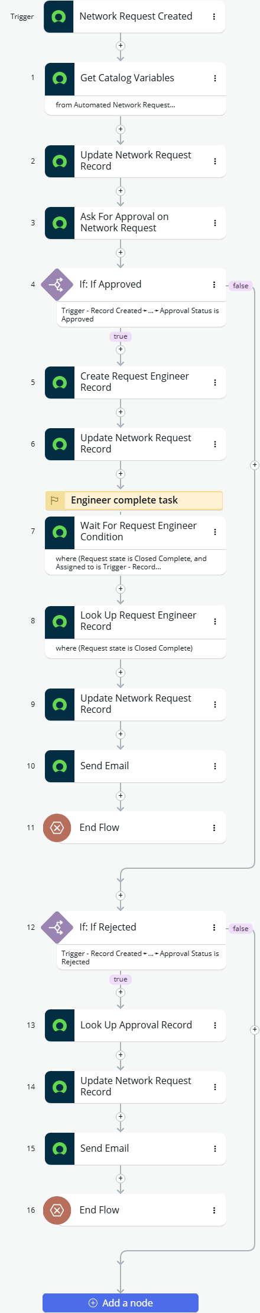

8. ADVANTAGES & DISADVANTAGES

Advantages
- Reduces manual effort
- Faster approvals
- Better transparency
- Improved tracking
- SLA compliance
- Centralized management
- Better reporting

Disadvantages
- Initial configuration is time-consuming
- Requires ServiceNow knowledge
- Depends on proper workflow design
- Requires user training

9. CONCLUSION
The Automated Network Request Management system successfully automates the network request lifecycle within an organization. The implementation improves operational efficiency, reduces manual intervention, and enhances visibility into request processing. The integration of approvals, tasks, SLA monitoring, notifications, and dashboards creates a scalable and efficient IT service management solution.

10. FUTURE SCOPE
Future enhancements may include:
- AI-based request prioritization
- Predictive SLA breach analysis
- Virtual Agent integration
- Mobile application integration
- Multi-level dynamic approvals
- Advanced analytics dashboards
- Integration with external network monitoring tools

11. APPENDIX

GitHub & Project Demo Link
GitHub Repository:
https://github.com/Yuvaraj11E/Automated-Network-Request-Management.git

Project Demo Video:
https://drive.google.com/file/d/15KL1OYRA9El9VBXUF0AcSJdVMuhazqZL/view?usp=sharing

