Ex.no: 1b | EDA – Data Science Frameworks(CRISPDM, SEMMA, KDD)

AIM:
To analyze the Netflix Movies and TV Shows dataset using Exploratory Data Analysis (EDA), visualize important patterns in content type, release year, ratings, and duration, preprocess the dataset, build a Machine Learning model to predict content duration, evaluate the model, and export the processed data to Excel.
ALGORITHM:
- Load the Netflix dataset using Pandas.
- Import required libraries such as Pandas, Matplotlib, Seaborn, and Scikit-learn.
- Display the first few records, dataset shape, information, and missing values.
- Check and remove duplicate records from the dataset.
- Analyze important features such as content type, release year, rating, duration, country, and listed-in categories.
- Handle missing values in the dataset.
- Convert categorical features such as type and rating into numerical form.
- Visualize the distribution of content duration using a histogram.
- Create a correlation heatmap to identify relationships between numerical features.
- Separate the input features (X) and target variable (y), using numerical duration as the target.
- Split the dataset into training and testing data.
- Train a Machine Learning model using the training data.
- Predict content duration using the test data.
- Evaluate the model using Mean Absolute Error (MAE) and R² score.
- Export the processed Netflix data to an Excel file.
- Display the analysis results, including model performance and evaluation metrics.
PROGRAM:
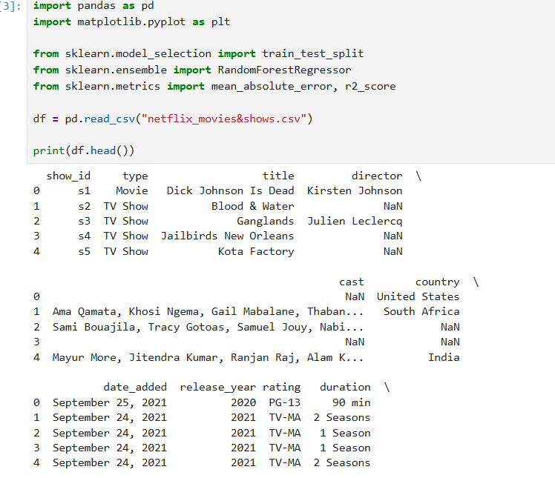
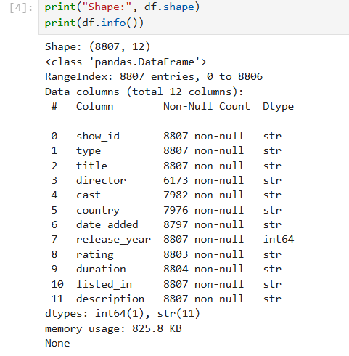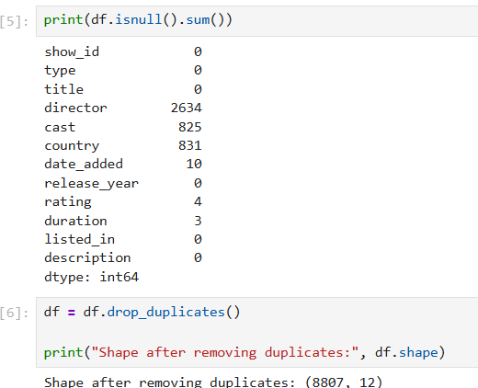

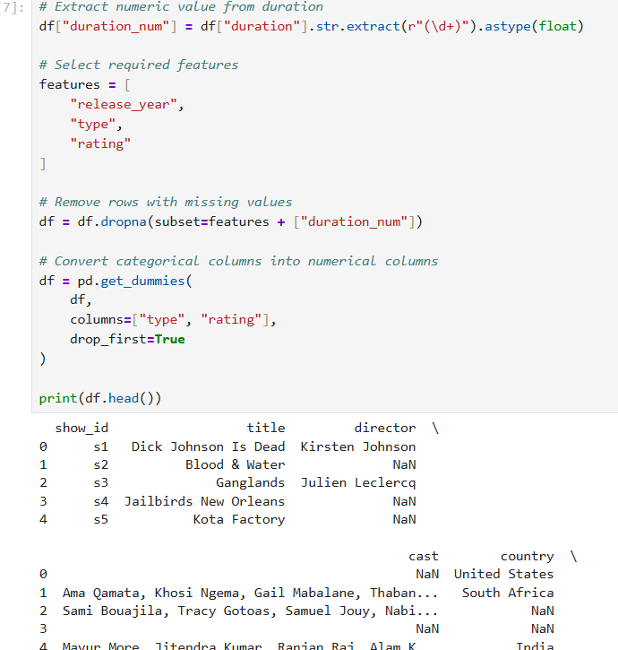

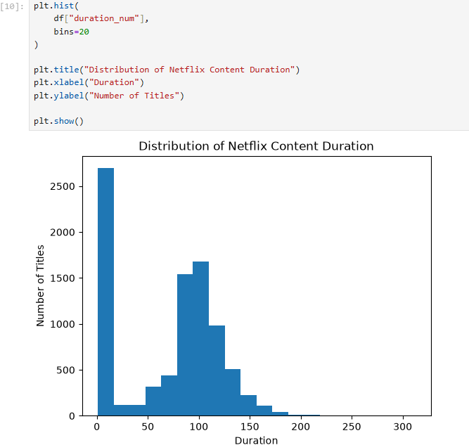
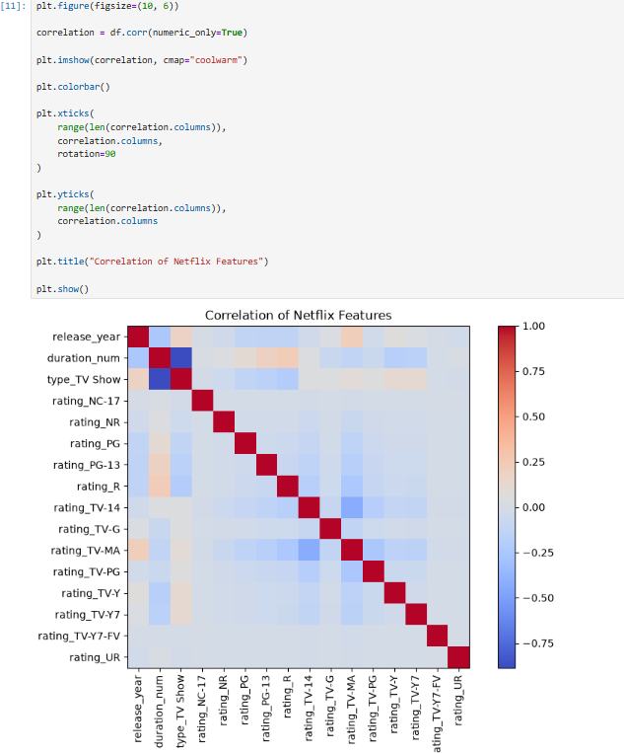
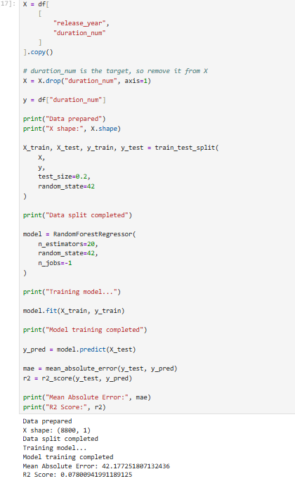

RESULT:
Thus, the insurance dataset was successfully analyzed using EDA, important patterns in medical charges were visualized, the data was preprocessed, and a Machine Learning model was built and evaluated to predict insurance charges. The processed dataset was also exported to Excel successfully.

