Ex.no:7a | DATA VISUALIZATION USING TABLEAU

Aim:
To connect, analyze, visualize, and create interactive dashboards using Tableau for effective business intelligence and data analytics.

Algorithm:
- Open Tableau Desktop/Tableau Public and connect the E-Commerce Orders and Sales Performance dataset.
- Verify the imported data containing Product Name, Category, Region, Sales, Quantity, Profit, and Order Date fields.
- Create worksheets by dragging the required fields to the Rows and Columns shelves.
- Create a bar chart to analyze product-wise sales using Product Name and Sales.
- Create a pie chart to visualize category-wise sales contribution using Category and Sales.
- Create a chart to analyze the variation in Sales and Quantity among products using Product Name, Sales, and Quantity.
- Create a calculated field named Sales with Tax using the formula [Sales] * 1.10.
- Apply a Region filter to analyze sales for individual regions.
- Create a Minimum Sales parameter and display products based on the selected minimum sales value.
- Combine the created worksheets into an interactive Sales Performance Dashboard.
- Add filters, parameters, charts, and KPI information to the dashboard for interactive analysis.
- Create a Tableau Story using the dashboard and worksheets to present overall sales performance, product-wise analysis, category-wise analysis, and regional analysis.
- Analyze the visualizations and identify important sales insights such as highest sales, lowest sales, average sales, and category contribution.

Output:
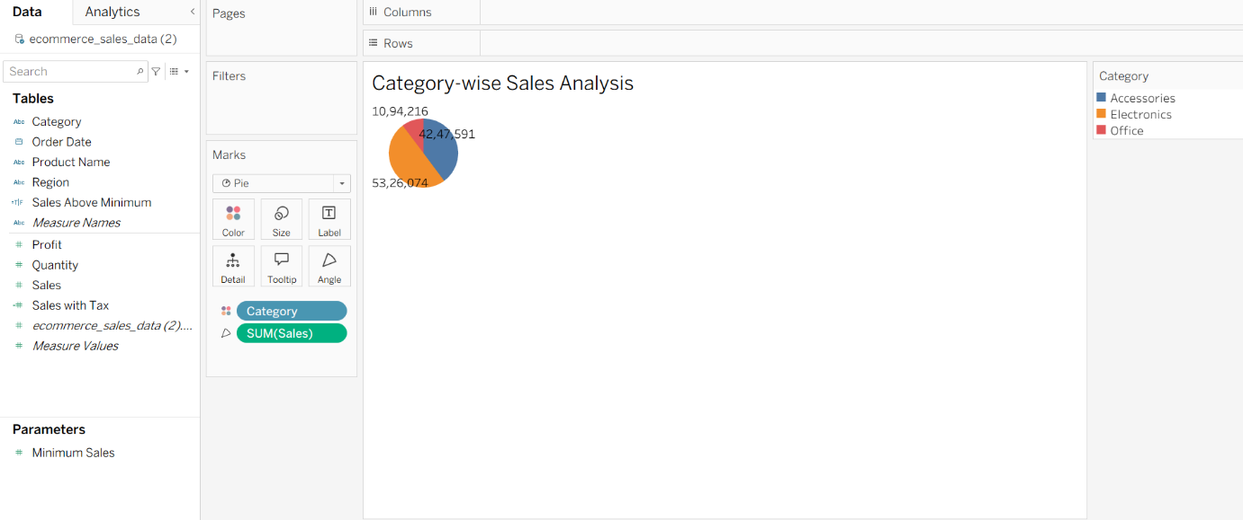
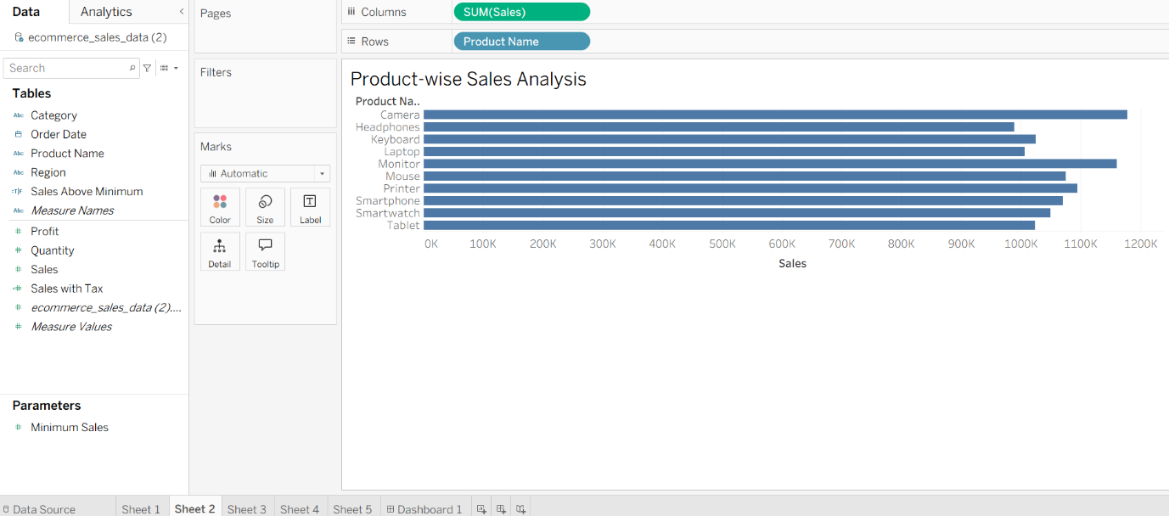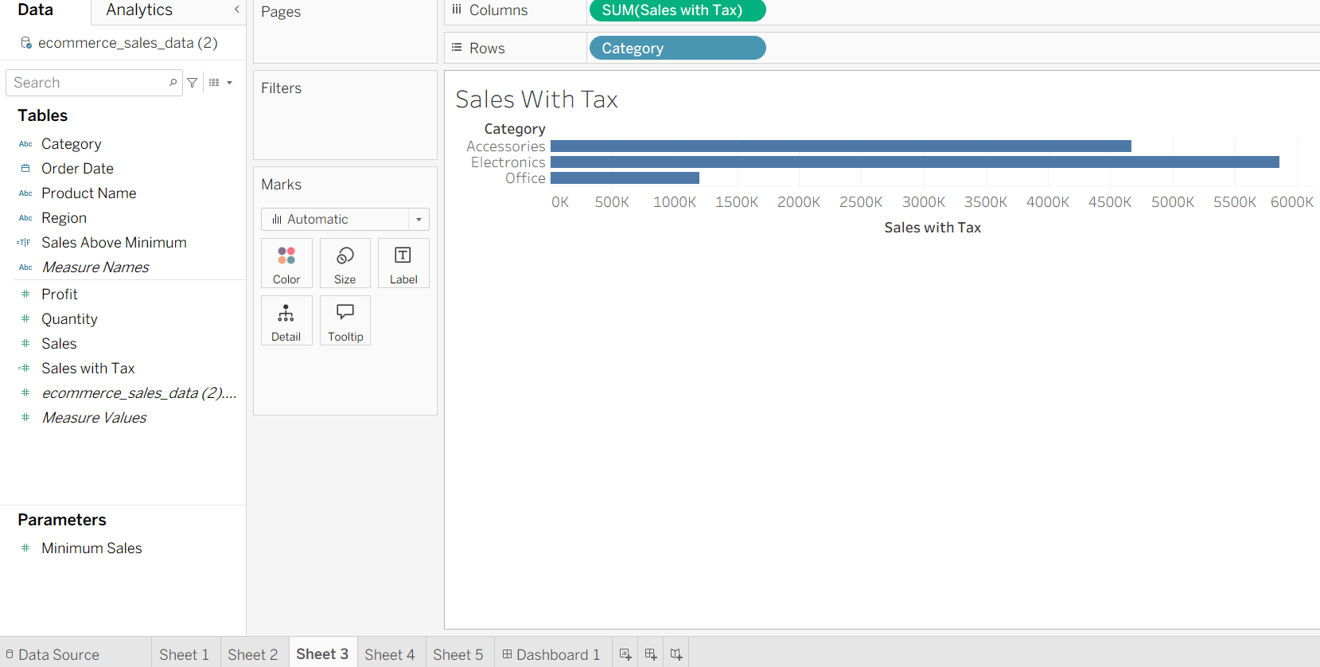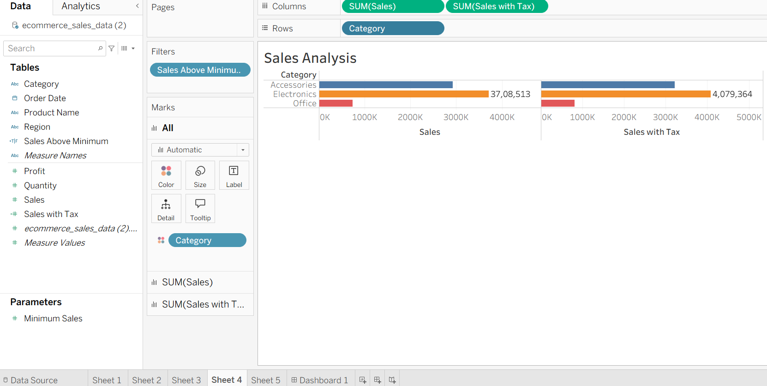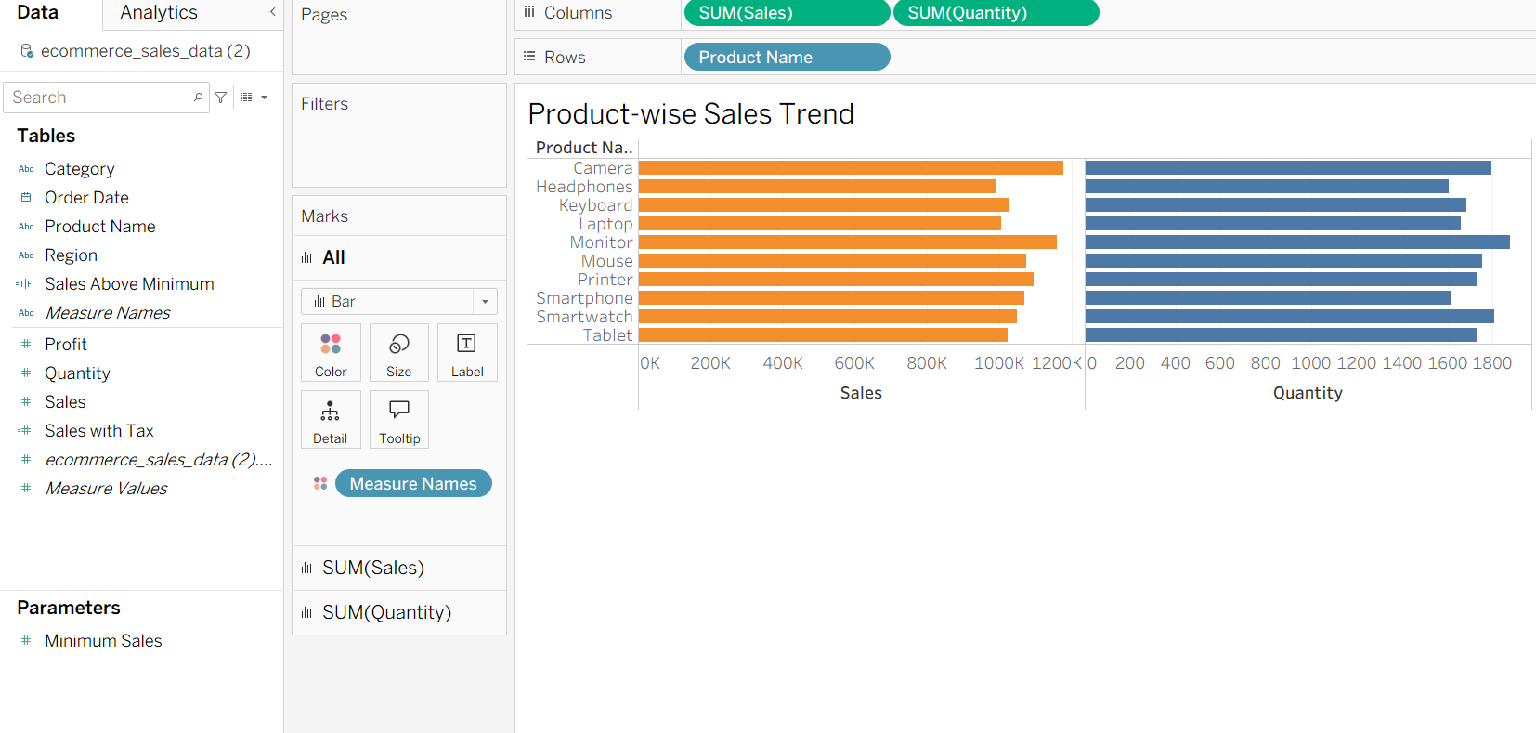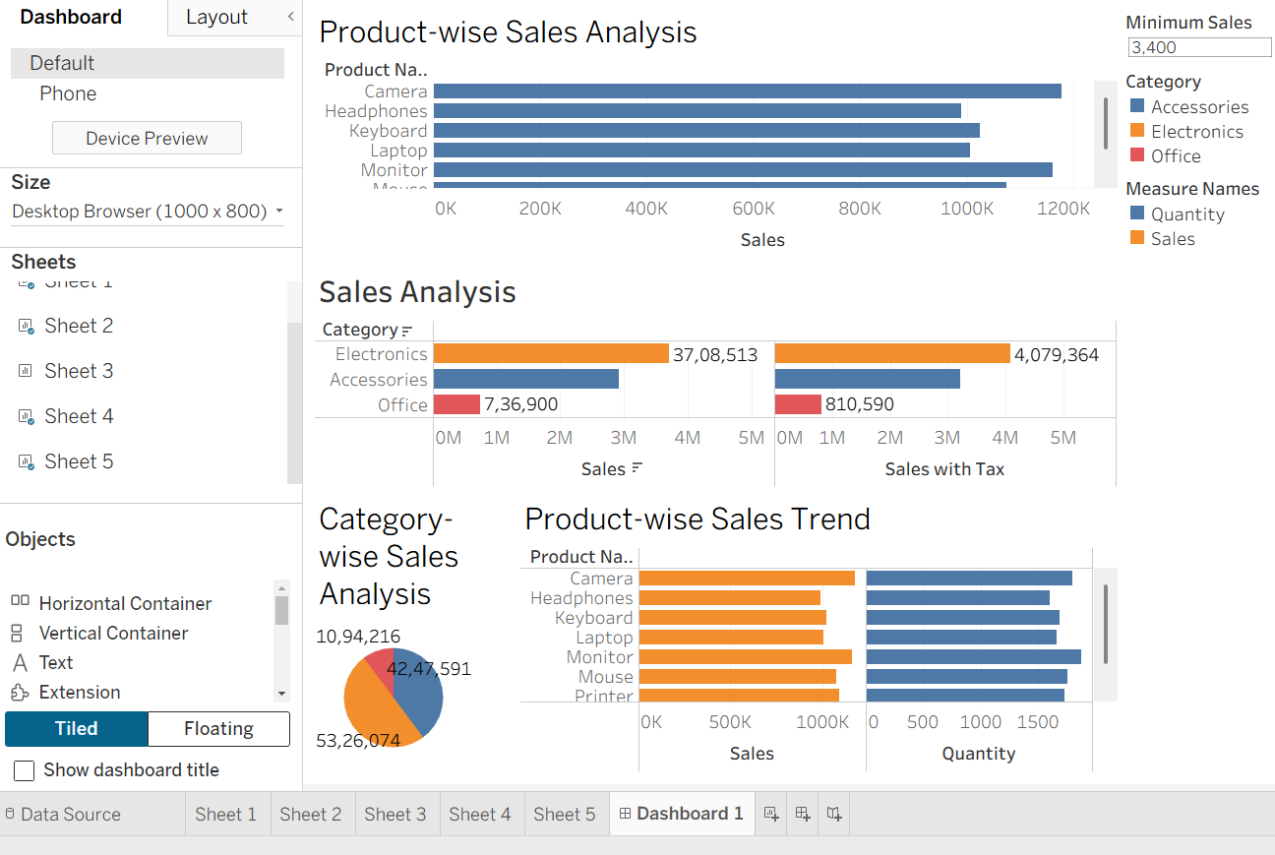

Result:
The E-Commerce Orders and Sales Performance dataset was successfully connected and analyzed using Tableau. Product-wise bar charts, category-wise pie charts, and product-wise sales and quantity charts were created successfully. A calculated field for Sales with Tax, an interactive Region filter, and a Minimum Sales parameter were applied. An interactive Sales Performance Dashboard and Tableau Story were created to present the analyzed results effectively.

