Ex.no:6 a | DATA VISUALIZATION USING POWER BI

Aim:
To Load the data into PowerBI and transform the data and visualize it to get insights.

Algorithm:

- Load the FIFA Players dataset containing player details and performance attributes.
- Check the Nationality slicer and filter the data according to the selected nationality.
- Calculate the total number of players from the dataset.
- Group the data by Nationality and count the players to create the bar chart.
- Group the data by Preferred Foot and calculate the player percentage to create the donut chart.
- Calculate the average Overall Rating and display it as a KPI card.
- Display the KPI card, bar chart, donut chart, and nationality slicer, updating them whenever the slicer selection changes.
Output:
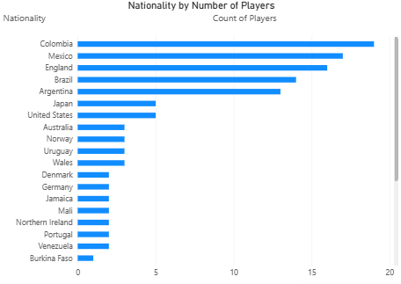-
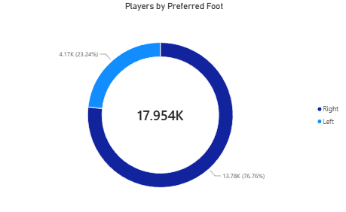
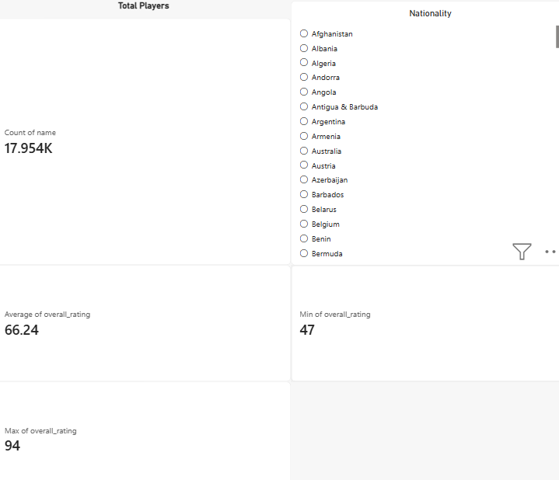

Result:
The data was successfully loaded into Power BI, transformed and analyzed, and visualized using charts and a dashboard to obtain meaningful insights from the sales data.

