Ex.no:7b | DATA VISUALIZATION USING TABLEAU

Aim:
To connect, analyze, visualize, and create an interactive dashboard using Tableau for effective analysis of FIFA player data.
Algorithm:
- Open Tableau Desktop and connect to the fifa_players(1).csv dataset.
- Verify the imported data and data types such as Name, Nationality, Age, Overall Rating, Potential, Value Euro, Wage Euro, Height Cm, Weight Kgs, and Preferred Foot.
- Create a worksheet to analyze nationality-wise player ratings.
- Create a bar chart to compare player ratings based on Preferred Foot.
- Create a pie chart to visualize the contribution of different Nationalities to the total number of players.
- Create a line chart to analyze the relationship between Age and Overall Rating.
- Create a calculated field named Physical Strength using the formula:
- [Height Cm] + [Weight Kgs]
- Apply Preferred Foot and Nationality filters to analyze selected players.
- Create a Minimum Player Value parameter to display players based on the selected minimum player value.
- Create a new dashboard and add the required worksheets and visualizations.
- Add KPI cards for Total Player Value, Average Overall Rating, and Number of Players.
- Arrange and format the charts, KPI cards, filters, and parameter.
- Save the completed FIFA Player Analysis Dashboard.
Output:
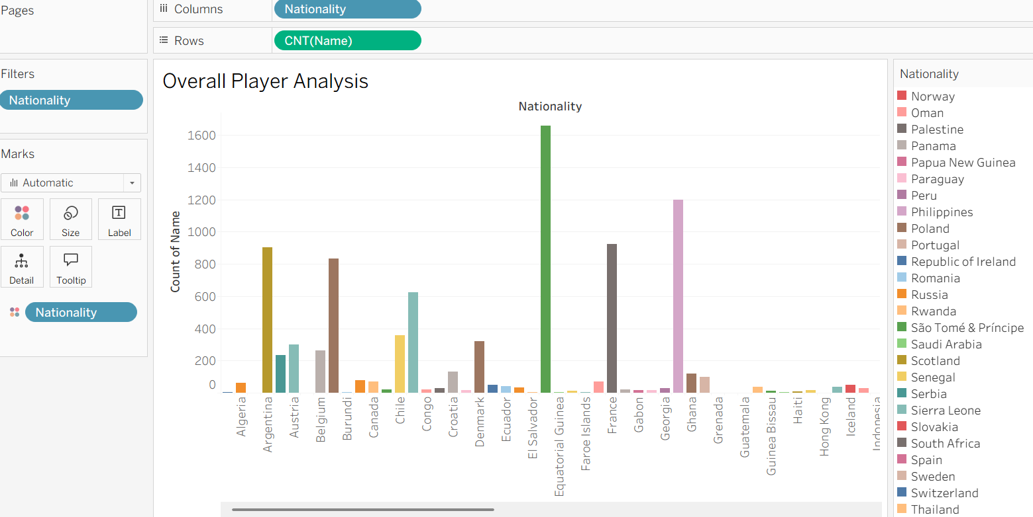

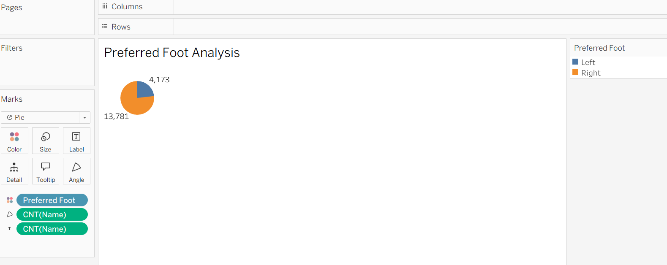

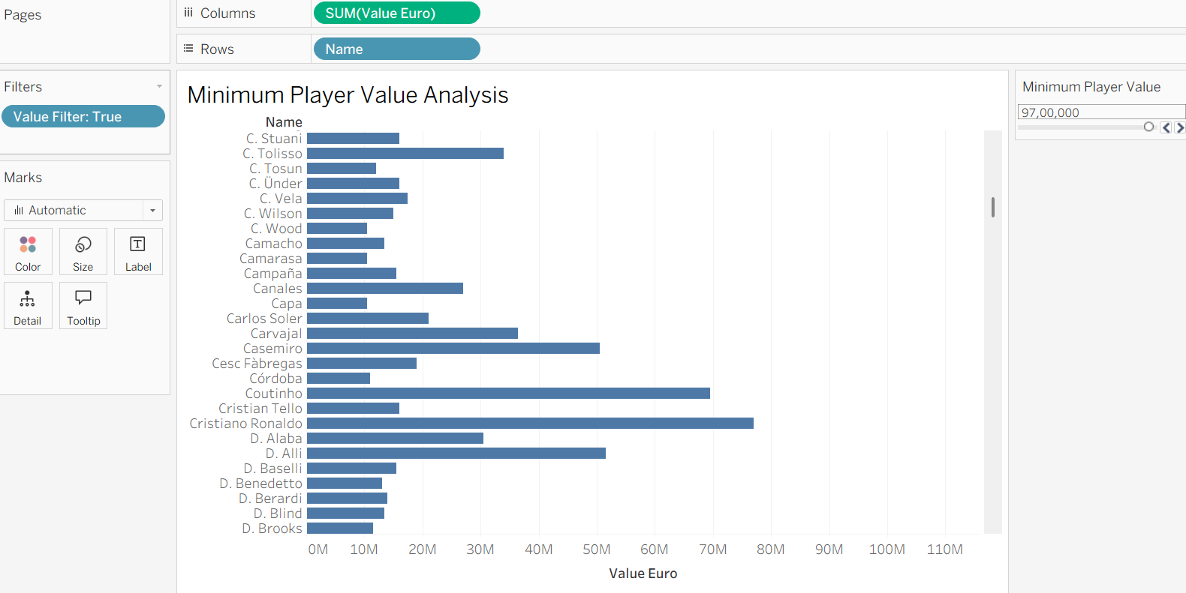

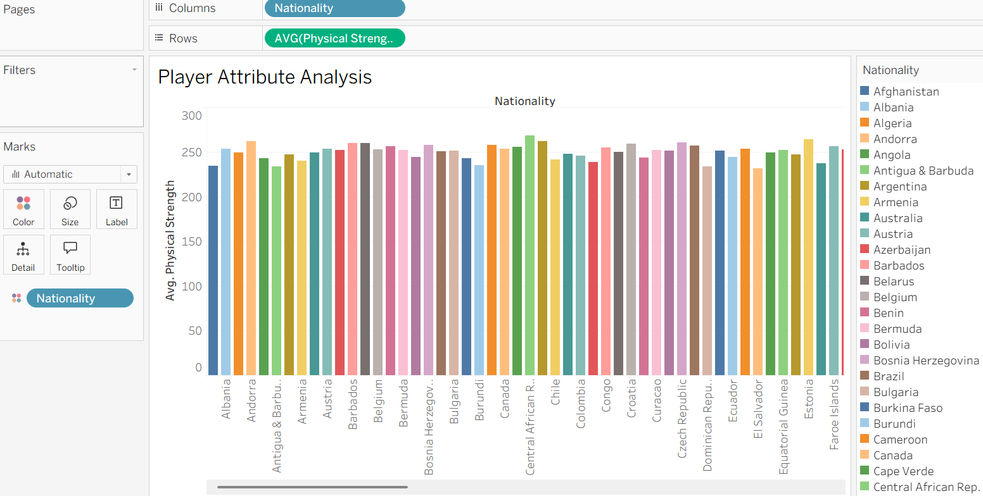

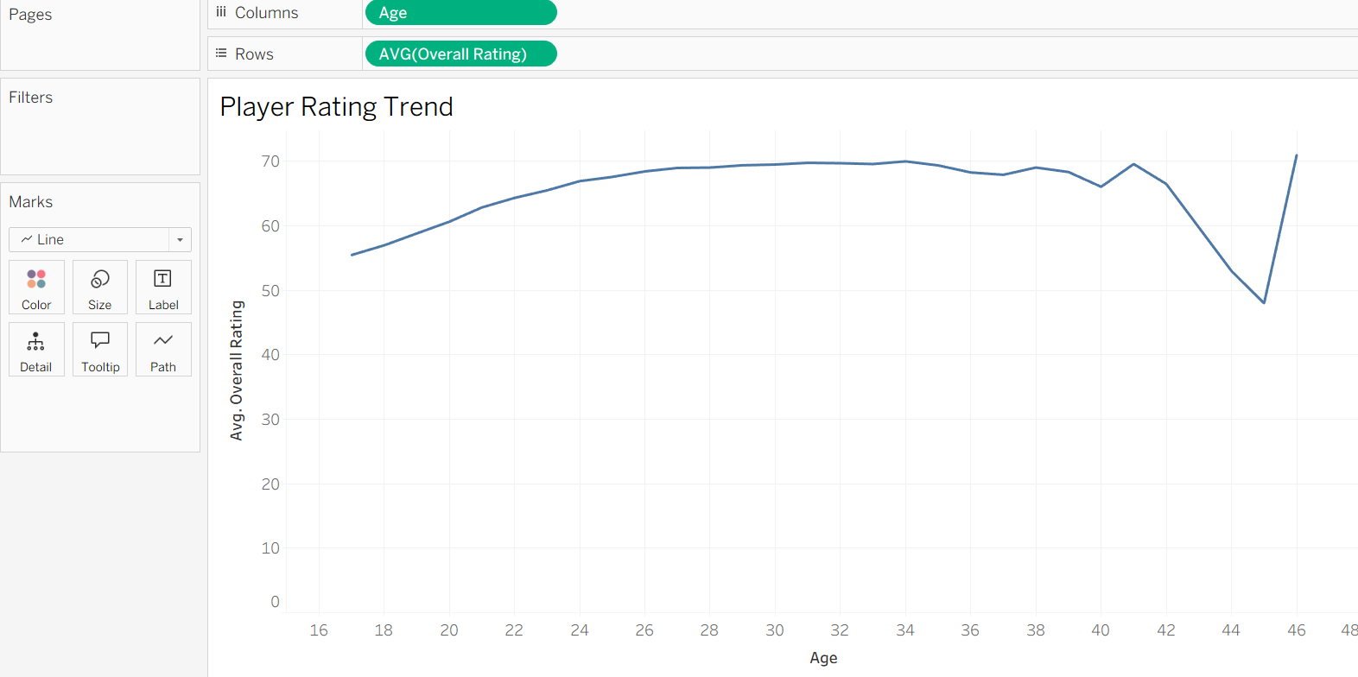

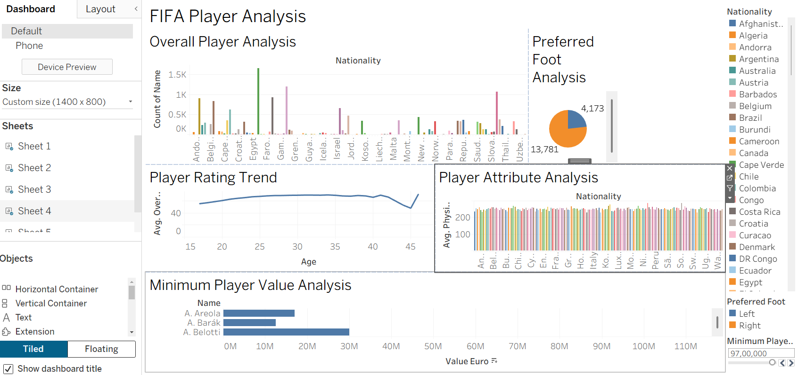

Result:
The FIFA Players dataset was successfully connected, analyzed, and visualized using Tableau. An interactive FIFA Player Analysis Dashboard was created using charts, a calculated field, filters, a parameter, and KPI cards to effectively analyze player ratings, values, attributes, and nationality-wise player information

