Ex.no:8 | MINI PROJECT – FIFA PLAYERS DATA ANALYTICS

Domain and Problem Statement:
Domain: Sports Analytics & Player Valuation
Problem Statement: Football clubs, scouts, and analysts face challenges in identifying high-value players, understanding the impact of age and position on market value, and evaluating international representation. This project transforms raw FIFA player statistics into structured business intelligence across Power BI and Tableau to evaluate player valuations, geographic distribution, performance metrics, and skill scores.

Dataset Description:
Dataset Name: FIFA Players Dataset.
Granularity: Each row represents a single professional football player's statistics and attributes..
Timeframe Covered: Current season snapshot.
Key Entities & Attributes:
- Demographics: name, full_name, age, nationality.
- Player Attributes: height_cm, preferred_foot, weak_foot, primary_position, is_international, age_group.
- Performance & Financials: overall_rating, value_euro, total_skill_score, value_per_rating.

Data Source:
Primary Source: Kaggle Open Datasets (FIFA Players Datasets).
Storage Infrastructure: Cleaned player records hosted within a local MySQL database instance (player_analytics).

Architecture:
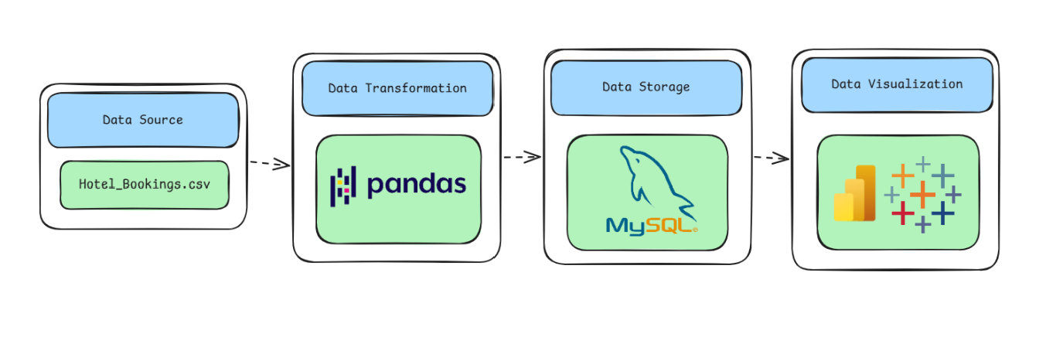

Program:
1. Python – Data Cleaning & Transformation
import pandas as pd
from sqlalchemy import create_engine, text
import urllib.parse

# Load dataset
df = pd.read_excel("fifa_players_mod.xlsx")

# Create a copy for processing
players = df.copy()

# Standardize column names
players.columns = (
players.columns
.str.lower()
.str.strip()
.str.replace(" ", "_")
.str.replace("(1-5)", "", regex=False)
)

# Handle missing values
players["value_euro"] = players["value_euro"].fillna(0)
players["national_team"] = players["national_team"].fillna("None")
players["national_team_position"] = players["national_team_position"].fillna("None")
players["national_jersey_number"] = players["national_jersey_number"].fillna(0)

# Remove duplicate records
players.drop_duplicates(inplace=True)

# Create derived columns
players["primary_position"] = players["positions"].str.split(",").str[0]
players["is_international"] = (players["national_team"] != "None").astype(int)

def age_group(age):
if age <= 21:
return "Youth (<=21)"
elif age <= 29:
return "Prime (22-29)"
return "Veteran (30+)"

players["age_group"] = players["age"].apply(age_group)

# Calculate skill scores and value per rating
skill_cols = ["crossing", "finishing", "heading_accuracy", "dribbling", "curve",
"freekick_accuracy", "long_passing", "sprint_speed", "shot_power",
"jumping", "stamina", "strength", "penalties"]
players["total_skill_score"] = players[skill_cols].sum(axis=1)
players["value_per_rating"] = (players["value_euro"] / players["overall_rating"]).round(2)

print("Original Shape:", df.shape)
print("Cleaned Shape:", players.shape)
players.head()

2. MySQL – Database and Data Loading
MySQL Command Prompt:
net start MySQL80
mysql -u root -p
MySQL:
CREATE DATABASE IF NOT EXISTS player_analytics;
Python/Jupyter:
username = "root"
password = "YOUR_MYSQL_PASSWORD"
safe_password = urllib.parse.quote_plus(password)
host = "localhost"
port = 3306

# Connect to MySQL database
db_engine = create_engine(f"mysql+pymysql://{username}:{safe_password}@{host}:{port}/player_analytics")

# Load cleaned data into MySQL
players.to_sql(
"fifa_players",
con=db_engine,
if_exists="replace",
index=False,
chunksize=5000
)

print("Data loaded successfully into MySQL.")
Verify:
pd.read_sql("SELECT COUNT(*) AS total_rows FROM fifa_players", db_engine)
Procedure:
Step 1: Data Preparation & Preprocessing (Python / Pandas)
- Load the raw Excel dataset into a Jupyter Notebook / Python script using pandas.read_excel().
- Inspect for null values and handle missing data in value_euro, national_team, and national_jersey_number.
- Feature engineer new categories: primary_position (extracting the first position), is_international (binary flag), and age_group (Youth, Prime, Veteran).
- Export the cleaned DataFrame to MySQL using sqlalchemy and to_sql().
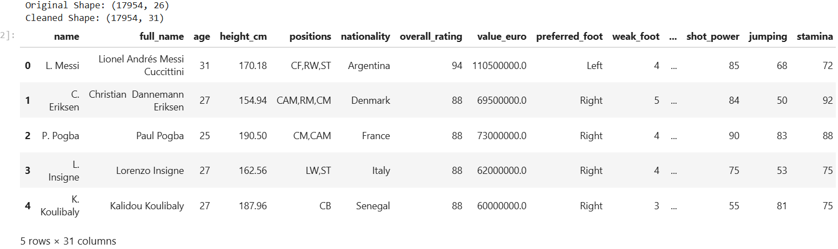
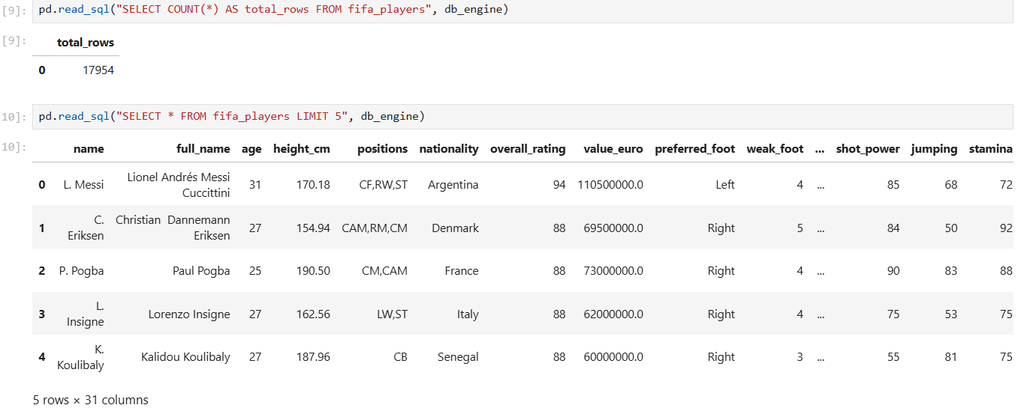

Step 2: SQL Database Connection & Data Ingestion
- Open Power BI Desktop → Click Get Data → Select MySQL Database.
- Enter the Server (localhost:3306) and Database Name (player_analytics).
- Enter authentication credentials, select the cleaned flat table (fifa_players), and click Transform Data to open Power Query.
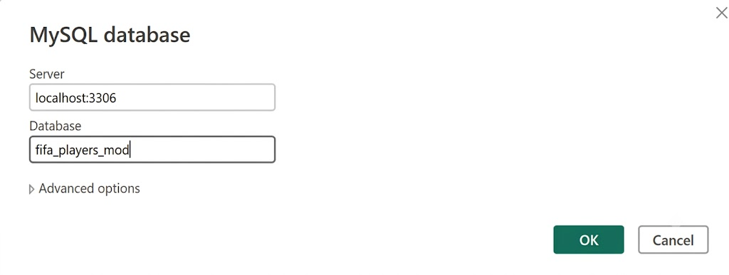

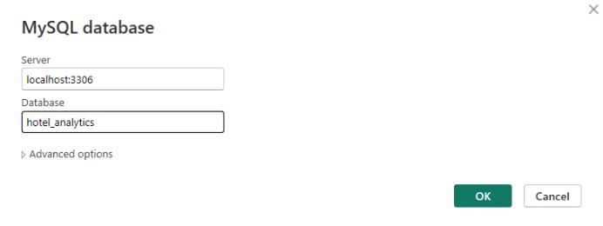
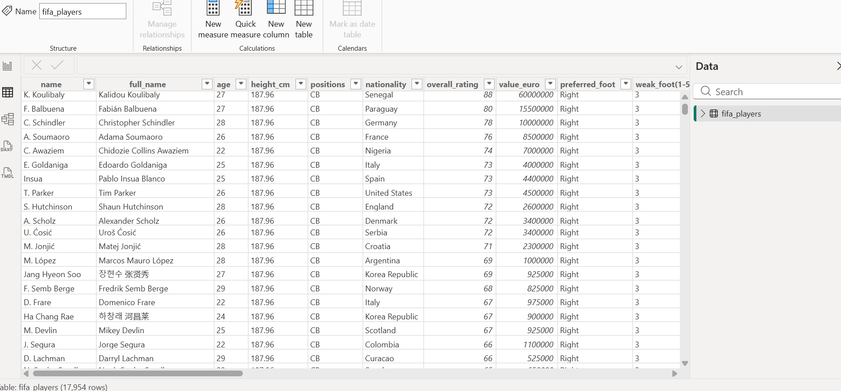

Step 3: Star Schema Data Modeling (Power BI)
- Open the Model View tab in Power BI.
- For optimal performance with this specific dataset size, maintain the cleaned fifa_players table as a flat, denormalized model.
- Verify all numeric fields are correctly categorized to allow for accurate DAX aggregations.

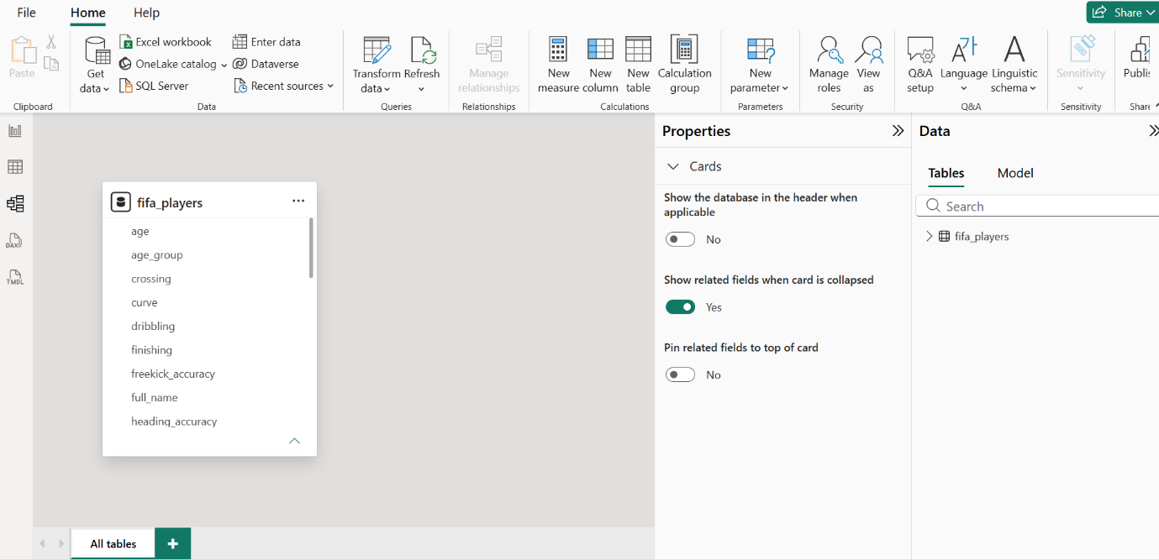

Step 4: Core Calculations & Measures (DAX)
Power BI Measures (DAX)
Create a dedicated _Measures table and add the following DAX calculations:
- Total Players:
- Total Market Value:
- International Rate (%):
- Average Overall Rateing :

Step 5: Power BI Final Executive Dashboard & Drill-Through

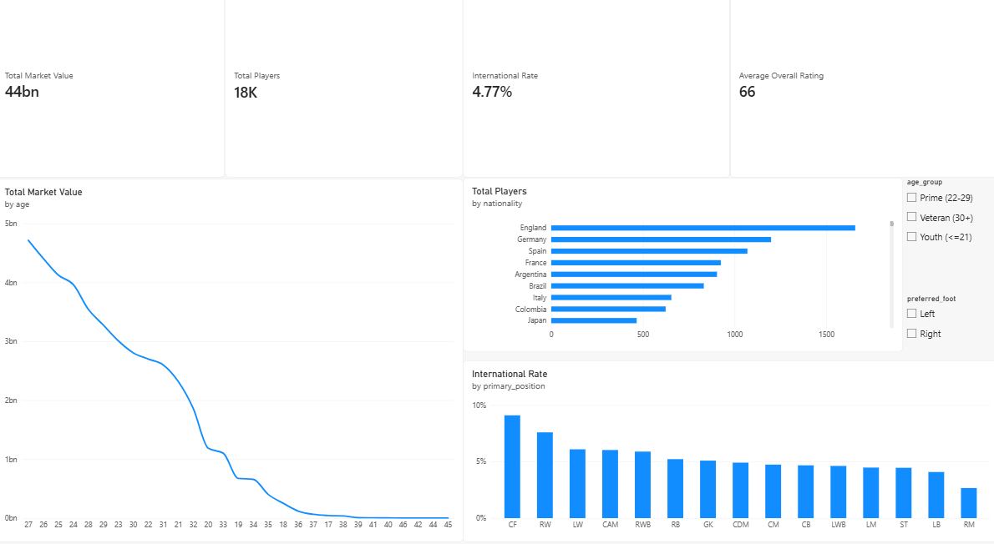

- Executive Canvas:
  - Place Card Visuals across the top: Total Market Value, Total Players, International Rate, Average Overall Rating.
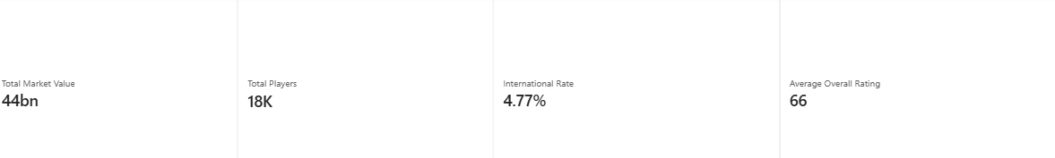
  - Add a Line Chart mapped to age (X-axis) and Total Market Value (Y-axis).
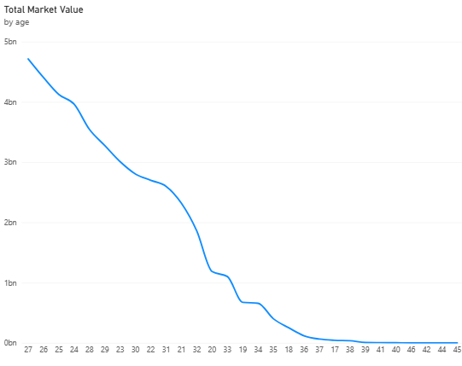

  - Add a Clustered Bar Chart for International Rate by primary_position.
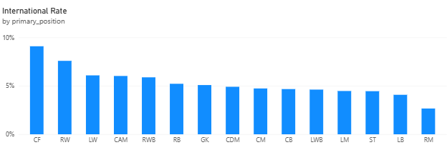

  - Add a Clustered Bar Chart for Total Players by nationality.
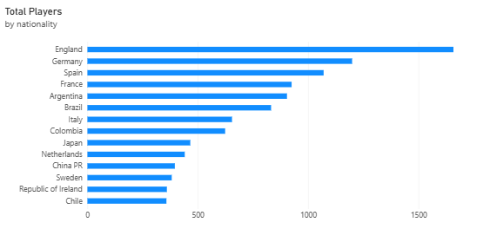

- Add Slicers for preferred_foot and age_group.

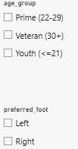

- Nationality Details Drill-Through Page:
- Create a second page named Nationality Details.
- Drag nationality into the Drill-through field bucket.
- Add a detailed Matrix/Table visual showing nationality, Total Players, Total Market Value, and Average Overall Rating.
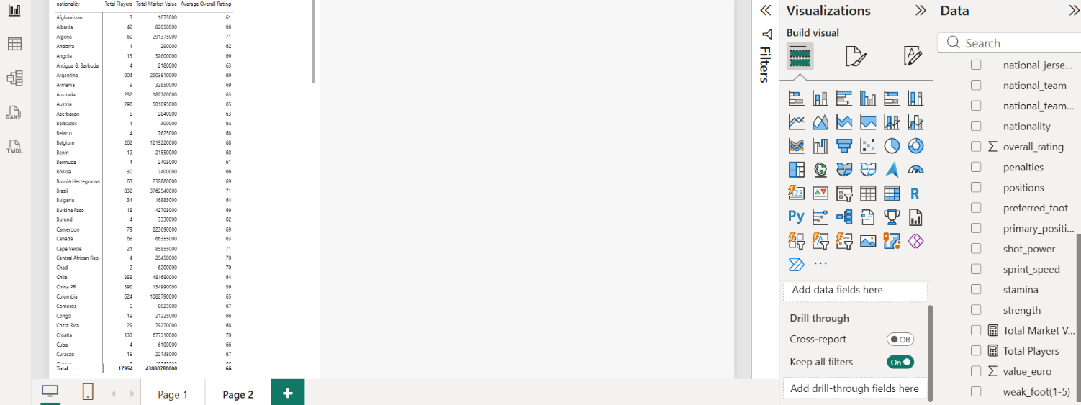

Step 6: Tableau Data Connection & Preparation
- Open Tableau Desktop.
- Under "To a Server", select MySQL. Enter Server (localhost), Database (player_analytics), and user credentials to pull the cleaned dataset.
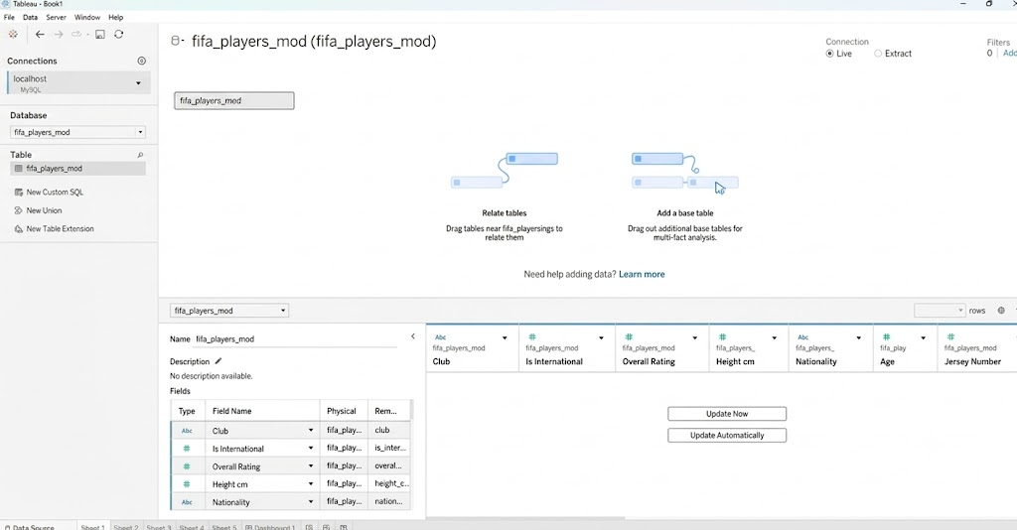

- Go to any sheet and build calculated fields matching the Power BI DAX formulas (Total Market Value, Total Players, International Rate, Average Overall Rating).
- Create a String Parameter named Select Metric containing the measure names to allow dynamic chart switching.
- Create a Dynamic Metric Measure using a CASE statement linked to the Parameter.

Step 7: Tableau Companion Dashboard & Interactive Story
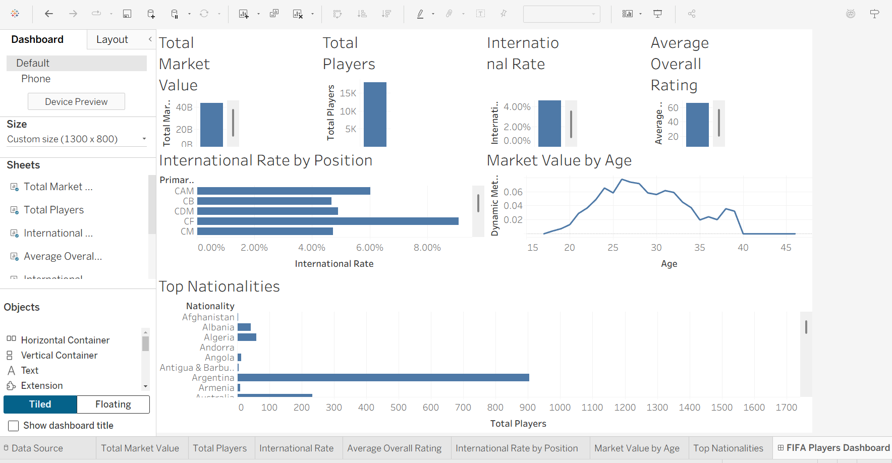

- Worksheets: Build KPI Cards, Market Value by Age Line Chart (using Dynamic Measure), International Rate by Position Bar Chart, and a Top Nationalities Bar Chart.
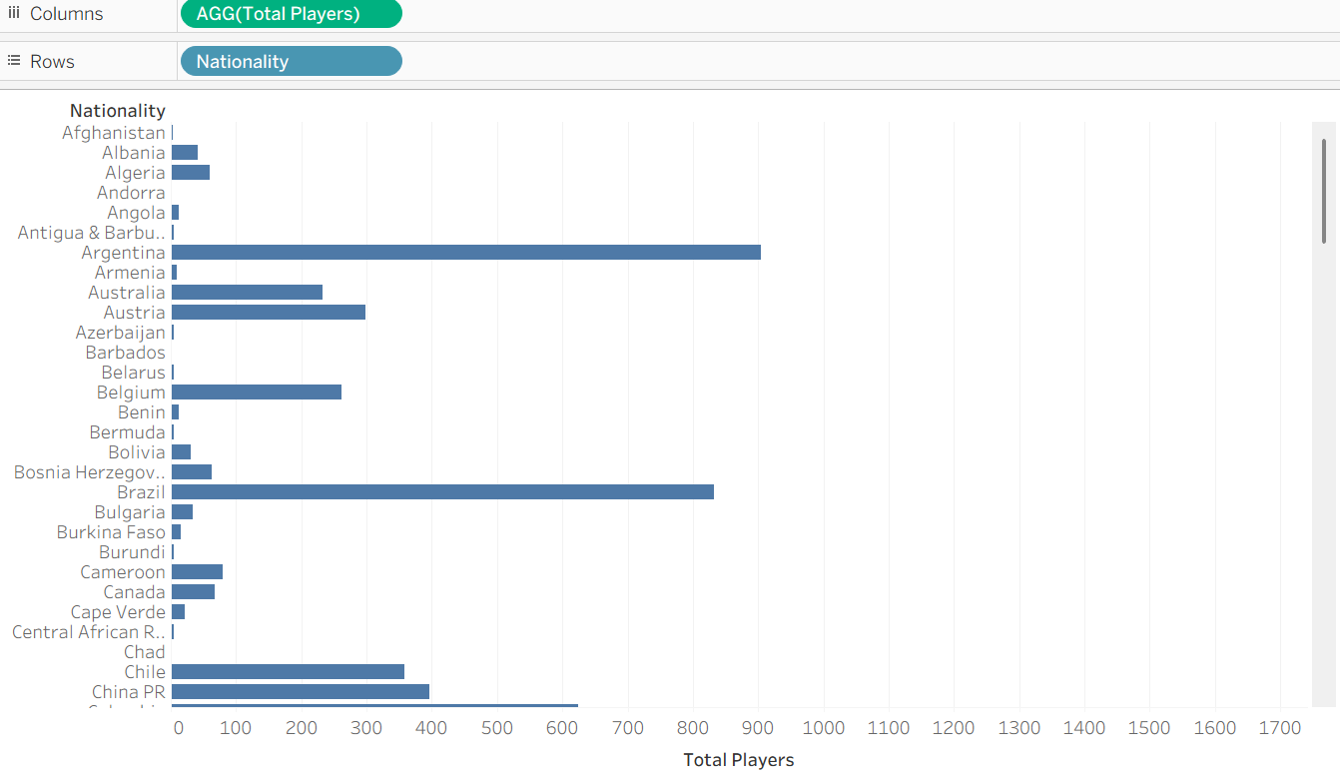

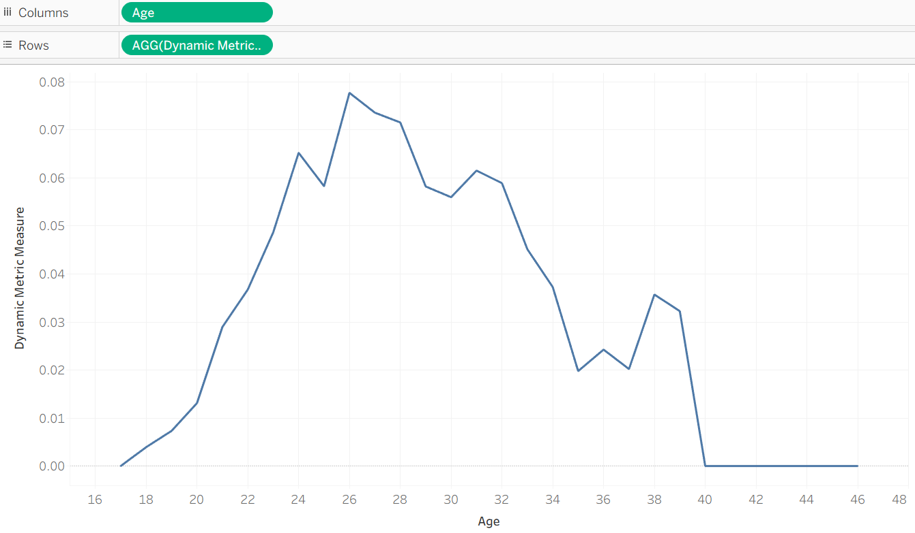

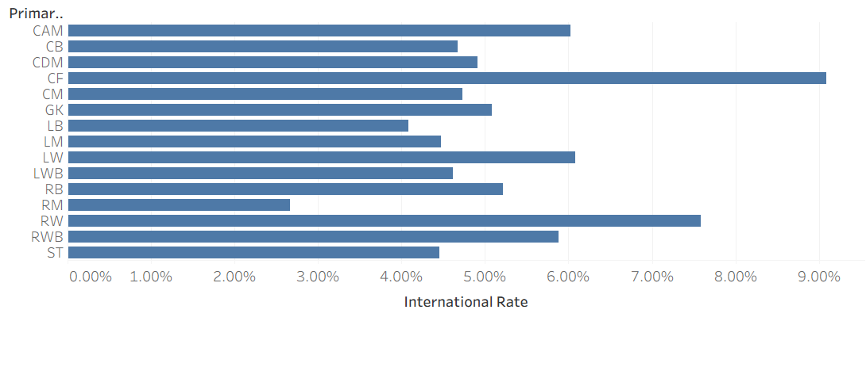

Observed Insights:
- Portfolio & Volume: The dataset captures 17,954 professional players generating EUR 43.88 Billion in Total Market Value, maintaining a global Average Overall Rating of 66.24.
- International Representation: The overall player base reflects a 4.77% International Call-up Rate, indicating the elite scarcity of national team selections relative to the total professional pool.
- Age & Valuation Trends: Average market valuations peak heavily during the "Prime (22-29)" age group (averaging EUR 2.99M per player), followed by a notable decline as players enter the "Veteran (30+)" demographic.
- Geographic Market Distribution: Talent production is heavily concentrated in major footballing hubs, with England serving as the top origin nation (1,658 players), followed by Germany, Spain, France, and Argentina.

