Ex.no:6 c | DATA VISUALIZATION USING POWER BI

Aim:
To Load the data into PowerBI and transform the data and visualize it to get insights.

Algorithm:

- Load the Netflix Movies and TV Shows dataset containing title, type, country, release year, rating, and genre information.
- Check the Country and Rating slicers and filter the dataset according to the selected values.
- Calculate Total Titles by counting all records in the dataset.
- Calculate Average Release Year using the release_year field and display it as a KPI card.
- Calculate Movie Count by counting records where type is Movie.
- Group the data by release_year and count the number of titles for each year to create the column chart.
- Group the data by type and calculate the number/percentage of titles for each type to create the donut chart.
- Display the KPI cards, column chart, donut chart, Country slicer, and Rating slicer, and update the visualizations whenever the slicer selections change.

Output:
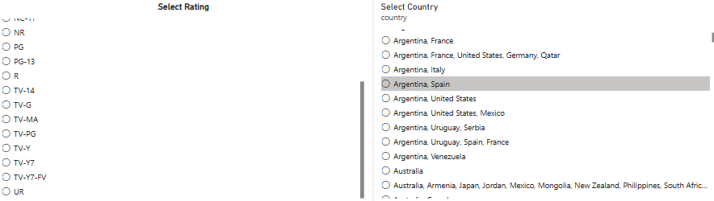

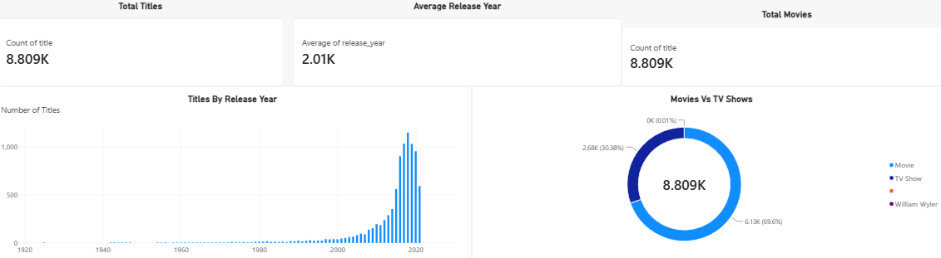

Result:
The data was successfully loaded into Power BI, transformed and analyzed, and visualized using charts and a dashboard to obtain meaningful insights from the sales data.

