Ex.no:9 | MINI PROJECT – ONLINE FOOD DELIVERY DATA ANALYTICS

Domain and Problem Statement:
Domain: Food Delivery Analytics & Customer Feedback
Problem Statement: Online food delivery platforms face challenges in customer retention, identifying target demographics, and understanding geographic hotspots for order volume. This project addresses these challenges by transforming raw customer and order records into structured business intelligence across Power BI and Tableau to evaluate demographic profiles, geographic demand distribution, feedback sentiment, and reorder probability.
Dataset Description:
Dataset Name: Online Food Delivery Dataset
Granularity: Each row represents a single customer's profile and feedback record.
Timeframe Covered: Cross-sectional snapshot.
Key Entities & Attributes:
- Demographics & Account: Age, Gender, Marital Status, Occupation, Monthly Income, Educational Qualifications, Family size.
- Location: latitude, longitude, Pin code.
- Customer & Performance: Customer Type, Output (Will Order Again), Feedback.

Data Source:
Primary Source: Kaggle Open Datasets (Online Food Delivery Dataset)
Storage Infrastructure: Cleaned customer records hosted within a local MySQL database instance (food_delivery_analytics).

Architecture:
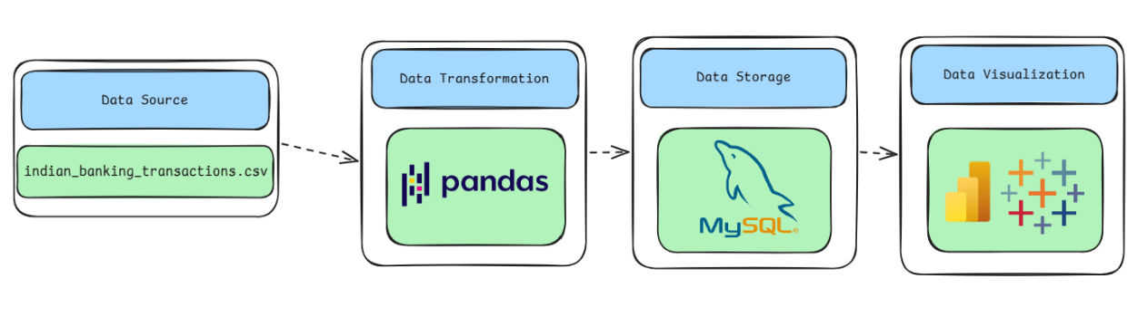

Program:
1. Python – Data Cleaning & Transformation
import pandas as pd
from sqlalchemy import create_engine, text

# 1. LOAD DATA
df = pd.read_csv("online_food_delivery_dataset.csv")

# 2. MAKE A COPY FOR CLEANING
food = df.copy()

# 3. DROP REDUNDANT COLUMN
if "Unnamed: 13" in food.columns:
food.drop(columns=["Unnamed: 13"], inplace=True)

# 4. HANDLE MISSING VALUES

food["Gender"] = food["Gender"].fillna("Unknown")
food["Marital Status"] = food["Marital Status"].fillna("Unknown")
food["Occupation"] = food["Occupation"].fillna("Unknown")
food["Monthly Income"] = food["Monthly Income"].fillna("Unknown")
food["Educational Qualifications"] = food["Educational Qualifications"].fillna("Unknown")
food["Customer Type"] = food["Customer Type"].fillna("Unknown")
food["Output"] = food["Output"].fillna("Unknown")
food["Feedback"] = food["Feedback"].fillna("Unknown")

food["Age"] = food["Age"].fillna(food["Age"].median())
food["Family size"] = food["Family size"].fillna(food["Family size"].median())
food["latitude"] = food["latitude"].fillna(0)
food["longitude"] = food["longitude"].fillna(0)

# 5. REMOVE DUPLICATES
food.drop_duplicates(inplace=True)

# 6. CLEAN TEXT COLUMNS
for col in food.select_dtypes(include="object").columns:
food[col] = food[col].astype(str).str.strip()

# 7. CLEAN COLUMN NAMES

food.columns = (
food.columns
.str.lower()
.str.strip()
.str.replace(" ", "_")
)
# 8. FINAL CHECK

print("Original rows:", len(df))
print("Cleaned rows:", len(food))
print("Columns:", len(food.columns))
food.head()

2. MySQL – Database and Data Loading
MySQL Command Prompt:
net start MySQL80
mysql -u root -p
MySQL:
CREATE DATABASE IF NOT EXISTS food_delivery_analytics;
Python/Jupyter:
# 9. CONNECT TO MYSQL & CREATE DATABASE
username = "root"
password = "YOUR_MYSQL_PASSWORD" # Update with your password
host = "localhost"
port = 3306

server_engine = create_engine(
f"mysql+pymysql://{username}:{password}@{host}:{port}"
)

with server_engine.connect() as connection:
connection.execute(
text("CREATE DATABASE IF NOT EXISTS food_delivery_analytics")
)

# 10. CONNECT TO TARGET DB & EXPORT

db_engine = create_engine(
f"mysql+pymysql://{username}:{password}@{host}:{port}/food_delivery_analytics"
)

food.to_sql(
"food_delivery_customers",
con=db_engine,
if_exists="replace",
index=False,
chunksize=5000
)

# 11. VERIFY MYSQL DATA
print(
pd.read_sql(
"SELECT COUNT(*) AS total_rows FROM food_delivery_customers",
db_engine
)
)

print(
pd.read_sql(
"SELECT * FROM food_delivery_customers LIMIT 5",
db_engine
)
)

Procedure:

Step 1: Data Preparation & Preprocessing (Python / Pandas)
- Load raw transactional dataset using pd.read_csv().
- Remove the trailing empty column (Unnamed: 13).
- Fill missing values with "Unknown" for categorical fields and medians for numerical fields.
- Trim whitespace from text columns and standardize column names to lowercase.
- Export cleaned records into MySQL (food_delivery_analytics.food_delivery_customers) via SQLAlchemy.

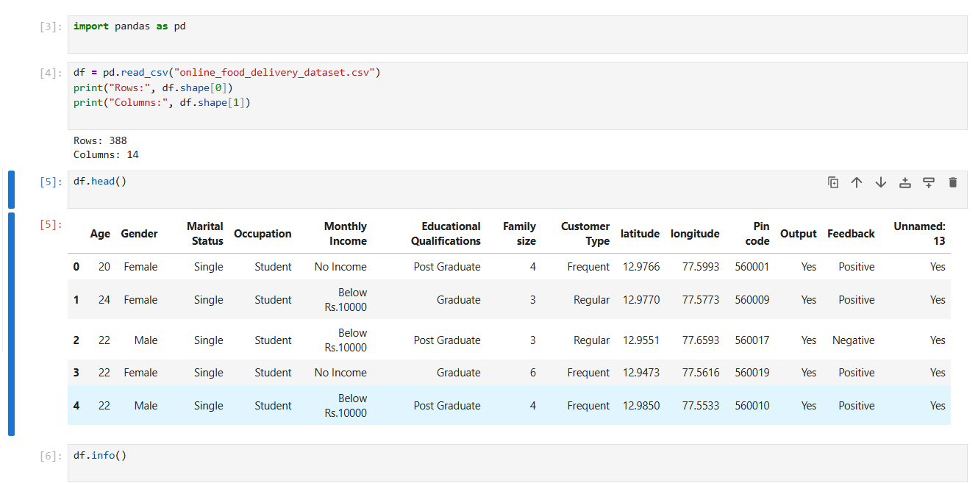

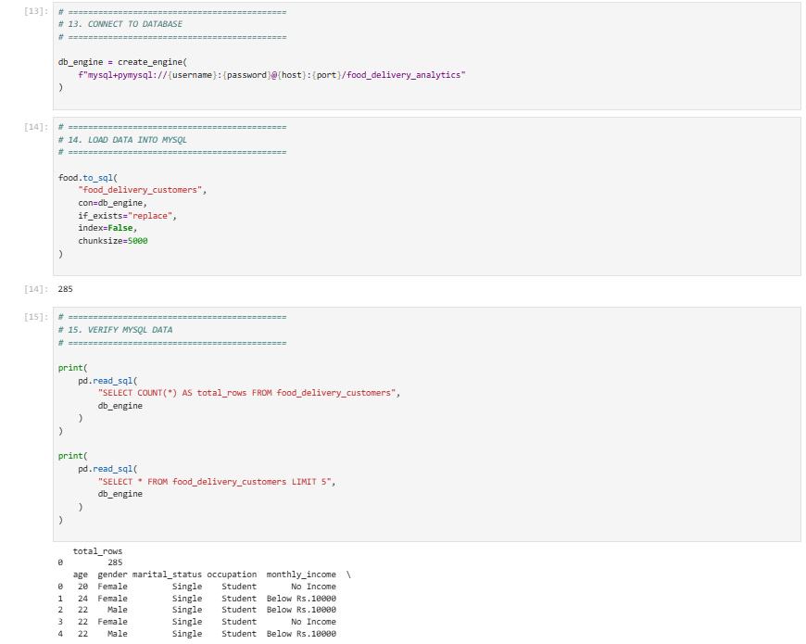

Step 2: SQL Database Connection & Data Ingestion
- Open Power BI Desktop → Click Get Data → Select MySQL Database.
- Enter Server (localhost:3306) and Database Name (food_delivery_analytics).
- Authenticate with root credentials, select food_delivery_customers, and click Transform Data to launch Power Query.

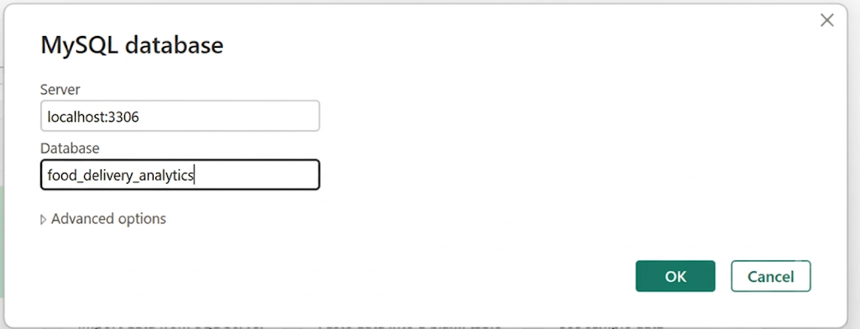

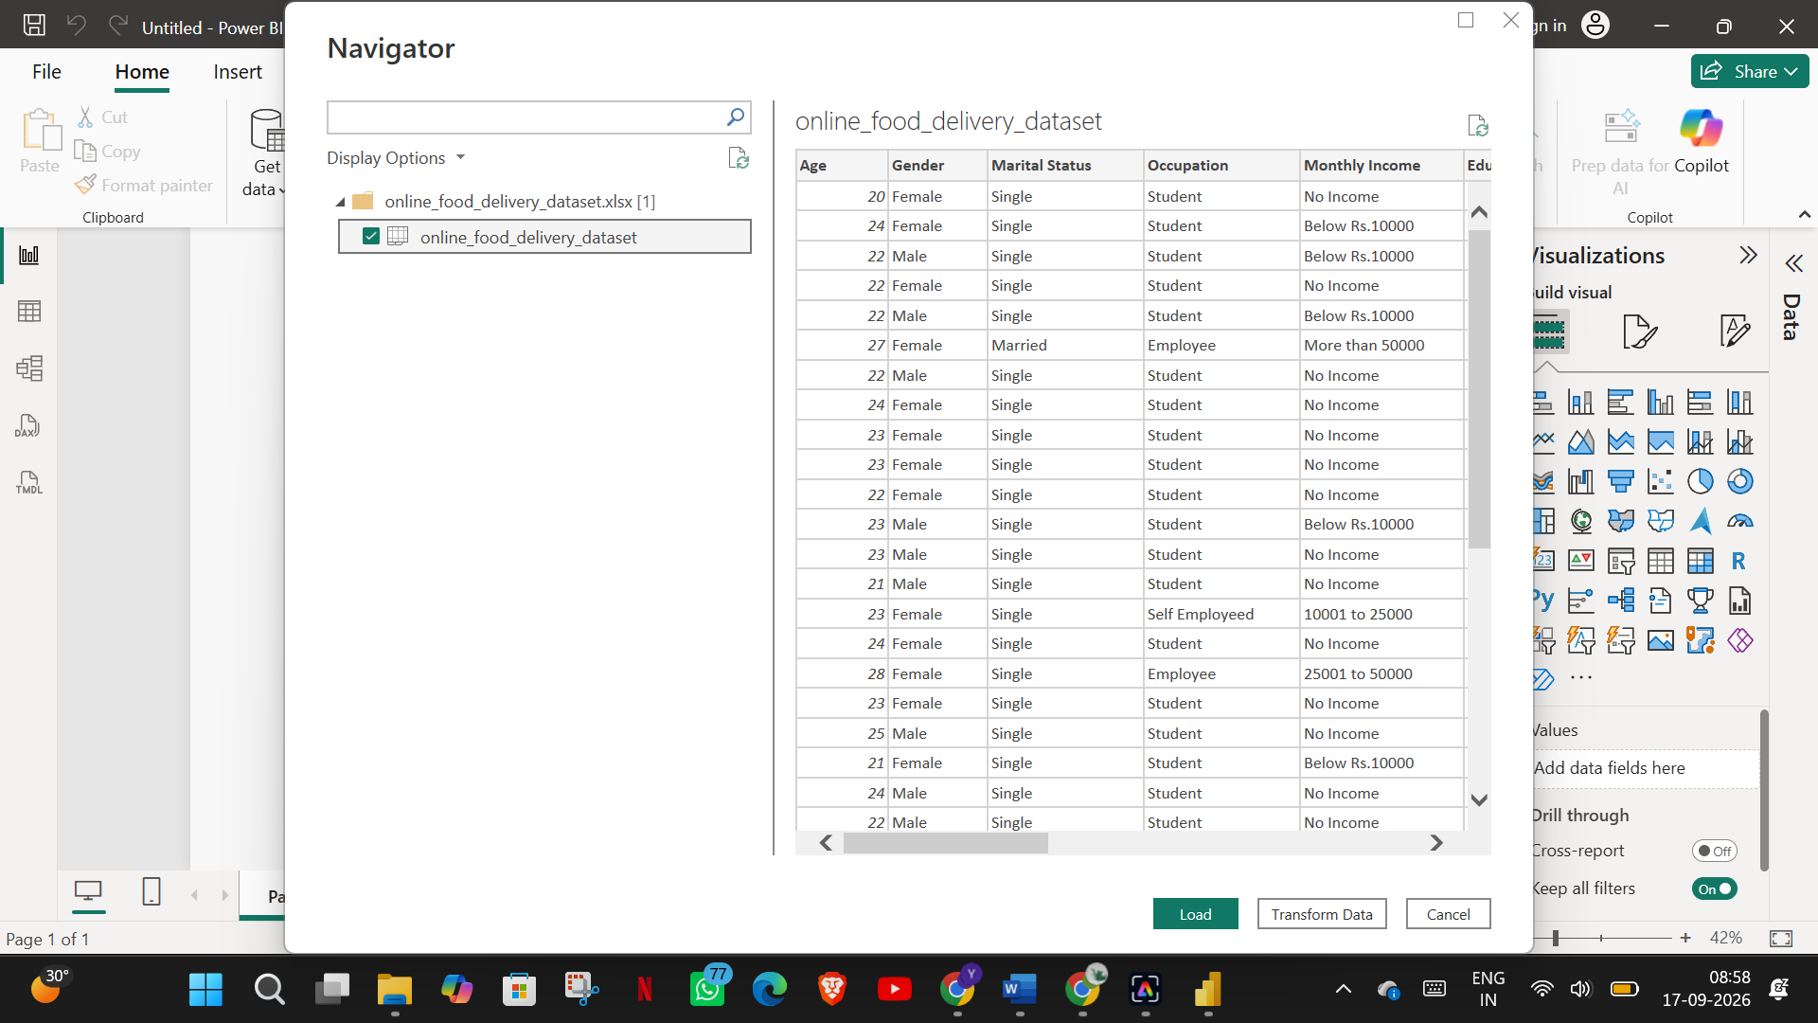

Step 3: Star Schema Data Modeling (Power BI)
- Table Splitting in Power Query:
Duplicate raw query banking_transactions into 3 separate entities: Fact_Transactions, • Duplicate raw query food_delivery_customers into 3 separate entities: Fact_Orders, Dim_Customer, and Dim_Location.
Dim_Customer: Retain age, gender, marital_status, occupation, monthly_income, educational_qualifications, family_size. Remove duplicates and add an Index Column named CustomerKey.
Dim_Location: Retain pin_code, latitude, longitude. Remove duplicates and add an Index Column named LocationKey.
Fact_Orders: Merge with Dim_Customer and Dim_Location to pull in Keys. Retain customer_type, output, feedback, and the new Keys. Remove redundant text columns.
Establishing Relationships in Model View:
Connect Dim_Customer[CustomerKey] → Fact_Orders[CustomerKey] (1:*).
Connect Dim_Location[LocationKey] → Fact_Orders[LocationKey] (1:*).

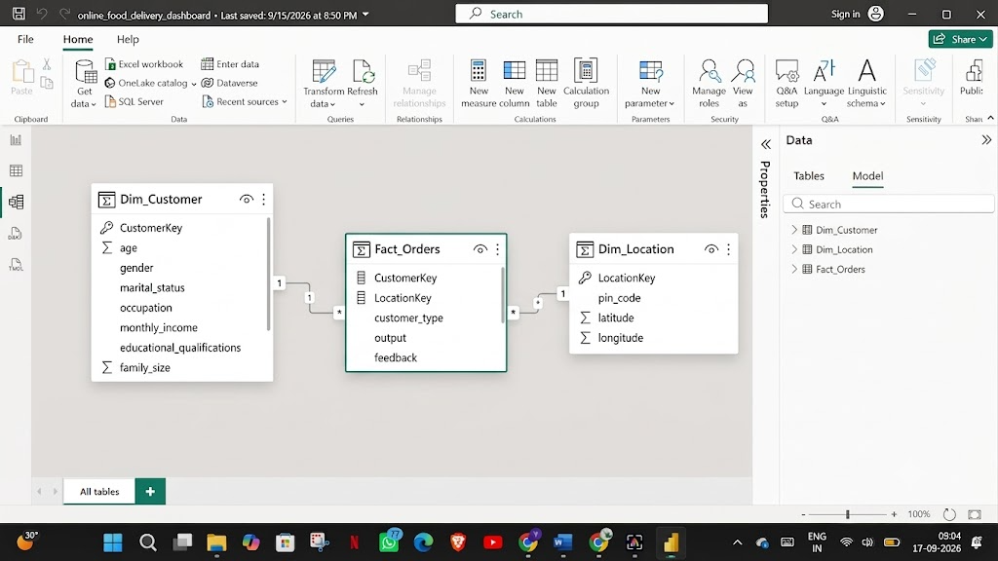

Step 4: Core Calculations & Measures (DAX)
Power BI Measures (DAX)
Create a dedicated _Measures table and add the following DAX calculations:
- Total Customers:
- Positive Feedback Count:
- Negative Feedback Rate:
- New Customers:
- Reorder Count:
- Average Family Size:
- Average Age:
Step 5: Power BI Final Executive Dashboard & Drill-Through

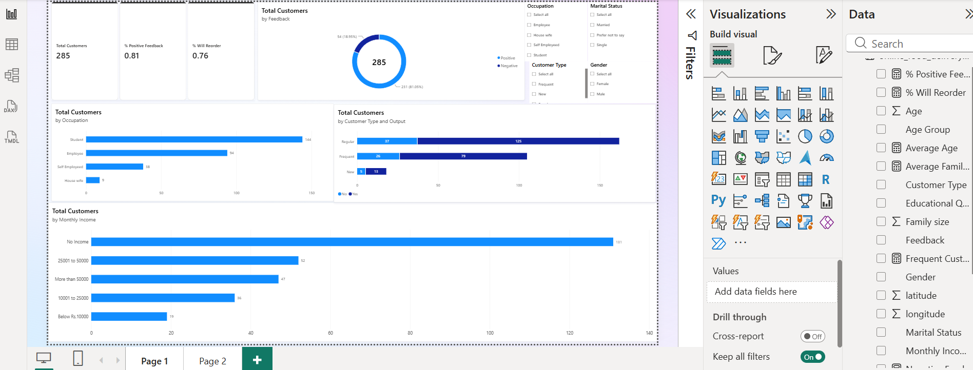

- Executive Canvas:
- Place Card Visuals for Total Customers, % Positive Feedback, and % Will Reorder. Add Clustered Bar Charts for Occupation and Monthly Income. Add a Donut Chart for Feedback distribution.

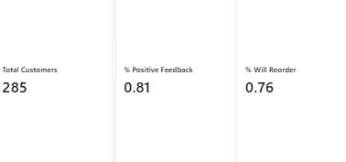
- Add a Stacked Bar Chart mapped to Total Customers by Customer Type and Output.
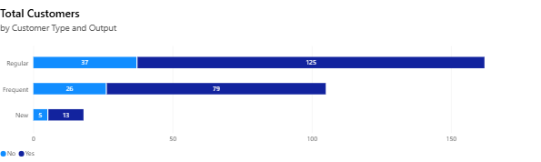
- Add Clustered Bar Charts for Occupation and Monthly Income

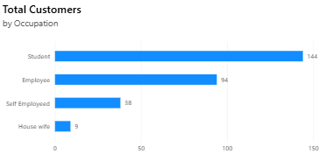
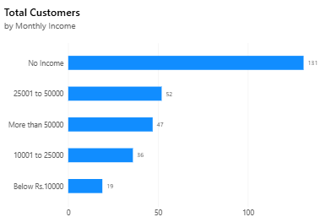

- Add a Donut Chart for Feedback distribution.
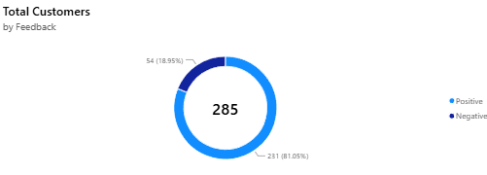

- Add Slicers for Occupation, Gender, Maritial status, Customer Type
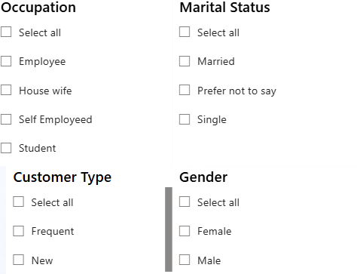

- Location Details Drill-Through Page:
- Create a second page named Location Details. Drag Dim_Location[pin_code] into the Drill-through field bucket. Add a Map visual plotting latitude and longitude.

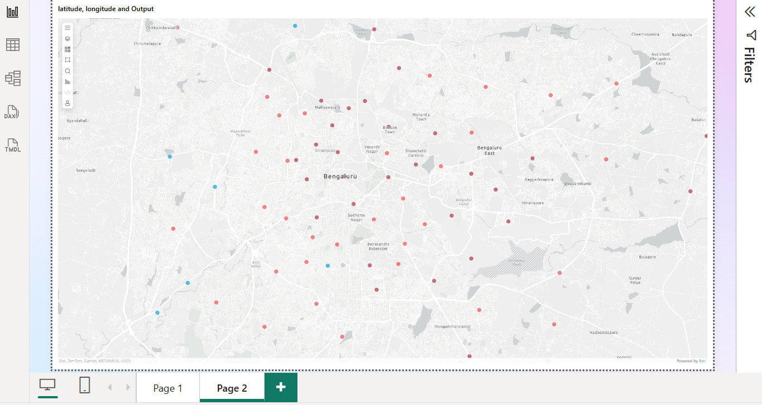

Step 6: Tableau Data Connection & Preparation
- Open Tableau Desktop. Under To a Server, select MySQL.
- Enter Server (localhost), Database (food_delivery_analytics), and user credentials.
- Create calculated fields for Total Orders, Avg Family Size, and a Parameter for Select Delivery Metric.

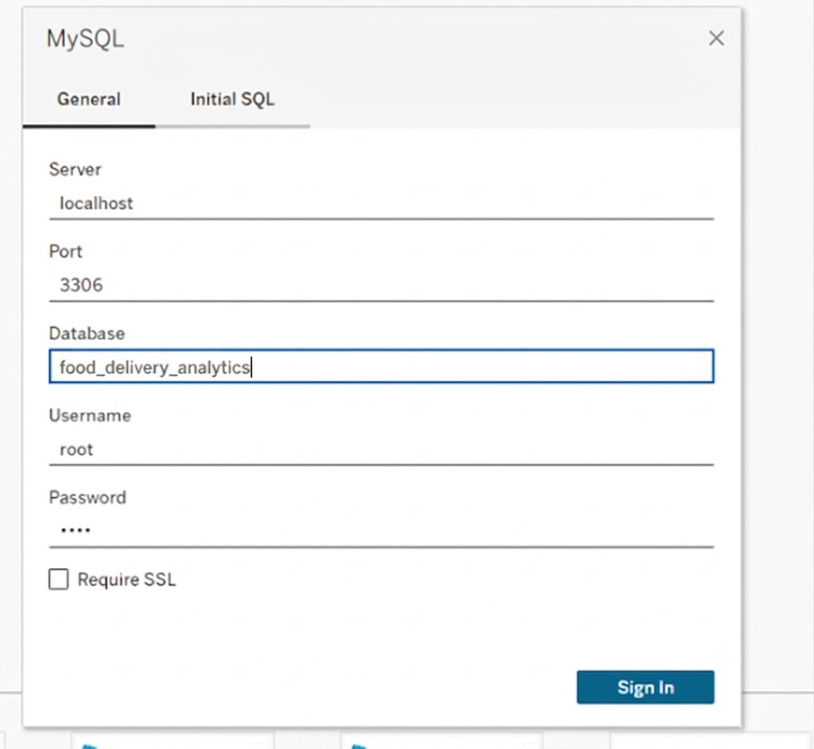

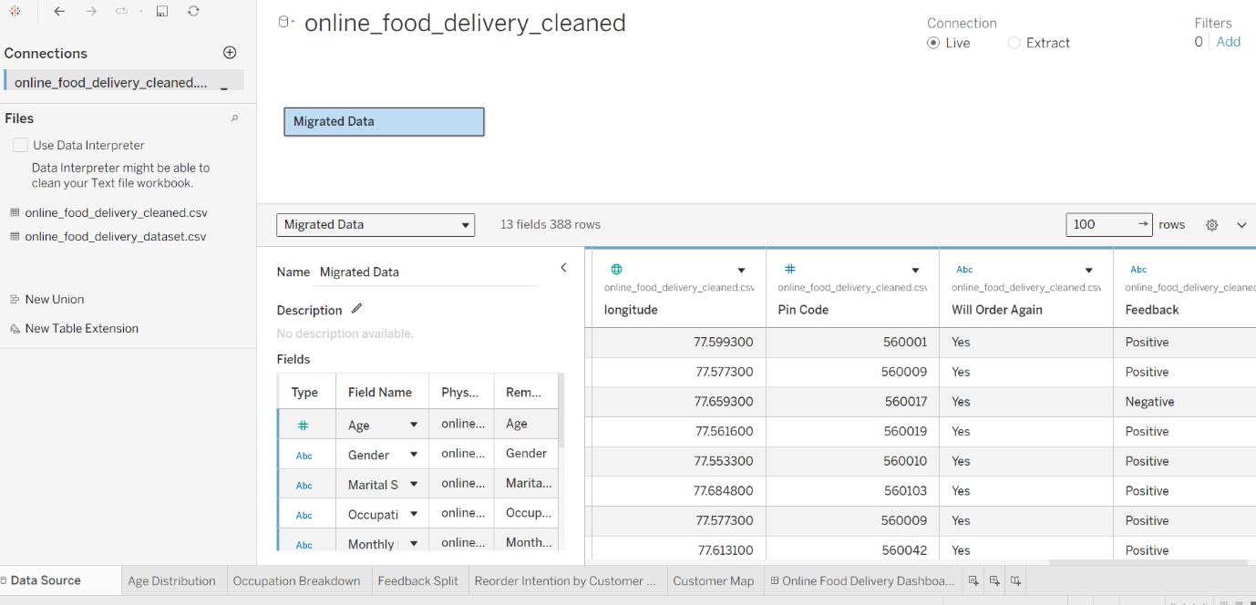

- Go to any sheet and build calculated fields:
- Total Customers:
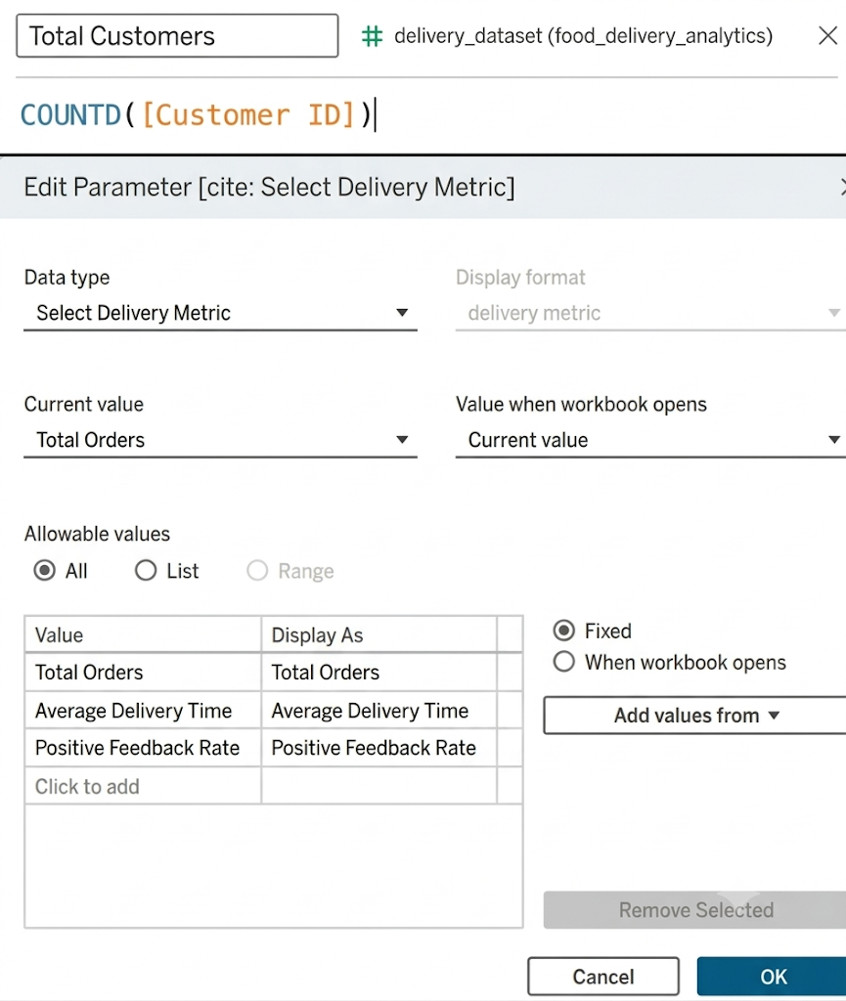
- Select Delivery Metric Parameter:

Step 7: Tableau Companion Dashboard & Interactive Story

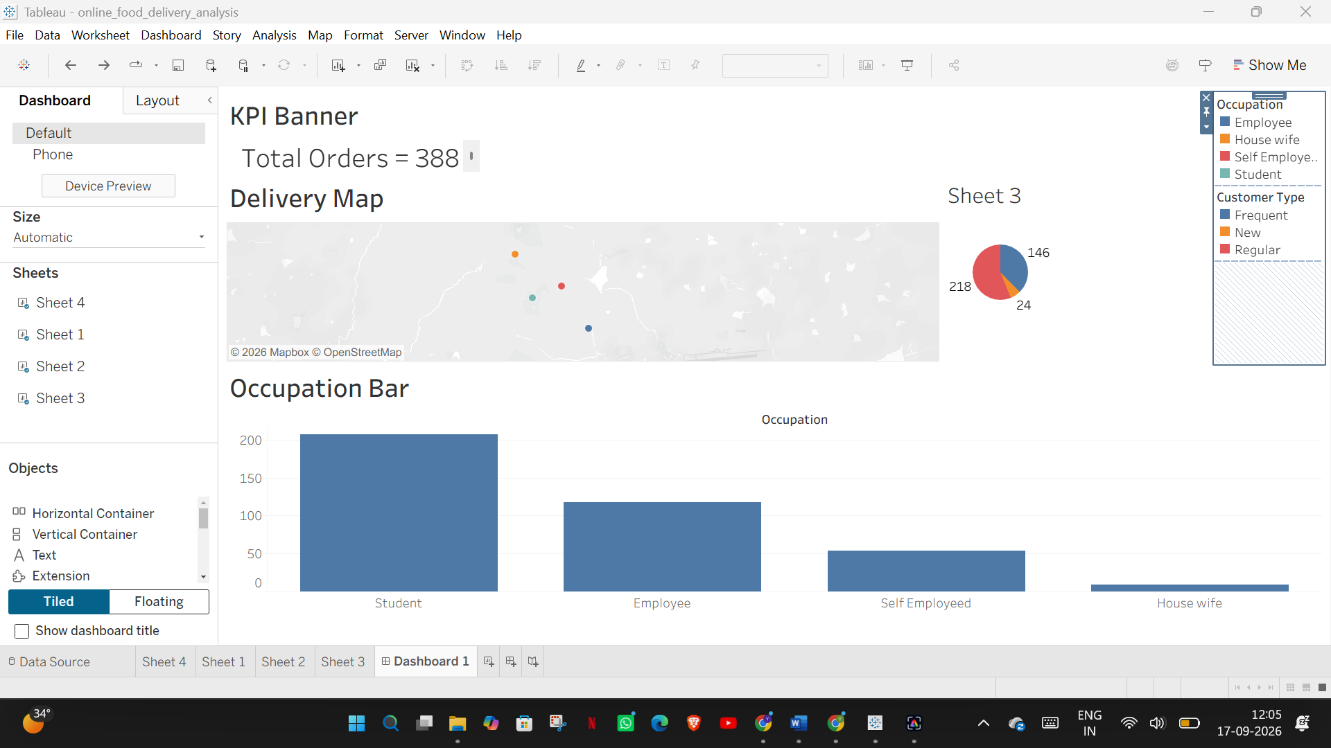

- Worksheets: Build KPI Panel, Delivery Map, Occupation Bar Chart, and Customer Type Pie Chart..
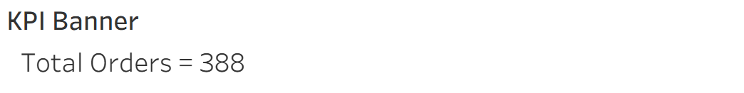
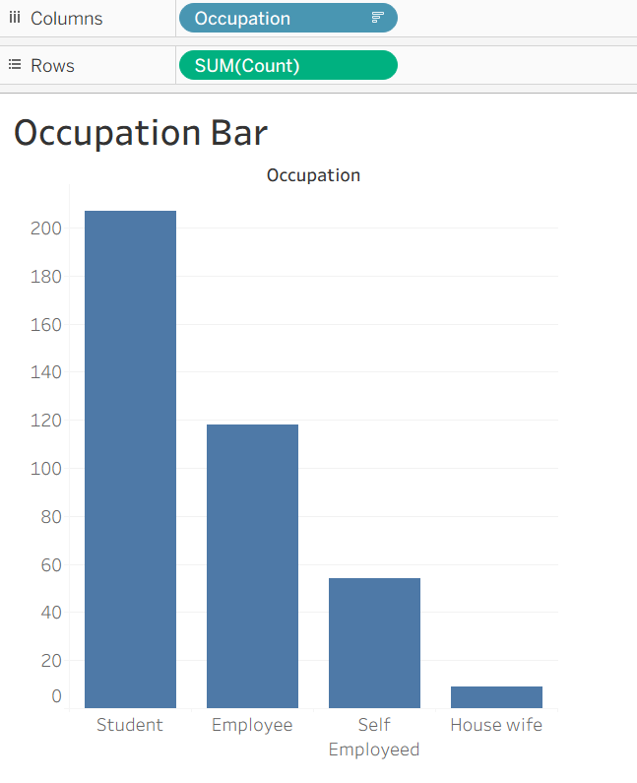
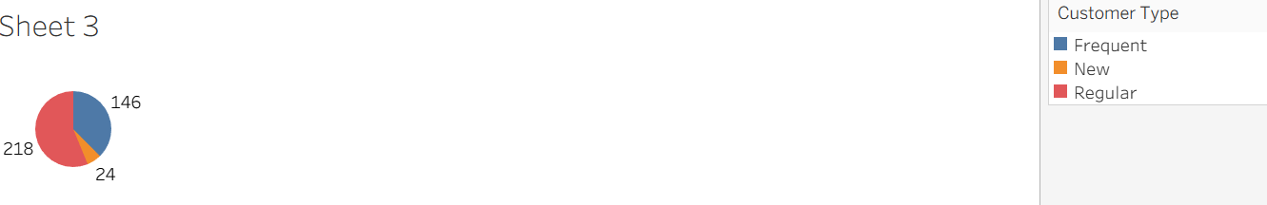

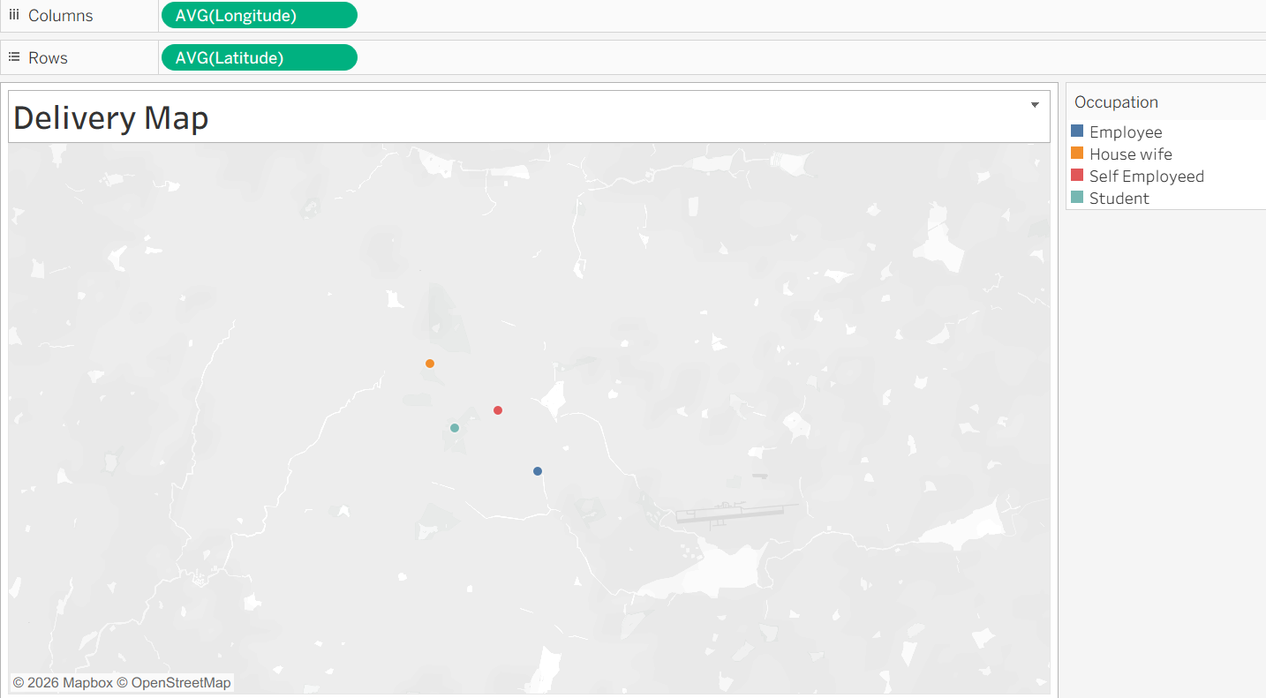

- Global Filters & Actions:
- Add the Metric Parameter control to the dashboard. Use the Delivery Map as a filter for the rest of the dashboard.
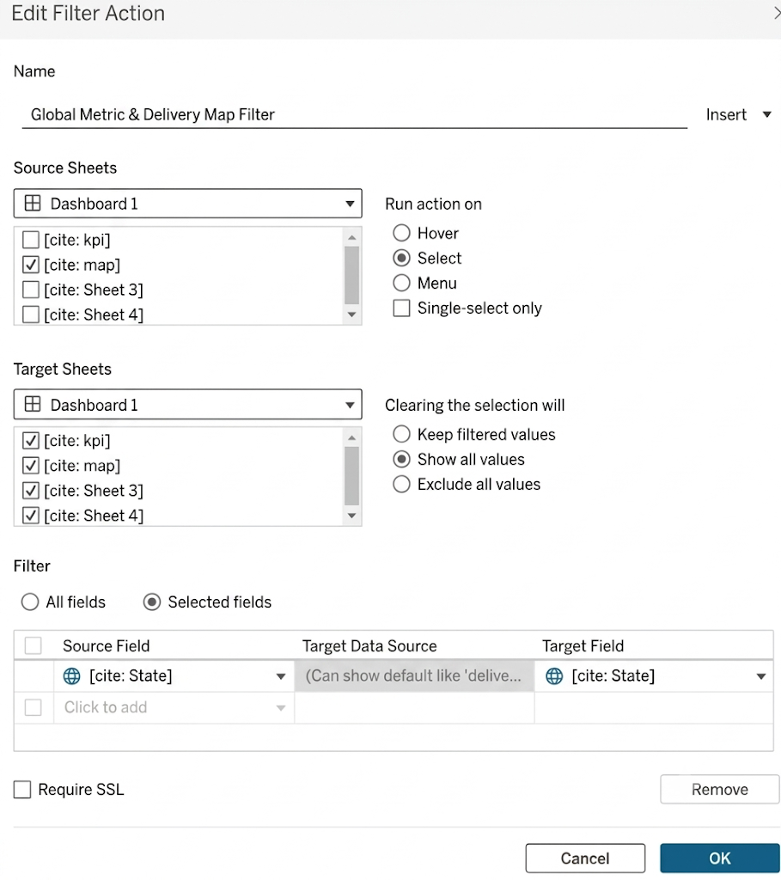

Observed Insights:
- Demographic Drivers: Students and young professionals represent the vast majority of the order volume. Customers in the "No Income" to "Below Rs.10000" Monthly Income brackets dominate the total user base.
- Customer Satisfaction: The platform maintains an overwhelmingly high Positive Feedback rate, which strongly correlates with customers stating "Yes" to ordering again.
- Geographical Concentration: Order demand is heavily clustered in specific geographic pockets (represented by specific Pin Codes and lat/lon coordinates), indicating prime locations for targeted marketing or optimized delivery routing.

