**WEEKLY REPORT AUTOMATION TOOL**

Name : Yuvaraj T Company : NortonLifeLock

Roll No **:** 2019202063 Mentor : Raja Ganapathy

Project Guide : Ms. B.Siva Shankari

**PROBLEM** **STATEMENT**

The weekly report of our Jira Dashboard are created manually at every time . Thus it is created by taking screenshots of the web page and organize manually by my team. We organize every screenshot and PDF will be created. Lastly, we create a mail with organized structure and we would send that organized mail to our higher officials.

**ABSTRACT**

We, at NortonLifeLock , designing a tool highly focus on Web Automation and Automated Mailing. This project is to create a Web Automated Tool to automate the IT work to maintain the weekly report of our Jira Dashboard. This project is to develop script to export the dashboard as PDF for regular interval. This tool is to capture and crop the screenshots of required graphs in the Dashboard page. We have to Scrape the required data from the Dashboard page by Web Scrapping. Once the required data is captured, it needs to be embedded in the email in specified format. This tool will send the Automated mail with the embedded contents where created above to the required persons.

The Technology stack used to build used to build the Weekly Report Automation Tool is Node.js, Puppeteer , Node Mailer, JIMP .

**ARCHITECTURE DIAGRAM :**

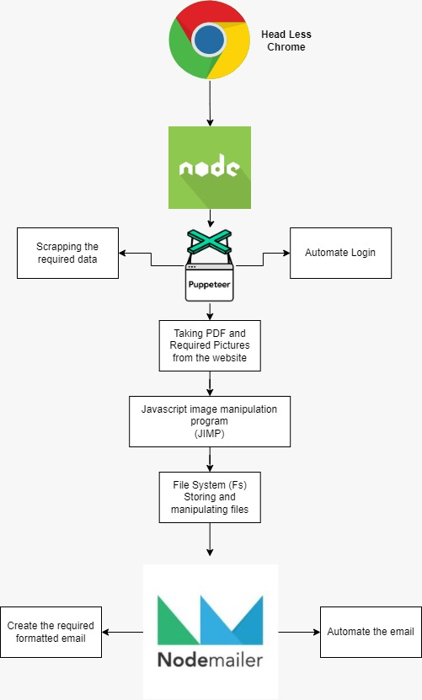

**PUPPETEER ARCHITECTURE :**

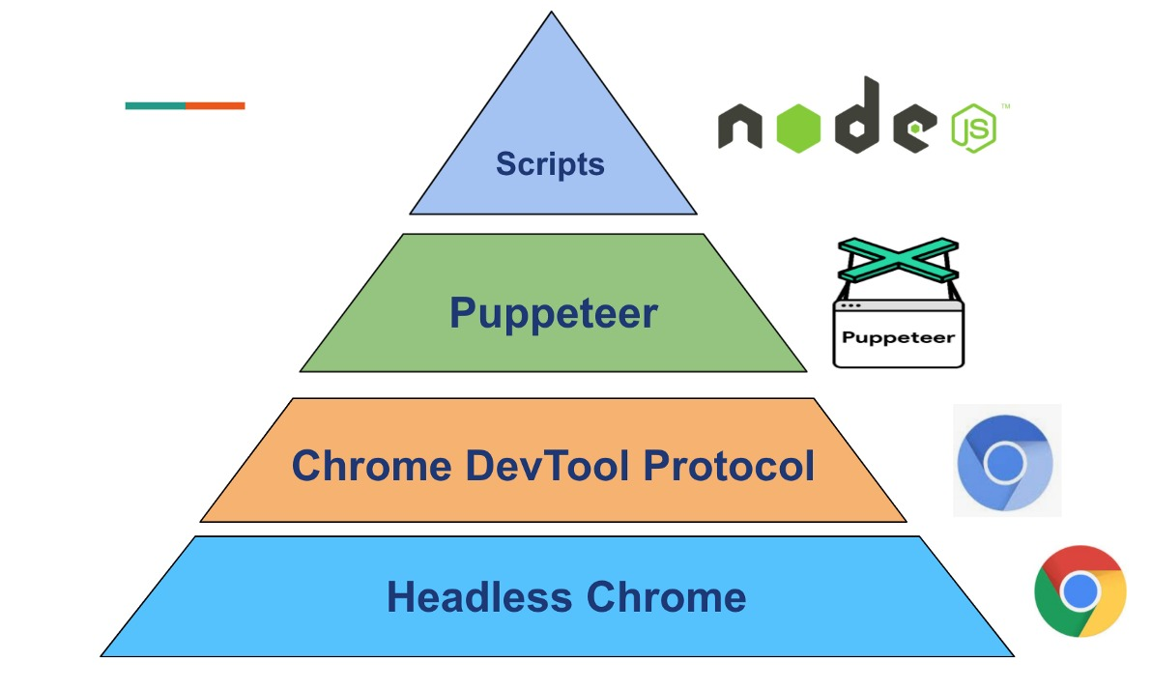

**TOOLS & TECHNIQUES**

Programming Language : JavaScript

Environment : Node Js

Major libraries will use :

* Puppeteer
* FS ( File System )
* JIMP ( JavaScript Image Manipulation Program )
* Node Mailer

**MODULES LIST**

* Web automation
* Scrapping of data
* Capturing snapshots
* Image manipulation
* File system management
* Designing the e-mail
* Automate the e-mail

**MODULES DESCRIPTION**

**WEB AUTOMATION:**

Opening a headless chrome using the puppeteer and gets navigated using URL given inside the puppeteer. Login into the desired website with the secret credentials. Puppeteer is used to capture the entire webpage and be viewed as PDF

**SCRAPPING OF DATA:**

The process of using automated code to extract the required content and data from a website by puppeteer. Automated method is to obtain large amounts of data from websites.

**IMAGE MANIPULATION:**

The captured snapshots and PDFs are cropped and edited with the package JIMP (JavaScript Image Manipulation Program)

**FILE SYSTEM MANAGEMENT:**

The captured images and PDFs are collected, stored and managed in the folder

With FS(File System) Package

**DESIGNING THE EMAIL:**

Design of email is done in this stage with the formatted template. Weekly reported issues are graphed against the solved ones. The photos are formatted in table view

**AUTOMATE THE EMAIL:**

Provided the sender addresses inside the automated code, email is sent with Node Mailer Library

Project Guide