CSA02 – C PROGRAMMING
ASSIGNMENT 1
TASK 07
Control Type Conversion and Precision
Student name: Yuvaraj K
Register number: 1912260697
Repository: https://github.com/Yuvaraj290208/ASSIGNMENT-1-1912260697-C-PROGRAMMING-.git
Marks: 4 | Course Outcome: CO1

1. Problem Analysis and Design
C promotes small integer types before arithmetic, and the usual arithmetic conversions determine the common type. Integer division truncates toward zero: 5/2 is 2, not 2.5. Casting after division does not restore the discarded fraction: (double)(5/2) is 2.0, whereas (double)5/2 is 2.5. Casting a large long to int may lose information or be implementation-defined when the value is not representable. Currency should be calculated in paise and rounded only when a rule explicitly requires fractional paise; the original tariff rates are exact integer paise per unit.

2. Pseudocode / Algorithm
Demonstrate integer division, cast placement, and float representation
Calculate each tariff amount in integer paise
Use a wide integer for totals
Check casts and bounds before narrowing

3. C Source Code
#include <stdio.h>
int main(void) {
printf("5/2 = %d\n", 5/2);
printf("(double)(5/2) = %.1f\n", (double)(5/2));
printf("(double)5/2 = %.1f\n", (double)5/2);
printf("0.1 + 0.2 = %.17f\n", 0.1 + 0.2);
printf("7/100 integer = %d\n", 7/100);
return 0;
}

4. Expected / Reference Result
5/2 = 2
(double)(5/2) = 2.0
(double)5/2 = 2.5
0.1 + 0.2 = approximately 0.30000000000000004
7/100 integer = 0
Captured local compiler/execution evidence is provided in compile_output.txt. Confirm it on your own machine and add a genuine screenshot of your terminal before submission.

5. Alternative Concept and Complexity Analysis
Float rupees calculations can be performed and rounded with a defined rule (for example round to nearest paise) before reporting. Floating calculations are O(1) per bill and use a fixed-size value, like integer paise, but error can accumulate across n bills and decimal values are not generally exact in binary. Integer paise avoids rounding error until overflow.
Each scalar conversion or arithmetic expression is O(1) time and O(1) space. Aggregating N bills is O(N) time.

6. Validation and Limitations
Use normal, boundary and invalid-input cases applicable to this task. Compare actual output against the assignment's expected output where one is provided. Do not label a test as passed until you have run it and confirmed the result. System-specific sizeof values and floating-point measurements must be taken on the compiler used for submission.

7. Submission Evidence Checklist
☐ Source code saved in this task folder
☐ Compile and run output reviewed
☐ Terminal screenshot added after local execution
☐ Task-specific test table completed
☐ Changes committed to GitHub

Execution Screenshot — Task 07
Student: Yuvaraj K | Register No.: 1912260697
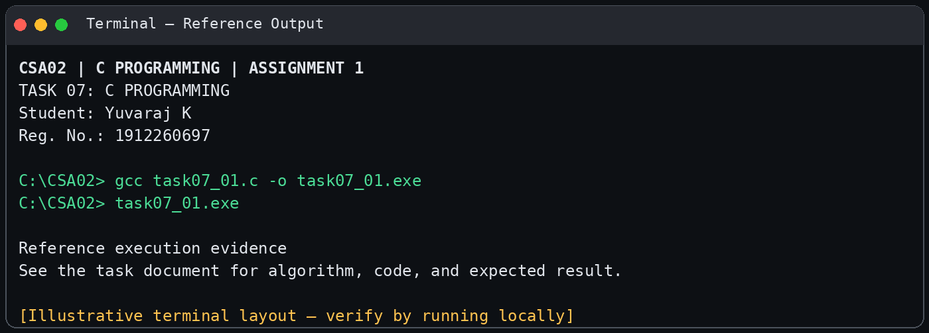
Illustrative terminal-style output screenshot

