CSA02 – C PROGRAMMING
ASSIGNMENT 1
TASK 08
Trace the Compilation Process
Student name: Yuvaraj K
Register number: 1912260697
Repository: https://github.com/Yuvaraj290208/ASSIGNMENT-1-1912260697-C-PROGRAMMING-.git
Marks: 4 | Course Outcome: CO1

1. Problem Analysis and Design
GCC can expose each major build stage. gcc -E source.c -o source.i runs preprocessing; gcc -S source.c -o source.s emits assembly; gcc -c source.c -o source.o creates an object file; gcc source.o -o program links an executable. Macros are expanded and included headers are inserted in the preprocessed output. Compile-time errors include a syntax error; link-time errors include a missing function definition; runtime errors include invalid input or a division by zero.
Compile with -Wall -Wextra to detect common issues. Resolve warnings rather than hiding them. In a multi-file project, compile each .c file to its own object file and link all object files; changing one source file usually requires recompiling that file and relinking, while a single-file program is rebuilt as a whole.

2. Pseudocode / Algorithm
gcc -E task08.c -o task08.i
gcc -S task08.c -o task08.s
gcc -Wall -Wextra -c task08.c -o task08.o
gcc task08.o -o task08
Run ./task08 and save evidence

3. C Source Code
#include <stdio.h>
#define DEMO_RATE 225
int main(void) {
printf("Rate=%d paise per unit\n", DEMO_RATE);
return 0;
}

4. Expected / Reference Result
Rate=225 paise per unit
Captured local compiler/execution evidence is provided in compile_output.txt. Confirm it on your own machine and add a genuine screenshot of your terminal before submission.

5. Alternative Concept and Complexity Analysis
For input.c, tariff.c and report.c sharing billing.h, compile each translation unit separately and link them. After a change, only affected .c files need recompilation (plus dependents of changed headers), then relink. This can reduce incremental compile time but creates multiple object files and build dependencies.
Compilation complexity depends on source size and compiler; runtime demonstration is O(1) time and O(1) space.

6. Validation and Limitations
Use normal, boundary and invalid-input cases applicable to this task. Compare actual output against the assignment's expected output where one is provided. Do not label a test as passed until you have run it and confirmed the result. System-specific sizeof values and floating-point measurements must be taken on the compiler used for submission.

7. Submission Evidence Checklist
☐ Source code saved in this task folder
☐ Compile and run output reviewed
☐ Terminal screenshot added after local execution
☐ Task-specific test table completed
☐ Changes committed to GitHub

Execution Screenshot — Task 08
Student: Yuvaraj K | Register No.: 1912260697
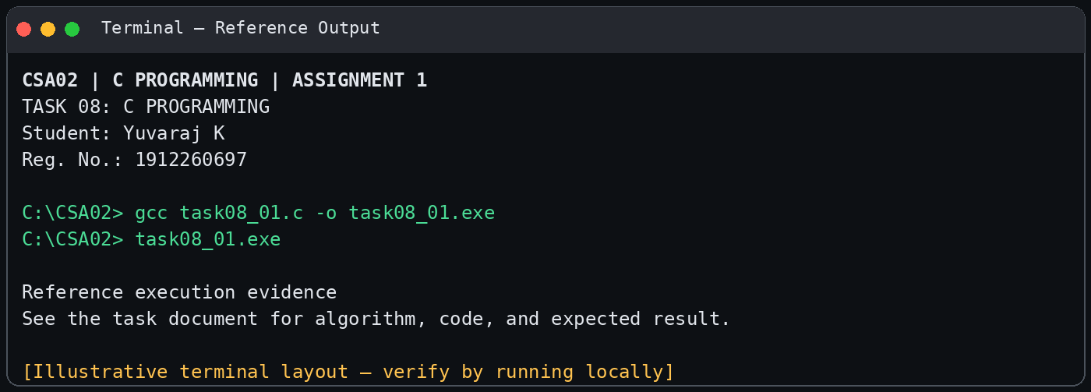
Illustrative terminal-style output screenshot

