CSA02 – C PROGRAMMING
ASSIGNMENT 1
TASK 10
Compare Expectations with Execution
Student name: Yuvaraj K
Register number: 1912260697
Repository: https://github.com/Yuvaraj290208/ASSIGNMENT-1-1912260697-C-PROGRAMMING-.git
Marks: 4 | Course Outcome: CO1

1. Problem Analysis and Design
For this task, compare a float-rupee accumulator with an integer-paise accumulator for the same generated bill amounts at 4,000, 60,000 and 800,000 records. Record the actual compiler, platform, exact test values, and measured totals. Results depend on chosen bills and evaluation order, so do not claim a universal numerical difference without running the experiment.
For overflow, compute a worst-case bound: maximum bill in paise multiplied by household count. int is commonly 32-bit and may overflow for district totals; long is platform-dependent (32-bit on some systems, 64-bit on common LP64 Unix-like systems); long long is at least 64 bits in standard C implementations. A double has a wide range but finite precision; it may represent large totals approximately rather than overflow like a bounded integer.

2. Pseudocode / Algorithm
For each N in {4000, 60000, 800000}:
total_paise = 0; total_float_rupees = 0.0
repeat N times using a documented set of bill amounts
compare total_paise / 100 with total_float_rupees
print sizeof and numeric limits
report absolute difference and whether integer bound is safe

3. C Source Code
#include <stdio.h>
#include <limits.h>
#include <float.h>
int main(void) {
const int counts[] = {4000, 60000, 800000};
for (int j = 0; j < 3; ++j) {
long long exact_paise = 0;
double rupees = 0.0;
for (int i = 0; i < counts[j]; ++i) {
exact_paise += 95000LL; /* ₹950.00 illustrative fixed bill */
rupees += 950.00;
}
long long float_as_paise = (long long)(rupees * 100.0 + 0.5);
printf("N=%d exact_paise=%lld double_rounded_paise=%lld difference=%lld\n",
counts[j], exact_paise, float_as_paise, float_as_paise-exact_paise);
}
printf("sizeof(int)=%zu sizeof(long)=%zu sizeof(long long)=%zu sizeof(double)=%zu\n",
sizeof(int), sizeof(long), sizeof(long long), sizeof(double));
printf("INT_MAX=%d LLONG_MAX=%lld DBL_DIG=%d\n", INT_MAX, LLONG_MAX, DBL_DIG);
return 0;
}

4. Expected / Reference Result
The exact total is N × 95000 paise. On common systems, this illustrative whole-rupee input often produces zero difference, which is itself a useful observation; fractional test values should also be tested to expose representation effects.
Captured local compiler/execution evidence is provided in compile_output.txt. Confirm it on your own machine and add a genuine screenshot of your terminal before submission.

5. Alternative Concept and Complexity Analysis
Using double for a district total avoids integer overflow over a very large range, but precision is finite and not every integer paise remains exactly representable at arbitrary magnitude. A long long is exact within its range; double is approximate beyond its integer precision limit. Both additions are O(1) time and use fixed space, typically 8 bytes on common systems.
The accumulation experiment is O(N) time and O(1) auxiliary space.

6. Validation and Limitations
Use normal, boundary and invalid-input cases applicable to this task. Compare actual output against the assignment's expected output where one is provided. Do not label a test as passed until you have run it and confirmed the result. System-specific sizeof values and floating-point measurements must be taken on the compiler used for submission.

7. Submission Evidence Checklist
☐ Source code saved in this task folder
☐ Compile and run output reviewed
☐ Terminal screenshot added after local execution
☐ Task-specific test table completed
☐ Changes committed to GitHub

Execution Screenshot — Task 10
Student: Yuvaraj K | Register No.: 1912260697
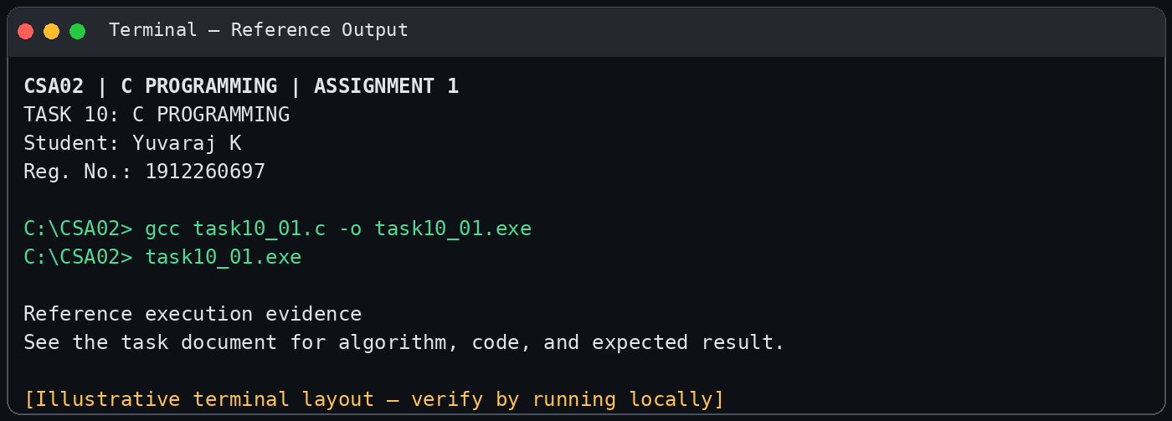
Illustrative terminal-style output screenshot

