CSA02 – C PROGRAMMING
ASSIGNMENT 1
TASK 04
Use Macros Safely
Student name: Yuvaraj K
Register number: 1912260697
Repository: https://github.com/Yuvaraj290208/ASSIGNMENT-1-1912260697-C-PROGRAMMING-.git
Marks: 4 | Course Outcome: CO1

1. Problem Analysis and Design
Safe function-like macros fully parenthesize every parameter occurrence and the complete expression. For example, #define SQUARE(x) ((x) * (x)) makes SQUARE(a + 1) expand as ((a + 1) * (a + 1)). The unsafe x*x form can change operator precedence. Even a parenthesized macro may evaluate an argument more than once, so SQUARE(i++) is unsafe. MAX(a,b) may evaluate one argument twice; MAX(i++,j) can therefore increment unexpectedly. Prefer static inline functions for side-effecting arguments and type-checked calculations.
gcc -E source.c displays preprocessed output. It expands macros and includes headers before compilation. A macro used k times may duplicate its expression at each use; an inline function can reduce source duplication, though the compiler may inline it. Exact machine-code size depends on optimization and compiler decisions.

2. Pseudocode / Algorithm
Define RUPEES_TO_PAISE(x) with full parentheses
Define SQUARE(x) as ((x) * (x))
Define MAX(a,b) with full parentheses, but document repeated evaluation
Prefer static inline functions when arguments may have side effects
Compile with gcc -E and inspect expansion

3. C Source Code
#include <stdio.h>
#define RUPEES_TO_PAISE(x) ((long long)(x) * 100LL)
#define SQUARE(x) ((x) * (x))
#define MAX(a, b) (((a) > (b)) ? (a) : (b))
static inline int square_int(int x) { return x * x; }
static inline int max_int(int a, int b) { return a > b ? a : b; }
int main(void) {
int a = 3, b = 7;
printf("SQUARE(a+1)=%d\n", SQUARE(a + 1));
printf("MAX(a,b)=%d\n", MAX(a, b));
printf("inline square=%d, inline max=%d\n", square_int(a + 1), max_int(a, b));
printf("Rs 12 to paise=%lld\n", RUPEES_TO_PAISE(12));
return 0;
}

4. Expected / Reference Result
SQUARE(a+1)=16
MAX(a,b)=7
inline square=16, inline max=7
Rs 12 to paise=1200
Captured local compiler/execution evidence is provided in compile_output.txt. Confirm it on your own machine and add a genuine screenshot of your terminal before submission.

5. Alternative Concept and Complexity Analysis
Example alternative: static inline int square_int(int x) { return x*x; } and static inline int max_int(int a,int b) { return a>b?a:b; }. A macro has no call overhead after expansion but may duplicate code; a function call may have overhead unless inlined. Both are O(1) for scalar inputs. Macro-expanded code size can grow with k uses; function code can be shared if not inlined.
Scalar macro/function operations are O(1) time and O(1) working space. Macro code may be duplicated O(k) times in generated source/code if used k times; function code can be shared, subject to inlining.

6. Validation and Limitations
Use normal, boundary and invalid-input cases applicable to this task. Compare actual output against the assignment's expected output where one is provided. Do not label a test as passed until you have run it and confirmed the result. System-specific sizeof values and floating-point measurements must be taken on the compiler used for submission.

7. Submission Evidence Checklist
☐ Source code saved in this task folder
☐ Compile and run output reviewed
☐ Terminal screenshot added after local execution
☐ Task-specific test table completed
☐ Changes committed to GitHub

Execution Screenshot — Task 04
Student: Yuvaraj K | Register No.: 1912260697
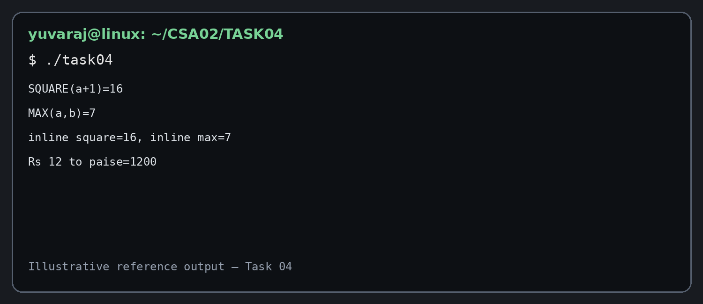
Illustrative terminal-style output screenshot

