Yuvaraj N
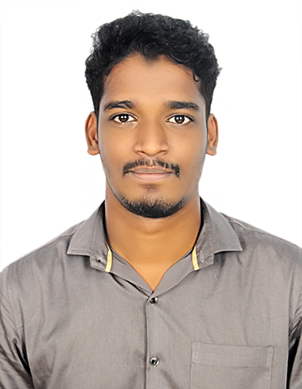
Software Developer(Full stack)

Email: yuvarajryd1@gmail.com
Phone: +917358758814
Location: Chennai, Tamil Nadu, India.
LinkedIn: www.linkedin.com/in/yuvaraj-n-748a911b0

OBJECTIVE:
To get an opportunity that allows me to showcase my skills and contribute to the company’s growth. To enhance my skills by taking on the challenging position and expanding my knowledge.

WORK EXPERIENCE:
Total 1 Year 6 Month Experience as Software Trainee in Full Stack .NET developer, MVC Developer, ASP.net Developer, React Developer from Human Cloud Soft.

PREVIOUS JOB ROLE:
S. No | Job Role | Experience | Willingness
1 | DotNet Developer(C#.net, ASP.net, MVC.net) | Currently Working | Ready to Work
2 | Web Designer | Currently Working | Ready to Work
3 | Software Tester | Currently Working | Ready to Work
4 | ReactJs Developer | Currently Working | Ready to Work

TECHNICAL OUALIFICATION:
- Microsoft Technologies: C# .net, MS SQL Server, .NET Framework 4.7.2, ASP .NET 5.0, MVC.NET.
- Programming Language: HTML, CSS, JS, PHP, BOOTSTRAP, REACT JS
- Database: MY SQL, Microsoft SQL Server
- Tools: SUBLIME TEXT, VISUAL STUDIO CODE, XAMPP, VISUAL STUDIO 2022
- Operating System: Windows 10 and Windows 11

CERTIFICATION:
S. No | Certifications | Technology
1 | Inspireotech Certified ASP.net Expert
2 | Inspireotech Certified ASP.net Expert
3 | Inspireotech Certified ASP.net Expert
4 | Inspireotech Certified ASP.net Expert
5
6
7
LANGUAGES:
- Tamil
- English

PERSONAL SKILLS:

PROJECTS:
- KKR Supermarket:
My Contribution: Designer & Code Developer
Client Name: Mr. Mohan
Team Members: 7
Duration: 4 Months
Language Used: C#, ASP .NET Framework
Framework: .Net Framework 4.7.2
Microsoft Technologies: SQL Server 2022, Visual Studio 2022
Description:
This project is based on client requirement. Here the client enters the entire stock details and has a follow up of sales, remaining stock, billing part. Client also has track on customer details, their discount details, gift vouchers if they are regular customer etc.,
Coding Standard followed:
US based coding Standard followed on Client Advice.
Design Pattern Followed:
Water Fall Model
Server Side - Add-On features in the Project — My Contribution:
  - Stored Procedures to access the database.
  - Exception Handling code using Try Catch Exception.
  - Normalized RDBMS databases.
  - Dynamic configurations using Config Files.
  - Optimized code.

Client Side - Add-On features in the Project — My Contribution:
- Very Strong JavaScript Validations.
- Regex Validation for email id and other patterns.

Design Specials - Add-Ons features in the Project — My Contribution:
- Custom Themes Created by our team.
- Custom Logo — Client Appreciated.
- Custom Icons for the entire project.

Testing — My Contribution:
- Manual Testing
- Functionality Testing
- Regression Testing

Device Compatibility Details:
- Used Bootstrap 5.0 Framework— Cross Device Compatibility Website Testing.

Documentation Creation:
- Specification Document
- Design Document
- Unit Test Case Document

Deployment:
- Git hub

- ZUMA Restaurant:
My Contribution: Designer & Code Developer
Client Name: Mr.
Team Members: 7
Duration: 6 Months
Language Used: C#, ASP .NET Framework
Framework: .Net Framework 4.7.2
Microsoft Technologies: SQL Server 2022, Visual Studio 2022
Description:
This project is based on client requirement. Here the client enters the entire stock details and has a follow up of sales, remaining stock, billing part. Client also has track on customer details, their discount details if they are regular customer etc.,

- Maran Car Rental:
My Contribution: Designer & Code Developer
Client Name: Mr. Maran
Team Members: 7
Duration: 5 Months
Language Used: C#, ASP .NET Framework
Framework: .Net Framework 4.7.2
Microsoft Technologies: SQL Server 2022, Visual Studio 2022
Description:
This project is based on client requirement. Here client has the entire control takes care of, availability of number of cars, auto’s etc., Client takes care of bookings and has track on customer and their frequency of bookings and accordingly offers discount for the customers. Feedback is given by customers which can be accessed by the client for their support.

EDUCATION:
- Completed Bachelor of Science in Computer Science - 7.4 CGPA – First class under Government Arts College For Men(Madras University).

DECLARATION:

I hereby declare that the above-mentioned information is correct up to my knowledge and I bear the responsible for the correctness of the above-mentioned particulars.

