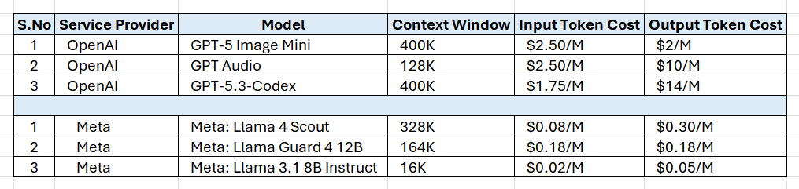
Model Name: GPT-5.x & O1/3
Prompt: Write a Java Selenium Code for ServiceNow Login Page
Tokens: 10
Characters: 52
