LoopHire: Loop Engineering-Based Intelligent Tech Stack Recommendation System for Recruitment

Problem Statement
Companies post Job Descriptions (JDs) on platforms like LinkedIn, Naukri, or their career pages.
However:
- HR teams sometimes write incomplete JDs.
- Similar technologies are written differently (e.g., JavaScript vs JS).
- Important skills may be omitted.
- There is no indication of the recommended learning path for candidates.
- AI-generated recommendations can miss relevant technologies or suggest outdated ones.
Current AI systems usually generate recommendations in a single pass without verifying them.

Proposed Solution
Develop a Loop Engineering-based system that continuously analyzes a job description, validates the extracted technologies, identifies missing skills, and refines the recommendations until a quality threshold is reached.
The system provides:
- Extracted skills
- Missing technologies
- Technology roadmap
- Learning priority
- Suggested certifications
- Confidence score

Real-Time Scenario
Imagine Microsoft posts a job:
Software Engineer
Requirements:
- Python , FastAPI, SQL, REST APIs, Docker.

A fresher uploads the JD.
The system returns:
Required Skills
✓ Python
✓ FastAPI
✓ SQL
✓ REST API
✓ Docker

Recommended Skills
✓ Git
✓ Linux
✓ CI/CD
✓ Kubernetes
✓ Azure

Learning Order

Python -> Git -> SQL -> FastAPI -> RestAPI -> Docker -> CI/CD -> Azure -> Kubernetes
Instead of only extracting keywords, the system explains why each technology matters.

Why Loop Engineering?
Normally,
JD -> LLM -> Technology List
Done.
If technologies are missing, the process ends there.

Proposed method:
Job Description -> Extract Skills -> Validate Skills -> Check Missing Technologies ->
Compare with Similar Job Descriptions -> Generate Recommendations -> Evaluate Recommendation Score -> Score > 90 -> No -> Improve Recommendation -> Repeat -> Final Output
The recommendation quality improves with each iteration.

Loop Architecture
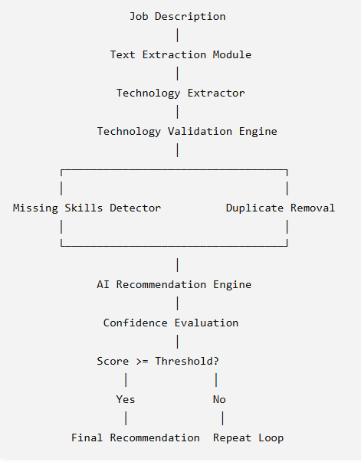

Proposed Modules
Module 1 — JD Upload
User uploads:
- PDF
- DOCX
- Text
Example:
Python Developer
Experience: 2 Years
Skills : Python, FastAPI, Docker, SQL, REST APIs
Module 2 — Skill Extraction
Extract:
Programming Languages
Frameworks
Databases
Cloud
Tools
Soft Skills
Output :
Languages, Python, Framework, FastAPI, Database, SQL, DevOps, Docker

Module 3 — Technology Validation
Check:
Is FastAPI related to Python?
YES
Is Docker useful?
YES
Is Git missing?
YES

Module 4 — Missing Skill Detection
System compares against industry knowledge.
Output : Recommended, Git, Linux, Azure, CI/CD, Kubernetes

Module 5 — Learning Path Generator
Instead of random ordering,
AI builds dependencies.
Example
Python -> Git -> SQL -> FastAPI -> REST API -> Docker -> Azure -> Kubernetes

Module 6 — Loop Controller
Evaluate:
Coverage
Completeness
Confidence
Missing technologies
Consistency
If score < 90
Repeat

Algorithm
while score < threshold:
extract_skills()
classify_skills()
validate_skills()
detect_missing()
generate_learning_path()
calculate_confidence()
improve_recommendations()

Evaluation Metrics
Metric | Description
Technology Extraction Accuracy | Correctly extracted skills
Precision | Correct recommendations
Recall | Missing skills identified
F1 Score | Overall extraction quality
Confidence Score | AI confidence
Number of Iterations | Loop count
Response Time | Execution time

Expected Output
Job Role : Backend Developer
Required Skills: Python, FastAPI, Docker, REST, SQL
Recommended Skills : Git, Linux, Azure, Kubernetes, CI/CD,
Learning Path:
Python -> Git -> SQL -> FastAPI -> Docker -> Azure -> Kubernetes
Overall Score :94%

Research Contribution
Most existing systems:
Input -> AI -> Output
Proposed framework:
Input -> Extract -> Validate -> Improve -> Re-evaluate -> Repeat -> Final Recommendation
The key contribution is the iterative improvement loop, which aims to increase the completeness and usefulness of technology recommendations compared with a single-pass approach.

Novel Feature (This is where idea becomes unique)
Add one more module that makes the work stand out.
Company Tech Stack Predictor
Besides recommending technologies, the system predicts:
Company Maturity Level
Example:
Startup
Expected Stack: FastAPI, React, Docker, MongoDB, GitHub Actions
OR
Enterprise
Expected Stack: Java, Spring Boot, Oracle, Kafka, Kubernetes, Azure, Jenkins

Company-wise Learning Path
Example:

TCS
Java, Python, Full-stack, Problem solving
Microsoft
C#, .NET, Azure, SQL Server, Git, Docker
Google
Python, Go, Kubernetes, GCP, TensorFlow
Amazon
Java, AWS, Spring Boot, DynamoDB, Lambda
Zoho
Java, MySQL, JavaScript, Linux

Git
This transforms the PoC from a simple JD parser into an AI Career Advisor, making it more compelling for both research and industry demonstrations.
A note on implementation
For the "company-specific stack" feature, avoid hardcoding assumptions about companies. Instead, build a knowledge base from:
- public job descriptions,
- official company technology blogs,
- engineering career pages,
- and validated technology mappings.
Then use the loop to:
- Extract technologies from the uploaded JD.
- Compare with the knowledge base for similar roles.
- Identify missing but commonly expected skills.
- Re-rank recommendations based on confidence.
- Repeat until the recommendation confidence stabilizes.
This approach is more scientifically defensible and gives a stronger methodology section in this idea because the recommendations are grounded in data rather than fixed rules.

