**IMAGE COMPRESSION**

**Load an image:**

load woman;

image(X)

title('Original Image')

colormap(map)

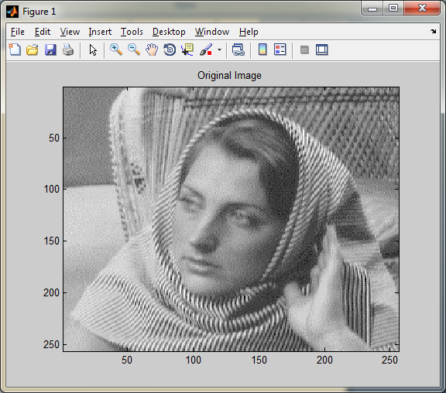

**Compress using thresholding method:**

n = 5; % Decomposition Level

w = 'sym8'; % Near symmetric wavelet

[c l] = wavedec2(X,n,w); % Multilevel 2-D wavelet decomposition.

opt = 'gbl'; % Global threshold

thr = 20; % Threshold

sorh = 'h'; % Hard thresholding

keepapp = 1; % Approximation coefficients cannot be thresholded

[xd,cxd,lxd,perf0,perfl2] = wdencmp(opt,c,l,w,n,thr,sorh,keepapp);

image(X)

title('Original Image')

colormap(map)

figure('Color','white'),image(xd)

title('Compressed Image - Global Threshold = 20')

colormap(map)

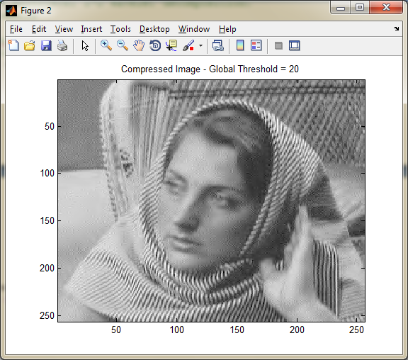

**norm recovery (%):**

perf0

76.2099

**Compression score (%):**

perfl2

99.9772