**FILTERING**

**Read the image:**

i=imread('westconcordaerial.png');

figure,imshow(i),title('Original image');

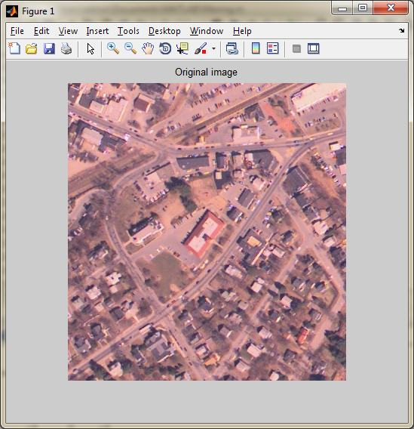

**Convert gray scale:**

g=rgb2gray(i);

figure,imshow(g),title('Gray image');

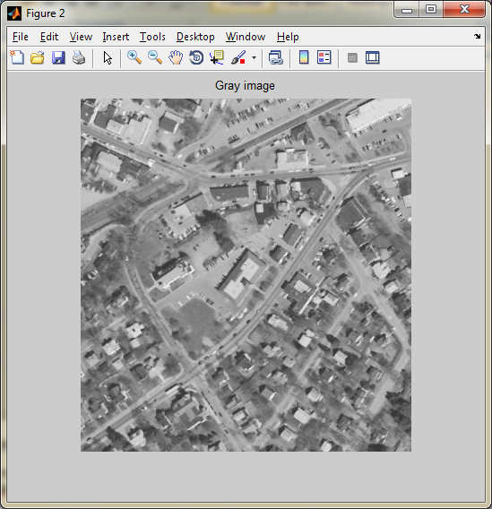

**Adding Gaussian Noise:**

j=imnoise(g,'Gaussian');

figure,imshow(j),title('Adding Gaussian noise in image');

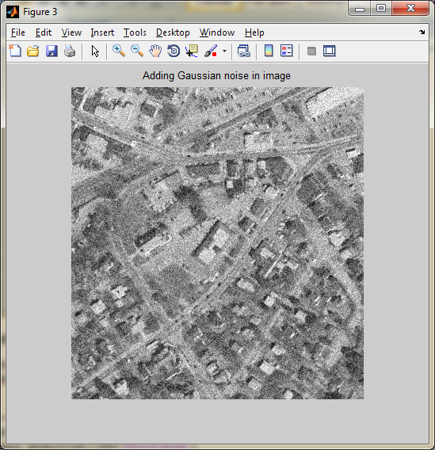

**Perform filter using imfilter() function:**

h = ones(5,5)/25;

rgb2 = imfilter(i,h);

figure, imshow(rgb2),title('filtered image');

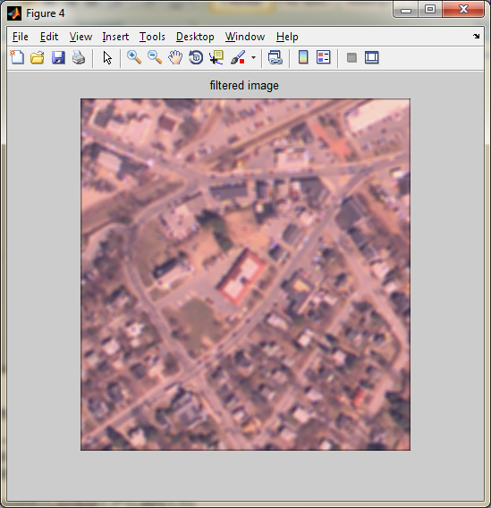

**Median filter:**

r=ordfilt2(j,median(1:3*3),ones(3,3));

figure,imshow(r),title('Median Filter');

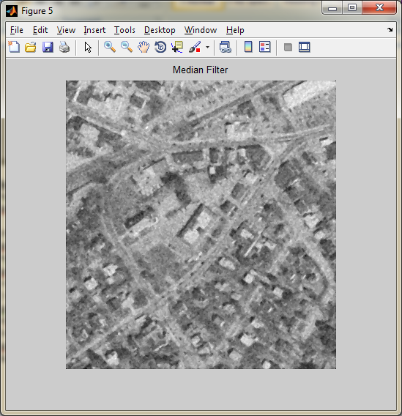

**Average filter:**

K=filter2(fspecial('average',3),j)/255;

figure,imshow(K),title('Average filter');

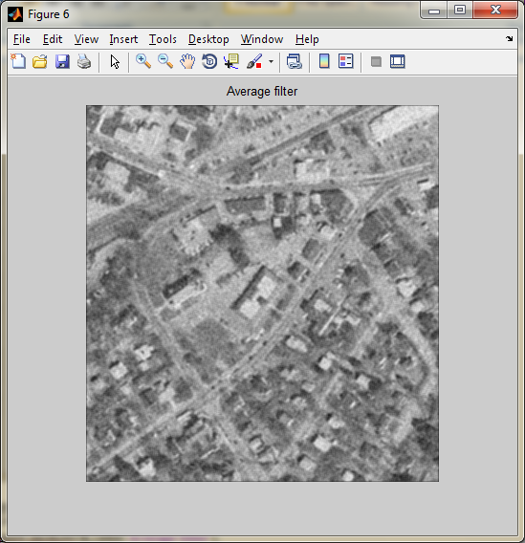

**Wiener filter:**

s=wiener2(j,[5 5 ]);

figure,imshow(s),title('wiener(Adaptive) filter');

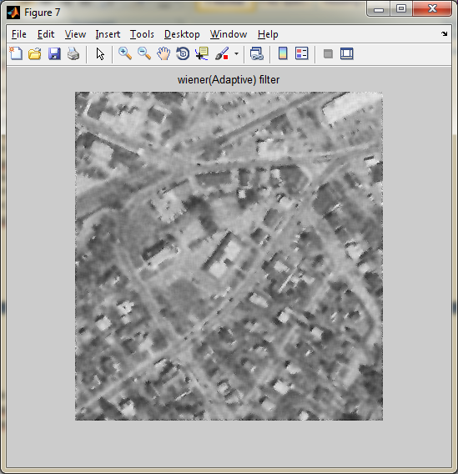

**Unsharpening a image using imfilter() function:**

h = fspecial('unsharp');

I2 = imfilter(g,h);

figure, imshow(I2), title('Unsharpening Filter Image')

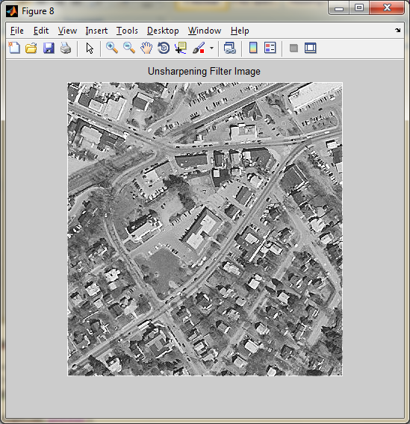

**Low Pass Filter:**

h=fspecial('gaussian');

I3=imfilter(g,h);

figure,imshow(I3),title('Gaussian low pass filter');

