**IMAGE ENHANCEMENT**

**Read the image:**

i=imread('img.jpg');

imshow(i);

title('Original image');

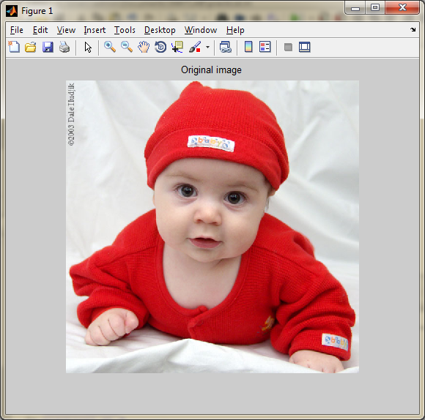

**Covert the image into grayscale:**

i=rgb2gray(i);

figure,imshow(i);

title('gray image');

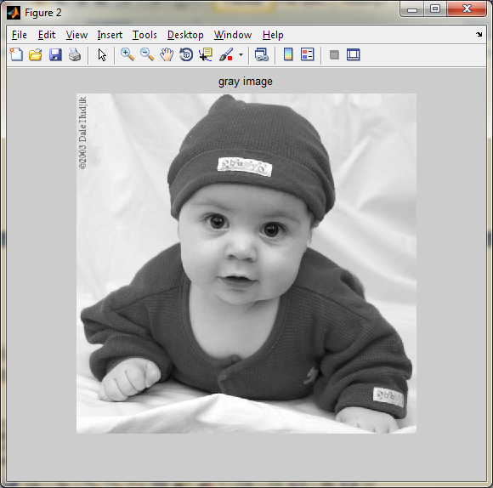

**Resize the image:**

i=imresize(i,[250,255]);

figure,imshow(i);

title('Resize the image');

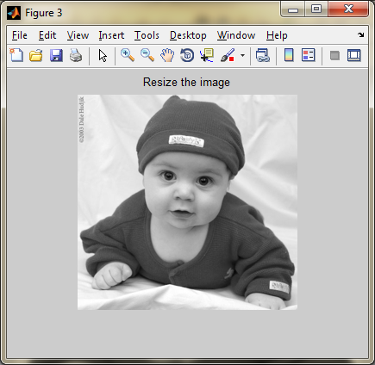

**Perform different enhancement technique:**

h3=imadjust(i,[],[],1);

h=imadjust(i,stretchlim(i),[0,1]);

h1=imadjust(i,[0,1],[1,0]);

h2=imadjust(i,[0.05,0.75],[0,1]);

subplot(2,2,1);

imshow(h3);

title('enhancement');

subplot(2,2,2);

imshow(h);

title('Stretching image');

subplot(2,2,3);

imshow(h1);

title('negative');

subplot(2,2,4);

imshow(h2);

title('intensity');

