**IMAGE SEGMENTATION**

**Read the image:**

i=imread('mir.jpg');

imshow(i),title('Original image');

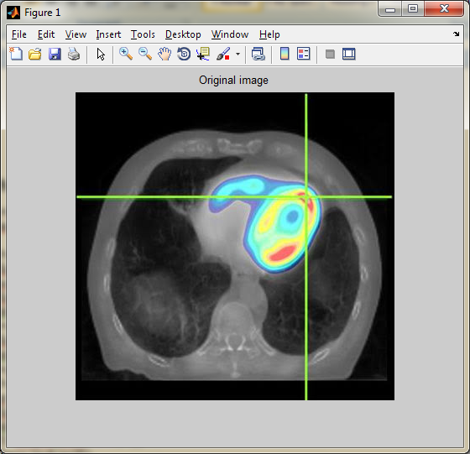

**Convert gray scale:**

f=rgb2gray(i);

figure,imshow(f),title('Gray image');

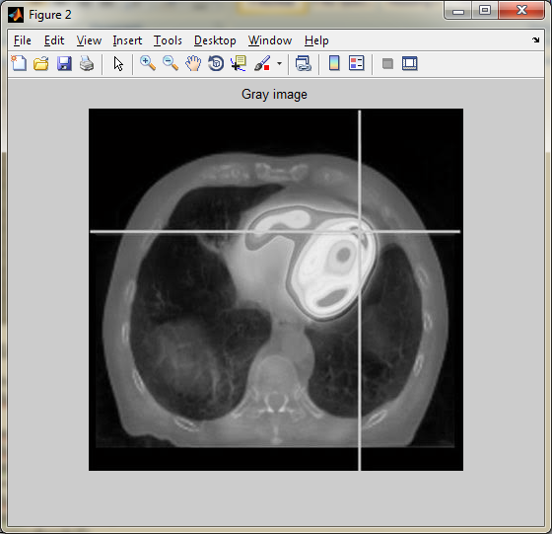

**Apply salt and pepper noise:**

noise_g=imnoise(f,'Salt & Pepper');

figure,imshow(noise_g),title('Salt & Pepper noise');

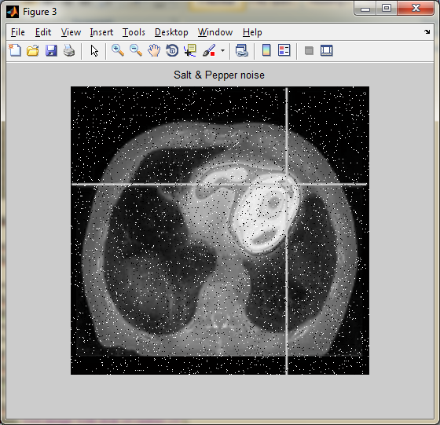

**Perform Median filter:**

r=ordfilt2(noise_g,median(1:3*3),ones(3,3));

figure,imshow(r),title('Median Filter')

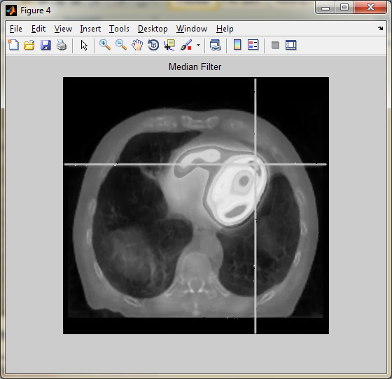

**Perform Thresholding method:**

t=graythresh(f);

f=mat2gray(f);

gt = (f>=t);

figure,imshow(gt),title('Global Thresholding');

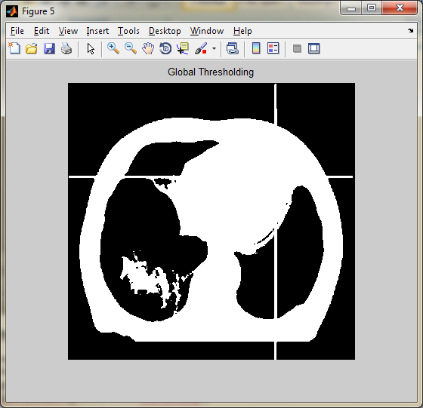

f1=imopen(f,strel('disk',20));

figure,imshow(f1),title('Test image with disk of radius 20');

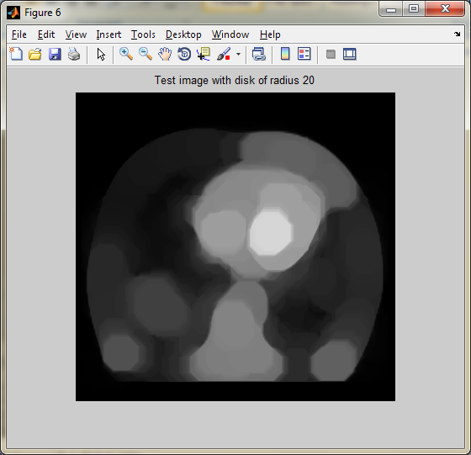

t=graythresh(f1);

f1=mat2gray(f1);

s=f1+t;

local_thres = (f>=s);

figure,imshow(local_thres),title('Local Thresholding');

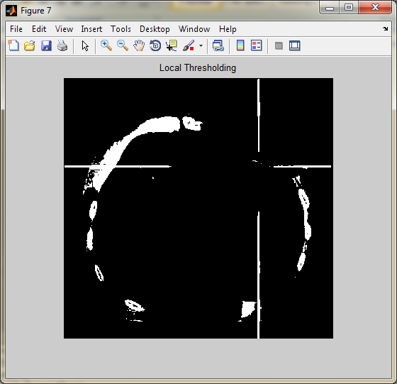

**Perform Watershed Transformation:**

L = watershed(f);

Lrgb = label2rgb(L);

figure, imshow(Lrgb), title('Watershed')

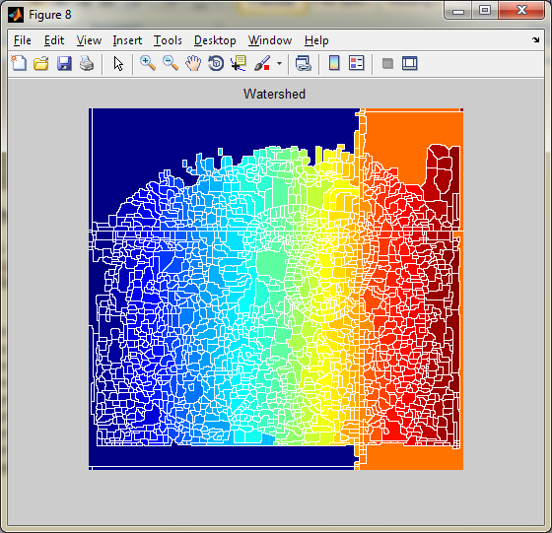

**Perform Line Detection:**

w1 = [-1 -1 2;-1 2 -1;2 -1 -1] % for line inclined at +45 degree

w2 = [2 -1 -1;-1 2 -1;-1 -1 2] % for lines inclined at -45 degree

w3 = [-1 -1 -1;2 2 2;-1 -1 -1] % for horizontal

w4 = [-1 2 -1;-1 2 -1;-1 2 -1] % for vertical lines

g=imfilter(f,w1);

g=imfilter(f,w2);

g=imfilter(f,w3);

g=imfilter(f,w4);

subplot(2,2,1);

imshow(g),title('Filter on W1');

subplot(2,2,2);

imshow(g), title('Filter on W2');

subplot(2,2,3);

imshow(g), title('Filter on W3');

subplot(2,2,4);

imshow(g), title('Filter on W4');

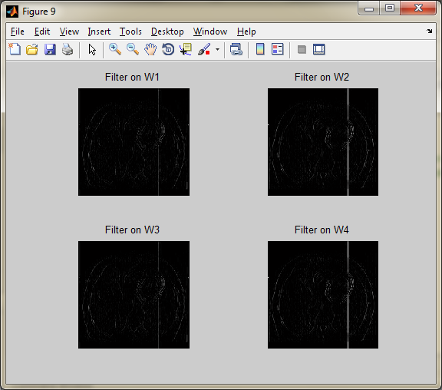

k=edge(g,'sobel','vertical');

figure,imshow(k),title('Line detection on Vertical Line');

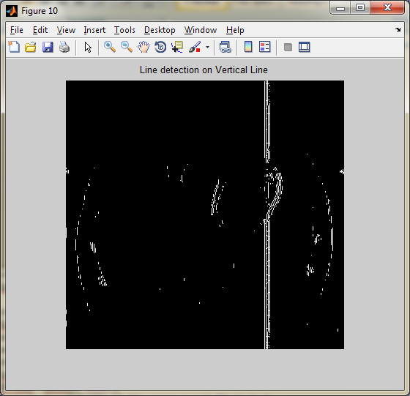

k=edge(g,'sobel','horizontal');

figure,imshow(k),title('Line detection on horizontical line');

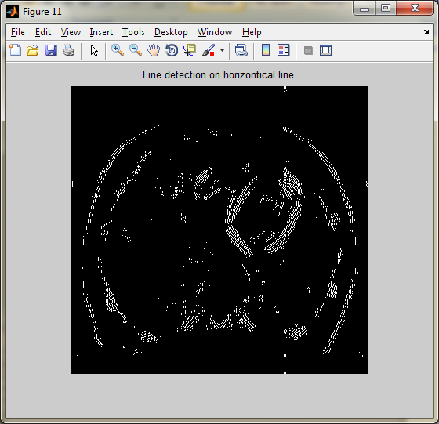

se90 = strel('line', 3, 90);

se0 = strel('line', 3, 0);

d=imdilate(f,[se90 se0]);

figure,imshow(d),title('Dilated image');

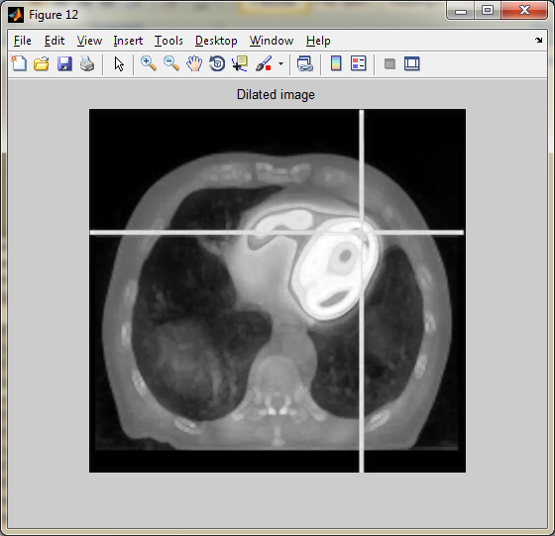

BWdfill = imfill(d, 'holes');

figure, imshow(BWdfill),title('binary image with filled holes');

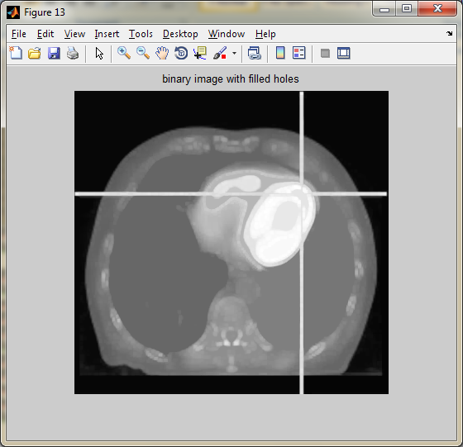

BWnobord = imclearborder(BWdfill, 4);

figure, imshow(BWnobord), title('cleared border image');

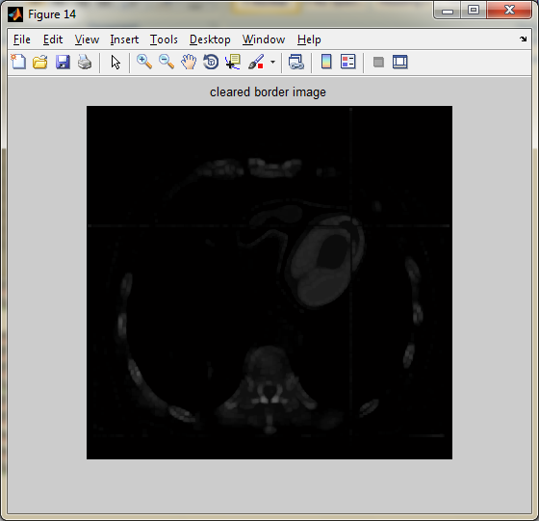

seD = strel('diamond',1);

BWfinal = imerode(BWnobord,seD);

BWfinal = imerode(BWfinal,seD);

figure, imshow(BWfinal), title('Extraction of Erosion');

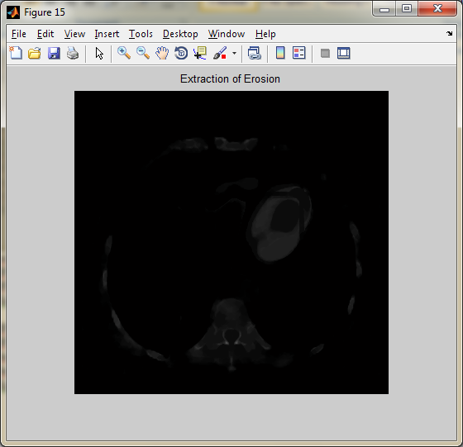

BWao = bwareaopen(BWfinal,5000);

BWoutline = bwperim(BWao);

Segout = f;

Segout(BWoutline) = 255;

figure, imshow(Segout), title('Segmented Image');

