**Library management system**

**Configuration:**

**Step 1:** Open Given project file in Visual studio 2019

**Step 2:** Install Requirements from Nuget Packages or .NetCLI

* **Requirements:**
  + Microsoft.EntityFrameworkCore(5.0.0)
  + Microsoft.EntityFrameworkCore.SqlServer(5.0.0)
  + Microsoft.EntityFrameworkCore.Tools(5.0.0)

**Step 3:** After install all the requirements need to migrate all the models into the database.

**Step 4:** Open Nuget Terminal from:

* Go to tools 🡪 NuGet Package Manager 🡪 Package manager Console.
* Now type “**add-migration <any name here>**”
* Now update database by enter this command
  + **“update-database”**
* Enable “**SQL server Object Explorer”**
  + Go to View 🡪 SQL Server Object Explorer
* Now expand local database and you can see our database name **“Librarymanagement”.**
* All setups Done.

**Step 5 :** Now run the application.

**Step 6:** You can do all the operations.

**Screenshots:**

**Home page: (/books)**

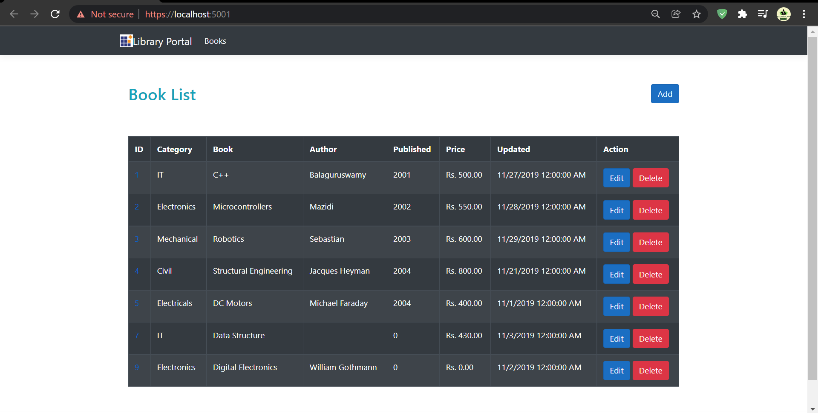

**Add Book page:**

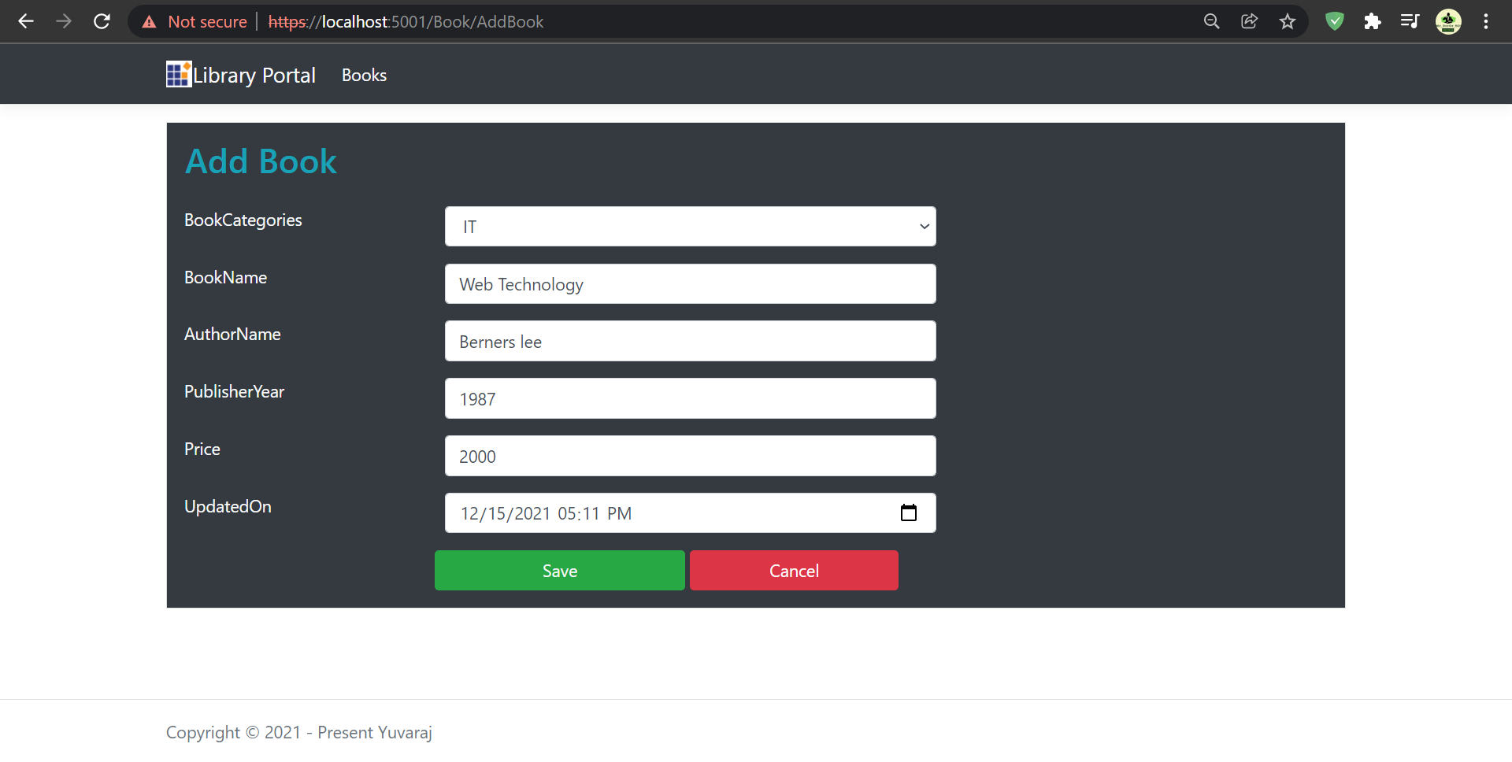

**After Adding Book:**

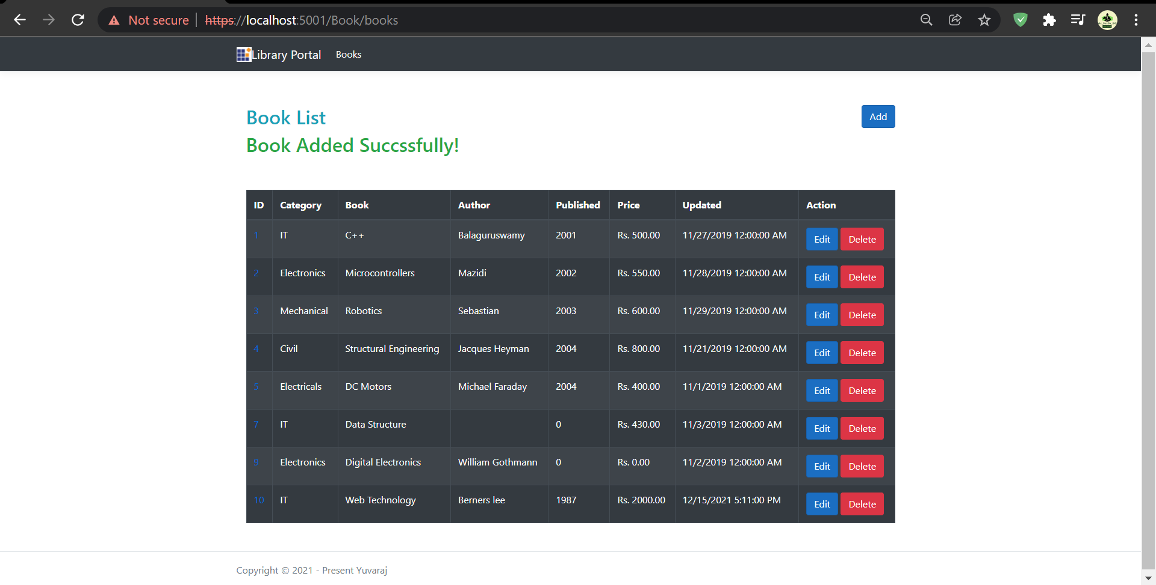

Status will be Displayed here!

**Edit Book page:**

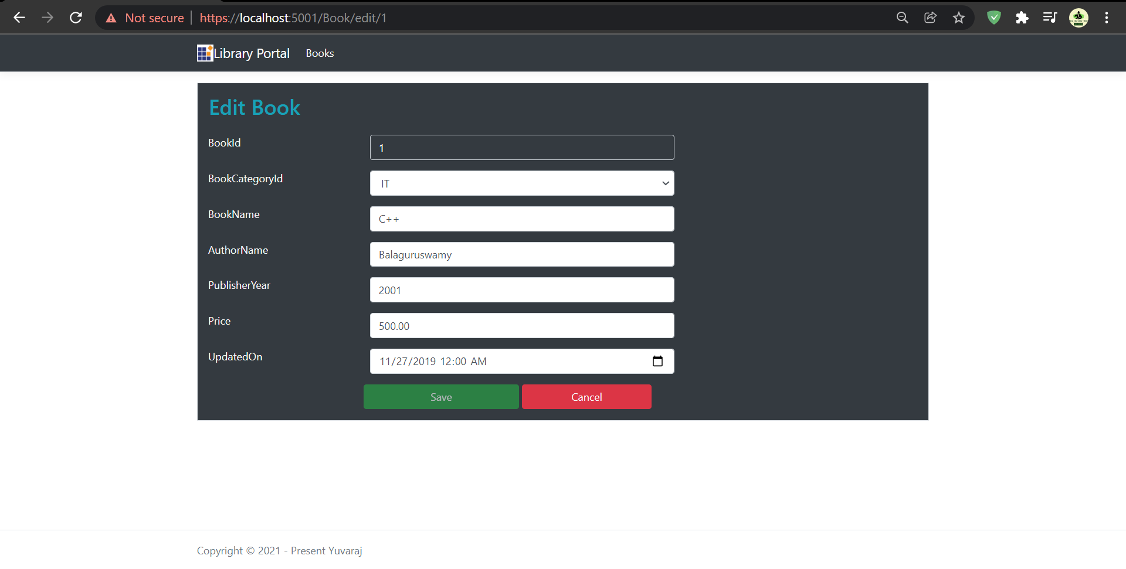

User Didn’t make any changes save button in disable state

**After Make changes in Edit book page:**

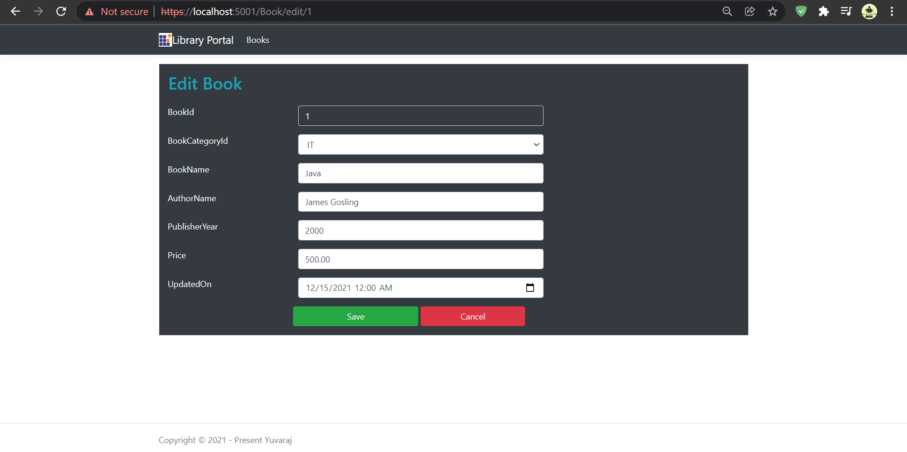

User change anything save button will enable

**After Save the edit:**

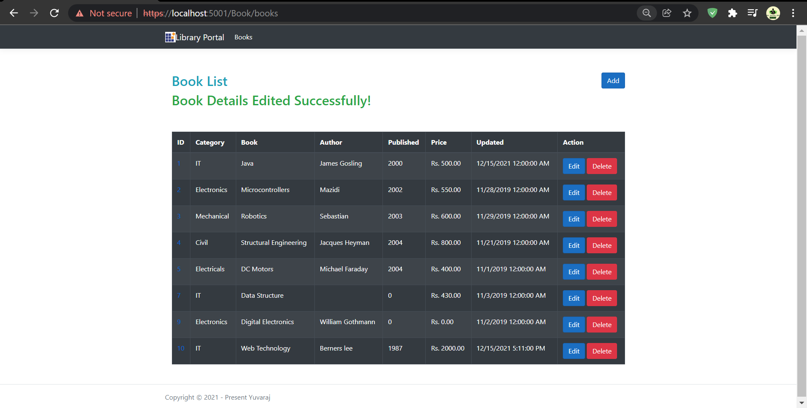

**Delete Page:**

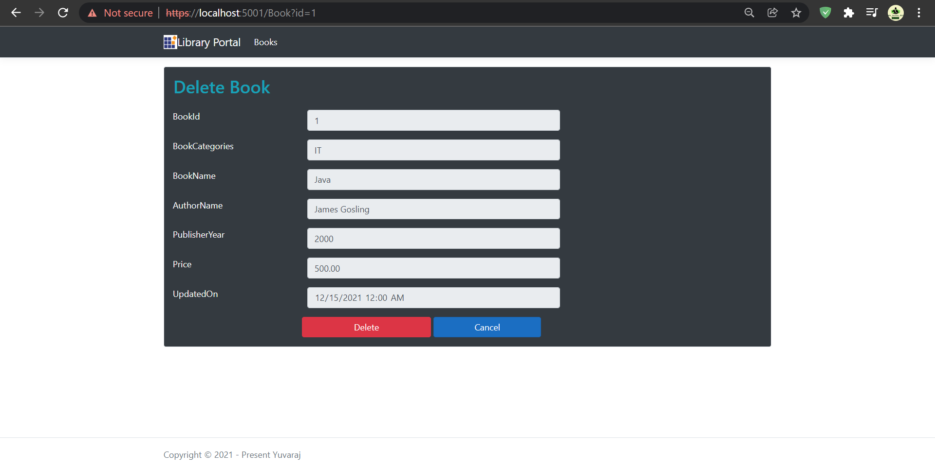

**After Delete The Book:**

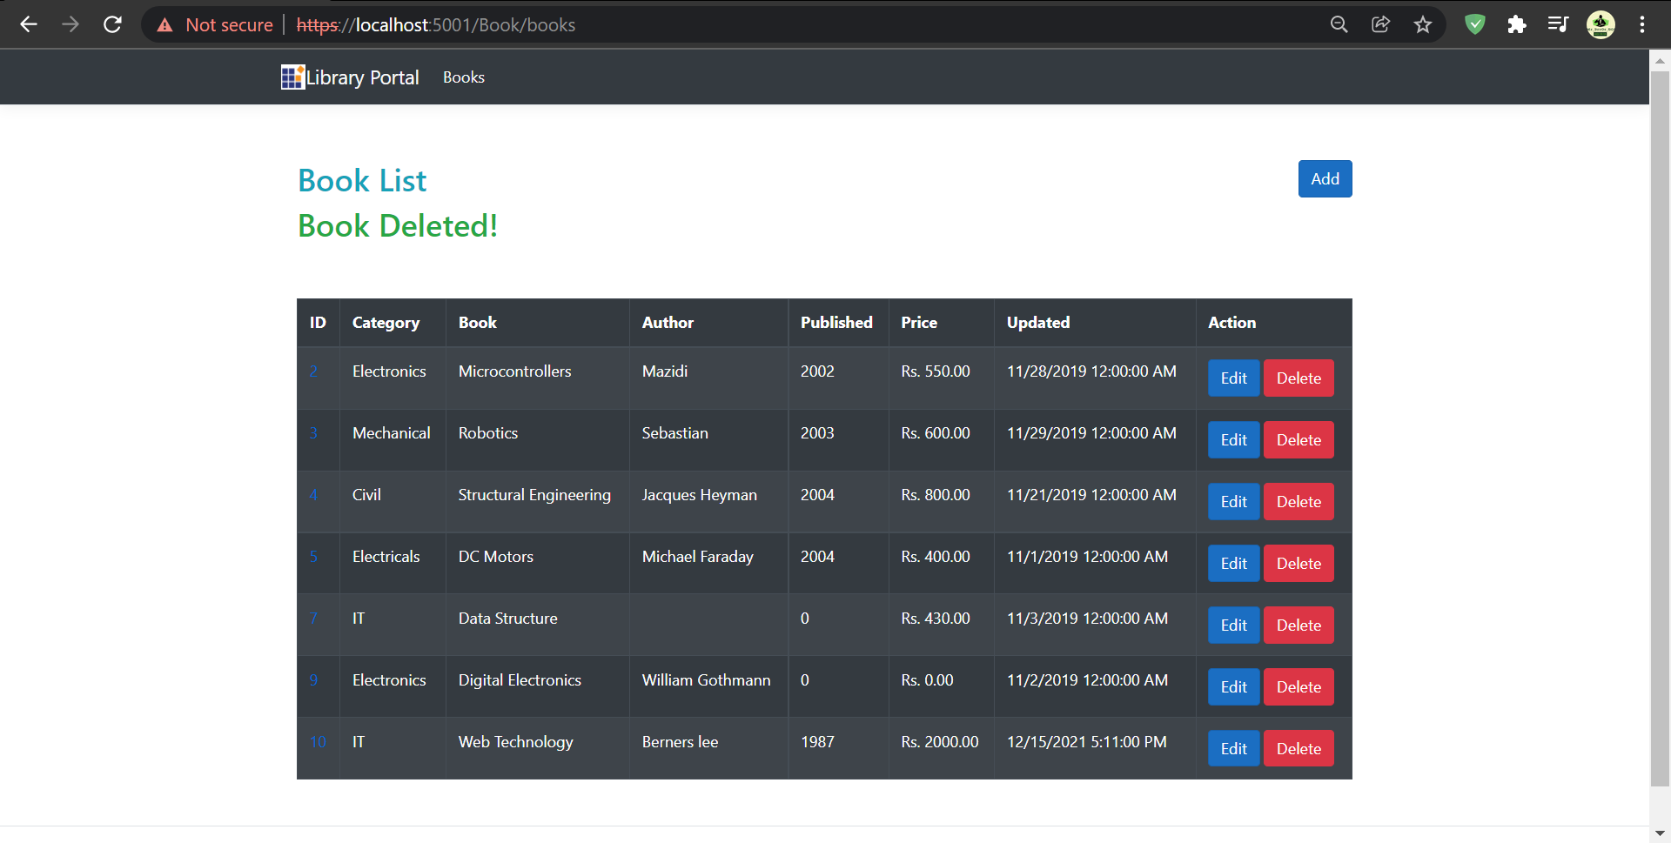

**Book Details Page:**

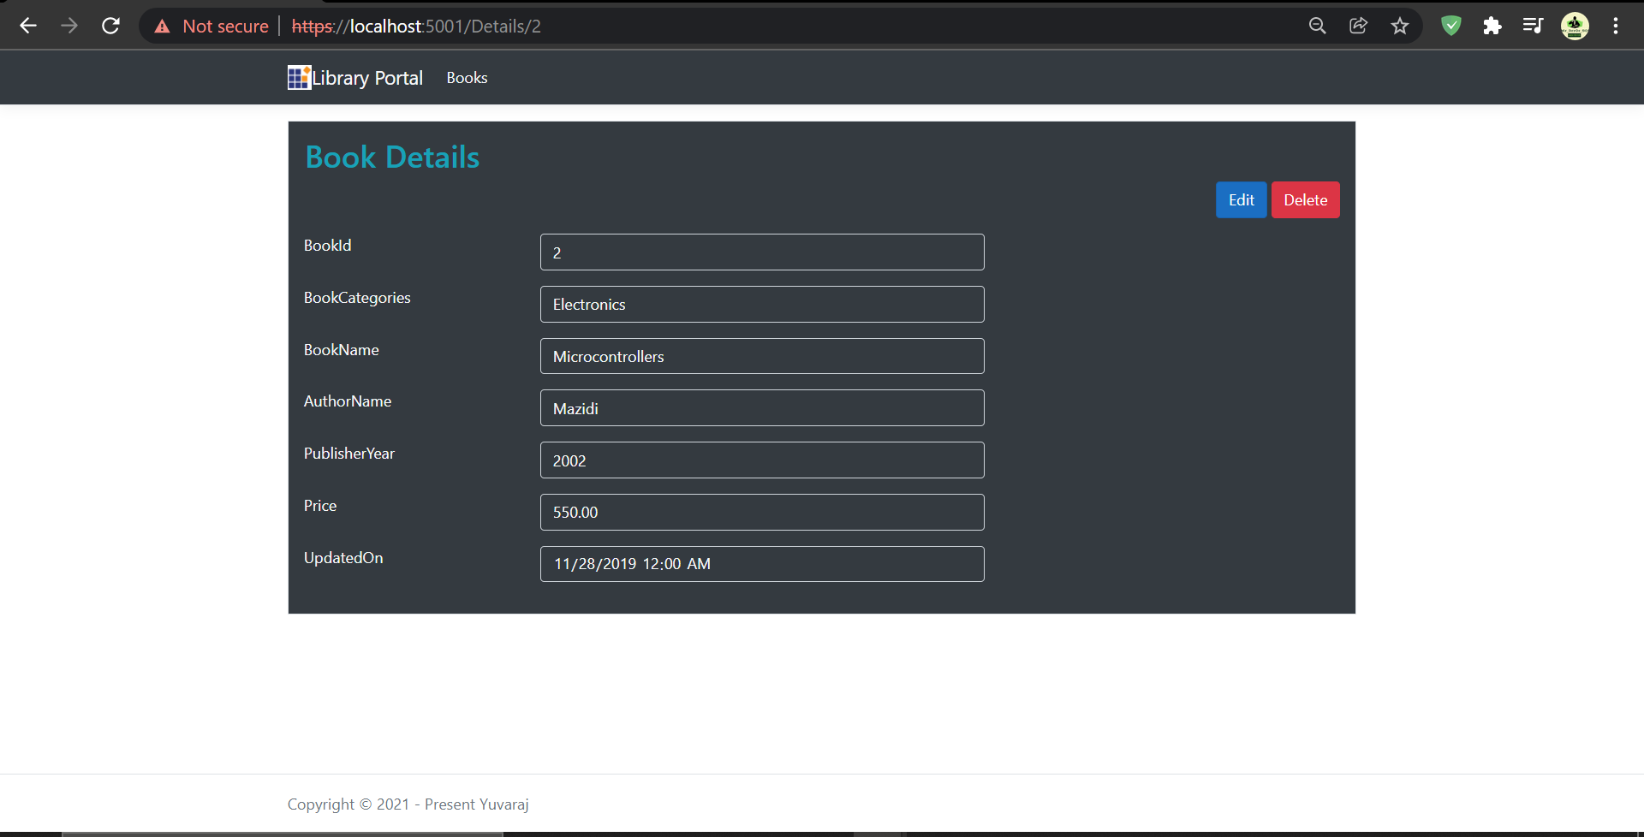

User Can directly navigate edit and delete page from Detail’s page

**Book Table:**

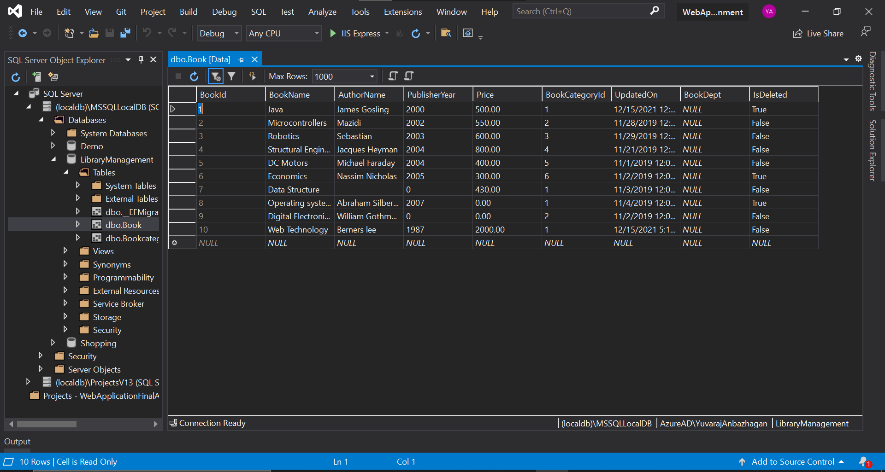

**BookCategory Table:**

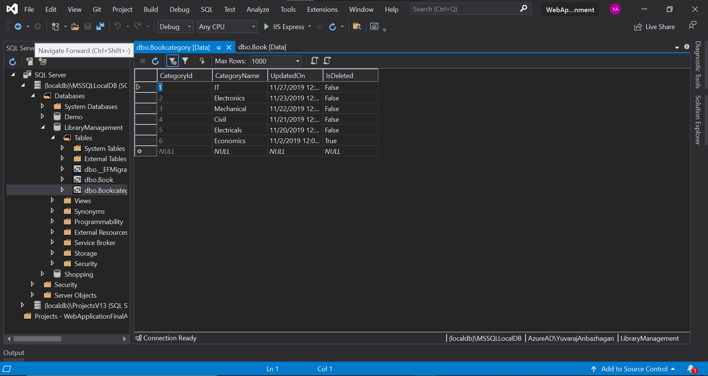

**Thank you**