ABSTRACT

University rankings such as those governed by the National Assessment and Accreditation Council (NAAC) and the National Institutional Ranking Framework (NIRF) serve as pivotal benchmarks for evaluating institutional quality, academic excellence, and resource optimization. This project focuses on designing a comprehensive RANK PORTAL: FACULTY MODULE BUILDER FOR INSTITUTIONAL ACCREDITATION to streamline the process of collecting, validating, and analyzing institutional data required for these ranking applications. By integrating automated workflows, robust data validation techniques, and efficient reporting mechanisms, the proposed system ensures the accuracy and reliability of data submitted for evaluation.
Key features include
- Automated Data Collection: Utilizing ICT tools to efficiently gather data across departments, resources, and faculty contributions.
- Validation Mechanisms: Implementing quality assurance protocols to prevent inconsistencies and ensure data compliance with NAAC and NIRF criteria.
- Resource Optimization: Capturing resource allocation data, including library assets, ICT facilities, and academic expenditures for ranking metrics.
- Role-Based Accessibility: Allowing departments, faculty, and administrators to input data tailored to their roles, ensuring accountability and transparency.
- This project highlights the challenges of data acquisition for ranking frameworks, while offering scalable solutions for improving institutional data workflows. The findings aim to empower universities to enhance their ranking performance while fostering quality improvements in governance and resource management. [6,7]
CHAPTER-I
1. Introduction

1.1 Overview of the Project
This project focuses on developing an integrated framework for data acquisition tailored to the requirements of institutional ranking systems such as NAAC (National Assessment and Accreditation Council) and NIRF (National Institutional Ranking Framework). These rankings play a critical role in evaluating universities on aspects like academic excellence, resource utilization, infrastructure, and governance quality. A well-structured RANK PORTAL: FACULTY MODULE BUILDER FOR INSTITUTIONAL ACCREDITATION ensures that universities can systematically collect, process, and submit data with accuracy and compliance.
1.2 Profile of the Organization
This project is tailored to meet the needs of universities and academic institutions striving for excellence in national and global rankings under frameworks such as NAAC (National Assessment and Accreditation Council) and NIRF (National Institutional Ranking Framework). By providing an efficient and secure data acquisition system, the platform empowers educational organizations to streamline data collection, validation, and submission processes, thereby boosting their operational effectiveness and ranking performance.
Key Organizational Goals Include
- Facilitating centralized and automated data acquisition to reduce manual efforts and errors.
- Enhancing institutional visibility by aligning with NAAC, NIRF, and other ranking frameworks.
- Ensuring accuracy and compliance through robust data validation mechanisms.
- Supporting role-based access to maintain transparency and accountability across departments.
Built on the Django framework, the project adopts a modular architecture to ensure ease of maintenance, scalability, and adaptability for future enhancements. Its focus on data security and process efficiency makes it an indispensable tool for institutions aiming to enhance their academic standards and resource optimization.

1.3 Module Description
The “RANK PORTAL: FACULTY MODULE BUILDER FOR INSTITUTIONAL ACCREDITATION” is structured into interconnected modules, each fulfilling specific functionalities to ensure efficient and secure data handling for stakeholders like administrators, departments, teachers, and scholars. Below is a detailed explanation of the key modules.
1.3.1 Admin Module
This module is the backbone of the system, offering centralized control over data management and organizational workflows.
Features
- Manage users, including teachers, scholars, and department staff.
- Oversee and update department details, resource allocations, and rankings-related data.
- Generate detailed reports aligned with NAAC and NIRF requirements.
- Ensure secure role-based access and data integrity.
Constraints
- Restricted access to authorized personnel for sensitive actions.
- Must ensure data compliance with ranking framework guidelines.
1.3.2 Faculty Module
This module handles the detailed management of teacher profiles and their contributions to institutional metrics.
Features
• Create and manage teacher profiles, including role-specific details like position and PAN.
• Document academic contributions such as publications, research activities, and projects.
Constraints
• Each teacher must be associated with a department.
• Accurate documentation of academic achievements is required for ranking evaluations.

1.3.3 Scholar Module
This module supports the management of scholar profiles and their academic and extracurricular achievements.
Features
- Maintain scholar information, including departmental affiliation and academic progress.
- Document achievements like internships, placements, and awards.
• Allow scholars to contribute data relevant to NAAC and NIRF criteria.
Constraints
• Scholars must be associated with their respective departments.
- Data inputs must be validated to ensure accuracy for ranking frameworks.

1.3.4 Teacher receiving Fellowship / Financial Support
This module manages records of teachers receiving fellowships or financial support for academic and research excellence. It ensures proper documentation of awards, funding sources, and recognition levels.
Features
- Maintain a list of teachers who have received fellowships or financial support.
- Record details of awards, including name, year, and awarding agency.
- Categorize recognition levels (Institutional, National, International).
- Track financial support received for research, conferences, or academic development
- Generate reports on fellowship distributions and academic achievements.
Constraints
- Fellowship and award details must be verified and approved by relevant authorities.
- Financial support records should comply with institutional and funding agency guidelines.
- Recognition levels must align with official classification standards.

1.3.5 Research Grants and Recognitions
This module tracks research grants and recognitions received by faculty members, ensuring proper documentation of funding sources, project details, and financial support for academic research.
Features
- Track demand ratio for courses based on applications and admissions.
- Store details of the funding agency and categorize it as Government or Non-Government.
- Record the year of award and total funds provided (INR in Lakhs).
- Track the duration of funded research projects.
- Generate reports on grant distribution and research impact.
Constraints
- Research projects must align with institutional and funding agency regulations.
- Duration and financial records should be periodically updated for accuracy.
1.3.6 Awards & Recognitions for Research Innovations
This module records and manages awards and recognitions received for research innovations, ensuring accurate documentation of achievements, awarding bodies, and categories of recognition.
Features
- Maintain a database of research innovations recognized with awards.
- Record details of the awardee (individual or team).
- Store information about the awarding agency.
- Track the year of the award and categorize recognition levels.
- Upload and manage relevant documents as proof of recognition.
- Generate reports on awarded research innovations.
Constraints
- Supporting documents should be verified for authenticity.
- Categories must align with institutional or industry-defined classifications.

1.3.7 Patents Published/Awarded During the Year
This module tracks patents granted or published during the year, documenting intellectual property contributions by faculty members and researchers.
Features
- Maintain a record of patents awarded or published.
- Store details of the patenter (individual or institution).
- Record the patent number and title of the patent.
- Generate reports on patents granted, categorized by department or research area.
Constraints
- Patents must be verified through official patent-granting authorities.
1.3.8 Ph.D.s Awarded Per Teacher
This module records and tracks Ph.D. degrees awarded under faculty supervision, ensuring proper documentation of research scholars, their guides, and thesis details.
Features
- Maintain a record of Ph.D. scholars awarded degrees.
- Store scholar details, including department affiliation.
- Track the title of the thesis.
Constraints
- Year of registration and award should match official academic records.
1.3.9 Research Papers in UGC Journals
This module tracks research papers published in UGC-recognized journals, ensuring proper documentation of scholarly contributions by faculty members and researchers.
Features
- Maintain a database of research papers published in UGC-approved journals.
- Store details of the journal, including name and ISSN number.
- Track the year of publication.
Constraints
- ISSN numbers and UGC recognition links must be validated.

1.3.10 Books and Chapters Published
This module tracks books and book chapters published by faculty members, ensuring proper documentation of academic contributions, conference proceedings, and publishing details.
Features
- Maintain a record of books and chapters published by teachers.
- Store the title of the book/chapter and related research paper.
- Track the name and type of the conference (National/International).
- Generate reports on faculty book publications and research impact.
Constraints
- Publications must be verified through official publisher records.
    - Report Generation Module
The Report Generation Module is an essential part of the “RANK PORTAL: DEPARTMENT MODULE BUILDER FOR INSTITUTIONAL ACCREDITATION.” It is designed to create comprehensive reports based on academic and administrative data, aiding stakeholders in performance evaluation and decision-making.
Features
- Customizable Report Templates: Allows users to generate reports tailored to specific criteria or requirements, such as department performance or institution-wide summaries.
- Criterion-Based Reports: Generates reports based on NAAC and NIRF criteria, including Curricular Aspects, Research & Innovations, and Governance metrics.
- Export Options: Supports exporting reports in various formats, including PDF, Excel, and Word, ensuring compatibility with institutional workflows.
- Data Aggregation: Combines data from different departments, criteria, and modules to provide consolidated insights for rankings.
- Graphical Visualizations: Automatically includes charts, graphs, and tables in the reports for better understanding and analysis of metrics.
- Auto-Summary Generation: Summarizes key findings and trends in the report, highlighting areas of strength and opportunities for improvement.
- Comparison Reports: Generates comparative reports across departments to identify performance gaps and foster collaboration.
- Automated Scheduling: Allows users to schedule periodic report generation for continuous evaluation and ranking updates.

Constraints
- Data Accuracy: The quality of the reports is heavily dependent on the accuracy of data submitted by departments.
- Compliance: Reports must adhere to NAAC and NIRF guidelines for data formatting and content structure.
- Permission-Based Access: Only authorized personnel (e.g., admins, department heads) can generate or view certain sensitive reports.

CHAPTER-II

2. System Analysis

System Analysis involves studying and evaluating the components, structure, and requirements of a system to ensure it functions efficiently. It helps in identifying hardware and software specifications, understanding user needs, and optimizing processes for smooth operation. This analysis is crucial for designing a robust and scalable system tailored to institutional requirements.

SYSTEM SPECIFICATION

HARDWARE SPECIFICATION
Processor : Intel Core i3 or higher
RAM : 4GB or higher
Disk Storage : 100GB or higher
Monitor : 15” or higher with a resolution of 1366 x 768 pixels

2.1.2 SOFTWARE SPECIFICATION
Front end : HTML5, CSS3, JavaScript, Bootstrap
Backend : Django (Python)
Platform : WINDOWS 10
Database : MySQL
Code Editor : Visual Studio code
Browser : Edge, Chrome

2.2 SOFTWARE DESCRIPTION

2.2.1 Hyper Text Markup Language (HTML)

HTML is the standard markup language used to structure the web pages of the system. It defines various elements of the interface, such as forms, tables, headings, and multimedia content, ensuring clear organization and rendering across devices. By providing a solid foundation, HTML ensures content accessibility and compatibility with different browsers and platforms.

2.2.2 CSS3 (Cascading Style Sheets)
CSS3 is used to define the presentation and styling of HTML elements. It manages the layout, colors, fonts, and overall visual aesthetics of the system. CSS3 enables the design of responsive interfaces that adapt seamlessly to different screen sizes, ensuring a smooth user experience on desktops, tablets, and mobile devices. Its separation of content from design makes it easier to maintain and update the system's look and feel.

2.2.3 JavaScript

JavaScript adds interactivity and dynamic behavior to the system. It is used to validate user inputs, manage real-time interactions, and enable asynchronous communication with the server for smooth data submission and retrieval. Features such as live form validation, real-time analytics dashboards, and interactive elements (e.g., dropdowns or filters) are implemented using JavaScript, enhancing the overall user experience.
2.2.4 Bootstrap
Bootstrap is a front-end framework that streamlines the development of responsive and mobile-first web interfaces. By providing pre-built CSS styles and JavaScript components such as modals, buttons, and grid systems, it ensures a modern, consistent design throughout the system. Bootstrap simplifies the design process, enabling developers to deliver a professional and user-friendly interface quickly. [2,4]
2.2.5 Django (Python)
Django is a high-level Python web framework employed to build the back-end functionality of the system. It follows the Model-View-Template (MVT) architectural pattern, allowing clear separation of concerns between the data layer, business logic, and user interface. Django provides built-in tools for user authentication, database integration, form handling, and routing, making the system secure, maintainable, and scalable. [1,3]

2.2.6 MySQL
MySQL is an open-source relational database management system (RDBMS) used for efficient storage and retrieval of system data. It organizes data into tables for entities such as users, departments, teacher profiles, resource allocations, and ranking metrics. MySQL enables complex queries and ensures data integrity through transactional features, making it an ideal choice for managing institutional data for NAAC and NIRF ranking submissions. Its scalability and robust security features protect sensitive information such as user profiles and academic data.

CHAPTER-III

3. System Design
System design is the process of transforming the requirements of the university ranking data acquisition system into a structured blueprint for implementation. This chapter focuses on converting the project specifications into system components, ensuring that the system is designed to meet user needs and perform efficiently within the frameworks of NAAC and NIRF.
3.1 Input Design
Input design defines how user data is captured, processed, and validated in the system. The platform ensures that all inputs are logical, accurate, and error-free, utilizing user-friendly forms to streamline interactions.
- Form Layout: Input forms are designed for simplicity and ease of use. Labels are consistently aligned, with clear and responsive input fields for a seamless user experience.
- User Registration: Collects user information such as name, email, role (e.g., Teacher, Scholar, Department Staff), and department. For teachers, additional fields like PAN and position are included.
- Data Collection: Departments input ICT resources, library data, and expenditure records. Teachers and scholars submit research contributions, publications, awards, and academic achievements.
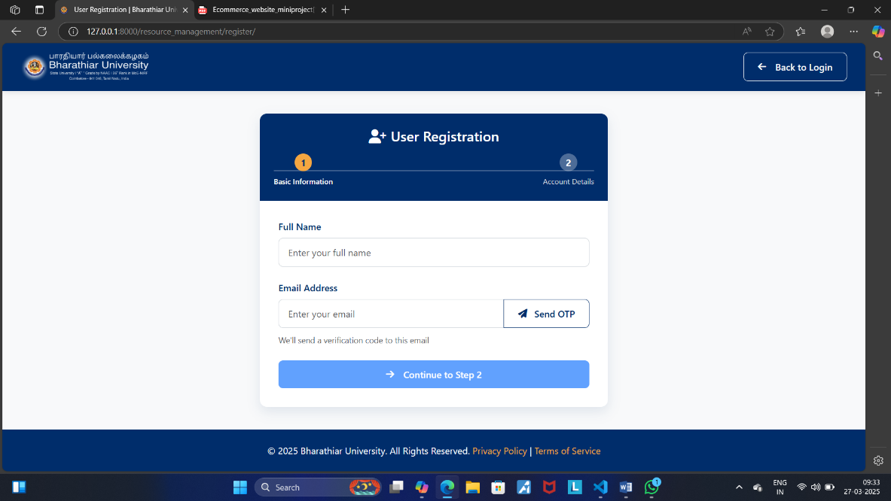
- Resource Inputs: Forms capture information about departmental resources, enabling structured reporting aligned with ranking metrics. Sample for input design is shown in Figure 3.1.1

Figure 3.1 Input Design
3.2 Validations
Validation ensures that user data and other system inputs are correct, consistent, and compliant with ranking framework requirements. The system implements rigorous checks to prevent errors and inconsistencies.
Email Validation
- Ensures email addresses are in the proper format (e.g., user@example.com).
- Checks against a list of valid domains to ensure legitimacy (e.g., no use of disposable email services).
Password Validation
Passwords must meet security criteria, such as:
- Minimum of 8 characters.
- Include at least one uppercase letter, one lowercase letter, one digit, and one special character.
- Ensures password confirmation matches the initial input.
Role Validation
- Validates the correct assignment of roles (e.g., Teacher, Scholar, Admin) based on permissions and departmental association.
- Prevents role duplication or unauthorized role changes.
Resource Validation
- Verifies that ICT and library resource entries do not exceed departmental thresholds or budgets.
- Ensures all required supporting documents (e.g., invoices, geo-tagged photos) are attached.
Academic Contribution Validation
- Checks for duplicate entries of publications, awards, and research projects to avoid redundancy.
- Verifies the authenticity of claims through supporting documents (e.g., DOI for papers, scanned certificates for awards).
Department Code Validation
- Ensures that all department codes are unique and follow a predefined naming convention (e.g., LIB01 for Library, ENG02 for Engineering).
Input Length Validation
- Limits the length of text inputs (e.g., names, descriptions) to prevent errors and ensure database compatibility.
Numeric Field Validation
- Verifies that numeric entries (e.g., student counts, expenditure amounts) fall within predefined valid ranges.
Date Validation
- Ensures that date entries (e.g., admission dates, award dates) are logical and within valid timeframes (e.g., not in the future or before a valid range).
File Upload Validation
- Confirms that uploaded files meet size and format requirements (e.g., PDFs, images).
- Scans uploaded documents for malicious content.
Data Dependency Validation
Ensures linked data entries are consistent. For example:
- Teachers must be associated with valid departments.
- Student scholarships must align with eligible courses.
Currency Validation
- Ensures that financial data (e.g., expenditures) are entered in the correct currency format (e.g., INR).
Criteria-Based Validation
- Ensures all departmental submissions are categorized under the correct NAAC and NIRF criteria (e.g., Curricular Aspects, Research). Sample for validation design is shown in Figure 3.2.1

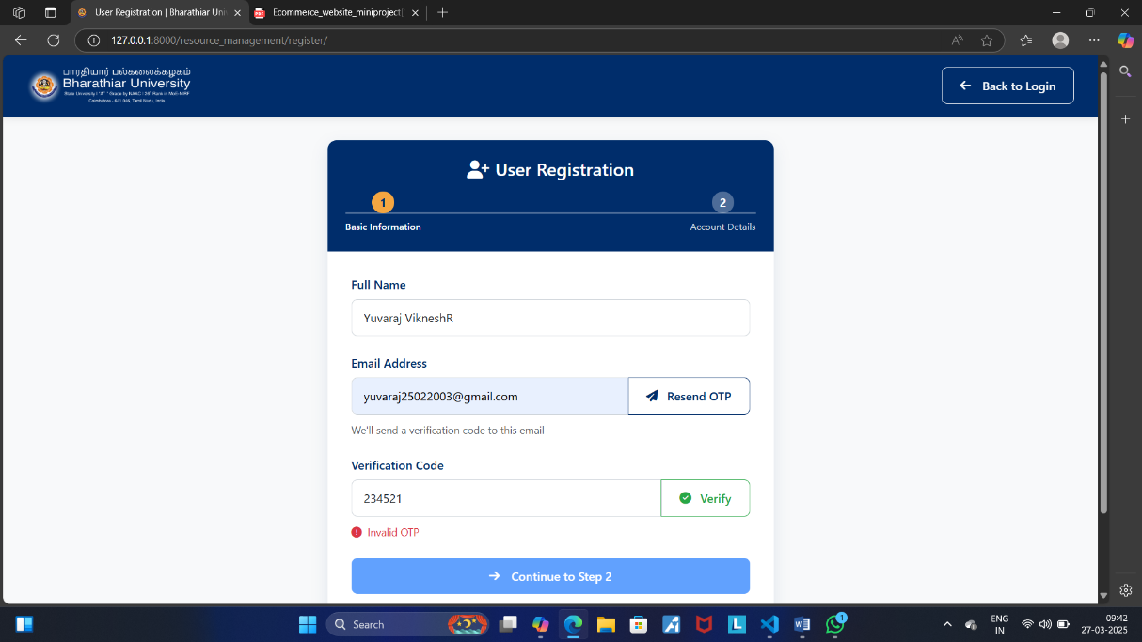
Figure 3.2 Validation Design

3.3 Output Design
Output design focuses on how user interactions and system processes deliver results. The system ensures that outputs are clear, accessible, and aligned with the requirements of institutional rankings.
- Registration Confirmation: Displays success messages upon user registration and profile updates.
- Ranking Reports: Generates NAAC and NIRF-aligned reports detailing academic achievements, resource usage, and expenditures.
- Admin Dashboard: Provides administrators with insights into data submissions, ranking progress, and performance metrics for departments.
- Department Reports: Displays summaries of ICT and library resources alongside academic contributions. Sample for output design is shown in Figure 3.3.1

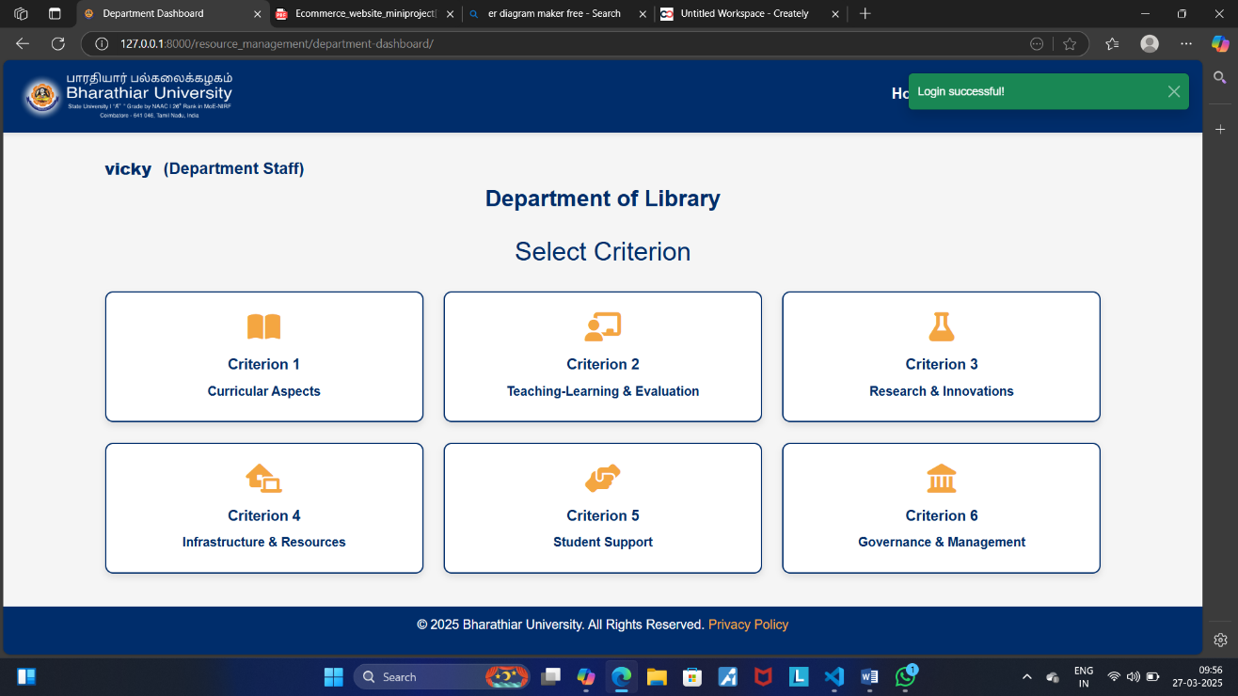
Figure 3.3 Output Design
3.4 Database Design
The database design ensures efficient data organization, quick access, and minimal redundancy. The system uses a relational database such as MySQL or PostgreSQL to store and manage all institutional data.
- User: Stores user data such as name, email, password, role, and department affiliation.
- Department: Maintains information about department codes, names, and associated resources like ICT facilities and library assets.
- Teacher: Stores teacher-specific data, including position, PAN, and academic contributions.
- Scholar: Captures scholar data, including their achievements, research projects, and extracurricular activities.
- Ranking Data: Includes information on academic contributions, resource utilization, and departmental metrics for NAAC and NIRF submissions.

3.4.1 Table name: User

Primary Key: id

Description of Table: The User table manages user account information and authentication credentials, providing the foundation for the UserProfile model and secure user access.

Field Name | Data Type | Size | Constraints | Description
id | Integer | 9 | Primary Key, Auto-increment | Unique identifier for each user record.
username | Varchar | 25 | Unique, Not Null | Username for the user account.
email | Varchar | 25 | Unique, Not Null | Email address for the user.
password | Varchar | 12 | Not Null | Encrypted password for user authentication.
first_name | Varchar | 15 | Nullable | First name of the user.
last_name | Varchar | 15 | Nullable | Last name of the user.
date_joined | DateTime | - | Auto-generated | Timestamp when the user account was created.
is_active | Boolean | - | Default True | Indicates whether the user account is active.
is_staff | Boolean | - | Default False | Identifies whether the user has admin privileges.

3.4.2 Table name: Department

Primary Key: department_code

Description of Table: The Department table stores details of academic and administrative departments within the institution.

Field Name | Data Type | Size | Constraints | Description
department_code | Varchar | 10 | Primary Key | Unique code identifying the department.
department_name | Varchar | 20 | Unique, Not Null | Name of the department.

3.4.3 Table name: UserProfile

Primary Key: user_id

Foreign Key: user_id, department_id

Description of Table: The UserProfile table extends the User model by adding department affiliations and user roles.
Field Name | Data Type | Size | Constraints | Description
user_id | Integer | - | Primary Key, Foreign Key | Unique identifier linking to the User table.
department_id | Varchar | 10 | Foreign Key, Nullable | Links to the Department table.
is_teacher | Boolean | - | Default False | Indicates if the user is a teacher.
is_scholar | Boolean | - | Default False | Indicates if the user is a scholar.
is_department_staff | Boolean | - | Default False | Indicates if the user is department staff.

3.4.4 Table name: Teacher

Primary Key: user_profile_id

Foreign Key: user_profile_id

Description of Table: The Teacher table stores professional details of teachers, such as their position and PAN.
Field Name | Data Type | Size | Constraints | Description
user_profile_id | Integer | - | Primary Key, Foreign Key | Links to the user_profile table.
position | Varchar | 25 | Choices | Job title/designation of the teacher.
pan | Varchar | 10 | Unique, Not Null | Permanent Account Number for identification.

3.4.5 Table name: OtpVerification

Primary Key: email

Description of Table: The OtpVerification table manages OTP-based user authentication.

Field Name | Data Type | Size | Constraints | Description
email | Varchar | 25 | Primary Key, Unique | Email address for OTP verification.
otp | Varchar | 6 | Not Null | One-Time Password for authentication.
created_at | DateTime | - | Auto-generated | Timestamp when the OTP was created.
expires_at | DateTime | - | Not Null | Expiration time for the OTP.
is_verified | Boolean | - | Default False | Indicates if the OTP has been verified.

3.4.8 Table name: EContentDevelopment

Primary Key: id

Foreign Key: teacher_id

Description of Table: Stores details of e-content modules developed by teachers, including the platform, launch date, and supporting documentation.

Field Name | Data Type | Size | Constraints | Description
id | Integer | - | Primary Key, Auto-increment | Unique identifier for the record.
teacher_id | Integer | - | Foreign Key, Not Null | Links to the Teacher table.
module_name | Varchar | 25 | Not Null | Name of the e-content module.
platform | Varchar | 20 | Not Null | Platform where the e-content was launched (e.g., YouTube).
launch_date | Date | - | Not Null | Launch date of the e-content module.
document_link | FileField | - | Nullable | Supporting document for the e-content module.
facility_available | Text | - | Not Null | Description of facilities available for e-content development.
video_link | URLField | - | Nullable | URL to the video content, if available.

3.4.11 Table name: TeacherAward

Primary Key: id

Foreign Key: teacher_id

Description of Table: Tracks awards received by teachers, including the level of recognition and awarding agency.
Field Name | Data Type | Size | Constraints | Description
id | Integer | - | Primary Key, Auto-increment | Unique identifier for the award record.
teacher_id | Integer | - | Foreign Key, Not Null | Links to the Teacher table.
award_name | Varchar | 25 | Not Null | Name of the award received.
recognition_level | Varchar | 12 | Choices (International, National, State, Institutional) | Level of recognition for the award.
year_of_award | PositiveInteger | - | Not Null | Year in which the award was given.
awarding_agency | Varchar | 25 | Not Null | Agency that conferred the award.

3.4.12 Table name: ResearchGrant

Primary Key: id

Foreign Key: department_id

Description of Table: Tracks research grants awarded to departments, including funding details and duration.

Field Name | Data Type | Size | Constraints | Description
id | Integer | - | Primary Key, Auto-increment | Unique identifier for the grant record.
scheme_name | Varchar | 25 | Not Null | Name of the grant scheme.
funding_agency | Varchar | 50 | Not Null | Name of the agency providing the funding.
grant_type | Varchar | 20 | Choices (Government, Non-Government) | Type of funding agency.
department_id | Varchar | 10 | Foreign Key, Not Null | Links to the Department table.
year_of_award | PositiveInteger | - | Not Null | Year in which the grant was awarded.
funds_provided | Decimal | 15,2 | Not Null | Total amount of funds provided under the grant.
duration | PositiveInteger | - | Not Null | Duration of the grant.
duration_unit | Varchar | 10 | Choices (Months, Years) | Unit of duration (e.g., months or years).

3.4.13 Table name: AwardRecognition

Primary Key: id

Foreign Key: department_id

Description of Table: Tracks awards and recognitions achieved in various categories, such as institutions, teachers, researchers, and students.

Field Name | Data Type | Size | Constraints | Description
id | Integer | - | Primary Key, Auto-increment | Unique identifier for each award record.
department_id | Varchar | 10 | Foreign Key, Not Null | Links to the Department table.
innovation_title | Varchar | 25 | Not Null | Title of the innovation for which the award was given.
awardee_name | Varchar | 25 | Not Null | Name of the awardee who received the recognition.
awarding_agency | Varchar | 25 | Not Null | Name of the agency that issued the award.
award_year | PositiveInteger | 4 | Not Null | Year in which the award was given.
category | Varchar | 20 | Choices (Institution, Teacher, Research Scholar, Student) | Award category.
document | FileField | - | Nullable | Supporting document for the award.

3.4.14 Table name: Patent

Primary Key: id

Foreign Key: department_id

Description of Table: Stores details of patents awarded to individuals or departments, including unique patent numbers and related documentation.

Field Name | Data Type | Size | Constraints | Description
id | Integer | - | Primary Key, Auto-increment | Unique identifier for the patent record.
department_id | Varchar | 10 | Foreign Key, Not Null | Links to the Department table.
patenter_name | Varchar | 25 | Not Null | Name of the individual or organization holding the patent.
patent_number | Varchar | 15 | Unique, Not Null | Unique number assigned to the patent.
title | Varchar | 25 | Not Null | Title of the patent.
award_year | PositiveInteger | 4 | Not Null | Year in which the patent was awarded.
document | FileField | - | Nullable | Supporting documentation for the patent.

3.4.15 Table name: PhDAward

Primary Key: id

Foreign Key: department_id

Description of Table: Tracks PhD scholars, their guides, and awarded research work titles.

Field Name | Data Type | Size | Constraints | Description
id | Integer | - | Primary Key, Auto-increment | Unique identifier for the PhD award record.
scholar_name | Varchar | 25 | Not Null | Name of the PhD scholar.
department_id | Varchar | 10 | Foreign Key, Not Null | Links to the Department table.
guides | Varchar | 25 | Not Null | Name(s) of the scholar’s guide(s).
title | Text | 20 | Not Null | Title of the research work completed by the scholar.
registration_year | PositiveInteger | 4 | Not Null | Year in which the scholar registered for the PhD.
award_year | PositiveInteger | 4 | Not Null | Year in which the PhD was awarded.
document | FileField | - | Nullable | Supporting document for the award.

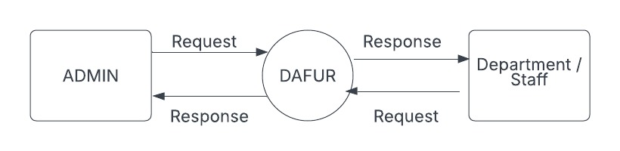
3.5 Data Flow Diagram

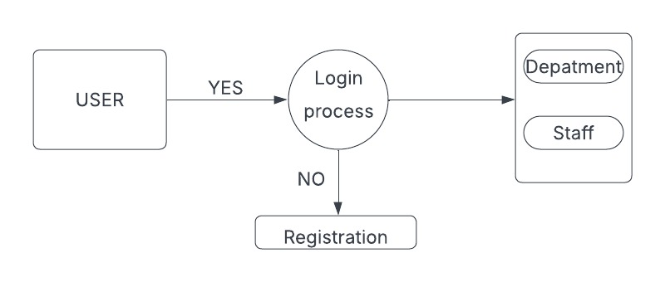
Level 0

Level 0
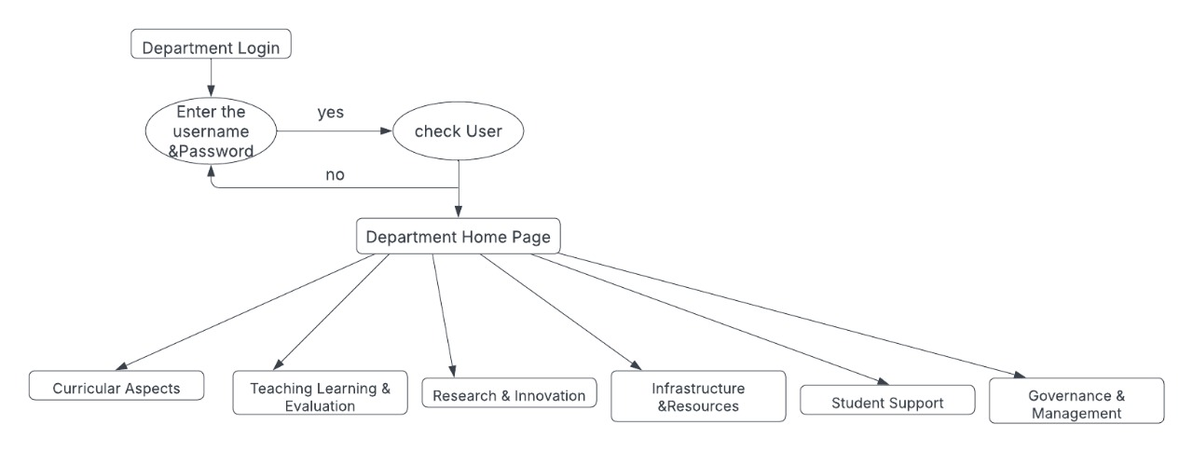

Level 1

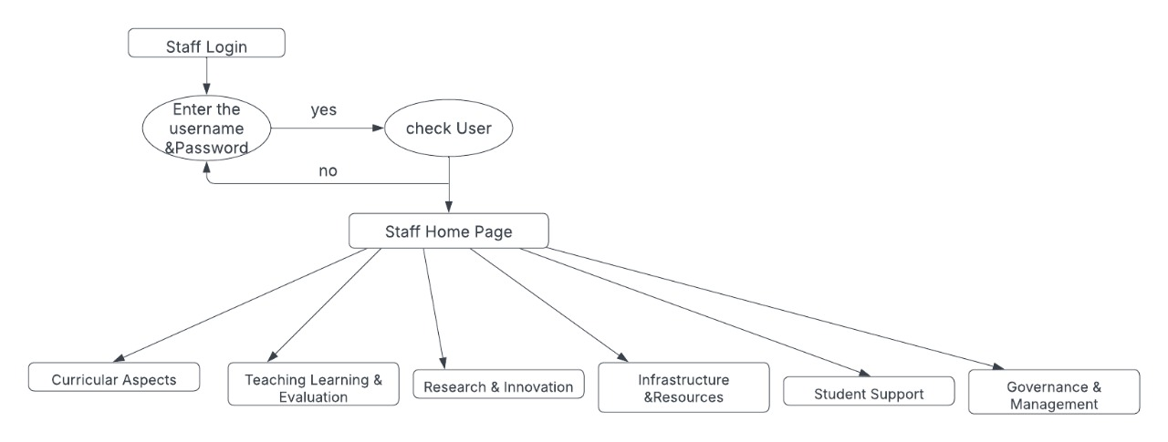
Level 1
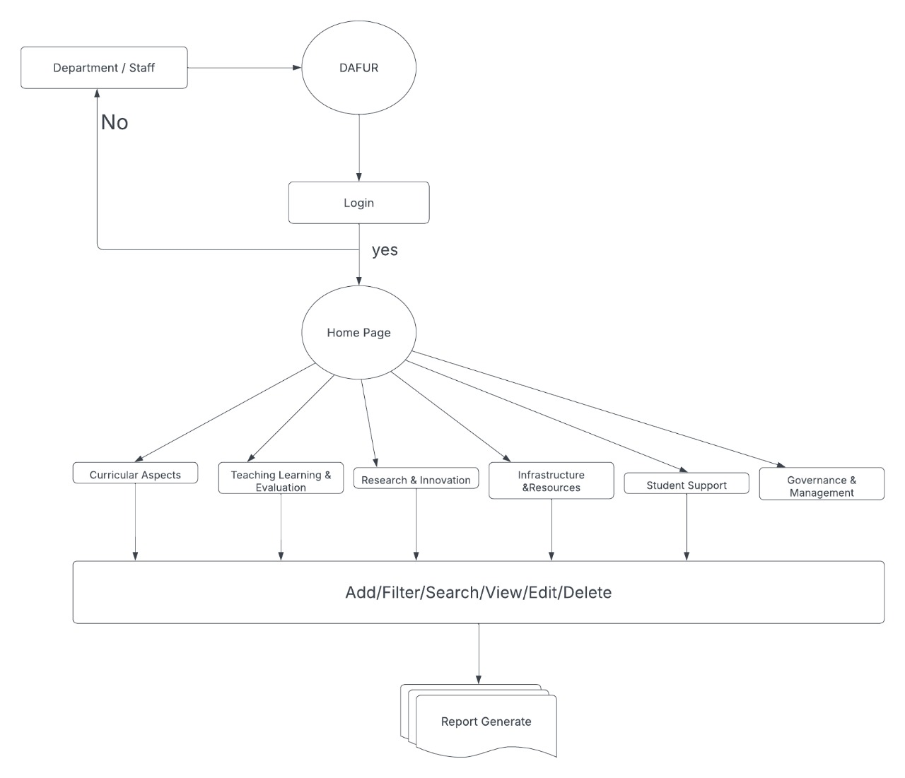

Level 2

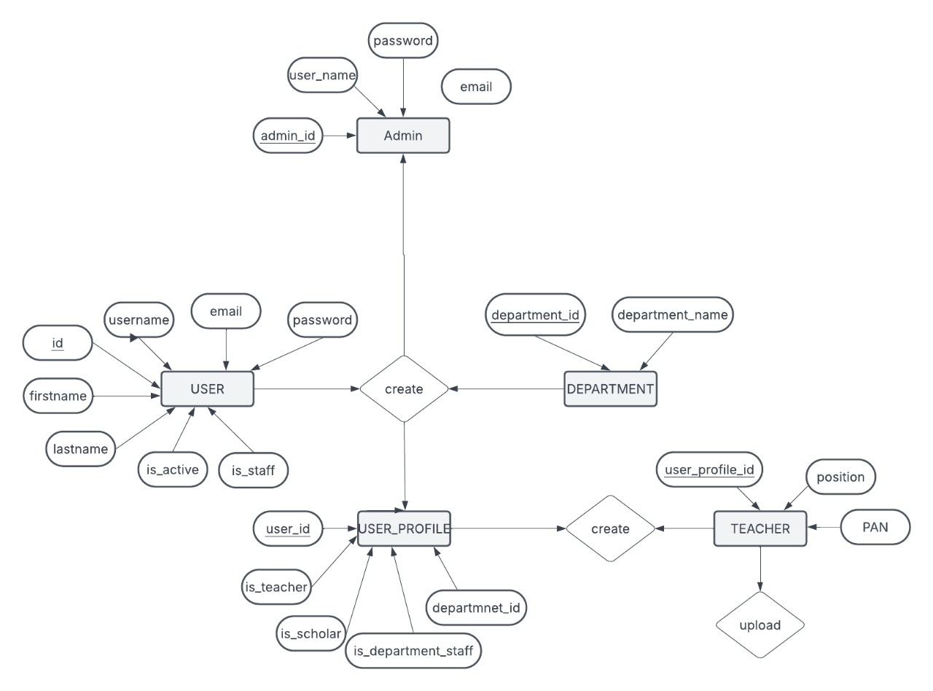
3.6 ER Diagram
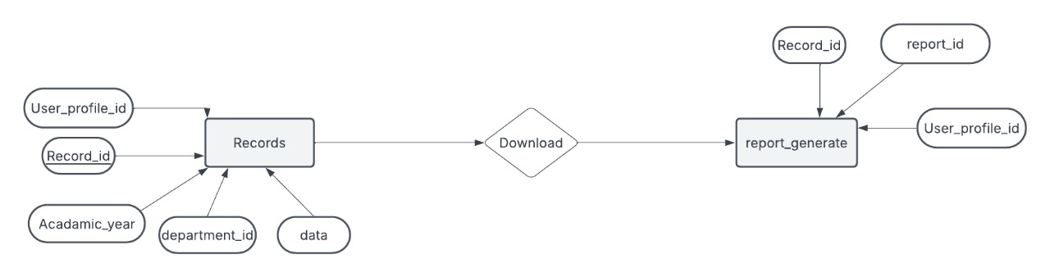

CHAPTER-IV

4. TESTING
For your system (which involves managing departments, teachers, research activities, patents, PhD awards, e-content, expenditures, etc.), the following testing techniques can be applied. Below is a detailed plan, including possible test cases and examples of real-time testing data:
4.1 Black Box Testing
Focus: Testing the system's behavior from a user’s perspective without knowledge of the internal code.
Key Areas Tested
User Interface (UI)
Objective: Ensure that forms (e.g., user registration, data submission) are intuitive and error free.
- Test Data: Submit a teacher's profile:
  - Input: Name: "John Doe", PAN: "ABCDE1234F", Role: "Teacher".
  - Expected: Form saves successfully and displays the success message.
- Test Case: Leave the "Department" field blank.
  - Expected: Error message: "Department is required."
Functional Behavior
- Objective: Verify functionality like adding patents, PhD awards, or research grants.
- Test Data: Add a patent:
  - Input: Patent Number: "PAT12345", Title: "AI Framework", Award Year: 2023.
  - Expected: Record is saved, and the patent details are viewable.
Edge Cases in Input Validation
- Objective: Ensure validation rules handle extreme inputs correctly.
- Test Data
  - Input an invalid email: "userexample.com" (missing "@").
  - Input a PAN: "AB123" (less than required length).
  - Expected: Error messages, e.g., "Invalid email format" and "PAN must be 10 characters."
Drop-Down Selection
- Objective: Test form behavior with invalid drop-down selections.
- Test Data:
  - Select a department that has been disabled or removed.
  - Expected: Error message, e.g., "Selected department is not available."
Multiple File Uploads
- Objective: Verify the ability to upload multiple supporting documents.
- Test Data
  - Upload a combination of valid (.pdf) and invalid (.exe) files.
  - Expected: Only valid files are accepted, invalid files generate an error.
Search Pagination
- Objective: Verify search results are correctly paginated.
- Test Data
  - Search query: "John" (expecting 120 results).
  - Expected: Results are paginated across multiple pages (e.g., 10 results per page).
4.2 White Box Testing
Focus: Test internal logic, including code-level validation and security aspects.
Key Areas Tested
Code Coverage
- Objective:Ensure all functions in models like Teacher, Department,ResearchGrant are exercised.
Test Data
- For TeacherAward, simulate saving multiple awards, ensuring foreign key checks are working properly.
  - Input: Teacher = "TeacherID123", Award = "Best Innovator".
  - Expected: The award is linked correctly to the teacher.
Security Vulnerabilities
- Objective: Test for issues like SQL injection in search functionalities.
- Test Data: Input malicious queries like ' OR '1'='1 in the search box.
  - Expected: Input is sanitized, preventing unauthorized access.
Boundary Testing for Loops
- Objective: Ensure loops (e.g., iterating through departments or teachers) handle edge cases.
- Test Data
  - Scenario: An empty list of teachers.
  - Expected: System handles it gracefully without crashing.
Database Constraints:
- Objective: Test foreign key and uniqueness constraints.
- Test Data
  - Attempt to add duplicate department codes.
  - Expected: Error: "Department code must be unique."
Exception Handling
- Objective: Ensure system handles runtime exceptions.
- Test Data
  - Trigger a database disconnection during an operation.
  - Expected: User-friendly error message: "Unable to save data. Please try again later."
4.3 Unit Testing
Focus: Testing individual modules like saving departments, linking teachers, or processing expenditures.
Key Areas Tested
- Validation Logic
  - Objective: Ensure field-level validations for models are accurate.
  - Test Data: For ResearchGrant, try saving without a mandatory field.
    - Input: Leave funding_agency blank.
    - Expected: Error message: "Funding agency is required."
- Database Interactions
- Objective: Verify CRUD operations.
- Test Data
    - Create a department record
      - Input: Department Code: "CSE01", Name: "Computer Science".
      - Expected: Record is saved in the database.
    - Update the department name
      - Input: Change to "Computer Science & Engineering".
      - Expected: Database reflects the updated name.
- Email Notification System
- Objective: Test email triggers for specific actions.
- Test Data
  - Add a new teacher or scholar, triggering email confirmation.
  - Expected: Email is sent with the correct subject and body.
- Date-Time Validation
- Objective: Ensure past, present, and future date inputs are handled properly.
- Test Data
  - Input: Date of publication = "31-02-2023" (invalid).
  - Expected: Error: "Invalid date format."
4.4 Functional Testing
Focus: Verifies that workflows align with business requirements.
Key Areas Tested
- Teacher Management
  - Objective: Test the workflow for adding a teacher and assigning them to a department.
  - Test Data
    - Teacher Details: Name: "Emily Brown", PAN: "GHIJK5678L", Department: "EEE".
    - Expected: Teacher appears in the department's teacher list.
- E-Content Development
  - Objective: Verify e-content entries.
  - Test Data
    - Add Content: Module Name: "Advanced Python", Platform: "YouTube", Launch Date: "2023-04-01".
    - Expected: The content record is saved and viewable under the teacher's profile.
- Bulk Data Entry
- Objective: Validate the bulk upload feature.
- Test Data
  - Upload a CSV with teacher details: "Name, PAN, Department, Email."
  - Expected: Records are imported successfully, and errors in invalid rows are logged.
- Report Generation
- Objective: Test generation of department-wise performance summaries.
- Test Data
  - Generate a report for research papers published in the last 3 years.
  - Expected: Report displays accurate data and is downloadable in PDF format.
4.5 Security Testing
Focus: Ensure the system is protected against unauthorized access and data breaches.
Key Areas Tested
- Data Encryption
  - Objective: Verify sensitive fields like passwords and payment details are encrypted.
  - Test Data: Create a new user:
    - Input: Password = "SecurePass123".
    - Expected: Password stored as a hashed value in the database.
- Role-Based Access Control
  - Objective: Ensure roles like Admin, Teacher, and Scholar have restricted access to respective features.
  - Test Data
    - Login as a teacher and attempt to edit department details.
    - Expected: Access is denied.
- Injection Attacks
  - Objective: Test forms and search fields for injection vulnerabilities.
  - Test Data: Input code snippets like <script>alert('Hacked!')</script> into forms.
    - Expected: Input is sanitized; no code is executed.
- Password Complexity
- Objective: Enforce password strength requirements.
- Test Data
  - Input weak passwords, e.g., "12345678", "password".
  - Expected: Error: "Password must include uppercase, lowercase, number, and special character."
- File Upload Security
- Objective: Ensure uploaded files are safe and validated.
- Test Data
  - Upload malicious scripts disguised as a PDF or image.
  - Expected: System rejects the file and logs the attempt.

4.6 Integration Testing
Focus: Testing interactions between various modules (e.g., Teacher, Department, and Expenditure).
Key Areas Tested
- Department and Teacher Relationship
  - Objective: Ensure teachers are correctly assigned to departments.
  - Test Data
    - Create Department: "Mechanical Engineering".
    - Assign Teachers: "Alice", "Bob".
    - Expected: Teachers appear under the correct department listing.
- Patents and Awards
  - Objective: Verify that awards and patents link correctly to their respective departments.
  - Test Data
    - Add Patent: Patent Number: "PAT56789", Title: "Energy Optimization".
    - Link to Department: "Energy Department".
    - Expected: Patent appears under the department's profile.
- Teacher’s Metrics in Department Rankings
- Objective: Verify teacher-specific metrics (e.g., research papers) contribute to department rankings.
- Test Data
  - Department: "Computer Science," Teachers: 5, Research Papers: 10.
  - Expected: Rankings reflect contributions from teacher research data.
- Scholarship Linking to Scholars
- Objective: Ensure scholarships are correctly assigned to scholars.
- Test Data
  - Scholar: "Alex"; Scholarship: "Merit Scholarship 2023."
  - Expected: Scholarship appears under Alex’s profile and the relevant department’s summary.

CHAPTER-V

5.1 Conclusion
In conclusion, the development of the “RANK PORTAL: FACULTY MODULE BUILDER FOR INSTITUTIONAL ACCREDITATION” demonstrates a thoughtful and systematic approach to creating a highly efficient platform for managing institutional data. Leveraging Django's versatile framework, the system integrates critical functionalities such as user authentication, department management, teacher and scholar profiles, research tracking, patent documentation, PhD awards, e-content development, and financial expenditure tracking. These features ensure a streamlined workflow for faculty, administrators, and scholars alike.
The platform’s user-focused design guarantees seamless navigation, role-based access, and responsive interfaces across multiple devices. Features such as automated data validation, integration of research contributions, and user-friendly data submission workflows enhance usability and performance. Its scalability and modular design empower the platform to adapt to evolving institutional needs, making it a robust solution for data-driven decision-making and compliance with accreditation requirements.
Collectively, these elements make the “RANK PORTAL: FACULTY MODULE BUILDER FOR INSTITUTIONAL ACCREDITATION” a reliable, secure, and future-ready tool for managing institutional excellence.
5.2 Future Enhancements
The “RANK PORTAL: FACULTY MODULE BUILDER FOR INSTITUTIONAL ACCREDITATION” is designed to be scalable and adaptable, paving the way for continuous improvement. Potential future enhancements include:
- AI-Driven Data Insights: Implementing machine learning algorithms to analyze research trends, faculty performance, and department growth, providing actionable insights for decision-making.
- Smart Resource Allocation: Introducing AI-based prediction models to optimize the allocation of ICT facilities, library resources, and departmental expenditures based on historical usage data.
- Chatbot for Academic Assistance: Integrating an AI-powered chatbot to support faculty, scholars, and administrators with real-time answers for system navigation, research submissions, and compliance processes.
- Advanced Analytics Dashboard: Developing a comprehensive visual dashboard for administrators to monitor performance metrics like research output, patent filings, and budget utilization across departments.
- Interoperability with External Platforms: Expanding the system to integrate with external platforms, such as research repositories (e.g., Google Scholar), academic networks, and funding agencies to streamline collaboration and data sharing.
- Enhanced Security Framework: Implementing advanced data protection measures, including two-factor authentication, end-to-end encryption for sensitive research and financial data, and automated vulnerability detection.
- Multi-Language and Localization Support: Enabling multilingual support for faculty and researchers from diverse backgrounds, ensuring that the system accommodates international users.
- Mobile Application or Progressive Web App (PWA): Developing a responsive mobile app or transforming the system into a PWA to enable users to access their profiles and data submissions on-the-go, providing flexibility and convenience.
- Recognition through Gamification: Introducing gamified features, such as badges or rankings, to acknowledge and encourage faculty, scholars, and departments for their achievements in research, patents, and teaching.

CHAPTER-VI

6. Reference
- Cited at “https://docs.djangoproject.com/en/5.1/https://mobbin.com/ browse/ ios/apps”- DEC(2024)
- Cited at “https://getbootstrap.com/docs/5.3/getting-started/introduction/https://www.mockplus.com/” – JAN(2025)
- Cited at “https://www.w3schools.com/django/” – JAN(2025)
- Cited at “https://getbootstrap.com/docs/5.3/getting-started/introduction/” – FEB(2025)
- Cited at “https://fontawesome.com/” – FEB(2025)
- Cited at “http://naac.gov.in/index.php/en/info-for-institutions/19-quick-links/32-accreditation-status” – MAR(2025)
- Cited at “https://www.nirfindia.org/home” –MAR(2025)

CHAPTER-VII

7. Appendix

7.1 Screenshots

7.1.1 Home Page

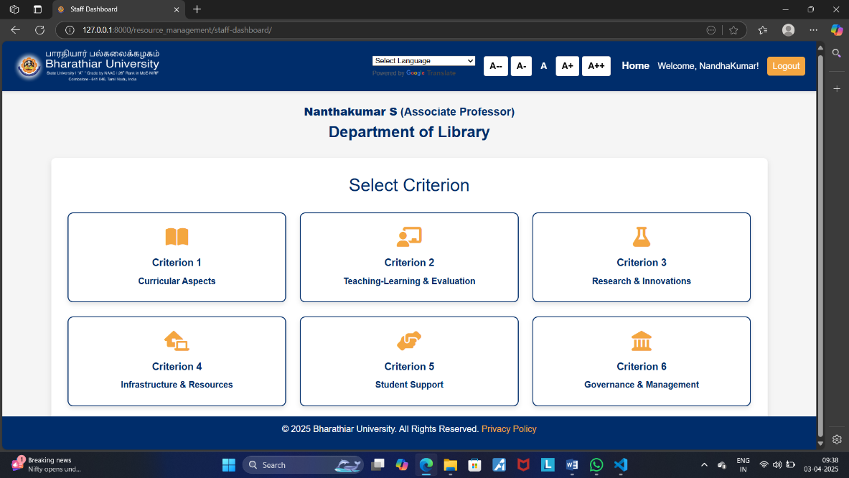
Figure 7.1 Home Page
Description: The screenshot showcases the main interface of the Department Dashboard for Bharathiar University, specifically for the Department of Library. It serves as the entry point for department staff to choose relevant criteria.

7.1.2 Department Dashboard

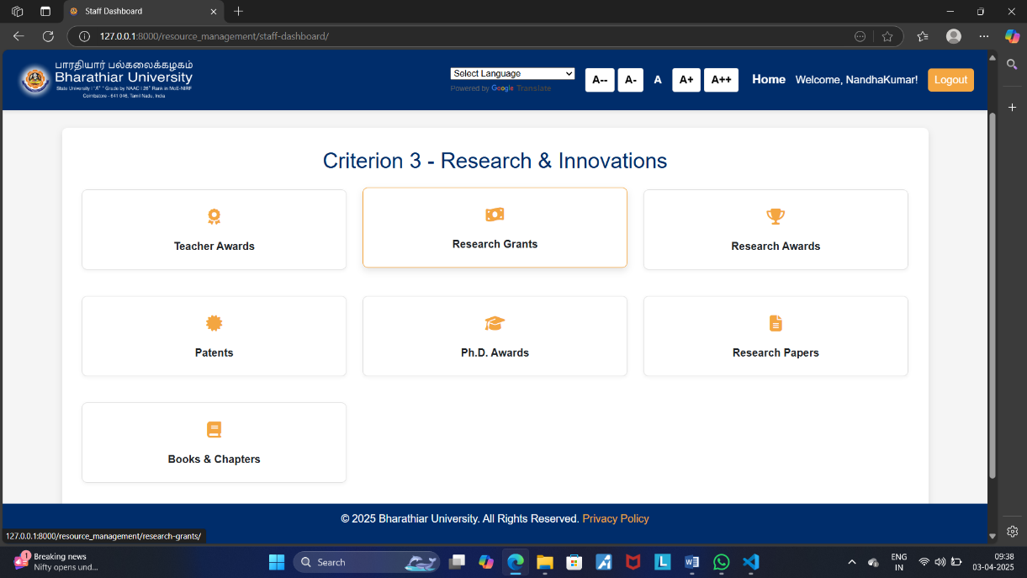
Figure 7.2 Department Dashboard: Criterion 4 – E-content Development
Description: The screenshot highlights the main interface of the "Criterion 4 - Research and Innovations" page in the Department Dashboard for Bharathiar University. This page is specific to the Department of Library and provides a streamlined view of resources and development tools. The interface is divided into four main functional sections.

7.1.3 E-Content Development

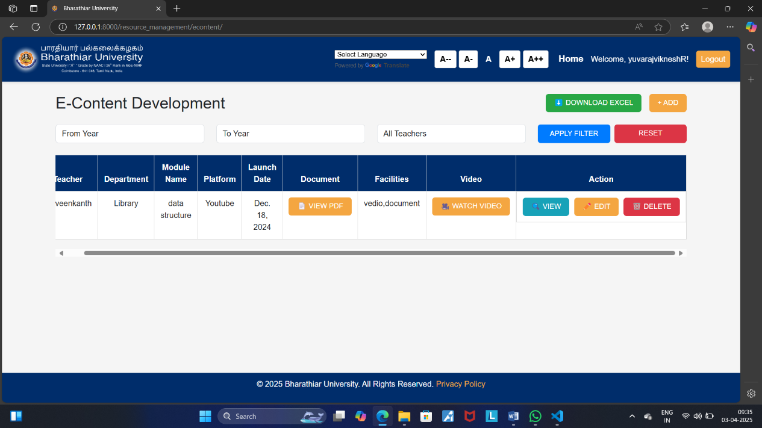
Figure 7.3 E-Content Development
Description: The screenshot displays the interface of the "E-Content Devlopment" page for Bharathiar University's Library Department. It provides a detailed overview of E-Content related infrastructure managed by the library staff.

7.1.4 Edit Module

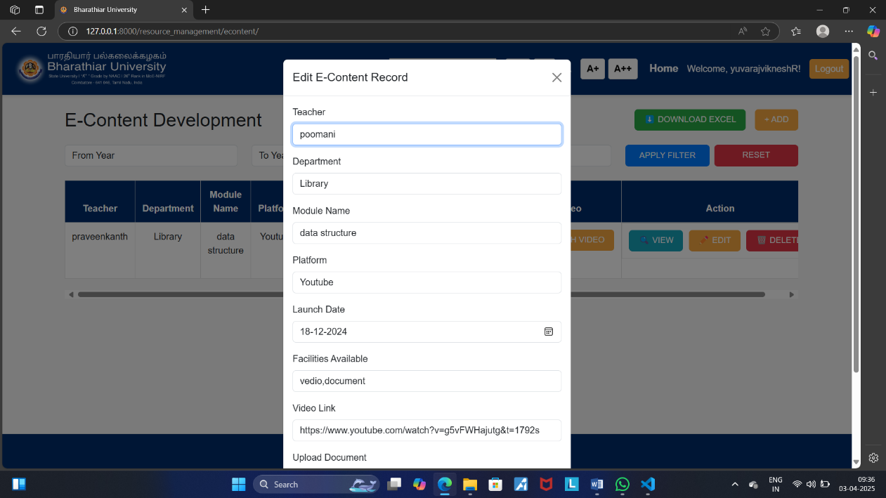
Figure 7.4 Edit Module
Description: The Edit Module interface allows users to modify existing records in the system. This module is presented as a pop-up form on the screen, overlaying the main page content for ease of access and focused interaction.

7.1.5 Detailed View Page

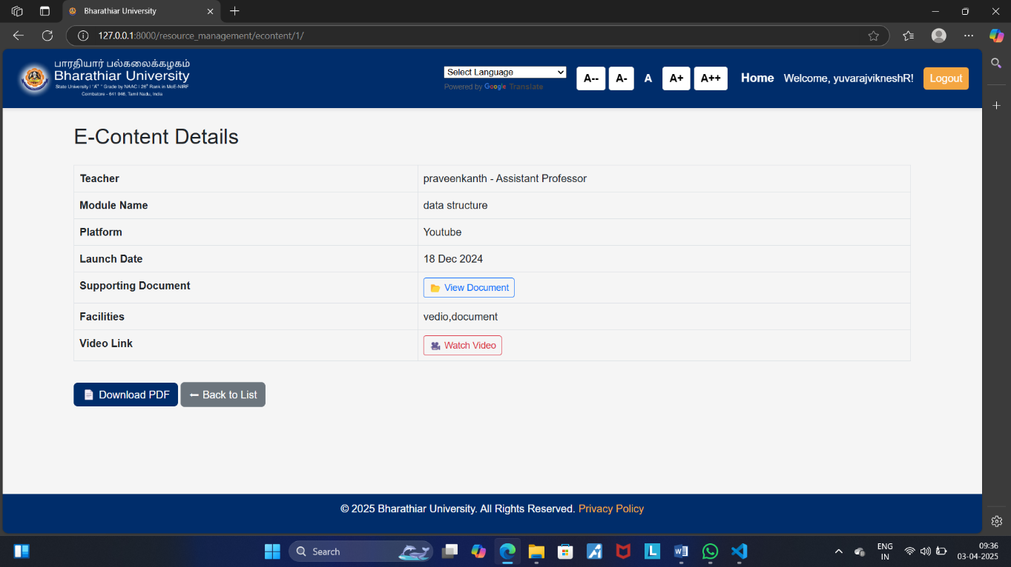
Figure 7.5 Detailed View Page – E-Content Details
Description: The screenshot showcases the Detailed View Page for a specific E-Content record within Bharathiar University's Library Department. This page provides a complete overview of the selected record, offering users a comprehensive look at all associated details.

7.1.6 Login Page

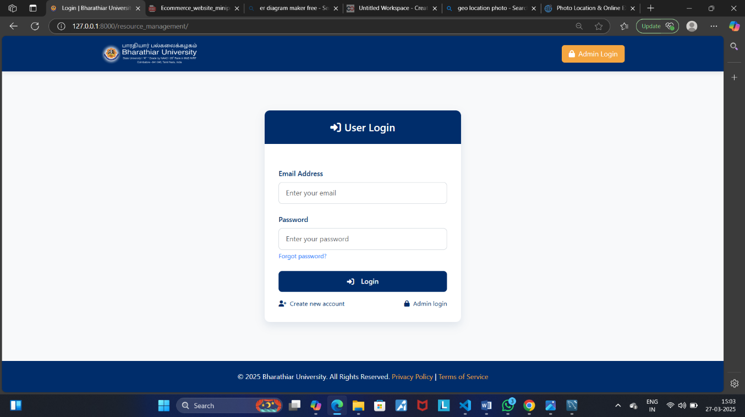

Figure 7.6 Login Page
Description: The image displays the login page for Bharathiar University, designed for user authentication. This page serves as the gateway to the university’s online platform and provides options for different types of users.

7.1.7 User Registration Page

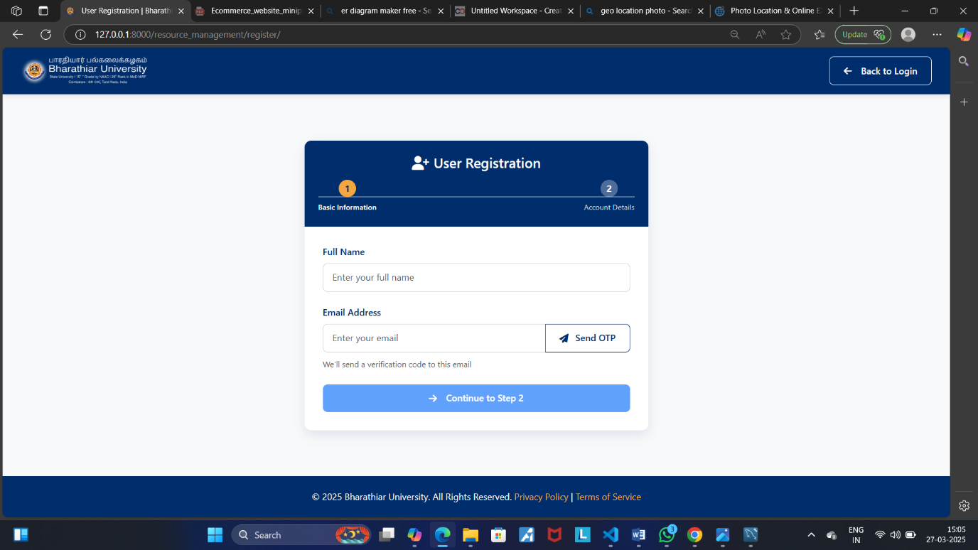
Figure 7.7 User Registration Page
Description: The image illustrates the User Registration Page for Bharathiar University. This page serves as the entry point for new users to create an account and is divided into two sections: Basic Information (currently active) and Account Details.

7.1.8 Add E-Content Record Page

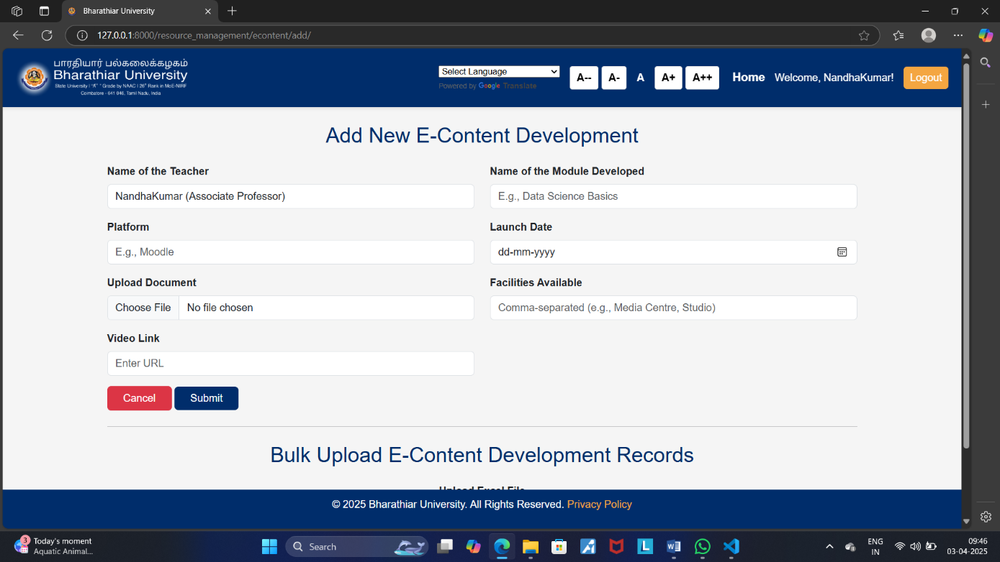
Figure 7.8 Add E-Content Record Page
Description: The image illustrates the E-Content Addition Page, part of Bharathiar University's platform. This page allows users to enter details for a new E-Content resource within the university's infrastructure.

7.1.9 Bulk Upload

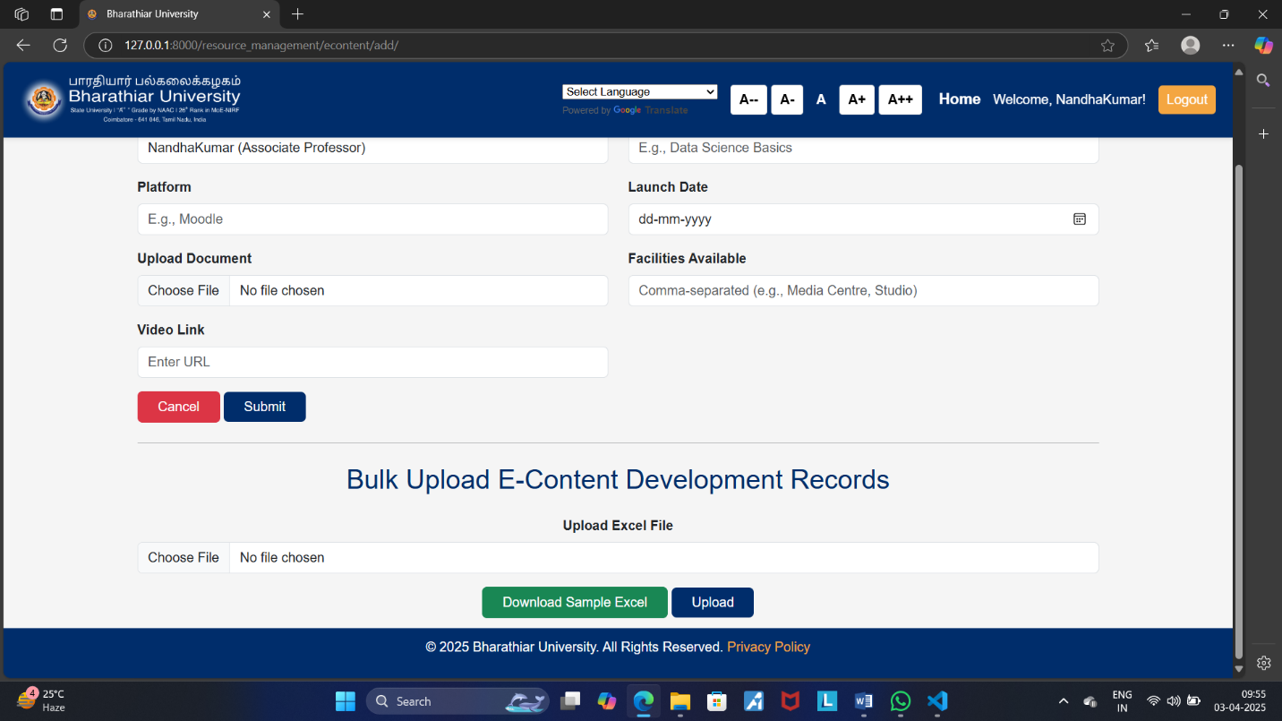

Figure 7.9 Bulk Upload
Description: The Bulk Upload feature allows users to upload multiple E-Content facility records simultaneously into the system. It simplifies data entry by supporting batch processing through an Excel template, making it particularly useful for managing large datasets efficiently.

