**Face Recognition**

**Introduction**

Face recognition is a biometric technique that identifies individuals by analyzing facial features from images or videos. It uses computer vision, machine learning, and AI to automate identity verification, often without the need for physical contact.

This technology is widely applied in areas such as public security, mobile phone authentication, and workplace access control. Its ability to function seamlessly and accurately in real-time environments has made it one of the most prominent biometric solutions today.

The key advantage of facial recognition is its non-intrusive nature. Unlike fingerprints or iris scans, it does not require direct physical interaction with the user, making it ideal for both surveillance and commercial use.

**Working Process of Face Recognition**

**Face Detection**

Face recognition begins with face detection, where the system locates one or more human faces in an input image or video frame. Advanced techniques like Haar cascades, HOG, and deep learning-based object detectors are often used for this step.

**Preprocessing**

Once the face is detected, preprocessing takes place. This includes tasks like resizing the image, adjusting lighting conditions, and aligning facial landmarks (such as the eyes, nose, and mouth) to ensure uniformity across samples.

**Feature Extraction**

The next step is feature extraction, where unique characteristics of the face are encoded into numerical data. Deep learning models like FaceNet and ArcFace generate embeddings—compact vectors that represent facial features mathematically.

**Matching and Decision**

The final step is face matching, where the extracted facial vector is compared to vectors stored in a database. Similarity measures such as Euclidean distance or cosine similarity determine whether the face matches a known identity.

**Real-Time Implementation and Use Cases**

In real-time systems, face recognition is integrated into CCTV networks, mobile apps, or embedded devices to identify individuals instantaneously. It is capable of tracking faces across multiple video frames, even in crowded environments.

Mobile phones often use facial recognition for unlocking devices or authorizing payments. The technology is also used in border control systems, smart attendance trackers, and personalized services in retail and advertising.

Modern systems often run on edge devices, allowing computations to occur locally on the device rather than in the cloud. This reduces latency, increases privacy, and ensures quick decision-making in time-sensitive applications.

Several software frameworks support face recognition development, including OpenCV, Dlib, DeepFace, and Google’s Mediapipe. These libraries offer tools for detection, alignment, embedding, and verification, making development easier and faster.

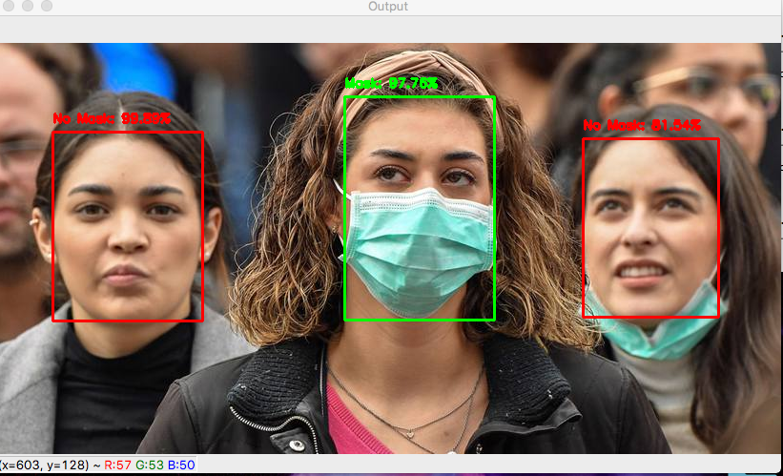

**How CNN Works**

1. **Input Layer**

* The image of a face is fed into the CNN.
* This image is usually in the form of pixels (e.g., a 100×100 RGB image = 3 channels × 100 rows × 100 columns).

**2. Convolutional Layers**

* These layers **scan the image using filters** (small windows) to detect features like edges, corners, eyes, nose, and mouth.
* Each filter slides over the image and creates a **feature map**, which highlights important patterns.

**Example**: One filter may learn to detect vertical edges (like the side of a nose), while another detects curves (like the mouth).

**3. Activation Function (ReLU)**

* After each convolution, a **ReLU (Rectified Linear Unit)** function is applied.
* It keeps only the important features by removing negative values, making the model focus on what matters.

**4. Pooling Layers**

* Pooling **shrinks** the image data by summarizing information, reducing size while keeping the important features.
* **Max pooling** is commonly used – it takes the **highest value** from a region.

**5. Flattening**

* After several layers of convolution and pooling, the result is flattened into a **1D vector** (a long list of numbers).
* This vector is a compressed **numerical summary of the face** – like its fingerprint.

**6. Fully Connected (Dense) Layers**

* These layers learn complex combinations of facial features.
* Finally, the network produces an **output** that can be:
  + A class label (e.g., "Person A", "Person B"), or
  + A unique vector/embedding (used for matching in face recognition).

