### Dashboards

Dashboards let you curate data from reports using charts, tables, and metrics. If your colleagues need more information, then they' readable to view your dashboard's data-supplying reports.

Dashboard filters make it easy for users to apply different data perspectives to a single dashboard.

### Create Dashboard

* 1. Click on Dashboards tab from the **Candidate Internal Result Card**

application.

1. Click on new dashboard.
2. Give name- **Candidate Internal Result Card**
3. Click create
4. Give your dashboard a name and click on +component
5. Select the **Candidate Internal Result** Report which you created.
6. For the data visualization select any of the chart, table etc. as per your choice/requirement.
7. Click add.
8. Click save.

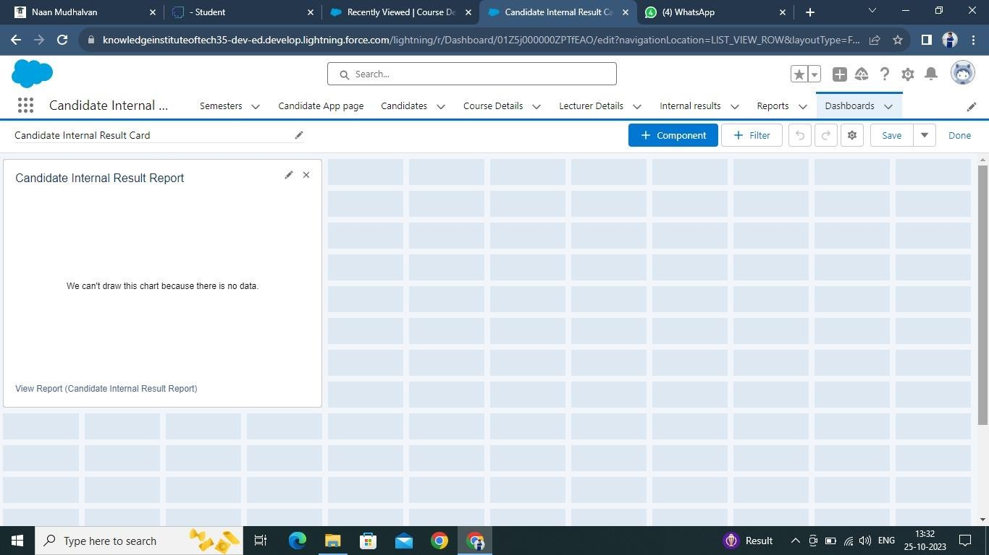

**View Dashboard**

1. Click on App Launcher on left side of screen.
2. Search **Candidate Internal Result Card** & click on it.
3. Click on Dashboard Tab.
4. Click on **Candidate Internal Result Card** see graph view of records.

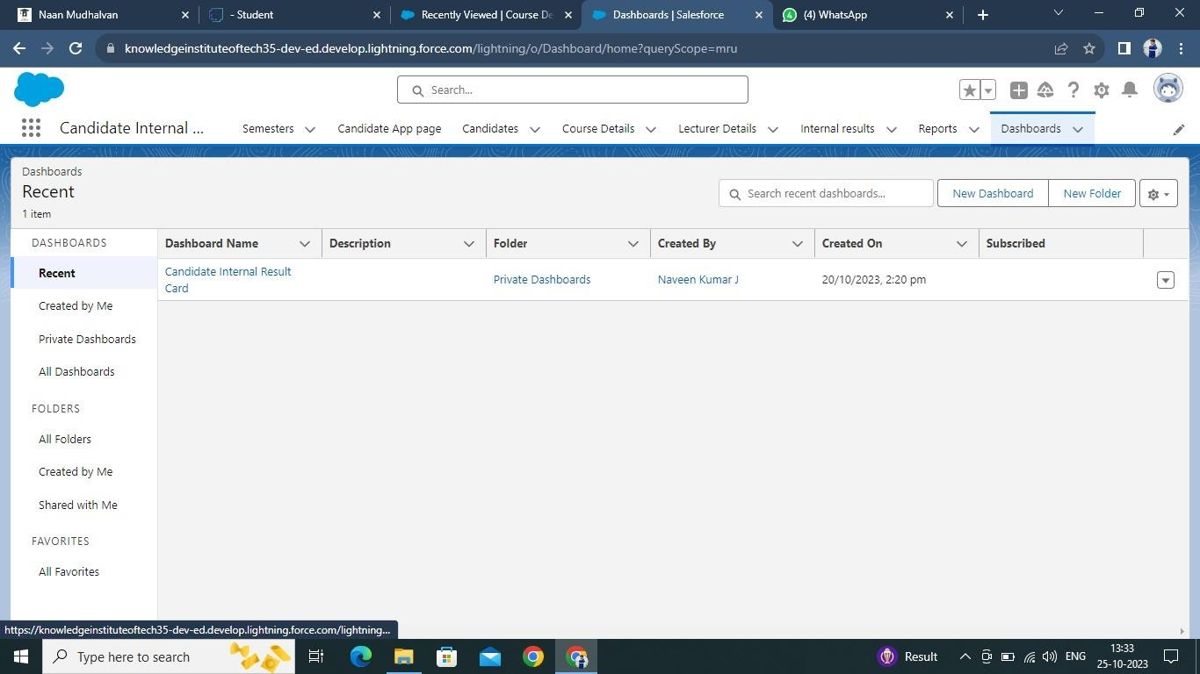

https://github.com/naveencsbs/Salesforce-Developer-Naan-

Mudhalavan/tree/main/Implementing%20CRM%20For%20Result%20Tracking%20Of

%20A%20Candidate%20With%20Internal%20Marks