### Dashboards

Dashboards let you curate data from reports using charts, tables, and metrics. If your colleagues need more information, then they' reable to view your dashboard's data-supplying reports.

Dashboard filters make it easy for users to apply different data perspectives to a single dashboard.

### Create Dashboard

* 1. Click on Dashboards tab from the **Candidate Internal Result Card**

application.

* 1. Click on new dashboard.
  2. Give name- **Candidate Internal Result Card**
  3. Click create
  4. Give your dashboard a name and click on +component
  5. Select the **Candidate Internal Result** Report which you created.
  6. For the data visualization select any of the chart, table etc. as per your choice/requirement.
  7. Click add.
  8. Click save.

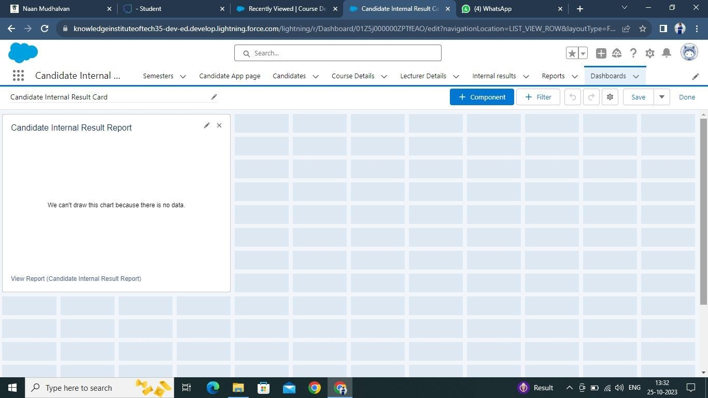

**View Dashboard**

1. Click on App Launcher on left side of screen.
2. Search **Candidate Internal Result Card** & click on it.
3. Click on Dashboard Tab.
4. Click on **Candidate Internal Result Card** see graph view of records.

