**Creation Of Semester Object For Candidate Internal Result Card**

1. Click on the gear icon and then select Setup.
2. Click on the object manager tab just beside the home tab.
3. After the above steps, have a look on the extreme right you will find a Create Dropdownclick on that and select Custom Object.
4. On the Custom Object Definition page, create the object as follows:
5. Label: **Semester**
6. Plural Label: **Semesters**
7. Record Name: **Semester** Name
8. Check the **Allow Reports**
9. Check the **Allow Search** And Click Save.

In the same way create **4** more objects as **Candidate, Course Detail, Lecturer Detail** and **Internal result.**

Plural Label: **Semesters**

1. Record Name: **Semester** Name
2. Check the **Allow Reports**
3. Check the **Allow Search** And Click Save.

In the same way create **4** more objects as **Candidate, Course Detail, Lecturer Detail** and **Internal result.**

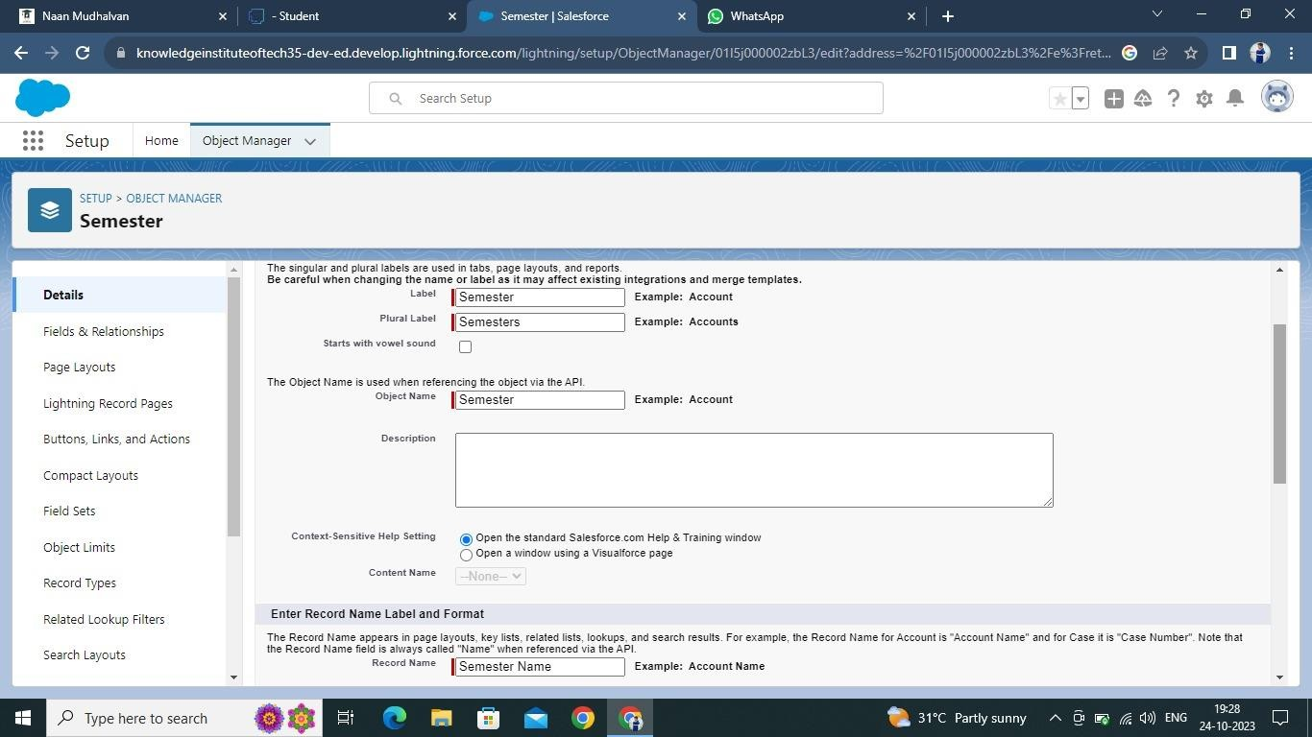

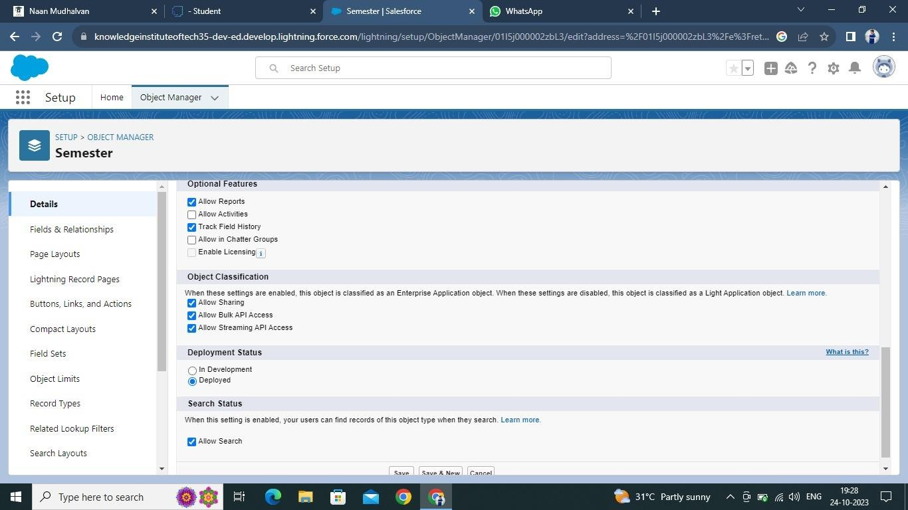

Plural Label: **Semesters**

1. Record Name: **Semester** Name
2. Check the **Allow Reports**
3. Check the **Allow Search** And Click Save.

In the same way create **4** more objects as **Candidate, Course Detail, Lecturer Detail** and **Internal result.**



